Revision of the catfish family Pimelodidae (Teleostei: Siluriformes) of Bolivia
Hitomi Torrico-Destre^{1*}, Matías Careaga¹, Mabel Maldonado¹, Fernando M. Carvajal-Vallejos¹
¹Unidad de Limnología y Recursos Acuáticos (ULRA), Departamento de Biología, Facultad de Ciencias y Tecnología (FCyT), Universidad Mayor de San Simón (UMSS), calle Sucre y Parque La Torre s/n, zona Las Cuadras, Cochabamba, Plurinational State of Bolivia.
*Author for correspondence: hitomitorricodestre@gmail.com
ABSTRACT
This study provides an updated list, morphological characterization, and an artificial dichotomous key for identifying Pimelodidae fish species of Bolivia. 346 specimens deposited in the UMSS–Museo d’Orbigny Ichthyological Collection (Cochabamba, Bolivia) were examined. The morphological characterization was based on 41 measurements. Species list considered the UMSS-Museo d’Orbigny Ichthyological Collection data base and records available in the literature for Bolivia. Forty-eight species and 24 genera were identified from the Amazon (44) and La Plata (16) basins. New records for Bolivia were Hypophthalmus celiae, H. oremaculatus, Iheringichthys megalops, and two new potential species within Propimelodus. Additionally, two new undescribed genera are listed: one collected (three specimens) from the bottom of the Beni River channel, and the another (one specimen) from the bottom of the Beni and the Mamoré rivers channels at the north of Bolivia. Species such as Pimelodus gr. blochii and P. gr. maculatus are taxonomically challenging and difficult to identify due to morphological similarities between them. This study reveals the high diversity of Pimelodidae in Bolivia, and the presence of new genera and species in the country.
INTRODUCTION
The Pimelodidae family comprises 116 valid species distributed among 30 genera (Fricke et al. 2023). Fishes of this family are characterized by a naked body (without bony plates or scales), well-separated nostrils, villiform teeth arranged in plates or patches, three pairs of barbels, and a well-developed adipose fin. For a long time, the family Pimelodidae sensu lato grouped some species that lacked synapomorphies supporting their classification. This group included species now positioned into Heptapteridae and Pseudopimelodidae, families recognized as monophyletic and distinct from Pimelodidae (Salles & Zuanon 2013). Currently, Pimelodidae sensu stricto is recognized as a monophyletic group based on three synapomorphies proposed by Lundberg et al. (1991): a dendritic arrangement of lateral line system on the head and nape, elongated lateral ethmoid-palatine condyle and a sutural joint between the fifth and sixth centra. Subsequently, Pinna (1993) described an additional synapomorphy supporting the monophyly of Pimelodidae: a bifurcated dorsal arising from the premaxilla. It is important to highlight that the dendritic arrangement of the lateral line system on the head and nape can also be observed in specimens of Ariidae, suggesting independent evolution. Additionally, the sutural joint between the fifth and sixth centra is absent in Megalonema (Lundberg & Littmann 2003).
Fishes of this family are endemic to the Neotropical region, exhibiting greater diversity in the basins of the Amazon, Paraná, Orinoco, and major rivers in the Guianas. Most adult pimelodids reach sizes ranging from approximately 20-80 cm in length; however, there are two extremes in adult lengths. On one hand, there are the most representative catfish of the Brachyplatystoma genus that can exceed lengths of 2 m, and on the other hand, there are as-yet-undescribed species inhabiting the bottom of Amazon channels, with lengths around 25 mm (Lundberg & Littmann 2003). Many species are popular among aquarium enthusiasts. Nevertheless, their most significant role is underscored in fisheries, as many species boast considerable sizes (Carvalho et al. 2022). They inhabit various habitats, ranging from small to large rivers with clear, black, or white waters, and even in lagoons. However, they are most commonly found in lowland rivers with strong currents (Lundberg & Littmann 2003). Most pimelodids dwell on the riverbeds and in turbid waters of streams. They are seldom found permanently inhabiting lacustrine or swampy environments (Gálvis et al. 1997).
In Bolivia, species of this family are distributed in the basins of the Amazon and La Plata. In the Bolivian Amazon, both subsistence and commercial fishing are primarily focused on large-sized species belonging to the families Pimelodidae, Serrasalmidae, and Characidae (Carvajal-Vallejos et al. 2011). The most exploited species within the Pimelodidae family belong to the genera Brachyplatystoma and Pseudoplatystoma (Carvajal-Vallejos et al. 2011, Van Damme et al. 2011), which can reach lengths exceeding two meters. Additionally, smaller-sized species from the genera Aguarunichthys, Calophysus, Duopalatinus, Hemisorubim, Hypophthalmus, Leiarius, Megalonema, Phractocephalus, Pimelodus, Pimelodina, Pinirampus, Platynematichthys, Platystomatichthys, Sorubim, Sorubimichthys, and Zungaro are also harvested (Carvajal-Vallejos et al. 2011). Consequently, many of these species may become overexploited and thus threatened (Sarmiento et al. 2014). This includes species such as the dorado (Brachyplatystoma rousseauxii), jaú (Zungaro jahu), and pintado (Pseudoplatystoma corruscans), which are being indiscriminately caught for subsistence, commercial, or recreational purposes. Furthermore, they face additional disturbances such as habitat destruction and contamination, as well as disruption of their life cycle due to the construction of hydroelectric dams that impede reproductive migrations (Van Damme et al. 2009).
In recent decades, the ichthyofauna of Bolivia has garnered increasing interest from scientists and national authorities, given its significant economic value and role as a protein source for local communities. Despite this, there is limited scientific literature on the Pimelodidae family in Bolivia, and information regarding its distribution and biology is scarce and scattered, with most studies focusing on listings or inventories (Carvajal-Vallejos et al. 2014a). Most of the lists or inventories are geographically limited to the systems of the Bolivian Amazon. Some of these include: Pearson (1937), with 21 species in the Beni and Mamoré sub-basins; Lauzanne & Loubens (1985), with 16 species for the Mamoré sub-basin; Lauzanne et al. (1991), with 17 species in the Amazon Basin; Pouilly et al. (2004), with 17 species for the floodplain of the Mamoré sub-basin; Pouilly et al. (2010), with 41 species for the lowlands of the Bolivian Amazon; Carvajal-Vallejos & Fernández (2011), with 41 species for the Amazon Basin. Literature for La Plata Basin is limited, with only a few studies such as Maldonado et al. (2019) with six species in the Pilcomayo sub-basin, and Sarmiento et al. (2019) with seven species in the Bermejo sub-basin. Some inventories covering both the Amazon and La Plata basins include Terrazas (1970) with nine species, Carvajal-Vallejos et al. (2014c) with 45 species recorded, and Torrico et al. (2020) with 50 species.
The objective of this study was to morphologically characterize the species of the Pimelodidae family in Bolivia, update the list of records by basins and sub-basins, and provide an artificial dichotomous key for identifying the species present in the country.
METHODS
A total of 346 specimens of the Pimelodidae family, corresponding to 24 valid genera and 48 valid species, were examined with preference given to individuals in better conservation condition and larger size. The examined material is deposited in the Ichthyological Collection UMSS – Museo d'Orbigny (Cochabamba, Bolivia), collected from the Amazon and La Plata basins. Institutional abbreviation: Universidad Mayor de San Simón (UMSS).
Measurements
Forty-one linear measurements were taken on specimens using a digital caliper with 0.01 mm of precision, whenever possible on the left side. The measurements were based on Stewart & Pavlik (1985), Lundberg & McDade (1986), Littmann et al. (2000), and Azpelicueta & Britski (2012). Additionally, the following measurements were added: (1) nuchal plate length, distance between the tip and the posterior margin of the plate; (2) distance between internal mental barbels; (3) distance between external mental barbels; (4) distance between internal and external mental barbels, distance between edges of the internal and external barbels; (5) distance between the origin of the dorsal fin and the origin of the anal fin; (6) distance between pelvic fins, distance between the origin of the left pelvic fin and the origin of the right pelvic fin; (7) distance between the origin of the dorsal fin and anterior caudal base; (8) distance between the origin of the adipose fin and the anterior caudal base; and (9) distance between the origin of the anal fin and the anterior caudal base (Figure 1, Table 1). Rays count was made against light, including each visible ray.
Taxonomic identification
The material was identified using the following keys and/or diagnoses for genera and/or species: Salles & Zuanon 2013; Aguarunichthys (Stewart 1986, Zuanon et al. 1993); Brachyplatystoma (Eigenmann & Eigenmann 1890, Lundberg & Akama 2005); Calophysus (Eigenmann & Eigenmann 1890); Cheirocerus (Stewart & Pavlik 1985); Duopalatinus (Eigenmann & Eigenmann 1888, Eigenmann & Eigenmann 1890, Eigenmann & Allen 1942); Exallodontus (Lundberg et al. 1991); Hemisorubim (Eigenmann & Eigenmann 1890, Mees 1974); Hypophthalmus (Littmann et al. 2021; Iheringichthys, Eigenmann & Norris 1900, Azpelicueta & Britski 2012; Leiarius, Eigenmann & Eigenmann 1890); Luciopimelodus (Eigenmann & Eigenmann 1890); Megalonema (Eigenmann 1912, Lundberg & Dahdul 2008); Phractocephalus (Eigenmann & Eigenmann 1890, Eigenmann & Allen 1942, Lundberg & Aguilera 2003); Pimelodina (Stewart 1986); Pimelodus (Eigenmann & Eigenmann 1890); Pinirampus (Eigenmann & Eigenmann 1890); Platynematichthys (Eigenmann & Eigenmann 1890, Guzmán et al. 2011); Platysilurus (Schultz 1944); Platystomatichthys (Eigenmann & Eigenmann 1890); Propimelodus (Lundberg & Parisi 2002, Parisini et al. 2006, Rocha et al. 2007); Pseudoplatystoma (Eigenmann & Eigenmann 1890, Eigenmann & Allen 1942, Mees 1974); Sorubim (Littmann et al. 2001a, Littmann et al. 2001b, Littmann 2007); Sorubimichthys (Eigenmann & Eigenmann 1890, Eigenmann & Allen 1942); Zungaro (Eigenmann & Allen 1942). The rays count of Brachyplatystoma juruense was based on Boulenger (1898), since the only specimen examined had its fins removed, except the dorsal fin.
Inventory and distribution
For the inventory, records from 1090 lots of the Ichthyological Collection UMSS – Museo d'Orbigny (Cochabamba, Bolivia) were used, supplemented with data from the literature (Carvajal-Vallejos & Fernández 2011, Sarmiento et al. 2019, Maldonado et al. 2019, Careaga et al. 2020, Maldonado et al. 2020, and Torrico et al. 2020). The distribution of species in Bolivia was determined at the level of the Amazon and La Plata basins and their respective sub-basins. For the Amazon Basin, sub-basins delimitation by Carvajal-Vallejos et al. (2014a) were considered. Some abbreviations are: Beni-Madre de Dios-Orthon sub-basin (B-MD-O), Mamoré-Iténez sub-basin (MM-I).
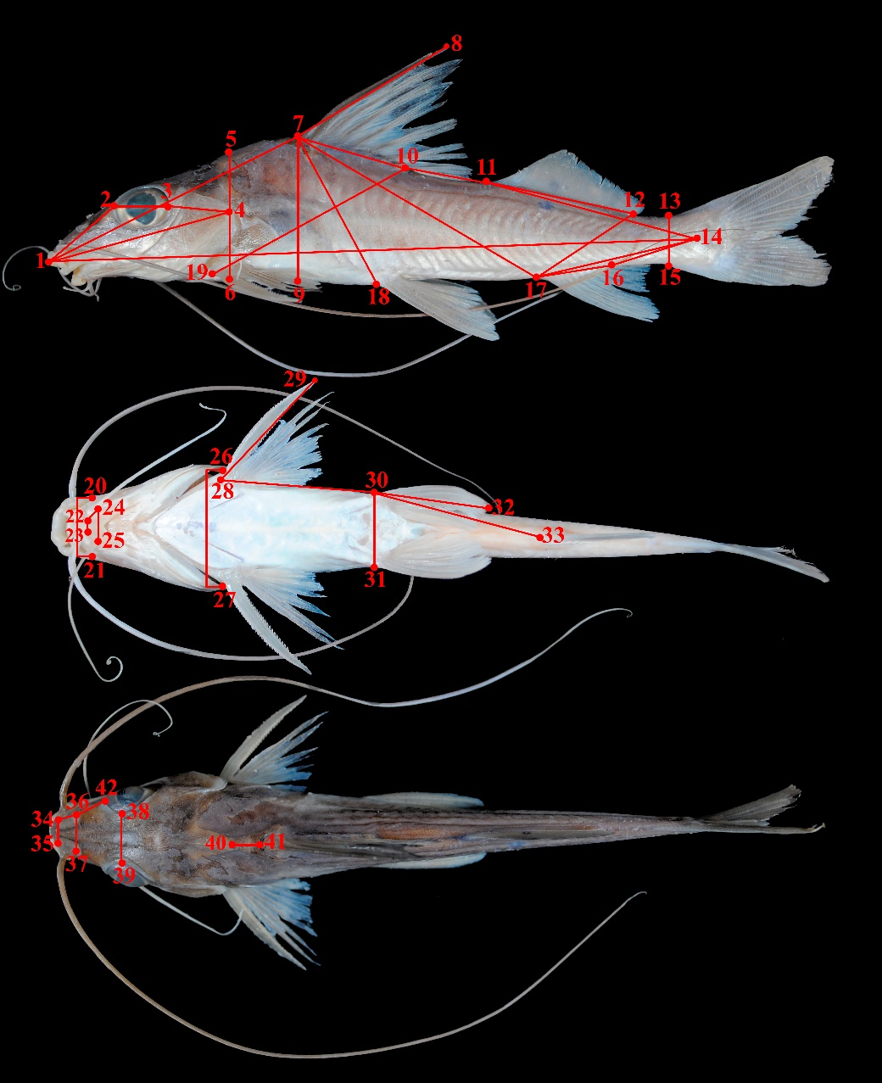
FIGURE 1. Diagram of morphometric measurements measured in Pimelodidae specimens. Descriptions of distances are specified in Table 1.
TABLE 1. Measurements taken for morphometric analysis.
Measurement | Landmarks
Dorsal length | 1-7
Nuchal plate length | 40-41
Interorbital distance | 38-39
Left posterior nostril to right posterior nostril | 36-37
Left anterior nostril to right anterior nostril | 34-35
Left anterior nostril to left posterior nostril | 34-36
Posterior nostril to anterior margin of orbit | 36-42
Head length | 1-4
Snout length | 1-2
Postorbital length | 3-4
Orbital diameter | 2-3
Head depth | 5-6
Mouth width | 20-21
Distance between internal mental barbels | 22-23
Distance between external mental barbels | 24-25
Distance between internal and external mental barbel | 22-24
Internal mental barbel length | -
External mental barbel length | -
Maxillary barbel length | -
Body width | 26-27
Body depth | 7-9
Pectoral fin origin to dorsal fin insertion | 19-10
Dorsal fin origin to pelvic fin origin | 7-18
Dorsal fin origin to anal fin origin | 7-17
Pectoral fin origin to pelvic fin origin | 28-30
Pelvic fin origin to anal fin origin | 30-33
Pectoral spine length | 28-29
Distance between pelvic fins | 30-31
Pelvic fin length | 30-32
Dorsal spine length | 7-8
Dorsal fin base length | 7-10
Dorsal fin insertion to adipose fin origin | 10-11
Adipose fin base length | 11-12
Anal fin base length | 17-16
Anal fin origin to adipose fin insertion | 17-12
Caudal peduncle height | 13-15
Standard length | 1-14
Dorsal fin origin to anterior caudal base | 7-14
Adipose fin origin to anterior caudal base | 11-14
Anal fin origin to anterior caudal base | 17-14
Caudal peduncle length | 16-14
RESULTS
List of species of the Pimelodidae family and their distribution in Bolivian basins and sub-basins
Forty-eight species and 24 genera were recorded in Bolivia (Appendix 1), in addition to two new genera: Pimelodidae nov. gen. 1 with three specimens and Pimelodidae nov. gen. 2 with one specimen.
Pimelodidae species are widely distributed in the Amazon and La Plata basins (Figure 2). The Amazon Basin showed higher species richness (50 spp.), while La Plata Basin exhibited lower richness (16 spp.). The Amazonian sub-basins Beni, Madre de Dios, and B-MD-O had a higher number of species (34, 33, and 32 respectively), whereas the Abuná and Parapetí sub-basins had the lowest numbers (three and two respectively) (Appendix 1).
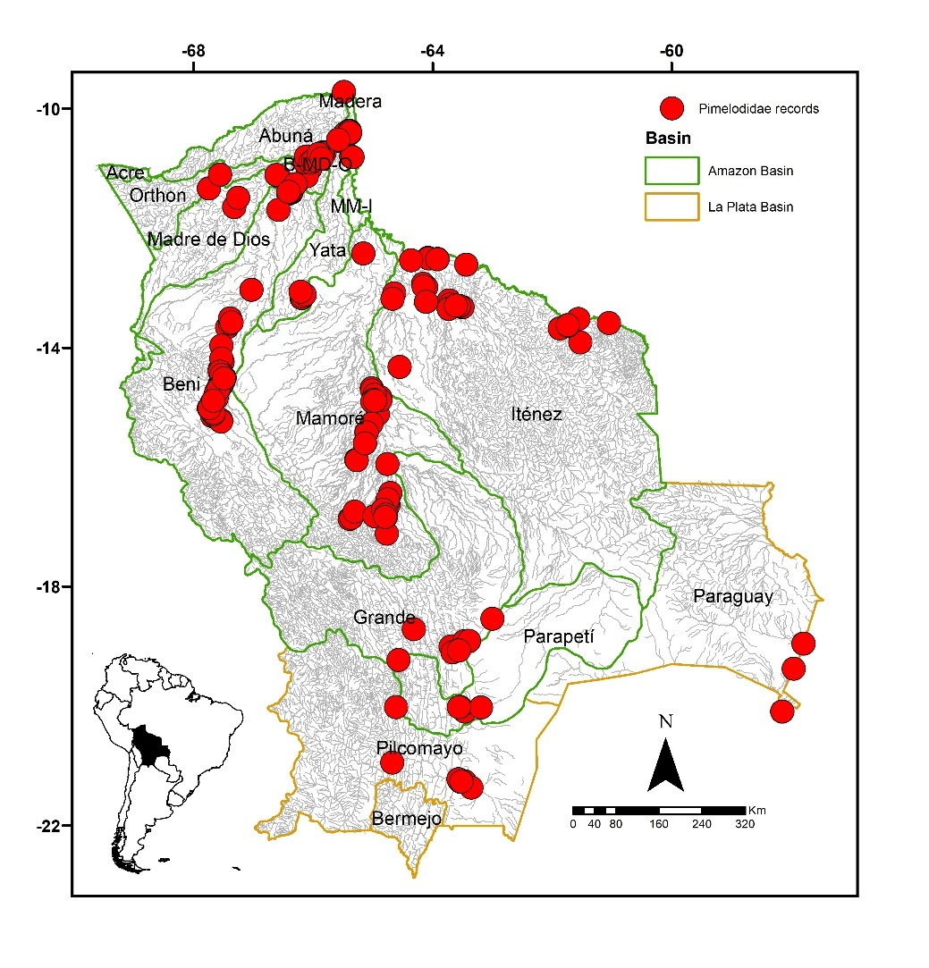
FIGURE 2. Collection sites of 1090 lots of Pimelodidae deposited in the Ichthyological Collection UMSS – d'Orbigny Museum (Cochabamba, Bolivia).
Descriptions of Pimelodidae family species recorded in Bolivia
Aguarunichthys Stewart 1986
Diagnosis. Subterminal mouth with a relatively long, conical snout and fleshy lips; wide premaxillary patches with posterolateral extensions; non-overlapping branchiostegal membranes; relatively short base of the adipose fin, separated from the dorsal fin (Stewart 1986).
Distribution. Amazon Basin (Figure 3).
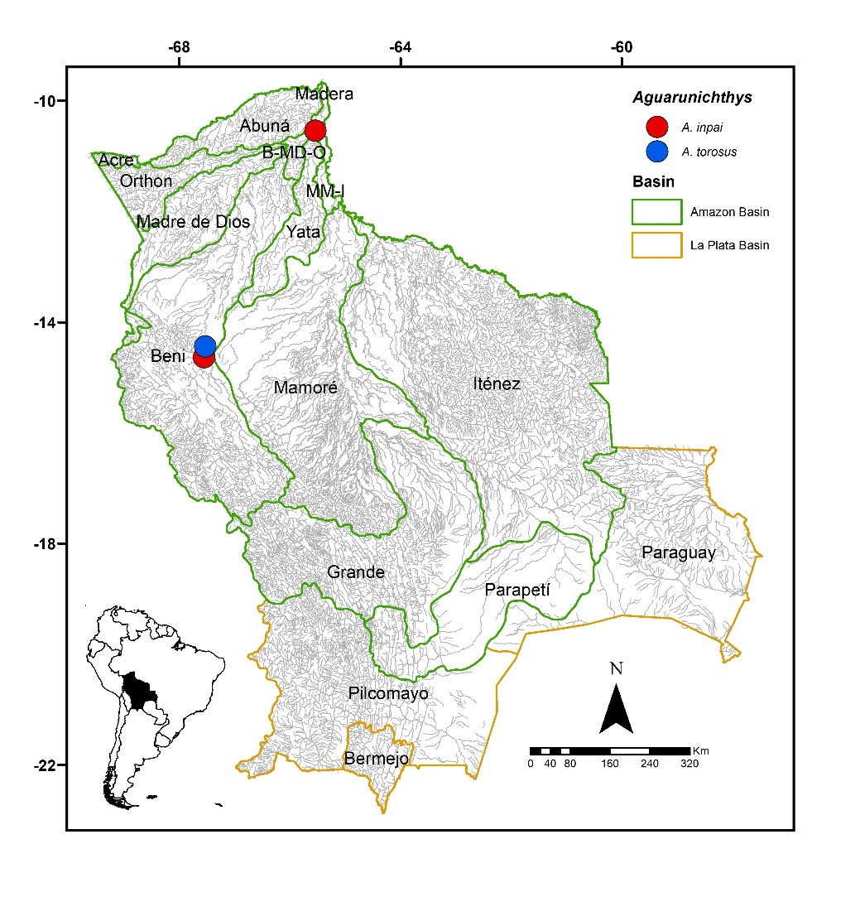
FIGURE 3. Collection sites of two lots of Aguarunichthys inpai and one of A. torosus deposited in the Ichthyological Collection UMSS – d'Orbigny Museum (Cochabamba, Bolivia).
Included species. Aguarunichthys inpai and A. torosus.
Comments. Genus proposed by Stewart (1986) for Aguarunichthys torosus Stewart as the type species. Currently, three species are known: A. inpai in the middle Amazon Basin, A. tocantinsensis in the Tocantins Basin, and A. torosus in the Amazon Basin (Fricke et al. 2023). Of the three valid species known, A. inpai and A. torosus are present in Bolivia.
Aguarunichthys inpai Zuanon, Rapp Py-Daniel & Jégu 1993 (Figure 4)
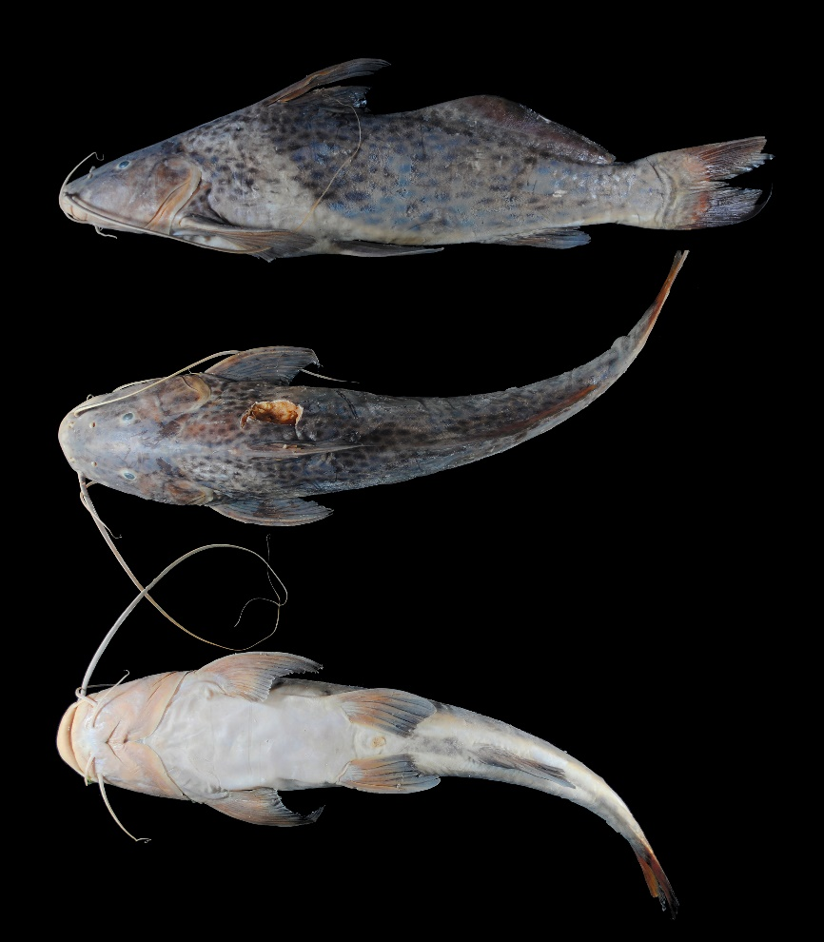
FIGURE 4. Aguarunichthys inpai, UMSS 16083, 358 mm SL, Beni River between Kaka and Tuichi, Beni sub-basin, Amazon Basin.
Examined material (2 specimens). Amazon Basin: UMSS 16083 (1, 336.7 mm SL), Beni River between Kaka and Tuichi Rivers, -14.637010 -67.5541900, 5 Sep 2015, L. Córdova, M. Jaldin, C. Rocabado; UMSS 18570 (1, 344.8 mm SL), Beni River, Cachuela Esperanza, -10.541983 -65.5387100, 23 Sep 2015, D. Barrozo.
Diagnosis. Aguarunichthys inpai differs from A. torosus by a clear band without spots extending between the bases of the dorsal and pelvic fins, left anterior nostril to right anterior nostril (18.2-19.4% HL vs. 16.8%), mouth width (46.7-47.4% HL vs. 42.5%), body width (22.2-22.6% SL vs. 20.7%), pectoral fin origin to dorsal fin insertion (29.5-29.6% SL vs. 27.4%).
Description. Morphometric data presented in Table 2. Straight and ascending profile from the tip of the snout to the origin of the dorsal fin. Head longer than wide; eyes in a supero-lateral position. Subterminal mouth with fleshy lips. Posterior supraoccipital process visibly absent. Humeral process absent. Pectoral fin extending to near the origin of the pelvic fin; first simple flexible and dorsoventrally flattened ray, with a serrated posterior margin. Pelvic fin extending just over half the distance between its origin and the anal fin origin. Pectoral fin longer than pelvic fin. Dorsal fin with the first simple flexible ray and without serrations. Adipose fin long and clearly separated from the dorsal fin. Anal fin with a slightly concave posterior margin. Base of adipose fin three times longer than the base of the anal fin. Forked caudal fin with the upper lobe slightly longer and pointed than the lower lobe. Maxillary barbels extending to just over half the base of the adipose fin; mental barbels shorter. Dorsal fin rays I+6, anal fin rays iii+8-9, pectoral fin rays I+13, pelvic fin rays i+5, caudal fin rays 15.
TABLE 2. Morphometric data of Aguarunichthys inpai. N: Number of individuals, SD: Standard deviation, Min: Minimum value, Max: Maximum value.
Measurements | N | Mean | SD | Min | Max
SL (mm) | 2 | 340.7 | 5.73 | 336.7 | 344.8
Percents of head length (% HL)
Interorbital distance | 2 | 26.4 | 1.6 | 25.2 | 27.5
Left posterior nostril to right posterior nostril | 2 | 20.6 | 0.2 | 20.4 | 20.8
Left anterior nostril to right anterior nostril | 2 | 18.8 | 0.8 | 18.2 | 19.4
Left anterior nostril to left posterior nostril | 2 | 15.9 | 0.2 | 15.8 | 16.1
Posterior nostril to anterior margin of orbit | 2 | 19.7 | 0.9 | 19.1 | 20.3
Snout length | 2 | 52.9 | 0.7 | 52.4 | 53.4
Postorbital length | 2 | 40.8 | 0.5 | 40.4 | 41.2
Orbital diameter | 2 | 8.70 | 0.2 | 8.50 | 8.80
Head depth | 2 | 64.8 | 3.1 | 62.6 | 67.0
Mouth width | 2 | 47.1 | 0.5 | 46.7 | 47.4
Distance between internal mental barbels | 2 | 14.6 | 0.8 | 14.0 | 15.1
Distance between external mental barbels | 2 | 41.0 | 0.2 | 40.8 | 41.1
Distance between internal and external mental barbel | 2 | 10.0 | 0.1 | 9.90 | 10.1
Percents of standard length (% SL)
Predorsal length | 2 | 35.5 | 1.4 | 34.6 | 36.5
Internal mental barbel length | 2 | 14.6 | 0.2 | 14.5 | 14.8
External mental barbel length | 2 | 23.8 | 1.2 | 22.9 | 24.6
Maxillary barbel length | 2 | 83.2 | 0.4 | 82.9 | 83.5
Body width | 2 | 22.4 | 0.3 | 22.2 | 22.6
Body depth | 2 | 22.2 | 0.3 | 22.0 | 22.4
Head length | 2 | 28.3 | 0.5 | 28.0 | 28.7
Pectoral fin origin to dorsal fin insertion | 2 | 29.6 | 0 | 29.5 | 29.6
Dorsal fin origin to pelvic fin origin | 2 | 27.4 | 0.2 | 27.2 | 27.6
Dorsal fin origin to anal fin origin | 2 | 44.0 | 0.8 | 43.4 | 44.5
Pectoral fin origin to pelvic fin origin | 2 | 25.0 | 0.9 | 24.3 | 25.6
Pelvic fin origin to anal fin origin | 2 | 23.7 | 0.3 | 23.5 | 23.9
Pectoral spine length | 2 | 22.4 | 0.1 | 22.4 | 22.4
Distance between pelvic fins | 2 | 15.0 | 0.5 | 14.6 | 15.3
Pelvic fin length | 2 | 17.0 | 0.5 | 16.7 | 17.4
Dorsal spine length | 2 | 23.9 | 1.2 | 23.1 | 24.7
Dorsal fin base length | 2 | 12.8 | 0.6 | 12.4 | 13.3
Dorsal fin insertion to adipose fin origin | 2 | 10.6 | 2.0 | 9.10 | 12.0
Adipose fin base length | 2 | 37.1 | 0.2 | 37.0 | 37.3
Anal fin base length | 2 | 12.0 | 0.6 | 11.6 | 12.5
Anal fin origin to adipose fin insertion | 2 | 24.8 | 1.6 | 23.6 | 26.0
Caudal peduncle height | 2 | 9.80 | 0.7 | 9.30 | 10.4
Dorsal fin origin to anterior caudal base | 2 | 69.5 | 2.0 | 68.1 | 70.9
Adipose fin origin to anterior caudal base | 2 | 46.7 | 1.1 | 45.9 | 47.4
Anal fin origin to anterior caudal base | 2 | 31.8 | 1.7 | 30.6 | 33.0
Caudal peduncle length | 2 | 19.5 | 1.3 | 18.6 | 20.4
Coloration in alcohol. Body background from cream to brown with small circular or oval dark spots on the dorsal and lateral sides; ventral region whitish. Diagonal unspotted band extending from the origin of the dorsal fin to the origin of the pectoral fin. Fins slightly pigmented and with spots.
Coloration in life. Coloration similar to individuals preserved in alcohol. The unspotted diagonal band in the anterior body region more visible in fresh individuals.
Distribution. Present in the Beni and B-MD-O sub-basins (Amazon Basin). Also recorded in the Madeira sub-basin (Amazon Basin) (Torrico et al. 2020).
Importance. Commercial fishing trade in Puerto Rico, Cobija and Rurrenabaque. Subsistence fishing in Rurrenabaque and Cachuela Esperanza (Carvajal-Vallejos et al. 2011).
Ecological notes. Regarding the habitat of this species, the only information comes from Zuanon et al. (1993), which indicates that it inhabits rivers with sediment-laden waters, at considerable depths (30 m), making its capture rare.
Aguarunichthys torosus Stewart 1986 (Figure 5)
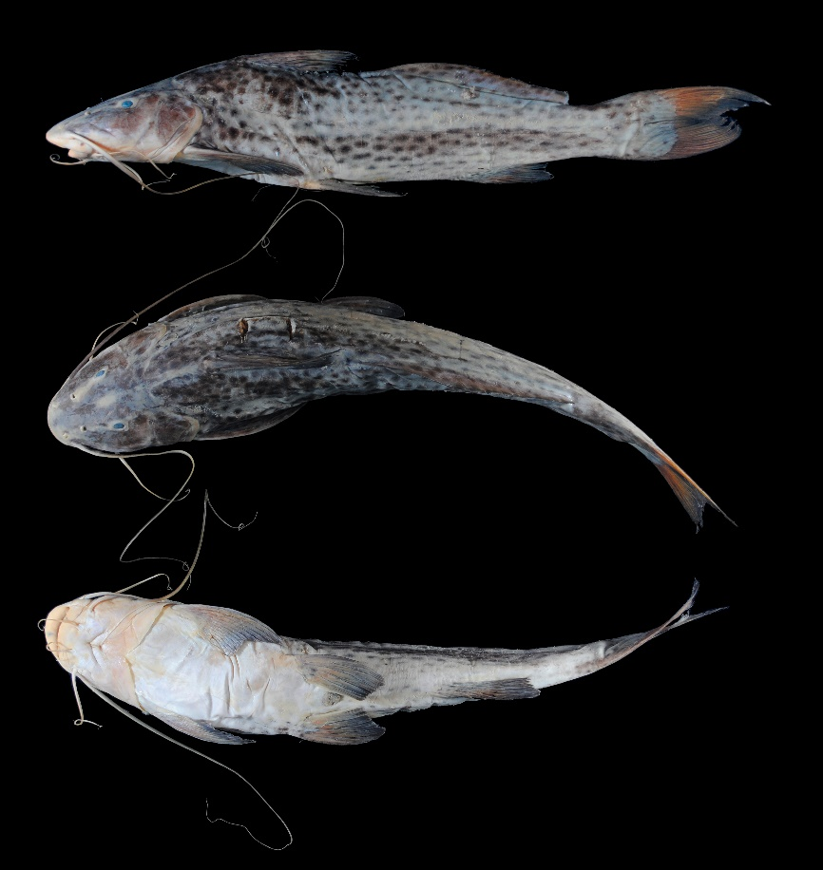
FIGURE 5. Aguarunichthys torosus, UMSS 7668, 344 mm SL, Beni River, Beni sub-basin, Amazon Basin.
Examined material (one specimen). Amazon Basin: UMSS 18574 (1, 344 mm SL), Beni River, Rurrenabaque, -14.440752 -67.5308970, 2 Dec 2007, F. Carvajal.
Common name. Chanana negro in Puerto Rico, Cobija (Pando), and Riberalta (Beni) (Carvajal-Vallejos et al. 2011).
Diagnosis. Review the diagnosis of A. inpai.
Description. Morphometric data presented in Table 3. Relatively straight and ascending profile from the tip of the snout to the origin of the dorsal fin. Head longer than wide; eyes in a superolateral position. Subterminal mouth with fleshy lips. Dentary with narrow patches and sharp posterolateral projections; wide premaxillary patch with posterolateral extensions; vomerian and palatine patches absent. Posterior supraoccipital process visibly absent. Humeral process absent. Pectoral fin extending very close to the origin of the pelvic fin; first simple flexible and dorsoventrally flattened ray, with a serrated posterior margin. Pelvic fin extending just over half the distance between its origin and the anal fin origin. Pectoral fin longer than pelvic fin. Dorsal fin with the first simple and flexible ray, without serrations. Adipose fin long and clearly separated from the dorsal fin. Base of the adipose fin three times longer than the base of the anal fin. Anal fin with a slightly concave posterior margin. Strongly bifurcated caudal fin with the upper lobe pointed and longer than the lower lobe. Maxillary barbels extending to just over half the base of the adipose fin; internal mental barbels extending to the origin of the pectoral fin; external mental barbels extending to approximately half of the first pectoral ray. Dorsal fin rays I+6; anal fin rays iii+9; pectoral fin rays I+13, pelvic fin rays i+5; caudal fin rays 15.
TABLE 3. Morphometric data of Aguarunichthys torosus. N: Number of individuals.
Measurements | N | Value
SL (mm) | 1 | 344
Percents of head length (% HL)
Interorbital distance | 1 | 26.9
Left posterior nostril to right posterior nostril | 1 | 19.0
Left anterior nostril to right anterior nostril | 1 | 16.8
Left anterior nostril to left posterior nostril | 1 | 17.0
Posterior nostril to anterior margin of orbit | 1 | 19.9
Snout length | 1 | 54.4
Postorbital length | 1 | 39.6
Orbital diameter | 1 | 8.90
Head depth | 1 | 68.9
Mouth width | 1 | 42.5
Distance between internal mental barbels | 1 | 13.4
Distance between external mental barbels | 1 | 40.7
Distance between internal and external mental barbel | 1 | 10.4
Percents of standard length (% SL)
Predorsal length | 1 | 34.7
Internal mental barbel length | 1 | 13.6
External mental barbel length | 1 | 25.5
Maxillary barbel length | 1 | 83.5
Body width | 1 | 20.7
Body depth | 1 | 23.2
Head length | 1 | 26.7
Pectoral fin origin to dorsal fin insertion | 1 | 27.4
Dorsal fin origin to pelvic fin origin | 1 | 27.3
Dorsal fin origin to anal fin origin | 1 | 43.2
Pectoral fin origin to pelvic fin origin | 1 | 25.4
Pelvic fin origin to anal fin origin | 1 | 24.0
Pectoral spine length | 1 | 21.3
Distance between pelvic fins | 1 | 14.8
Pelvic fin length | 1 | 16.8
Dorsal spine length | 1 | 21.7
Dorsal fin base length | 1 | 12.7
Dorsal fin insertion to adipose fin origin | 1 | 10.1
Adipose fin base length | 1 | 37.6
Anal fin base length | 1 | 13.3
Anal fin origin to adipose fin insertion | 1 | 25.4
Caudal peduncle height | 1 | 9.0
Dorsal fin origin to anterior caudal base | 1 | 70.0
Adipose fin origin to anterior caudal base | 1 | 46.9
Anal fin origin to anterior caudal base | 1 | 32.6
Caudal peduncle length | 1 | 19.3
Coloration in alcohol. Body background grayish with dark circular or oval spots on the dorsal and lateral sides; whitish ventral region with some diffuse spots between the pelvic and anal fins. Fins grayish with spots.
Coloration in life. Coloration similar to individuals preserved in alcohol.
Distribution. Present in the Beni sub-basin (Amazon Basin). Also recorded in the Madre de Dios sub-basin (Amazon Basin) (Carvajal-Vallejos & Fernández 2011).
Importance. Commercial fishing trade in Puerto Rico and Cobija, and subsistence fishing in Riberalta (Carvajal-Vallejos et al. 2011).
Brachyplatystoma Bleeker 1862
Diagnosis. Caudal fin of young and subadult individuals with elongated filaments; premaxillary patch with long, slender, and depressible internal teeth, short, stronger, and recurved external teeth; vomerian and palatine patches present; caudal fin strongly bifurcated (Eigenmann & Eigenmann 1890, Lundberg & Akama 2005).
Distribution. Amazon Basin (Figure 6).
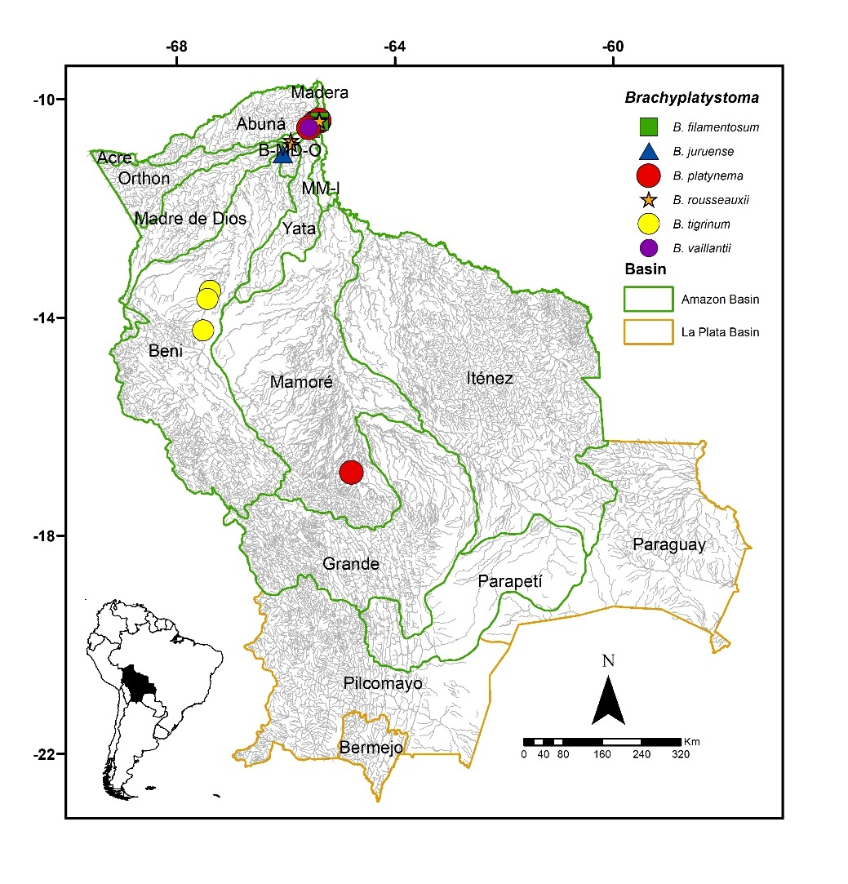
FIGURE 6. Collection sites of three lots of Brachyplatystoma filamentosum, one of B. juruense, 16 of B. platynema, 12 of B. rousseauxii, six of B. tigrinum, and three of B. vaillantii deposited in the Ichthyological Collection UMSS – d'Orbigny Museum (Cochabamba, Bolivia). Some symbols represent more than one lot.
Included species. Brachyplatystoma filamentosum, B. platynema, B. rousseauxii, B. tigrinum, B. juruense, and B. vaillantii.
Comments. Genus proposed by Bleeker (1862) for Platystoma vaillantii Valenciennes 1840 as the type species, currently synonymous with B. vaillantii.
This genus was reviewed by Lundberg & Akama (2005), who in addition to describing the B. capapretum species, placed the monotypic genera Merodontus and Goslinia as synonyms of Brachyplatystoma based on two synapomorphies. Additionally, these authors established a new tribe for Brachyplatystoma and Platynematichthys called Brachyplatystomatini based on two synapomorphies. Furthermore, they used the name Malacobagrus Bleeker (previously used for the genus Brachyplatystoma) as a subgenus within Brachyplatystoma to include B. capapretum, B. filamentosum, and B. rousseauxii.
Currently, seven species are known. B. capapretum Lundberg & Akama in the Amazon Basin; B. filamentosum (Lichtenstein 1819) in the Amazon, Orinoco, and the major rivers of the Guyanas; B. juruense (Boulenger 1898) in the Amazon and Orinoco basins; B. platynema Boulenger 1898 in the Amazon and Orinoco basins; B. rousseauxii (Castelnau 1855) in Bolivia, Colombia, Ecuador, French Guiana, Peru, Venezuela; B. tigrinum (Britski 1981) in the Amazon Basin; B. vaillantii (Valenciennes 1840) in the Amazon, Orinoco, and the major rivers of the Guyanas (Fricke et al. 2023). Carvajal-Vallejos (2013), based on molecular analyses, suggested that Brachyplatystoma could include Platynematichthys or be composed only to the subgenus Malacobagrus (B. rousseauxii, B. capapretum, and B. filamentosum) with B. vaillantii as sister group, so the rest of the Brachyplatystoma species should be considered as distinct genera and therefore resurrecting Goslinea and Merodontus.
Six of the seven recognized valid species, B. filamentosum, B. juruense, B. platynema, B. rousseauxii, B. tigrinum, and B. vaillantii, are present in Bolivia.
Brachyplatystoma filamentosum (Lichtenstein 1819) (Figure 7)
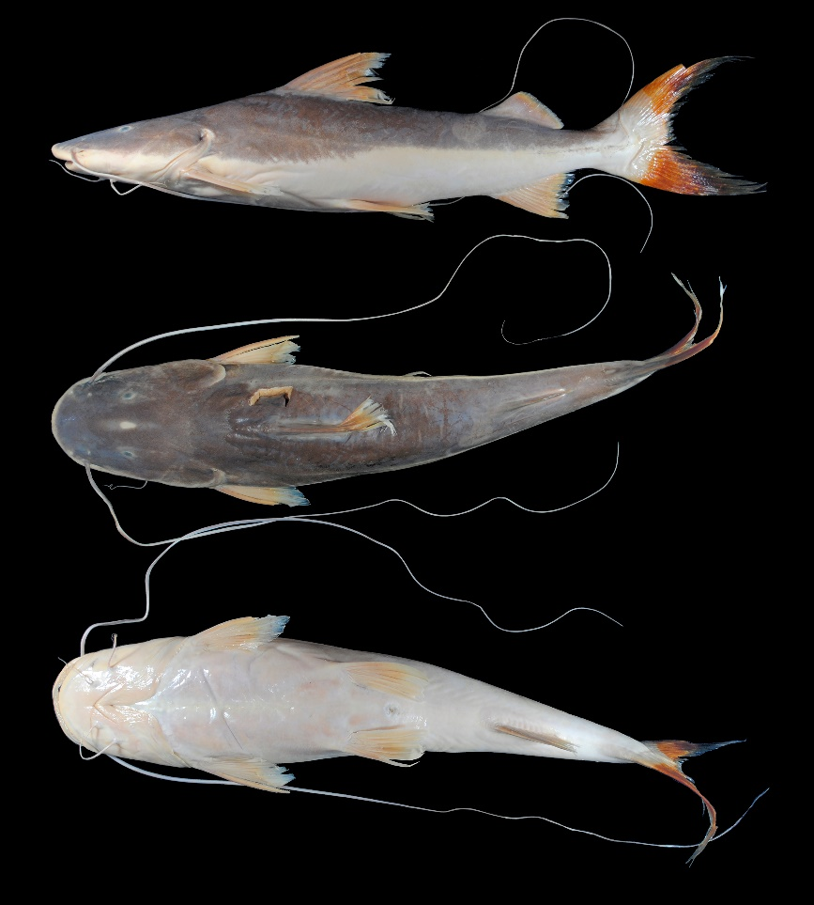
FIGURE 7. Brachyplatystoma filamentosum, UMSS 7700, 380 mm SL, Mamoré River, above Villa Bella, Mamoré-Iténez sub-basin, Amazon Basin.
Examined material (one specimen). Amazon Basin: UMSS 7700 (1, 406.6 mm SL), Mamoré River, above Villa Bella, -10.396734 -65.3848990, 24 Mar 2008, F. Carvajal.
Common names. Dorado de piel in Puerto Rico and Cobija (Pando), pirahiba in Riberalta, Trinidad, Rurrenabaque, and Cachuela Esperanza (Beni), azulejo in Rurrenabaque (Beni), blanquillo in Rurrenabaque (Beni), bacalao in Puerto Villarroel (Cochabamba) (Lauzanne & Loubens 1985, Carvajal-Vallejos et al. 2011).
Diagnosis. Brachyplatystoma filamentosum differs from its congeners in the following: from B. juruense by the left posterior nostril to right posterior nostril (31.5% HL vs. 25.4%), posterior nostril to anterior margin of orbit (20.3% HL vs. 28.1%), mouth width (52.6% HL vs. 56.9%), distance between internal mental barbels (19.6% HL vs. 27.9%), distance between external mental barbels (38.6% HL vs. 44.7%), head depth (50.1% HL vs. 60.5%), internal mental barbel length (4.8% SL vs. 13.4%), external mental barbel length (17.8% SL vs. 22.4%), predorsal length (40.5% SL vs. 34.1%), head length (30.5% SL vs. 25%), adipose fin base length (14.4% SL vs. 18.4%), anal fin origin to adipose fin insertion (16.4% SL vs. 20.5%); from B. platynema by the interorbital distance (27.5% HL vs. 17-18.8%), left posterior nostril to right posterior nostril (31.5% HL vs. 19.6-21.1%), distance between anterior nostrils (32.7% HL vs. 24.5-27%), posterior nostril to anterior margin of orbit (20.3% HL vs. 29.8-31.7%), snout length (48.2% HL vs. 54.8-59%), postorbital length (46.5% HL vs. 39.3-40.4%), mouth width (52.6% HL vs. 41.4-46.3%), distance between external mental barbels (38.6% HL vs. 29.6-34.7%), internal mental barbel length (4.8% SL vs. 27.8-48.4%), external mental barbel length (17.8% SL vs. 40.3-67%), body width (22.6% SL vs. 16.4-17.2%), pectoral fin origin to dorsal fin insertion (30.4% SL vs. 25.5-26.8%); from B. rousseauxii by the posterior nostril to anterior margin of orbit (20.3% HL vs. 24.6-25.5%), body width (22.6% SL vs. 17.8-18.6%), pectoral fin origin to pelvic fin origin (27.1% SL vs. 22.3-22.4%); from B. tigrinum by the interorbital distance (27.5% HL vs. 17.4-19.7%), left posterior nostril to right posterior nostril (31.5% HL vs. 17.7-19.8%), distance between anterior nostrils (32.7% HL vs. 21.6-23.3%), posterior nostril to anterior margin of orbit (20.3% HL vs. 32.3-33%), mouth width (52.6% HL vs. 38-41.3%), body width (22.6% SL vs. 14.1-17.8%), pectoral fin origin to dorsal fin insertion (30.4% SL vs. 23.5-25.2%), adipose fin base length (14.4% SL vs. 20.9-24.7%); from B. vaillantii by the posterior nostril to anterior margin of orbit (20.3% HL vs. 25-26.5%), postorbital length (46.5% HL vs. 41.9-42.5%), head depth (50.1% HL vs. 62.8-62.9%), internal mental barbel length (4.8% SL vs. 17.4-17.5%), external mental barbel length (17.8% SL vs. 40.3-42.4%), dorsal fin insertion to adipose fin origin (22% SL vs. 13.2-14.1%), adipose fin base length (14.4% SL vs. 24-24.8%).
Description. Morphometric data presented in Table 4. Straight ascending profile from the snout to the dorsal fin. Head longer than wide; eyes in a superolateral position. Mouth in a subterminal position with approximately half of the premaxillary patch exposed. Premaxilla with vomerine patches widely separated from the premaxillaries; vomerine patches in contact with palatines exhibiting prominent posterolateral lobes (Appendix 1). Dentary with large, curved, and closely spaced external teeth; small, slender, straight, and depressible internal teeth. Posterior supraoccipital process visibly absent. Humeral process broad-based and pointed. Posterior supraoccipital process with sides narrowing without contacting the nuchal plate. Pectoral fin extending to just over half the distance between its origin and pelvic fin origin; pectoral spine strongly ossified. Pelvic fin extending to approximately half the distance between its origin and anal fin origin. Pectoral and pelvic fins almost equally long. Dorsal fin with a flexible spine at the distal end. Adipose fin small and triangular. Anal fin with a slightly concave posterior margin. Base of the adipose fin longer than the base of the anal fin. Bifurcated caudal fin with moderately pointed lobes. Maxillary barbels extending beyond the adipose fin, in some individuals beyond the base of the caudal fin; mental barbels shorter. Dorsal fin rays I+6; anal fin rays VI+9; pectoral fin rays I+9; pelvic fin rays I+5; caudal fin rays 15.
TABLE 4. Morphometric data of Brachyplatystoma filamentosum. N: Number of individuals,
Measurements | N | Value
SL (mm) | 1 | 406.6
Percents of head length (% HL)
Nuchal plate length | 1 | 16.2
Interorbital distance | 1 | 27.5
Left posterior nostril to right posterior nostril | 1 | 31.5
Left anterior nostril to right anterior nostril | 1 | 32.7
Left anterior nostril to left posterior nostril | 1 | 13.7
Posterior nostril to anterior margin of orbit | 1 | 20.3
Snout length | 1 | 48.2
Postorbital length | 1 | 46.5
Orbital diameter | 1 | 6.90
Head depth | 1 | 50.1
Mouth width | 1 | 52.6
Distance between internal mental barbels | 1 | 19.6
Distance between external mental barbels | 1 | 38.6
Distance between internal and external mental barbel | 1 | 11.8
Percents of standard length (% SL)
Predorsal length | 1 | 40.5
Internal mental barbel length | 1 | 4.80
External mental barbel length | 1 | 17.8
Maxillary barbel length | 1 | 138.0
Body width | 1 | 22.6
Body depth | 1 | 19.7
Head length | 1 | 30.5
Pectoral fin origin to dorsal fin insertion | 1 | 30.4
Dorsal fin origin to pelvic fin origin | 1 | 24.3
Dorsal fin origin to anal fin origin | 1 | 40.5
Pectoral fin origin to pelvic fin origin | 1 | 27.1
Pelvic fin origin to anal fin origin | 1 | 25.3
Pectoral spine length | 1 | 17.2
Distance between pelvic fins | 1 | 13.9
Pelvic fin length | 1 | 15.1
Dorsal fin base length | 1 | 12.7
Dorsal fin insertion to adipose fin origin | 1 | 22.0
Adipose fin base length | 1 | 14.4
Anal fin base length | 1 | 11.4
Anal fin origin to adipose fin insertion | 1 | 16.4
Caudal peduncle height | 1 | 6.50
Dorsal fin origin to anterior caudal base | 1 | 59.8
Adipose fin origin to anterior caudal base | 1 | 25.6
Anal fin origin to anterior caudal base | 1 | 24.1
Caudal peduncle length | 1 | 12.3
Coloration in alcohol. The body exhibits a gray upper midsection and a whitish underside; dorsal head gray. Ventral region whitish. Fins appear yellowish; adipose fin subtly gray.
Coloration in life. The body and head display shades ranging from gray to olive with metallic undertones. Juvenile individuals may have diffuse black spots on their flanks.
Distribution. Present in the B-MD-O and MM-I sub-basins (Amazon Basin). Also recorded in the Madre de Dios, Beni, Mamoré and Iténez sub-basins (Amazon Basin) (Carvajal-Vallejos & Fernández 2011).
Importance. Commercial fishing trade in Puerto Rico, Cobija, Riberalta, Rurrenabaque, Cachuela Esperanza and Puerto Villarroel (Carvajal-Vallejos et al. 2011).
Ecological notes. A carnivorous species, primarily feeding on fish. Inhabits the river bed main channel, with reports of its presence in the estuarine zone of the Amazon River. Juveniles may occasionally be found in swamps and/or floodplain lagoons. This species is considered the largest catfish and is therefore overexploited in various parts of the Amazon (Sarmiento et al. 2014). It undergoes reproductive migrations (Keith et al. 2000).
Brachyplatystoma juruense (Boulenger 1898) (Figure 8)
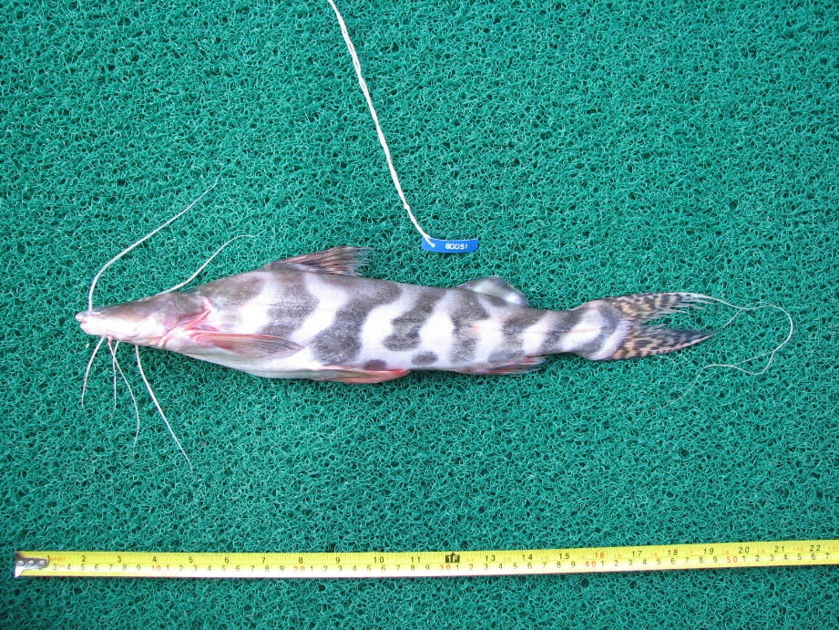
FIGURE 8. Brachyplatystoma juruense, Photograph: Fernando M. Carvajal-Vallejos, specimen purchased at Belén Market, Iquitos, Peru.
Examined material (one specimen). Amazon Basin: UMSS 11874 (1, 501.6 mm SL), specimen purchased at Abasto Market – Riberalta, individual from Cachuela Esperanza, -11.008393 -66.0511130, 13 Mar 2012.
Diagnosis. Brachyplatystoma juruense differs from its congeners in the following: from B. filamentosum by the left posterior nostril to right posterior nostril (25.4% SL vs. 31.5% SL), posterior nostril to anterior margin of orbit (28.1% SL vs. 20.3% SL), mouth width (56.9% vs. 52.6% SL), distance between internal mental barbels (27.9% SL vs. 19.6% SL), distance between external mental barbels (44.7% SL vs. 38.6% SL), head depth (60.5% SL vs. 50.1% SL), internal mental barbel length (13.4% HL vs. 4.8% HL), external mental barbel length (22.4% HL vs. 17.8% HL), predorsal length (34.1% HL vs. 40.5% HL), head length (25% HL vs. 30.5% HL), adipose fin base length (18.4% HL vs. 14.4% HL), anal fin origin to adipose fin insertion (20.5% HL vs. 16.4% HL); from B. platynema by interorbital distance (24.4% SL vs. 17-18.8% SL), left posterior nostril to right posterior nostril (25.4% SL vs. 19.6-21.1% SL), snout length (51.5% SL vs. 54.8-59% SL), postorbital length (46.9% SL vs. 39.3-40.4% SL), mouth width (56.9% SL vs. 41.4-46.3% SL), distance between internal mental barbels (27.9% SL vs. 13.5-19% SL), distance between external mental barbels (44.7% SL vs. 29.6-34.7% SL), head depth (60.5% SL vs. 44.2-48.9% SL), internal mental barbel length (13.4% HL vs. 27.8-48.4% HL), external mental barbel length (22.4% HL vs. 40.3-67% HL); from B. rousseauxii by the left posterior nostril to right posterior nostril (25.4% SL vs. 29.5-29.6% SL), mouth width (56.9% SL vs. 46.9-50.6% SL), distance between internal mental barbels (27.9% SL vs. 20.4-23.4% SL), distance between external mental barbels (44.7% SL vs. 29.8-35.1% SL), head depth (60.5% SL vs. 49.8-50.6% SL), internal mental barbel length (13.4% HL vs. 7.1-7.3% HL), predorsal length (34.1% HL vs. 38.7-40.8% HL); from B. tigrinum by interorbital distance (24.4% SL vs. 17.4-19.7% SL), left posterior nostril to right posterior nostril (25.4% SL vs. 17.7-19.8% SL), distance between anterior nostrils (29.1% SL vs. 21.6-23.3% SL), posterior nostril to anterior margin of orbit (28.1% SL vs. 32.3-33% SL), snout length (51.5% SL vs. 53.4-56.8% SL), mouth width (56.9% SL vs. 38-41.3% SL), distance between internal mental barbels (27.9% SL vs. 16.5-22% SL), distance between external mental barbels (44.7% SL vs. 26.6-35.4% SL), head depth (60.5% SL vs. 37.6-48.1% SL); from B. vaillantii by postorbital distance (46.9% SL vs. 41.9-42.5% SL), distance between internal mental barbels (27.9% SL vs. 19.4-19.6% SL), distance between external mental barbels (44.7% SL vs. 37.6-40.5% SL), external mental barbel length (22.4% HL vs. 40.3-42.4% HL), dorsal fin insertion to adipose fin origin (21.8% HL vs. 13.2-14.1% HL), adipose fin base length (18.4% HL vs. 24-24.8% HL). Additionally, B. juruense can also be differentiated from all its congeners by having a body with broad, dark bands arranged approximately vertically on the flanks and irregular spots on the caudal fin.
Description. Morphometric data presented in Table 5. Straight ascending profile from the snout to the origin of the dorsal fin. Head longer than wide; eyes dorsally positioned. Mouth in subterminal position with a very small portion of the premaxillaries exposed. Premaxilla with vomerine patches in contact with the premaxillaries; vomerine patches contacting the palatines with prominent posterolateral extensions (Appendix 1). Dentary with small, curved, and densely spaced teeth. Posterior supraoccipital process visibly absent. Humeral process basally spined. Pectoral fin reaching at most the origin of the pelvic fin; ossified spine with serrated inner margin. Pelvic fin reaching at most half the distance between its origin and the anal fin origin. Dorsal fin with ossified distal end. Adipose fin short and triangular. Anal fin with slightly concave posterior margin. Base of the adipose fin longer than the base of the anal fin. Forked caudal fin with the first simple ray of each lobe very elongated, forming a caudal filament. Maxillary barbels reaching or extending beyond the dorsal fin; mental barbels shorter. Dorsal fin rays I+6, anal fin rays 14, pectoral fin rays 11 (Boulenger 1898).
TABLE 5. Morphometric data of Brachyplatystoma juruense. N: Number of individuals.
Measurements | N | Value
SL (mm) | 1 | 501.6
Percents of head length (% HL)
Interorbital distance | 1 | 24.4
Left posterior nostril to right posterior nostril | 1 | 25.4
Left anterior nostril to right anterior nostril | 1 | 29.1
Left anterior nostril to left posterior nostril | 1 | 12.2
Posterior nostril to anterior margin of orbit | 1 | 28.1
Snout length | 1 | 51.5
Postorbital length | 1 | 46.9
Orbital diameter | 1 | 6.40
Head depth | 1 | 60.5
Mouth width | 1 | 56.9
Distance between internal mental barbels | 1 | 27.9
Distance between external mental barbels | 1 | 44.7
Distance between internal and external mental barbel | 1 | 9.0
Percents of standard length (% SL)
Predorsal length | 1 | 34.1
Internal mental barbel length | 1 | 13.4
External mental barbel length | 1 | 22.4
Maxillary barbel length | 1 | 28.8
Body width | 1 | 20.4
Body depth | 1 | 20.3
Head length | 1 | 25.0
Dorsal fin origin to anal fin origin | 1 | 23.8
Dorsal fin base length | 1 | 12.2
Dorsal fin insertion to adipose fin origin | 1 | 21.8
Adipose fin base length | 1 | 18.4
Anal fin base length | 1 | 14.1
Anal fin origin to adipose fin insertion | 1 | 20.5
Caudal peduncle height | 1 | 9.30
Dorsal fin origin to anterior caudal base | 1 | 65.6
Adipose fin origin to anterior caudal base | 1 | 33.5
Anal fin origin to anterior caudal base | 1 | 28.6
Caudal peduncle length | 1 | 14.5
Coloration in life. Cream-colored body with oblique or anastomosed black bands arranged on the flanks; head dorsally the same color as the bands. Pectoral, pelvic, dorsal, and anal fins with some areas of grayish color; adipose fin with black bands from the flank extending over its surface; caudal fin with small black spots arranged irregularly.
Distribution. Present in the B-MD-O sub-basin (Amazon Basin).
Importance. There is no available information.
Brachyplatystoma platynema Boulenger 1898 (Figure 9)
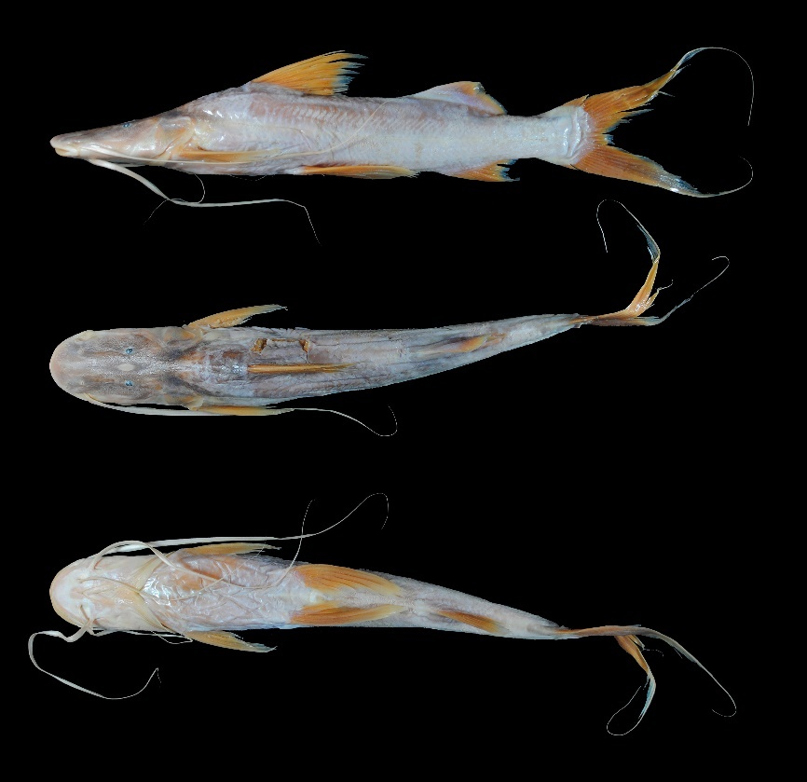
FIGURE 9. Brachyplatystoma platynema, UMSS 7174, 259 mm SL, Beni River, Cachueriña, Villa Bella, B-MD-O sub-basin, Amazon Basin.
Examined material (six specimens). Amazon Basin: UMSS 6131 (1, 582 mm SL), Ichilo River, Puerto Villarroel ICH 5A, -16.838889 -64.7916667, 19 Sep 2007, F. Carvajal; UMSS 7174 (1, 274.8 mm SL), Beni River, Cachueriña, Villa Bella, -10.424455 -65.4703710, 24 Jul 2007, F. Carvajal; UMSS 7247 (1, 550.3 mm SL), same data as UMSS 6131; UMSS 7624 (1, 508.6 mm SL), Madeira River, Villa Bella, -10.373000 -65.3884450, 22 Oct 2007, F. Carvajal; UMSS 16977 (1, 467.3 mm SL), Madeira River, Villa Bella, -10.373000 -65.3884450, 1 Aug 2007, M. Mercado; UMSS 17283 (1, 420.5 mm SL), Beni River, Cachuela Esperanza, -10.521983 -65.5787100, 23 Sep 2015, D. Barrozo.
Common name. Baboso in Riberalta and Rurrenabaque (Beni); blanquillo in Rurrenabaque, Cachuela Esperanza (Beni), and Puerto Villarroel (Cochabamba) (Carvajal-Vallejos et al. 2011).
Diagnosis. Brachyplatystoma platynema differs from its congeners in the following: from B. filamentosum by the interorbital distance (17-18.8% HL vs. 27.5%), left posterior nostril to right posterior nostril (19.6-21.1% HL vs. 31.5%), distance between anterior nostrils (24.5-27% HL vs. 32.7%), posterior nostril to anterior margin of orbit (29.8-31.7% HL vs. 20.3%), snout length (54.8-59% HL vs. 48.2%), postorbital length (39.3-40.4% HL vs. 46.5%), mouth width (41.4-46.3% HL vs. 52.6%), distance between external mental barbels (29.6-34.7% HL vs. 38.6%), internal mental barbel length (27.8-48.4% SL vs. 4.8%), external mental barbel length (40.3-67% SL vs. 17.8%), body width (16.4-17.2% SL vs. 22.6%), pectoral fin origin to dorsal fin insertion (25.5-26.8% SL vs. 30.4%); from B. juruense by the interorbital distance (17-18.8% HL vs. 24.4%), left posterior nostril to right posterior nostril (19.6-21.1% HL vs. 25.4%), snout length (54.8-59% HL vs. 51.5%), postorbital length (39.3-40.4% HL vs. 46.9%), mouth width (41.4-46.3% HL vs. 56.9%), distance between internal mental barbels (13.5-19% HL vs. 27.9%), distance between external mental barbels (29.6-34.7% HL vs. 44.7%), internal mental barbel length (27.8-48.4% SL vs. 13.4%), external mental barbel length (40.3-67% SL vs. 22.4%); from B. rousseauxii by the interorbital distance (17-18.8% HL vs. 23.1-25.6%), left posterior nostril to right posterior nostril (19.6-21.1% HL vs. 29.5-29.6%), posterior nostril to anterior margin of orbit (29.8-31.7% HL vs. 24.6-25.5%), internal mental barbel length (27.8-48.4% SL vs. 7.1-7.3%), external mental barbel length (40.3-67% SL vs. 17.2-23%), pectoral spine length (18.1-19.6% SL vs. 13.6-14.5%), adipose fin base length (16.8-19.7% SL vs. 13.8-15.3%); from B. tigrinum in the internal mental barbel length (27.8-48.4% SL vs. 8.4-9.9%), external mental barbel length (40.3-67% SL vs. 17.7-18.7%), dorsal spine length (19.4-20.5% SL vs. 16.2-16.9%); from B. vaillantii by the interorbital distance (17-18.8% HL vs. 25.7-26.1%), left posterior nostril to right posterior nostril (19.6-21.1% HL vs. 27-28%), head depth (44.2-48.9% HL vs. 62.8-62.9%), mouth width (41.4-46.3% HL vs. 51.1-53.9%), internal mental barbel length (27.8-48.4% SL vs. 17.4-17.5%), dorsal fin insertion to adipose fin origin (19.6-21.6% SL vs. 13.2-14.1%), adipose fin base length (16.8-19.7% SL vs. 24-24.8%). Additionally, B. platynema can also be differentiated from all its congeners by having a pair of broad and flattened maxillary barbels.
Description. Morphometric data presented in Table 6. Straight profile slightly ascending from the snout to the midpoint between the eye and the most distal part of the operculum, then with a more pronounced slope to the origin of the dorsal fin. Head longer than wide and depressed with eyes in a dorsal position. Snout relatively long and flattened; mouth in a subterminal position with approximately half of the premaxillary patches exposed. Premaxilla with vomerian patches in contact or close to the premaxillaries; vomerian patches in contact with the palatines, which exhibit prominent posterolateral lobes (Appendix 2). Dentary with large, curved, and closely spaced external teeth; internal teeth small, thin, straight, and depressible. Posterior supraoccipital process visibly absent. Humeral process in the form of a spine. Pectoral fin extending to near the origin of the pelvic fin; ossified spine. Pelvic fin extending to the midpoint between its origin and the anal fin. Pectoral and pelvic fins equally long. Dorsal fin with a flexible distal tip. Adipose fin short and triangular. Anal fin with a concave posterior margin. Base of the adipose fin longer than the base of the anal fin. Bifurcated caudal fin with the first simple ray of each lobe greatly elongated, forming a caudal filament. Maxillary barbels extending beyond the dorsal fin; mental barbels shorter. Dorsal fin rays I+6; anal fin rays v-vi+10-11; pectoral fin rays I+10-11; pelvic fin rays i+5; caudal fin rays 15.
TABLE 6. Morphometric data of Brachyplatystoma platynema. N: Number of individuals, SD: Standard deviation, Min: Minimum value, Max: Maximum value.
Measurements | N | Mean | SD | Min | Max
SL (mm) | 6 | 467.3 | 110.5 | 274.8 | 582
Percents of head length (% HL)
Interorbital distance | 6 | 17.5 | 0.7 | 17.0 | 18.8
Left posterior nostril to right posterior nostril | 6 | 20.4 | 0.6 | 19.6 | 21.1
Left anterior nostril to right anterior nostril | 6 | 25.8 | 1.0 | 24.5 | 27.0
Left anterior nostril to left posterior nostril | 6 | 11.4 | 0.7 | 10.4 | 12.4
Posterior nostril to anterior margin of orbit | 6 | 31.1 | 0.7 | 29.8 | 31.7
Snout length | 6 | 56.8 | 1.4 | 54.8 | 59.0
Postorbital length | 6 | 40.0 | 0.4 | 39.3 | 40.4
Orbital diameter | 6 | 4.60 | 0.7 | 4.0 | 5.90
Head depth | 6 | 46.3 | 1.7 | 44.2 | 48.9
Mouth width | 6 | 43.1 | 1.8 | 41.4 | 46.3
Distance between internal mental barbels | 6 | 15.4 | 1.9 | 13.5 | 19.0
Distance between external mental barbels | 6 | 31.3 | 1.9 | 29.6 | 34.7
Distance between internal and external mental barbel | 6 | 9.80 | 0.6 | 8.80 | 10.6
Percents of standard length (% SL)
Predorsal length | 6 | 37.7 | 1.2 | 36.5 | 39.3
Internal mental barbel length | 5 | 35.1 | 8.1 | 27.8 | 48.4
External mental barbel length | 5 | 49.1 | 10.3 | 40.3 | 67.0
Maxillary barbel length | 5 | 58.6 | 10.4 | 48.8 | 76.4
Body width | 6 | 16.8 | 0.3 | 16.4 | 17.2
Body depth | 6 | 18.2 | 0.6 | 17.4 | 18.7
Head length | 6 | 28.3 | 1.2 | 26.2 | 29.9
Pectoral fin origin to dorsal fin insertion | 6 | 26.0 | 0.6 | 25.5 | 26.8
Dorsal fin origin to pelvic fin origin | 6 | 21.0 | 1.1 | 19.9 | 22.3
Dorsal fin origin to anal fin origin | 6 | 41.9 | 1.4 | 39.8 | 43.5
Pectoral fin origin to pelvic fin origin | 6 | 22.8 | 1.2 | 21.5 | 24.6
Pelvic fin origin to anal fin origin | 6 | 29.1 | 1.4 | 27.2 | 31.1
Pectoral spine length | 5 | 19.0 | 0.6 | 18.1 | 19.6
Distance between pelvic fins | 6 | 11.1 | 0.5 | 10.4 | 11.8
Pelvic fin length | 6 | 19.6 | 2.1 | 17.0 | 23.3
Dorsal spine length | 3 | 20.1 | 0.6 | 19.4 | 20.5
Dorsal fin base length | 6 | 11.0 | 0.5 | 10.4 | 11.9
Dorsal fin insertion to adipose fin origin | 6 | 20.7 | 0.8 | 19.6 | 21.6
Adipose fin base length | 6 | 18.0 | 1.0 | 16.8 | 19.7
Anal fin base length | 6 | 12.2 | 0.9 | 10.8 | 13.2
Anal fin origin to adipose fin insertion | 6 | 16.7 | 0.6 | 16.0 | 17.6
Caudal peduncle height | 6 | 7.40 | 0.4 | 7.10 | 7.90
Dorsal fin origin to anterior caudal base | 6 | 62.2 | 1.0 | 61.2 | 64.0
Adipose fin origin to anterior caudal base | 6 | 31.3 | 1.3 | 30.1 | 33.3
Anal fin origin to anterior caudal base | 6 | 25.4 | 1.1 | 24.4 | 27.0
Caudal peduncle length | 6 | 13.2 | 0.6 | 12.5 | 13.9
Coloration in alcohol. Body with the dorsum and head dorsally of a subdued gray color, with the region of the supraoccipital darker. Dorsal, pectoral, pelvic, anal, and caudal fins yellowish; adipose fin subdued gray.
Coloration in life. Body with the dorsum gray; the head dorsally darker than the dorsum. Dorsal, pectoral, pelvic, and anal fins whitish; adipose fin the same color as the dorsum or lighter; caudal fin with the edge of the lower lobe grayish.
Distribution. Present in the Madeira, Mamoré, B-MD-O and MM-I sub-basins (Amazon Basin). Also recorded in the Madre de Dios, Beni, and Iténez sub-basins (Amazon Basin) (Carvajal-Vallejos & Fernández 2011).
Importance. Commercial and subsistence fishing trade in Riberalta, Rurrenabaque, Cachuela Esperanza, and Puerto Villarroel (Carvajal-Vallejos et al. 2011).
Ecological notes. Inhabits white-water rivers; it can also be found in freshwater estuaries (Barthem & Goulding 1997). Apparently undergoes migrations during the high water or flood season (Burgess 1989).
Brachyplatystoma rousseauxii (Castelnau 1855) (Figure 10)
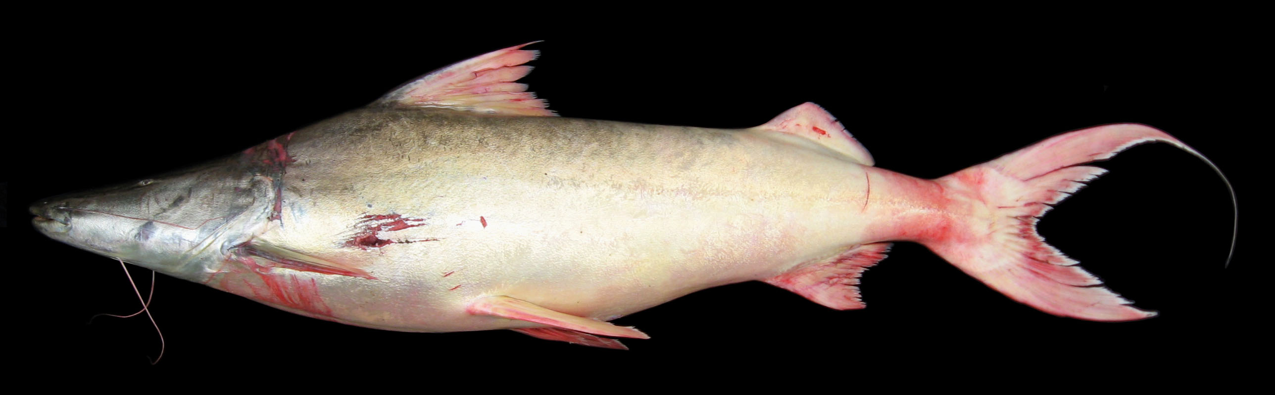
FIGURE 10. Brachyplatystoma rousseauxii, specimen collected in the Ichilo River, Puerto Villarroel, Mamoré sub-basin. Photograph by Fernando M. Carvajal-Vallejos.
Examined material (two specimens). Amazon Basin: UMSS 16976 (1, 601.5 mm SL), Madeira River, Villa Bella, -10.373000 -65.3884450, 1 Aug 2007, M. Mercado; UMSS 17474 (1, 424.1 mm SL), Mamoré River, upstream from Villa Bella, -10.403147 -65.3813550, 27 Jul 2007, F. Carvajal.
Common name. Dorado de piel in Puerto Rico, Cobija (Pando); dorado in Riberalta, Rurrenabaque, and Cachuela Esperanza (Beni); gringo in Rurrenabaque (Beni); plateado in Puerto Villarroel (Cochabamba) (Carvajal-Vallejos et al. 2011).
Diagnosis. Brachyplatystoma rousseauxii differs from its congeners in the following: from B. filamentosum by the posterior nostril to anterior margin of orbit (24.6-25.5% HL vs. 20.3%), body width (17.8-18.6% SL vs. 22.6%), pectoral fin origin to pelvic fin origin (22.3-22.4% SL vs. 27.1%); from B. juruense by the left posterior nostril to right posterior nostril (29.5-29.6% HL vs. 25.4%), mouth width (46.9-50.6% HL vs. 56.9%), distance between internal mental barbels (20.4-23.4% HL vs. 27.9%), distance between external mental barbels (29.8-35.1% HL vs. 44.7%), head depth (49.8-50.6% HL vs. 60.5%), internal mental barbel length (7.1-7.3% SL vs. 13.4%), predorsal length (38.7-40.8% SL vs. 34.1%); from B. platynema by the interorbital distance (23.1-25.6% HL vs. 17-18.8%), left posterior nostril to right posterior nostril (29.5-29.6% HL vs. 19.6-21.1%), posterior nostril to anterior margin of orbit (24.6-25.5% HL vs. 29.8-31.7%), internal mental barbel length (7.1-7.3% SL vs. 27.8-48.4%), external mental barbel length (17.2-23% SL vs. 40.3-67%), pectoral spine length (13.6-14.5% SL vs. 18.1-19.6%), adipose fin base length (13.8-15.3% SL vs. 16.8-19.7%); from B. tigrinum by the interorbital distance (23.1-25.6% HL vs.17.4-19.7%), left posterior nostril to right posterior nostril (29.5-29.6% HL vs. 17.7-19.8%), distance between anterior nostrils (30.6-31.4% HL vs. 21.6-23.3%), posterior nostril to anterior margin of orbit (24.6-25.5% HL vs. 32.3-33%), mouth width (46.9-50.6% HL vs.38-41.3%), adipose fin base length (13.8-15.3% SL vs. 21-24.7%); from B. vaillantii by head depth (49.8-50.6% HL vs. 62.8-62.9%), internal mental barbel length (7.1-7.3% SL vs. 17.4-17.5%), external mental barbel length (17.2-23% SL vs. 40.3-42.4%), dorsal fin insertion to adipose fin origin (23.2% SL vs. 13.2-14.1%); adipose fin base length (13.8-15.3% SL vs. 24-24.8%). Additionally, B. rousseauxii can also be differentiated from all its congeners by having a body with a golden to silvery sheen in life.
Description. Morphometric data presented in Table 7. Straight ascending profile from the tip of the snout to the origin of the dorsal fin. Head longer than wide with eyes in dorsal position. Mouth terminal. Premaxilla with vomerine patches widely separated from the premaxillaries; vomerine patches in contact with the palatines, which have prominent posterolateral lobes. Dentary with large, curved, and closely spaced outer teeth; inner teeth small, slender, straight, and depressible (Appendix 1). Posterior supraoccipital process visibly absent. Humeral process not visible. Pectoral fin extending approximately halfway between its origin and pelvic fin origin; spine strongly ossified. Pelvic fin extending approximately halfway between its origin and anal fin origin. Pectoral fin slightly shorter than the pelvic fin. Dorsal fin with a flexible spine at the distal end. Adipose fin short and triangular. Anal fin with a concave posterior margin. Base of the adipose fin longer than the base of the anal fin. Bifurcated caudal fin with pointed lobes. Maxillary barbels reaching at most the origin of the pectoral fin; mental barbels shorter. Dorsal fin rays I+6; anal fin rays iii-v +10; pectoral fin rays I+8; pelvic fin rays i+5; caudal fin rays 15.
TABLE 7. Morphometric data of Brachyplatystoma rousseauxii. N: Number of individuals, SD: Standard deviation, Min: Minimum value, Max: Maximum value.
Measurement | N | Mean | SD | Min | Max
SL (mm) | 2 | 512.8 | 125.4 | 424.1 | 602
Percents of head length (% HL)
Interorbital distance | 2 | 24.4 | 1.7 | 23.1 | 25.6
Left posterior nostril to right posterior nostril | 2 | 29.6 | 0.1 | 29.5 | 29.6
Left anterior nostril to right anterior nostril | 2 | 31.0 | 0.6 | 30.6 | 31.4
Left anterior nostril to left posterior nostril | 2 | 11.6 | 0.2 | 11.4 | 11.7
Posterior nostril to anterior margin of orbit | 2 | 25.0 | 0.6 | 24.6 | 25.5
Snout length | 2 | 51.9 | 0.2 | 51.8 | 52.1
Postorbital length | 2 | 43.3 | 0.6 | 42.8 | 43.7
Orbital diameter | 2 | 6.20 | 0.8 | 5.70 | 6.80
Head depth | 2 | 50.2 | 0.5 | 49.8 | 50.6
Mouth width | 2 | 48.7 | 2.6 | 46.9 | 50.6
Distance between internal mental barbels | 2 | 21.9 | 2.2 | 20.4 | 23.4
Distance between external mental barbels | 2 | 32.4 | 3.8 | 29.8 | 35.1
Distance between internal and external mental barbel | 2 | 11.1 | 0.4 | 10.8 | 11.4
Percents of standard length (% SL)
Predorsal length | 2 | 39.8 | 1.5 | 38.7 | 40.8
Internal mental barbel length | 2 | 7.20 | 0.1 | 7.10 | 7.30
External mental barbel length | 2 | 20.0 | 4.1 | 17.2 | 22.9
Maxillary barbel length | 1 | 27.7 | * | 27.7 | 27.7
Body width | 2 | 18.2 | 0.6 | 17.8 | 18.6
Body depth | 2 | 20.1 | 0.9 | 19.4 | 20.7
Head length | 2 | 29.5 | 1.2 | 28.6 | 30.3
Pectoral fin origin to dorsal fin insertion | 2 | 28.6 | 0.7 | 28.1 | 29.0
Dorsal fin origin to pelvic fin origin | 2 | 23.0 | 1.0 | 22.3 | 23.7
Dorsal fin origin to anal fin origin | 2 | 42.0 | 2.3 | 40.4 | 43.6
Pectoral fin origin to pelvic fin origin | 2 | 22.3 | 0.1 | 22.3 | 22.4
Pelvic fin origin to anal fin origin | 2 | 28.6 | 5.5 | 24.7 | 32.5
Pectoral spine length | 2 | 14.1 | 0.6 | 13.6 | 14.5
Distance between pelvic fins | 2 | 13.8 | 0.4 | 13.5 | 14.1
Pelvic fin length | 2 | 16.4 | 0.1 | 16.3 | 16.5
Dorsal fin base length | 2 | 11.6 | 0.3 | 11.4 | 11.8
Dorsal fin insertion to adipose fin origin | 2 | 23.2 | 0.0 | 23.2 | 23.2
Adipose fin base length | 2 | 14.6 | 1.1 | 13.8 | 15.3
Anal fin base length | 2 | 11.8 | 0.1 | 11.8 | 11.9
Anal fin origin to adipose fin insertion | 2 | 16.7 | 0.0 | 16.7 | 16.7
Caudal peduncle height | 2 | 6.60 | 0.4 | 6.30 | 6.90
Dorsal fin origin to anterior caudal base | 2 | 61.1 | 0.6 | 60.7 | 61.5
Adipose fin origin to anterior caudal base | 2 | 26.4 | 0.4 | 26.1 | 26.7
Anal fin origin to anterior caudal base | 2 | 24.1 | 0.7 | 23.6 | 24.7
Caudal peduncle length | 2 | 12.3 | 0.4 | 12.0 | 12.6
Coloration in life. Body and head golden or silvery, with the back and dorsal region of the head darker in contrast. All fins whitish.
Distribution. Present in the Madeira, B-MD-O and MM-I sub-basins (Amazon Basin). Also recorded in the Madre de Dios, Beni, Mamoré and Iténez sub-basins (Amazon Basin) (Carvajal-Vallejos & Fernández 2011).
Importance. Commercial and subsistence fishing trade in Puerto Rico, Cobija, Riberalta, Rurrenabaque, Cachuela Esperanza, and Puerto Villarroel (Carvajal-Vallejos et al. 2011).
Ecological notes. It primarily feeds on fish and inhabits the main channels of white-water rivers and tributaries of black and clear waters. Occasionally, it enters floodplains to feed (Barthem & Goulding 1997). It undertakes the longest migration in continental waters (over 3000 km), from the headwaters of the Amazon Basin in the Andean foothills (breeding area) to the Amazon estuary (nursery area) (Carvajal-Vallejos et al. 2014b).
Brachyplatystoma tigrinum (Britski 1981) (Figure 11)
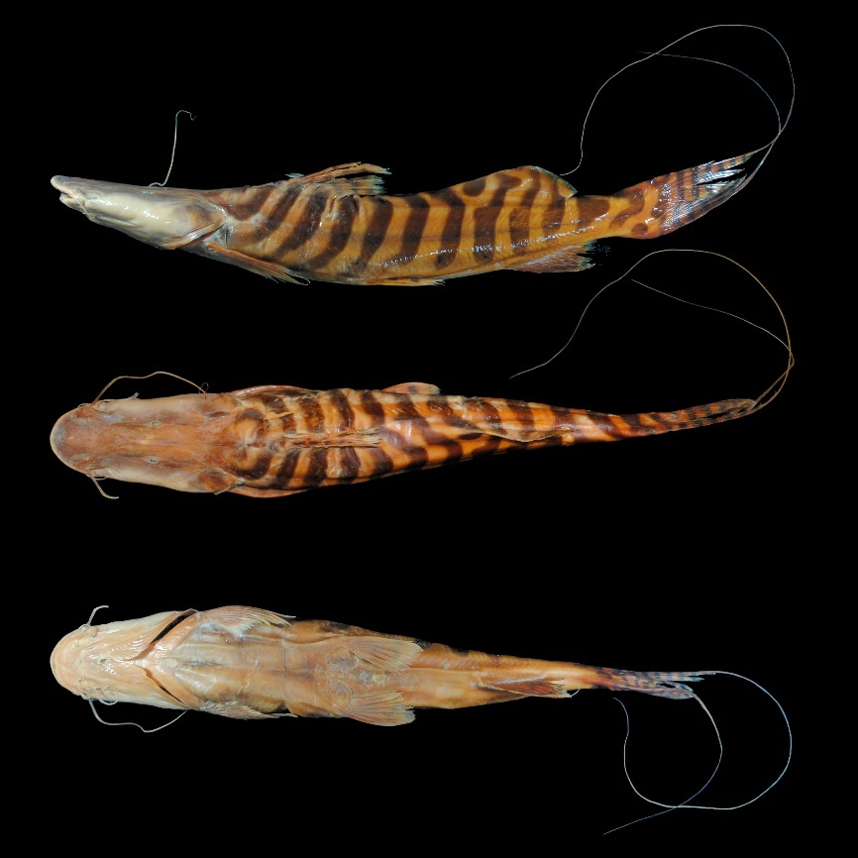
FIGURE 11. Brachyplatystoma tigrinum, UMSS 7185, 450 mm SL, Beni River, Cachueriña, Villa Bella, B-MD-O sub-basin, Amazon Basin.
Examined material (six specimens). Amazon Basin: UMSS 7131 (1, 702.1 mm SL), Beni River, Tequeje stream, -13.514744 -67.3890170, 3 May 2008, F. Carvajal; UMSS 7185 (1, 478.1 mm SL), Beni River, Cachueriña, Villa Bella, -10.424455 -65.4703710, 26 Jul 2007, F. Carvajal; UMSS 7680 (1, 610.1 mm SL), Beni River, Copaina, -14.241324 -67.5143300, 9 Dec 2007, F. Carvajal; UMSS 7745 (1, 676.4 mm SL), Beni River, Cocal, -13.664875 -67.4391500, 4 May 2008, F. Carvajal; UMSS 17287 (1, 537.5 mm SL), Beni River, Cachuela Esperanza, -10.521983 -65.5787100, 23 Sep 2015, D. Barrozo; UMSS 17288 (1, 550.2 mm SL), same data as UMSS 17287.
Common name. Zebra in Riberalta, Rurrenabaque, and Cachuela Esperanza (Beni) (Carvajal-Vallejos et al. 2011).
Diagnosis. Brachyplatystoma tigrinum differs from its congeners in the following: from B. filamentosum by the interorbital distance (17.4-19.7% HL vs. 27.5%), left posterior nostril to right posterior nostril (17.7-19.8% HL vs. 31.5%), distance between anterior nostrils (21.6-23.3% HL vs. 32.7%), posterior nostril to anterior margin of orbit (32.3-33% HL vs. 20.3%), mouth width (38-41.3% HL vs. 52.6%), body width (14.1-17.8% SL vs. 22.6%), pectoral fin origin to dorsal fin insertion (23.5-25.2% SL vs. 30.4%), adipose fin base length (20.9-24.7% SL vs. 14.4%); from B. juruense by the interorbital distance (17.4-19.7% HL vs. 24.4%), left posterior nostril to right posterior nostril (17.7-19.8% HL vs. 25.4%), distance between anterior nostrils (21.6-23.3% HL vs. 29.1%), posterior nostril to anterior margin of orbit (32.3-33% L vs. 28.1%), snout length (53.4-56.8% HL vs. 51.5%), mouth width (38-41.3% HL vs. 56.9%), distance between internal mental barbels (16.5-22% HL vs. 27.9%), distance between external mental barbels (26.6-35.4% HL vs. 44.7%), head depth (37.6-48.1% HL vs. 60.5%); from B. platynema by the internal mental barbel length (8.4-9.9% SL vs. 27.8-48.4%), external mental barbel length (17.7-18.7% SL vs. 40.3-67%), dorsal spine length (16.2-16.9% SL vs. 19.4-20.5%); from B. rousseauxii by the interorbital distance (17.4-19.7% HL vs. 23.1-25.6%), left posterior nostril to right posterior nostril (17.7-19.8% HL vs. 29.5-29.6%), distance between anterior nostrils (21.6-23.3% HL vs. 30.6-31.4%), posterior nostril to anterior margin of orbit (32.3-33% HL vs. 24.6-25.5%), mouth width (38-41.3% HL vs. 46.9-50.6%), adipose fin base length (20.9-24.7% SL vs. 13.8-15.3%); from B. vaillantii by the interorbital distance (17.4-19.7% HL vs. 25.7-26.1%), left posterior nostril to right posterior nostril (17.7-19.8% HL vs. 27-28%), distance between anterior nostrils (21.6-23.3% HL vs. 30.2-32.3%), posterior nostril to anterior margin of orbit (32.3-33% HL vs. 25-26.5%), head depth (37.6-48.1% HL vs. 62.8-63%); mouth width (38-41.3% HL vs. 51.1-53.9%), internal mental barbel length (8.4-9.9% SL vs. 17.4-17.5%), external mental barbel length (17.7-18.7% SL vs. 40.3-42.4%), maxillary barbel length (31.8-40% SL vs. 78.9-82.9%), dorsal spine length (16.2-16.9% SL vs. 20.5-22.4%). Additionally, B. tigrinum can also be differentiated from all congeners by having a body with narrow, dark bands arranged diagonally on the flanks, including the caudal fin where they are vertical.
Description. Morphometric data presented in Table 8. Straight profile slightly ascending from the snout to the midpoint between the eye and the most distal part of the operculum, then with a steeper slope up to the origin of the dorsal fin. Head longer than wide and noticeably depressed with eyes in a dorsal position. Relatively long and flattened snout; mouth in a subterminal position with approximately half of the premaxillary patches exposed. Premaxilla with vomerine patches widely separated from the premaxillaries and palatines, the latter without prominent posterolateral lobes. Dentary with small, curved, and densely spaced external teeth; internal teeth thin, straight, and depressible (Annex 2). Posterior supraoccipital process with a broad base, narrowing sides, and in contact with the nuchal plate. Humeral process not visible. Pectoral fin extending beyond the midpoint between its origin and the pelvic fin origin. Pelvic fin extending to approximately halfway between its origin and the anal fin origin. Pectoral fin longer than the pelvic fin. Dorsal fin with a flexible distal end. Moderately long adipose fin. Anal fin with a slightly concave posterior margin and an elongated filament on the longest ray. Adipose fin base twice as long as the anal fin base. Bifurcated caudal fin with the first ray of each lobe greatly elongated, forming a caudal filament. Maxillary barbels extending beyond the origin of the dorsal fin; mandibular barbels shorter. Dorsal fin rays I+6; anal fin rays VI+9-10; pectoral fin rays I+9; pelvic fin rays I+5; caudal fin rays 15.
TABLE 8. Morphometric data of Brachyplatystoma tigrinum. N: Number of individuals, SD: Standard deviation, Min: Minimum value, Max: Maximum value.
Measurement | N | Mean | SD | Min | Max
SL (mm) | 6 | 592.4 | 86.3 | 478.1 | 702.1
Percents of head length (% HL)
Nuchal plate length | 6 | 16.4 | 0.7 | 15.2 | 17.3
Interorbital distance | 6 | 18.0 | 0.9 | 17.4 | 19.7
Left posterior nostril to right posterior nostril | 6 | 18.6 | 0.7 | 17.7 | 19.8
Left anterior nostril to right anterior nostril | 6 | 22.1 | 0.7 | 21.6 | 23.3
Left anterior nostril to left posterior nostril | 6 | 8.90 | 0.4 | 8.50 | 9.40
Posterior nostril to anterior margin of orbit | 6 | 32.5 | 0.3 | 32.3 | 33.0
Snout length | 6 | 54.6 | 1.2 | 53.4 | 56.8
Postorbital length | 6 | 42.2 | 0.5 | 41.7 | 43.0
Orbital diameter | 6 | 4.10 | 0.2 | 3.80 | 4.30
Head depth | 6 | 45.2 | 3.9 | 37.6 | 48.1
Mouth width | 6 | 39.1 | 1.2 | 38.0 | 41.3
Distance between internal mental barbels | 6 | 18.6 | 2.0 | 16.5 | 22.0
Distance between external mental barbels | 6 | 29.7 | 3.4 | 26.6 | 35.4
Distance between internal and external mental barbel | 6 | 9.60 | 0.6 | 8.60 | 10.1
Percents of standard length (% SL)
Predorsal length | 6 | 37.8 | 0.8 | 37.2 | 39.4
Internal mental barbel length | 6 | 9.10 | 0.5 | 8.40 | 9.90
External mental barbel length | 6 | 18.1 | 0.4 | 17.7 | 18.7
Maxillary barbel length | 5 | 35.3 | 3.6 | 31.8 | 40.0
Body width | 6 | 16.7 | 1.3 | 14.1 | 17.8
Body depth | 6 | 18.0 | 1.2 | 15.7 | 18.8
Head length | 6 | 30.2 | 1.0 | 29.6 | 32.1
Pectoral fin origin to dorsal fin insertion | 6 | 24.5 | 0.6 | 23.5 | 25.2
Dorsal fin origin to pelvic fin origin | 6 | 23.2 | 0.8 | 22.0 | 24.5
Dorsal fin origin to anal fin origin | 6 | 42.7 | 1.9 | 39.6 | 44.2
Pectoral fin origin to pelvic fin origin | 6 | 24.0 | 1.3 | 22.6 | 26.4
Pelvic fin origin to anal fin origin | 6 | 26.5 | 1.4 | 24.2 | 28.1
Pectoral spine length | 6 | 18.1 | 0.4 | 17.5 | 18.5
Distance between pelvic fins | 6 | 13.4 | 0.5 | 12.8 | 14.1
Pelvic fin length | 6 | 14.4 | 0.7 | 13.7 | 15.3
Dorsal spine length | 3 | 16.6 | 0.3 | 16.2 | 16.9
Dorsal fin base length | 6 | 11.5 | 0.2 | 11.2 | 11.8
Dorsal fin insertion to adipose fin origin | 6 | 17.8 | 1.8 | 16.3 | 20.6
Adipose fin base length | 6 | 23.0 | 1.6 | 20.9 | 24.7
Anal fin base length | 6 | 12.8 | 0.8 | 11.8 | 13.8
Anal fin origin to adipose fin insertion | 6 | 17.6 | 1.2 | 16.4 | 19.6
Caudal peduncle height | 6 | 7.30 | 0.2 | 6.90 | 7.60
Dorsal fin origin to anterior caudal base | 6 | 63.2 | 2.0 | 59.3 | 64.8
Adipose fin origin to anterior caudal base | 6 | 33.9 | 1.4 | 32.2 | 35.8
Anal fin origin to anterior caudal base | 6 | 24.8 | 1.4 | 23.1 | 27.0
Coloration in alcohol. Body and head yellowish with diagonal black bands arranged on the flanks. Dorsal, pectoral, pelvic, and anal fins have a yellowish background with black bands; adipose fin with body bands extending onto its surface; caudal fin yellowish with well-defined black bands.
Coloration in life. Yellowish areas of the body and fins whitish. Head dorsally the same color as the bands. The band pattern on the body and fins remains the same as in individuals preserved in alcohol.
Distribution. Present in the Beni and B-MD-O sub-basins (Amazon Basin). Also recorded in the Madeira, Madre de Dios, and Iténez sub-basins (Amazon Basin) (Carvajal-Vallejos & Fernández 2011).
Importance. Commercial and subsistence fishing trade in Riberalta, Rurrenabaque, and Cachuela Esperanza (Carvajal-Vallejos et al. 2011). Juvenile specimens have ornamental purposes (Alcántara et al. 2009).
Ecological notes. A piscivorous species, inhabits the main channels of large rivers (Alcántara et al. 2009).
Brachyplatystoma vaillantii (Valenciennes 1840) (Figure 12)
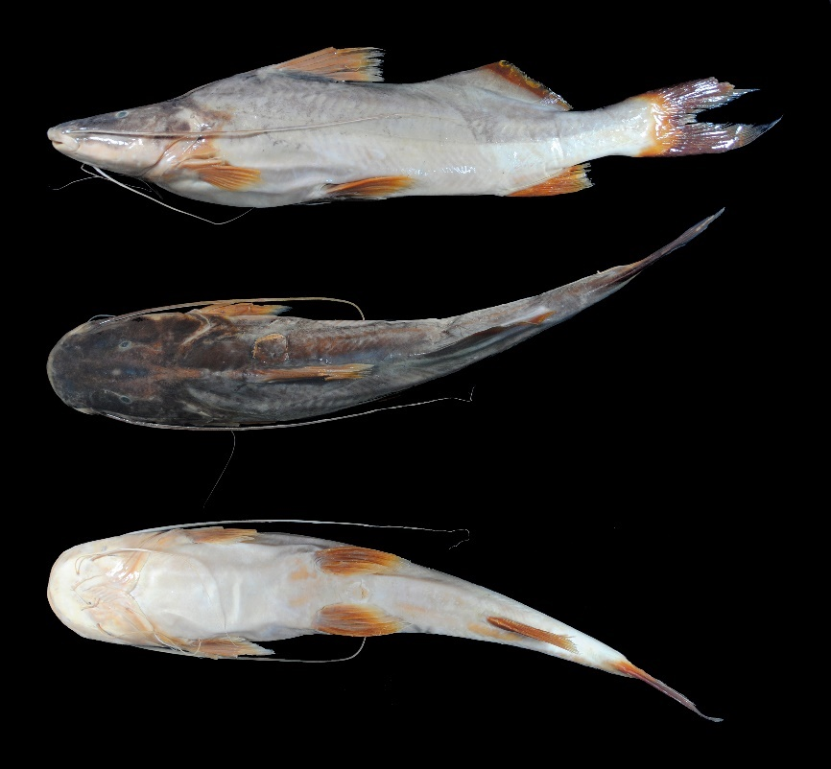
FIGURE 12. Brachyplatystoma vaillantii, UMSS 17281, 410 mm SL, Beni River, Cachuela Esperanza, B-MD-O sub-basin, Amazon Basin.
Examined material (two specimens). Amazon Basin: UMSS 17281 (1, 435.8 mm SL), Beni River, Cachuela Esperanza, -10.521983 -65.5787100, 23 Sep 2015, D. Barrozo; UMSS 17282 (1, 389.4 mm SL), same data as UMSS 17281.
Common name. Dorado de piel in Puerto Rico and Cobija (Pando) (Carvajal-Vallejos et al. 2011).
Diagnosis. Brachyplatystoma vaillantii differs from its congeners in the following: from B. filamentosum by the posterior nostril to anterior margin of orbit (25-26.5% HL vs. 20.3%), postorbital length (41.9-42.5% HL vs. 46.5%), head depth (62.8-62.9% HL vs. 50.1%), internal mental barbel length (17.4-17.5% SL vs. 4.8%), external mental barbel length (40.3-42.4% SL vs. 17.8%), dorsal fin insertion to adipose fin origin (13.2-14.1% SL vs. 22% SL), adipose fin base length (24-24.8% SL vs. 14.4%); from B. juruense by the postorbital distance (41.9-42.5% HL vs. 46.9%), distance between internal mental barbels (19.4-19.6% HL vs. 27.9%), distance between external mental barbels (37.6-40.5% HL vs. 44.7%), external mental barbel length (40.3-42.4% SL vs. 22.4%), dorsal fin insertion to adipose fin origin (13.2-14.1% SL vs. 21.8%), adipose fin base length (24-24.8% SL vs. 18.4%); from B. platynema by the interorbital distance (25.7-26.1% HL vs. 17-18.8%), left posterior nostril to right posterior nostril (27-28% HL vs.19.6-21.1%), head depth (62.8-62.9% HL vs. 44.2-48.9%), mouth width (51.1-53.9% HL vs. 41.4-46.3%), internal mental barbel length (17.4-17.5% SL vs. 27.8-48.4%), dorsal fin insertion to adipose fin origin (13.2-14.1% SL vs. 19.6-21.6%), adipose fin base length (24-24.8% SL vs. 16.8-19.7%); from B. rousseauxii by head depth (62.8-62.9% HL vs. 49.8-50.6%), internal mental barbel length (17.4-17.5% SL vs. 7.1-7.3%), external mental barbel length (40.3-42.4% SL vs. 17.2-23%), dorsal fin insertion to adipose fin origin (13.2-14.1% SL vs. 23.2%), adipose fin base length (24-24.8% SL vs. 13.8-15.3%); from B. tigrinum by the interorbital distance (25.7-26.1% HL vs. 17.4-19.7%), left posterior nostril to right posterior nostril (27-28% HL vs. 17.7-19.8%), distance between anterior nostrils (30.2-32.3% HL vs. 21.6-23.3%), posterior nostril to anterior margin of orbit (25-26.5% HL vs. 32.3-33%), head depth (62.8-63% HL vs. 37.6-48.1%), mouth width (51.1-53.9% HL vs. 38-41.3%), internal mental barbel length (17.4-17.5% SL vs. 8.4-9.9%), external mental barbel length (40.3-42.4% SL vs. 17.7-18.7%), maxillary barbel length (78.9-82.9% SL vs. 31.8-40%), dorsal spine length (20.5-22.4% SL vs. 16.2-16.9%).
Description. Morphometric data presented in Table 9. Straight ascending profile from the snout to approximately the height of the origin of the pectoral fin, then with a steeper slope up to the origin of the dorsal fin. Head longer than wide with eyes in a dorsal position. Mouth in a subterminal position with a small portion of the premaxillary patch exposed. Premaxilla with vomerine patches narrowly separated from the premaxillaries; vomerine patches in contact with the palatines, the latter without prominent posterolateral lobes. Dentary with large, curved, and closely spaced external teeth; internal teeth small, thin, straight, and depressible (Annex 3). Posterior supraoccipital process elongated and in contact with the nuchal plate. Humeral process broad-based and pointed. Pectoral fin extending beyond the midpoint between its origin and the pelvic fin; ossified spine present. Pelvic fin extending to less than halfway between its origin and the anal fin origin. Dorsal fin with a flexible spine at the distal end. Long adipose fin. Anal fin with a slightly concave posterior margin. Adipose fin twice as long as the base of the anal fin. Bifurcated caudal fin with pointed lobes. Maxillary barbels extending beyond the adipose fin, often reaching the caudal fin; mandibular barbels shorter. Dorsal fin rays I+6; anal fin rays VI+10; pectoral fin rays I+10; pelvic fin rays I+5; caudal fin rays 15.
TABLE 9. Morphometric data of Brachyplatystoma vaillantii. N: Number of individuals, SD: Standard deviation, Min: Minimum value, Max: Maximum value.
Measurements | N | Mean | SD | Min | Max
SL (mm) | 2 | 412.6 | 32.8 | 389.4 | 435.8
Percents of head length (% HL)
Nuchal plate length | 2 | 14.6 | 1.4 | 13.6 | 15.6
Interorbital distance | 2 | 25.9 | 0.3 | 25.7 | 26.1
Left posterior nostril to right posterior nostril | 2 | 27.5 | 0.7 | 27.0 | 28.0
Left anterior nostril to right anterior nostril | 2 | 31.3 | 1.5 | 30.3 | 32.3
Left anterior nostril to left posterior nostril | 2 | 11.7 | 1.5 | 10.6 | 12.8
Posterior nostril to anterior margin of orbit | 2 | 25.8 | 1.1 | 25.0 | 26.5
Snout length | 2 | 51.0 | 0.6 | 50.6 | 51.4
Postorbital length | 2 | 42.2 | 0.4 | 41.9 | 42.5
Orbital diameter | 2 | 8.30 | 0.8 | 7.80 | 8.90
Head depth | 2 | 62.9 | 0.0 | 62.8 | 62.9
Mouth width | 2 | 52.5 | 2.0 | 51.1 | 53.9
Distance between internal mental barbels | 2 | 19.5 | 0.2 | 19.4 | 19.6
Distance between external mental barbels | 2 | 39.0 | 2.1 | 37.6 | 40.5
Distance between internal and external mental barbel | 2 | 11.9 | 0.6 | 11.5 | 12.3
Percents of standard length (% SL)
Predorsal length | 2 | 37.5 | 0.2 | 37.4 | 37.7
Internal mental barbel length | 2 | 17.5 | 0.0 | 17.4 | 17.5
External mental barbel length | 2 | 41.4 | 1.5 | 40.3 | 42.4
Maxillary barbel length | 2 | 80.9 | 2.8 | 78.9 | 82.9
Body width | 2 | 20.4 | 1.4 | 19.4 | 21.4
Body depth | 2 | 22.6 | 0.1 | 22.5 | 22.6
Head length | 2 | 28.8 | 0.0 | 28.8 | 28.8
Pectoral fin origin to dorsal fin insertion | 2 | 30.4 | 0.9 | 29.8 | 31.1
Dorsal fin origin to pelvic fin origin | 2 | 24.6 | 0.9 | 23.9 | 25.2
Dorsal fin origin to anal fin origin | 2 | 43.5 | 0.3 | 43.3 | 43.7
Pectoral fin origin to pelvic fin origin | 2 | 24.1 | 1.1 | 23.3 | 24.9
Pelvic fin origin to anal fin origin | 2 | 39.4 | 17.3 | 27.1 | 51.6
Distance between pelvic fins | 2 | 12.4 | 0.3 | 12.1 | 12.6
Pelvic fin length | 2 | 16.5 | 0.1 | 16.5 | 16.5
Dorsal spine length | 2 | 21.4 | 1.4 | 20.5 | 22.4
Dorsal fin base length | 2 | 13.3 | 0.6 | 12.9 | 13.7
Dorsal fin insertion to adipose fin origin | 2 | 13.6 | 0.7 | 13.2 | 14.1
Adipose fin base length | 2 | 24.4 | 0.6 | 24.0 | 24.8
Anal fin base length | 2 | 12.8 | 0.7 | 12.3 | 13.3
Anal fin origin to adipose fin insertion | 2 | 18.9 | 1.8 | 17.6 | 20.2
Caudal peduncle height | 2 | 8.40 | 0.7 | 7.90 | 8.90
Dorsal fin origin to anterior caudal base | 2 | 63.0 | 1.1 | 62.2 | 63.8
Adipose fin origin to anterior caudal base | 2 | 36.5 | 0.1 | 36.5 | 36.6
Anal fin origin to anterior caudal base | 2 | 26.1 | 0.7 | 25.6 | 26.6
Caudal peduncle length | 2 | 13.3 | 0.0 | 13.3 | 13.3
Coloration in alcohol. Body of a faint gray color with the dorsal and head region dorsally darker. Ventral region whitish. Dorsal, pectoral, pelvic, anal, and caudal fins yellowish; adipose fin grayish.
Coloration in life. Coloration similar to individuals preserved in alcohol.
Distribution. Present in the B-MD-O sub-basin (Amazon Basin). Also recorded in the Madre de Dios sub-basin (Amazon Basin) (Carvajal-Vallejos & Fernández 2011).
Importance. Commercial fishing trade in Puerto Rico and Cobija (Carvajal-Vallejos et al. 2011).
Ecological notes. Feeds on fish. Juveniles and subadults frequently inhabit river mouths. Engages in reproductive migrations (Keith et al. 2000). It is the only species in the genus that forms schools, and it is very voracious and non-selective regarding the types of fish used for feeding (Galvis et al. 2006).
Calophysus Müller & Troschel 1843
Diagnosis. A row of teeth (not patches) with rounded cusps in both jaws; first ray of dorsal and pectoral fins soft and longer than the subsequent soft first ray; long adipose fin; body light brown, with dark spots or occasionally without them (Eigenmann & Eigenmann 1890).
Distribution. Amazon Basin (Figure 13).
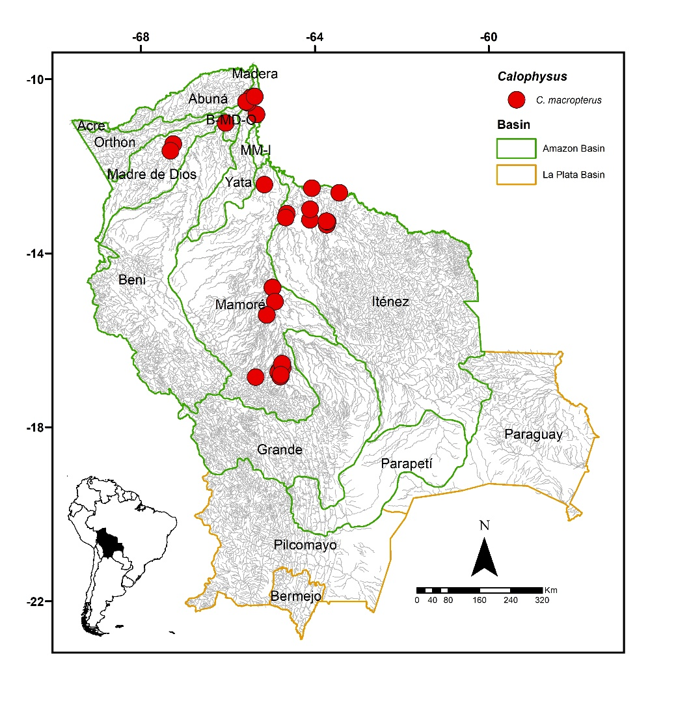
FIGURE 13. Collection sites of 123 lots of Calophysus macropterus deposited in the Ichthyological Collection UMSS – Museo d'Orbigny (Cochabamba, Bolivia). Some symbols represent more than one lot.
Included species. Monospecific genus, with Calophysus macropterus as the sole representative.
Comments. Genus proposed by Müller & Troschel (1843) for Pimelodus macropterus Lichtenstein 1819 as the type species, currently synonymous with C. macropterus. Only one species is known, C. macropterus (Lichtenstein 1819).
Calophysus macropterus (Lichtenstein 1819) (Figure 14)
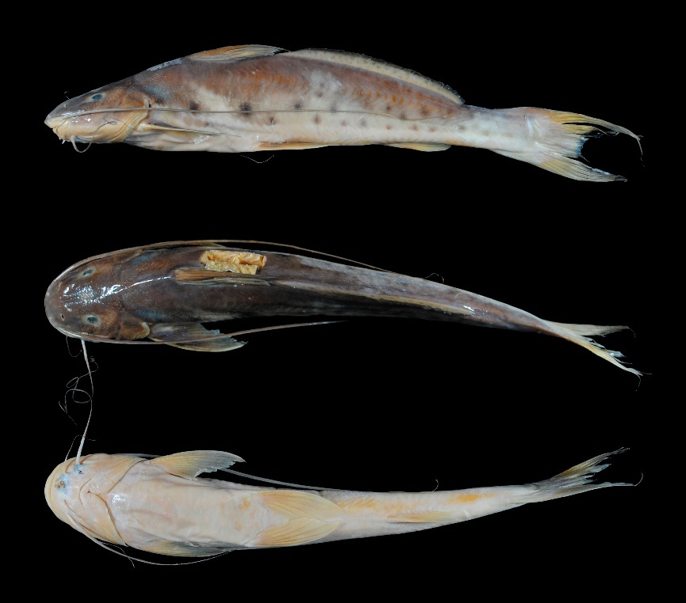
FIGURE 14. Calophysus macropterus, UMSS 7715, 230 mm SL, Mamoré River, above Villa Bella, Mamoré-Iténez sub-basin, Amazon Basin.
Examined material (20 specimens). Amazon Basin: UMSS 2304 (1, 316.1 mm SL), Ichilo River, Puerto Yuca ICH 5B, -16.804600 -64.7806670, 1 May 1994, M. Maldonado, L. Meneses; UMSS 4053.1 (1, 278.6 mm SL), Ichilo River, Corte Hondo Lagoon, -16.637389 -64.7401667, 19 Nov 2006, F. Carvajal, E. De La Barra, C. Flores; UMSS 6889 (1, 279.3 mm SL), Beni River, Cachueriña, Villa Bella, -10.424455 -65.4703710, 23 Mar 2008, F. Carvajal; UMSS 7175 (1, 300.6 mm SL), same data as UMSS 6889; UMSS 7547 (1, 273.2 mm SL), Ichilo River, Puerto Villarroel ICH 5A, -16.838889 -64.7916667, 20 Sep 2007, F. Carvajal; UMSS 7572 (1, 291.9 mm SL), same data as UMSS 7547; UMSS 7573 (1, 271.8 mm SL), same data as UMSS 7547; UMSS 7577 (1, 284.5 mm SL), same data as UMSS 7547; UMSS 7646 (1, 307 mm SL), Manupare River, -11.493352 -67.2559150, 4 Nov 2007, F. Carvajal; UMSS 7576 (1, 315.4 mm SL), same data as UMSS 7547; UMSS 7578 (1, 295.6 mm SL), same data as UMSS 7547; UMSS 7620 (1, 284.8 mm SL), Mamoré River, above Villa Bella, -10.403147 -65.3813550, 22 Oct 2007, F. Carvajal; UMSS 7701 (1, 317.8 mm SL), Mamoré River, above Villa Bella, -10.396734 -65.3848990, 24 Mar 2008, F. Carvajal; UMSS 7718 (1, 298 mm SL), same data as UMSS 7701; UMSS 7731 (1, 279.3 mm SL), same data as UMSS 6889; UMSS 17483 (1, 297 mm SL), Mamoré River, San Antonio de Loros, -15.116667 -64.9166667, 11 Jul 2006, A. Parada; UMSS 17485 (1, 268 mm SL), same data as UMSS 17483; UMSS 17719 (1, 318 mm SL), Mamoré River, above Villa Bella, -10,403147 -65,3813550, 29 Oct 2007, R. Palacios; UMSS 17720 (1, 297.2 mm SL), same data as UMSS 17719; UMSS 17721 (1, 325 mm SL), Beni River, Cachuela Esperanza, -10.521983 -65.5787100, 23 Sep 2015, D. Barrozo.
Common name. Blanquillo in Riberalta, Trinidad, Rurrenabaque, Cachuela Esperanza (Beni), and Puerto Villarroel (Cochabamba) (Carvajal-Vallejos et al. 2011).
Diagnosis. Same as the genus.
Description. Morphometric data presented in Table 10. Slightly convex profile from the tip of the snout to the anterior margin of the eye, then straight ascending to the dorsal fin. Head longer than wide with eyes in a superolateral position. Mouth in a subterminal position; premaxilla and dentary with a row of teeth with rounded cusps, never forming patches. Posterior supraoccipital process elongated. Humeral process absent. Pectoral fin extending very close to the origin of the pelvic fin; first simple flexible ray longer than the rest. Pelvic fin extending to approximately halfway between its origin and the anal fin origin. Pectoral fin longer than the pelvic fin. Dorsal fin with the first simple flexible ray. Long adipose fin, with the origin close to the dorsal fin but visually separated from it. Anal fin with a slightly concave posterior margin. Adipose fin base four times longer than the base of the anal fin. Bifurcated caudal fin with pointed lobes. Maxillary barbels surpassing the anal fin; mandibular barbels shorter. Dorsal fin rays I+6; anal fin rays III+8-9; pectoral fin rays I+11-12; pelvic fin rays I+5; caudal fin rays 15.
TABLE 10. Morphometric data of Calophysus macropterus. N: Number of individuals, SD: Standard deviation, Min: Minimum value, Max: Maximum value.
Measurement | N | Mean | SD | Min | Max
SL (mm) | 20 | 294.9 | 17.4 | 268 | 325
Percents of head length (% HL)
Nuchal plate length | 20 | 10.7 | 1.1 | 8.70 | 12.6
Interorbital distance | 20 | 31.6 | 1.4 | 28.8 | 33.8
Left posterior nostril to right posterior nostril | 20 | 22.2 | 0.9 | 20.6 | 24.1
Left anterior nostril to right anterior nostril | 20 | 18.7 | 0.8 | 17.2 | 20.6
Left anterior nostril to left posterior nostril | 20 | 16.6 | 1.8 | 14.9 | 23.5
Posterior nostril to anterior margin of orbit | 20 | 24.0 | 0.7 | 22.8 | 25.3
Snout length | 20 | 53.8 | 0.6 | 52.8 | 55.0
Postorbital length | 20 | 37.8 | 0.7 | 36.4 | 39.4
Orbital diameter | 20 | 14.1 | 0.9 | 12.4 | 15.5
Head depth | 20 | 72.0 | 3.9 | 65.4 | 81.5
Mouth width | 20 | 54.2 | 2.0 | 50.8 | 59.2
Distance between internal mental barbels | 20 | 17.3 | 1.7 | 14.2 | 21.7
Distance between external mental barbels | 20 | 41.7 | 1.9 | 38.6 | 46.1
Distance between internal and external mental barbel | 20 | 10.6 | 0.7 | 9.50 | 11.7
Percents of standard length (% SL)
Predorsal length | 20 | 30.7 | 1.0 | 28.4 | 32.7
Internal mental barbel length | 20 | 20.4 | 2.1 | 14.7 | 23.8
External mental barbel length | 20 | 42.2 | 3.8 | 32.9 | 47.8
Maxillary barbel length | 20 | 76.6 | 6.9 | 63.6 | 86.3
Body width | 20 | 19.0 | 1.1 | 16.4 | 20.8
Body depth | 20 | 20.6 | 1.2 | 18.2 | 22.5
Head length | 20 | 22.7 | 1.2 | 21.1 | 25.4
Pectoral fin origin to dorsal fin insertion | 20 | 27.7 | 0.9 | 26.2 | 29.3
Dorsal fin origin to pelvic fin origin | 20 | 26.0 | 1.4 | 23.3 | 27.9
Dorsal fin origin to anal fin origin | 20 | 47.6 | 1.0 | 45.6 | 49.7
Pectoral fin origin to pelvic fin origin | 20 | 25.7 | 1.0 | 24.2 | 27.8
Pelvic fin origin to anal fin origin | 20 | 28.4 | 1.1 | 26.2 | 30.2
Pectoral spine length | 20 | 21.6 | 1.0 | 20.2 | 23.8
Distance between pelvic fins | 20 | 12.5 | 0.6 | 11.7 | 14.1
Pelvic fin length | 20 | 18.9 | 1.1 | 16.9 | 21.2
Dorsal spine length | 19 | 24.2 | 2.6 | 17.2 | 29.5
Dorsal fin base length | 20 | 12.8 | 1.0 | 9.60 | 15.0
Dorsal fin insertion to adipose fin origin | 20 | 5.30 | 0.9 | 3.80 | 7.0
Adipose fin base length | 20 | 43.1 | 1.6 | 40.5 | 47.0
Anal fin base length | 20 | 11.7 | 0.8 | 10.6 | 13.0
Anal fin origin to adipose fin insertion | 20 | 20.7 | 1.2 | 17.9 | 23.0
Caudal peduncle height | 20 | 8.60 | 0.9 | 5.40 | 9.60
Dorsal fin origin to anterior caudal base | 20 | 72.1 | 1.7 | 69.5 | 75.8
Adipose fin origin to anterior caudal base | 20 | 55.0 | 1.6 | 52.8 | 58.6
Anal fin origin to anterior caudal base | 20 | 29.4 | 0.9 | 28.2 | 30.9
Caudal peduncle length | 20 | 17.6 | 0.7 | 16.5 | 19.0
Coloration in alcohol. Body pale gray with the upper half and dorsal part of the head in a dark gray color. Ventral region whitish. Flank region has some black spots of similar size to the eye or smaller, with some individuals lacking spots on the skin and having a gray color. Dorsal, pectoral, and pelvic fins grayish; adipose fin yellowish with small black spots; anal and caudal fins yellowish.
Coloration in life. Body grayish to olive with metallic green tones. Diffuse black spots of different sizes.
Distribution. Present in the Madre de Dios, Mamoré, Iténez, B-MD-O and MM-I sub-basins (Amazon Basin). Also recorded in the Madeira, Beni (Carvajal-Vallejos & Fernández 2011), Yata (Careaga et al. 2020), Grande (Maldonado et al. 2020) and Acre sub-basins (Amazon Basin) (Torrico et al. 2020).
Importance. Commercial and subsistence fishing trade in Riberalta, Rurrenabaque, Cachuela Esperanza, and Puerto Villarroel (Carvajal-Vallejos et al. 2011).
Ecological notes. Omnivorous species with a carnivorous tendency, feeding on fish, crustaceans, and plant material (flowers, seeds, fruits). Inhabits the bottom of the main river channels and deep areas of lagoons. Can also be found in flooded forests. Undertakes short migrations for reproduction (Sarmiento et al. 2014). Highly opportunistic and scavenging, feeding on remains of fish and other vertebrates trapped in nets (Galvis et al. 2006).
Cheirocerus Eigenmann 1917
Diagnosis. Mouth completely in ventral position with a pair of lateral pouches on the upper lip; gill arch with fleshy papillae; vomerian and palatine patches absent; humeral process absent; pectoral fin finely serrated and ossified; posterior supraoccipital process elongated and articulated to the nuchal plate; long adipose fin (Stewart & Pavlik 1985).
Distribution. Amazon Basin (Figure 15).
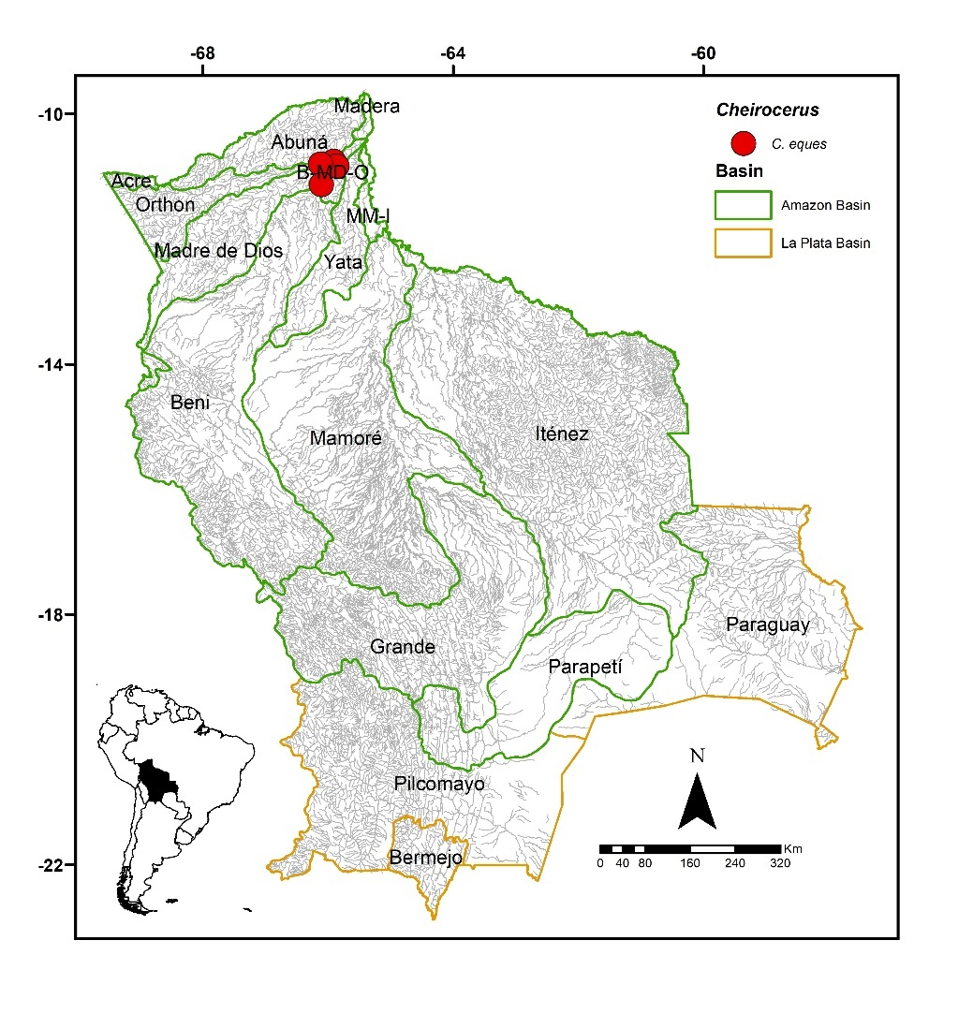
FIGURE 15. Collection sites of eight lots of Cheirocerus eques deposited in the Ichthyological Collection UMSS – Museo d'Orbigny (Cochabamba, Bolivia). Some symbols represent more than one lot.
Included species. Cheirocerus eques.
Comments. Genus proposed by Eigenmann (1917) for Cheirocerus eques Eigenmann as the type species. Stewart & Pavlik (1985) redescribed this genus based on its premaxilla, swim bladder, and mouth.
Currently, three species are known: C. eques in the Amazon Basin, C. goeldii (Steindachner 1908) in Brazil, Colombia, Ecuador, and Peru, and C. abuelo (Schultz 1944) in the Maracaibo Lake Basin (Fricke et al. 2023). Of the three valid species known, C. eques is present in Bolivia.
Cheirocerus eques Eigenmann 1917 (Figure 16)
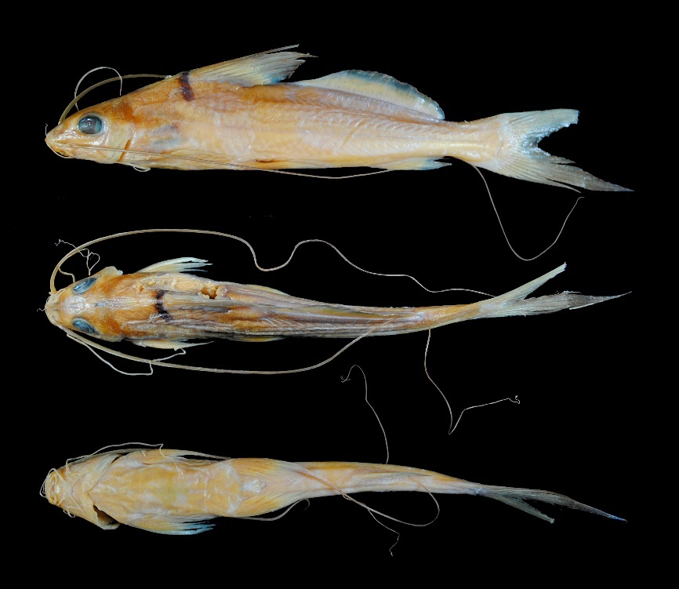
FIGURE 16. Cheirocerus eques, UMSS 10608, 117 mm SL, Beni River, Florida stream, B-MD-O sub-basin, Amazon Basin.
Examined material (five specimens). Amazon Basin: UMSS 10608 (1, 107.9 mm SL), Beni River, Florida stream, -10.756444 -65.9073889, 14 Jun 2011, F. Carvajal, T. Pérez, A. Argote, F. Vieira; UMSS 11077 (1, 87.4 mm SL), Beni River, Florida, -10.837330 -65.8581000, 27 Oct 2001, F. Carvajal, T. Pérez, A. Argote, F. Machicao; UMSS 11298 (1, 61.8 mm SL), same data as UMSS 11077; UMSS 13260 (1, 74.8 mm SL), Orthon River, -10.802622 -66.1166667, 6 Nov 2012, T. Oberdorff, J. Zubieta, F. Carvajal, A. Argote, D. Barrozo; UMSS 13299 (1, 45.3 mm SL), Ivón stream, -11.134083 -66.1049444, 3 Nov 2012, T. Oberdorff, J. Zubieta, F. Carvajal, A. Argote, D. Barrozo.
Diagnosis. Same as the genus.
Description. Morphometric data presented in Table 11. Profile slightly convex from the tip of the snout to the eye, then straight ascending to the dorsal fin. Head longer than wide with eyes in lateral position. Mouth entirely in ventral position with fleshy lips, upper lip with a deep pouch on each side. Premaxillary patches, vomerian and palatine teeth absent; premaxillaries sometimes present in juveniles. Posterior supraoccipital process elongated and in contact with the nuchal plate. Humeral process absent. Pectoral fin extending to near the origin of the pelvic fin; ossified and serrated spine on the inner margin. Pelvic fin extending to approximately half the distance between its origin and the anal fin origin. Pectoral and pelvic fins of equal length. Dorsal fin with the first simple and slender flexible ray. Adipose fin long but clearly separated from the dorsal fin. Anal fin with a nearly straight posterior margin. Base of the adipose fin almost three times longer than the base of the anal fin. Caudal fin bifurcated with pointed lobes. Maxillary barbels long, extending beyond the caudal fin; mental barbels shorter. Dorsal fin rays I+6; anal fin rays iii-iv+7; pectoral fin rays I+9-10; pelvic fin rays i+5; caudal fin rays 15.
TABLE 11. Morphometric data of Cheirocerus eques. N: Number of individuals, SD: Standard deviation, Min: Minimum value, Max: Maximum value.
Measurements | N | Mean | SD | Min | Max
SL (mm) | 5 | 75.4 | 23.9 | 45.3 | 107.8
Percents of head length (% HL)
Interorbital distance | 5 | 25.7 | 2.6 | 23.9 | 29.9
Left posterior nostril to right posterior nostril | 5 | 18.1 | 3.6 | 12.8 | 22.1
Left anterior nostril to right anterior nostril | 5 | 12.5 | 1.9 | 10.2 | 14.4
Left anterior nostril to left posterior nostril | 5 | 14.2 | 3.4 | 9.10 | 18.4
Posterior nostril to anterior margin of orbit | 5 | 18.9 | 3.1 | 14.7 | 21.8
Snout length | 5 | 46.6 | 4.3 | 40.3 | 52.0
Postorbital length | 5 | 28.0 | 1.2 | 26.0 | 29.0
Orbital diameter | 5 | 31.3 | 1.5 | 29.9 | 33.0
Head depth | 5 | 78.0 | 3.2 | 74.1 | 81.5
Mouth width | 5 | 24.0 | 2.3 | 21.3 | 27.5
Distance between internal mental barbels | 5 | 16.1 | 2.4 | 12.8 | 19.4
Distance between external mental barbels | 5 | 38.1 | 3.5 | 34.5 | 42.7
Distance between internal and external mental barbel | 5 | 13.6 | 1.1 | 12.5 | 15.3
Percents of standard length (% SL)
Predorsal length | 5 | 36.5 | 0.7 | 35.5 | 37.1
Internal mental barbel length | 5 | 26.6 | 1.5 | 25.3 | 28.5
External mental barbel length | 5 | 52.5 | 7.7 | 43.6 | 59.7
Maxillary barbel length | 5 | 170.6 | 6.8 | 163.0 | 177.4
Body width | 5 | 16.3 | 0.6 | 15.4 | 17.1
Body depth | 5 | 20.1 | 1.7 | 17.8 | 21.8
Head length | 5 | 22.5 | 1.2 | 20.6 | 23.9
Pectoral fin origin to dorsal fin insertion | 5 | 31.3 | 1.5 | 29.1 | 33.0
Dorsal fin origin to pelvic fin origin | 5 | 22.9 | 1.8 | 20.4 | 25.3
Dorsal fin origin to anal fin origin | 5 | 46.2 | 3.1 | 42.4 | 50.0
Pectoral fin origin to pelvic fin origin | 5 | 22.9 | 2.5 | 20.9 | 26.4
Pelvic fin origin to anal fin origin | 5 | 30.6 | 1.8 | 27.9 | 32.5
Pectoral spine length | 5 | 20.3 | 1.7 | 17.6 | 22.0
Distance between pelvic fins | 5 | 12.0 | 0.9 | 11.1 | 13.2
Pelvic fin length | 5 | 20.6 | 0.5 | 19.9 | 21.3
Dorsal spine length | 3 | 33.1 | 0.4 | 32.8 | 33.5
Dorsal fin base length | 5 | 16.3 | 0.9 | 15.4 | 17.2
Dorsal fin insertion to adipose fin origin | 5 | 7.40 | 1.7 | 5.20 | 9.70
Adipose fin base length | 5 | 35.5 | 1.2 | 34.3 | 36.9
Anal fin base length | 5 | 12.2 | 0.7 | 11.4 | 13.3
Anal fin origin to adipose fin insertion | 5 | 19.9 | 1.3 | 18.1 | 21.3
Caudal peduncle height | 5 | 8.0 | 0.5 | 7.20 | 8.40
Dorsal fin origin to anterior caudal base | 5 | 71.9 | 8.2 | 65.8 | 86.4
Adipose fin origin to anterior caudal base | 5 | 45.3 | 0.9 | 44.5 | 46.5
Anal fin origin to anterior caudal base | 5 | 25.8 | 1.5 | 24.1 | 27.6
Caudal peduncle length | 5 | 13.4 | 2.9 | 9.70 | 16.5
Coloration in alcohol. Body and head yellowish with a dark band crossing the nape at the origin of the dorsal fin. Dorsal fin yellowish with dark distal ends of the rays, the rest of the fins yellowish.
Distribution. Present in the Orthon, Beni and B-MD-O sub-basins (Amazon Basin). Also recorded in the Madeira, Madre de Dios, Mamoré, Iténez (Carvajal-Vallejos & Fernández 2011), Yata (Careaga et al. 2020) and MM-I sub-basins (Amazon Basin) (Torrico et al. 2020).
Importance. There is no available information.
Ecological notes. Species that feeds mostly on benthic invertebrates. Inhabits the depths of turbid rivers and has nocturnal habits (Stewart & Pavlik 1985).
Duopalatinus Eigenmann & Eigenmann 1888
Diagnosis. Vomerine and palatine patches widely separated with slender teeth; premaxillary patch elongated and depressible; caudal fin strongly bifurcated with long and pointed lobes; adipose fin longer than the anal fin (Eigenmann & Eigenmann 1888, Eigenmann & Eigenmann 1890, Eigenmann & Allen 1942).
Distribution. Amazon Basin (Figure 17).
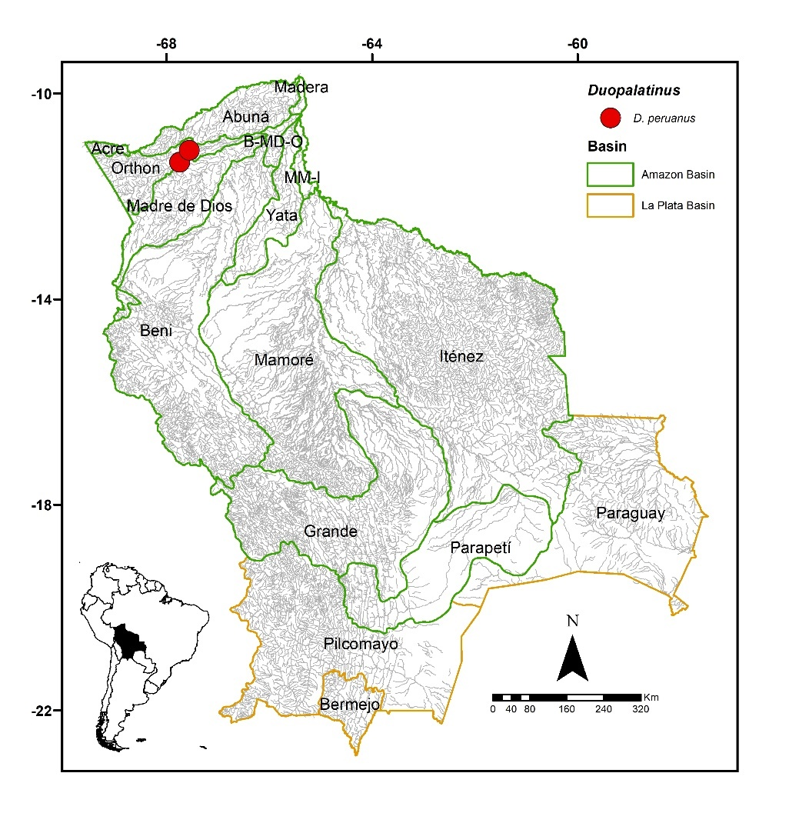
FIGURE 17. Collection sites of two lots of Duopalatinus peruanus deposited in the Ichthyological Collection UMSS - Museum d'Orbigny (Cochabamba, Bolivia).
Included species. Duopalatinus peruanus.
Comments. Genus proposed by Eigenmann & Eigenmann (1888) for Platystoma emarginatum Valenciennes 1840 as the type species, currently a synonym for D. emarginatus. Currently, two species are known: D. emarginatus (Valenciennes 1840) in the San Francisco Basin, and D. peruanus Eigenmann & Allen 1942 in the Amazon and Orinoco basins (Fricke et al. 2023). Of the two valid species known, D. peruanus is present in Bolivia.
Duopalatinus peruanus Eigenmann & Allen 1942 (Figure 18)
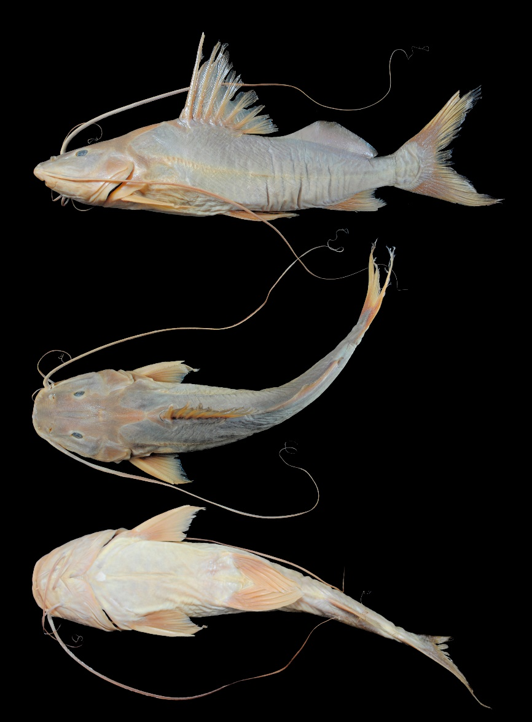
FIGURE 18. Duopalatinus peruanus, UMSS 7323, 244.8 mm SL, Manuripi River, Puerto Cárdenas, Orthon sub-basin, Amazon Basin.
Examined material (two specimens). Amazon Basin: UMSS 5966 (1, 290.7 mm SL), Orthon River, Puerto Rico Community, -11.103443 -67.5586640, 22 Jun 2007, H. Muñoz; UMSS 7323 (1, 244.8 mm SL), Manuripi River, Puerto Cárdenas, -11.336204 -67.7432300, 1 Dec 2002, F. Carvajal.
Diagnosis. Same as the genus.
Description. Morphometric data presented in Table 12. Straight ascending profile from the tip of the snout to behind the eye, then slightly convex to the origin of the dorsal fin. Head longer than wide, eyes in dorsal position. Mouth in subterminal position, with the premaxillary patch partially exposed. Wide premaxillary patch, with many small and weak teeth; vomerian patches united, palatine patches oval and separated from the vomerian patches. Posterior supraoccipital process with a broad base and in contact with the nuchal plate. Large humeral process, triangular and pointed. Pectoral fin extending to approximately half the distance between its origin and the pelvic fin origin; pectoral spine strongly ossified, serrated on the inner margin, and shorter than the first branched ray. Pelvic fin extending to just over half the distance between its origin and the anal fin origin. Pectoral fin shorter than the pelvic fin. Dorsal fin with the spine shorter than the first branched ray. Adipose fin long, noticeably separated from the dorsal fin. Base of the adipose fin twice as long as the base of the anal fin. Forked caudal fin. Maxillary barbels extending beyond the caudal fin; internal mental barbels extending to before the origin of the pectoral fin; external mental barbels extending to the tip of the pectoral fin. Dorsal fin rays I+6; anal fin rays iii+8; pectoral fin rays I+10; pelvic fin rays i+5; caudal fin rays 15.
TABLE 12. Morphometric data of Duopalatinus peruanus. N: Number of individuals, SD: Standard deviation, Min: Minimum value, Max: Maximum value.
Measurements | N | Mean | SD | Min | Max
SL (mm) | 2 | 267.8 | 32.4 | 244.8 | 290.7
Percents of head length (% HL)
Nuchal plate length | 2 | 13.3 | 1.0 | 12.6 | 14.1
Interorbital distance | 2 | 27.9 | 0.1 | 27.8 | 27.9
Left posterior nostril to right posterior nostril | 2 | 26.5 | 0.6 | 26.0 | 26.9
Left anterior nostril to right anterior nostril | 2 | 26.2 | 0.8 | 25.6 | 26.7
Left anterior nostril to left posterior nostril | 2 | 13.1 | 1.9 | 11.7 | 14.4
Posterior nostril to anterior margin of orbit | 2 | 20.2 | 1.4 | 19.2 | 21.2
Snout length | 2 | 50.1 | 1.0 | 49.4 | 50.9
Postorbital length | 2 | 41.2 | 0.0 | 41.2 | 41.2
Orbital diameter | 2 | 13.4 | 1.6 | 12.3 | 14.6
Head depth | 2 | 68.1 | 2.4 | 66.4 | 69.8
Mouth width | 2 | 54.2 | 0.8 | 53.6 | 54.8
Distance between internal mental barbels | 2 | 12.9 | 1.1 | 12.1 | 13.6
Distance between external mental barbels | 2 | 39.6 | 1.1 | 38.8 | 40.4
Distance between internal and external mental barbel | 2 | 11.9 | 0.2 | 11.7 | 12.0
Percents of standard length (% SL)
Predorsal length | 2 | 41.4 | 0.1 | 41.3 | 41.5
Internal mental barbel length | 2 | 21.2 | 3.0 | 19.0 | 23.3
External mental barbel length | 2 | 43.2 | 4.2 | 40.2 | 46.1
Maxillary barbel length | 2 | 135.5 | 5.5 | 131.6 | 139.4
Body width | 2 | 25.6 | 0.2 | 25.5 | 25.7
Body depth | 2 | 26.3 | 0.7 | 25.8 | 26.8
Head length | 2 | 30.4 | 0.4 | 30.1 | 30.7
Pectoral fin origin to dorsal fin insertion | 2 | 35.9 | 0.8 | 35.3 | 36.5
Dorsal fin origin to pelvic fin origin | 2 | 29.1 | 1.6 | 28.0 | 30.3
Dorsal fin origin to anal fin origin | 2 | 44.1 | 0.4 | 43.8 | 44.4
Pectoral fin origin to pelvic fin origin | 2 | 26.9 | 0.6 | 26.5 | 27.3
Pelvic fin origin to anal fin origin | 2 | 25.3 | 0.0 | 25.3 | 25.3
Pectoral spine length | 2 | 16.0 | 2.4 | 14.3 | 17.7
Distance between pelvic fins | 2 | 13.9 | 0.6 | 13.5 | 14.3
Pelvic fin length | 2 | 19.3 | 0.5 | 19.0 | 19.7
Dorsal spine length | 2 | 22.9 | 1.2 | 22.0 | 23.8
Dorsal fin base length | 2 | 17.2 | 0.3 | 17.0 | 17.4
Dorsal fin insertion to adipose fin origin | 2 | 7.90 | 0.5 | 7.50 | 8.20
Adipose fin base length | 2 | 28.8 | 0.2 | 28.6 | 28.9
Anal fin base length | 2 | 10.8 | 0.3 | 10.6 | 11.0
Anal fin origin to adipose fin insertion | 2 | 19.6 | 0.6 | 19.2 | 20.1
Caudal peduncle height | 2 | 7.60 | 0.1 | 7.60 | 7.70
Dorsal fin origin to anterior caudal base | 2 | 62.7 | 1.5 | 61.7 | 63.8
Adipose fin origin to anterior caudal base | 2 | 37.9 | 0.7 | 37.3 | 38.4
Anal fin origin to anterior caudal base | 2 | 26.3 | 0.6 | 25.8 | 26.7
Caudal peduncle length | 2 | 14.9 | 0.9 | 14.2 | 15.5
Coloration in alcohol. Body and head pale gray, with the dorsal region slightly darker. Ventral region whitish. Adipose fin pale gray; all other fins yellowish.
Distribution. Present in the Orthon sub-basin (Amazon Basin). Also recorded in the Madre de Dios and Beni sub-basins (Amazon Basin) (Torrico et al. 2020).
Importance. There is no available information.
Exallodontus Lundberg, Mago-Leccia & Nass 1991
Diagnosis. Premaxillary and dentary patches with 2-3 rows of conical teeth; short dorsal spine contained 5.6-8.6 times in standard length (SL); short head contained 4-5.2 times in SL; relatively small eyes contained 7.4-12 times in head length; posterior supraoccipital process with a pronounced crest (Lundberg et al. 1991).
Distribution. Amazon Basin (Figure 19).
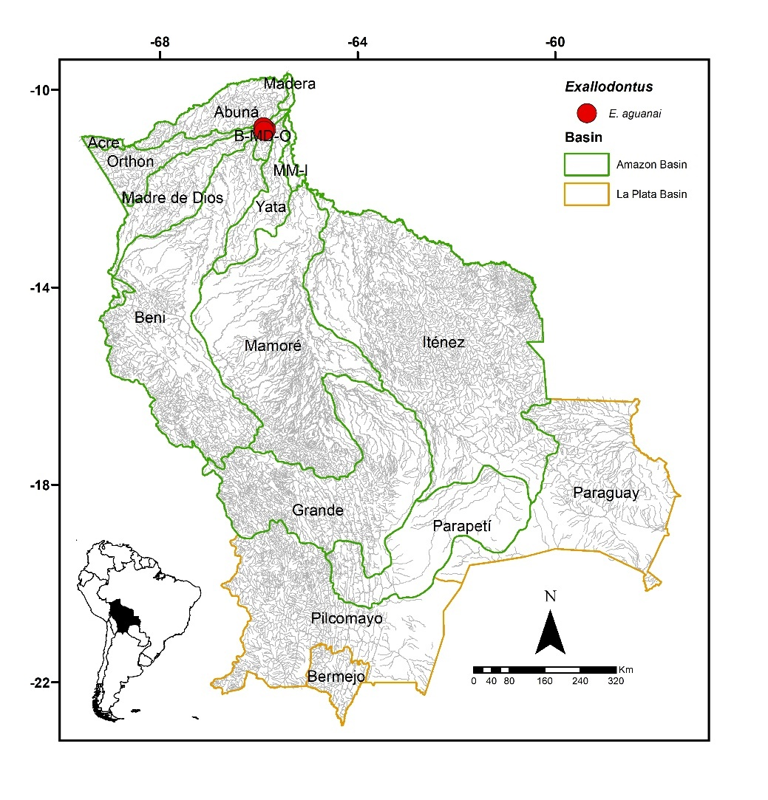
FIGURE 19. Collection sites of five lots of Exallodontus aguanai deposited in the Ichthyological Collection UMSS – Museo d'Orbigny (Cochabamba, Bolivia). Some symbols represent more than one lot.
Included species. Monospecific genus, with Exallodontus aguanai as the sole representative.
Comments. Genus proposed by Lundberg et al. (1991) for Exallodontus aguanai Lundberg et al. as the type species.
Exallodontus aguanai Lundberg, Mago-Leccia & Nass 1991 (Figure 20)
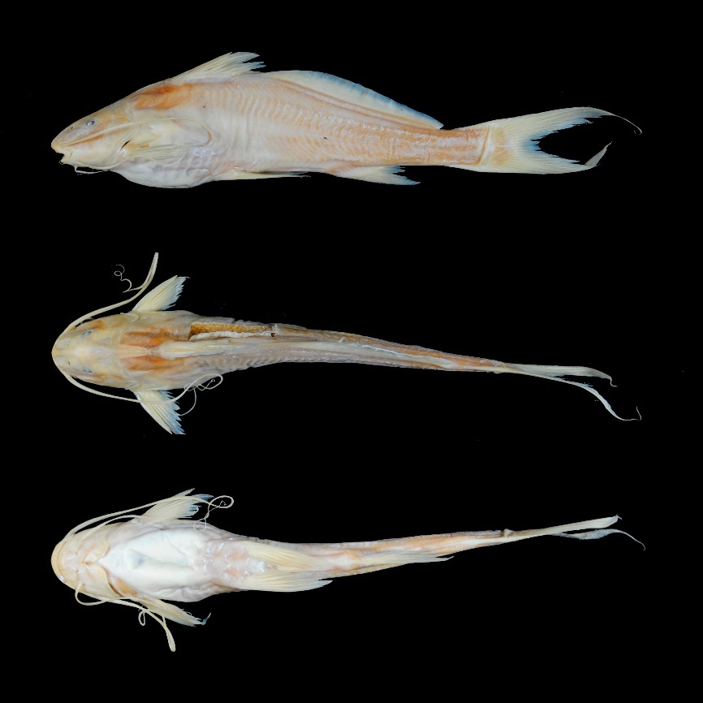
FIGURE 20. Exallodontus aguanai, UMSS 10343, 128 mm SL, Beni River, Florida, B-MD-O sub-basin, Amazon Basin.
Examined material (two specimens). Amazon Basin: UMSS 10343 (1, 126.9 mm SL), Beni River, Florida, -10.801944 -65.8515556, 12 Apr 2011, F. Carvajal, T. Pérez, A. Argote, D. Méndez, T. Araújo, B. Feitoza; UMSS 10649 (1, 77.1 mm SL), Beni River, Florida Stream, -10.756444 -65.9073889, 14 Jun 2011, F. Carvajal, T. Pérez, A. Argote, F. Vieira.
Diagnosis. Same as the genus.
Description. Morphometric data presented in Table 13. Profile slightly convex from the tip of the snout to the anterior margin of the eye, then straight ascending to the origin of the dorsal fin. Head longer than wide; eyes in laterodorsal position. Mouth in subterminal position; two or three rows of teeth on the premaxilla and dentary; no vomerian and palatine teeth. Posterior supraoccipital process elongated and in contact with the nuchal plate. Humeral process broad and pointed. Pectoral fin extending very close to the origin of the pelvic fin; strong, pointed, and serrated spine on both margins. Pelvic fin extending very close to the origin of the anal fin; posterior margin truncated. Pectoral fin shorter than pelvic fin. Dorsal fin with a strong, pungent, and distally serrated spine. Adipose fin very long, originating immediately behind the dorsal fin. Base of the adipose fin four times longer than the base of the anal fin. Anal fin with a concave posterior margin. Caudal fin strongly forked with pointed lobes. Maxillary barbels extending beyond the origin of the anal fin; mental barbels shorter. Dorsal fin rays I+6; anal fin rays ii+8-9; pectoral fin rays I+10; pelvic fin rays i+5; caudal fin rays 15.
TABLE 13. Morphometric data of Exallodontus aguanai. N: Number of individuals, SD: Standard deviation, Min: Minimum value, Max: Maximum value.
Measurements | N | Mean | SD | Min | Max
SL (mm) | 2 | 102.0 | 35.2 | 77.1 | 126.9
Percents of head length (% HL)
Nuchal plate length | 2 | 8.30 | 1.0 | 7.60 | 9.0
Interorbital distance | 2 | 29.4 | 1.4 | 28.4 | 30.4
Left posterior nostril to right posterior nostril | 2 | 16.8 | 1.3 | 16.0 | 17.7
Left anterior nostril to right anterior nostril | 2 | 15.9 | 5.4 | 12.1 | 19.7
Left anterior nostril to left posterior nostril | 2 | 18.9 | 0.4 | 18.6 | 19.2
Posterior nostril to anterior margin of orbit | 2 | 14.1 | 1.3 | 13.1 | 15.0
Snout length | 2 | 48.5 | 0.7 | 48.0 | 49.0
Postorbital length | 2 | 42.1 | 1.8 | 40.8 | 43.4
Orbital diameter | 2 | 10.6 | 0.7 | 10.1 | 11.1
Head depth | 2 | 94.1 | 11.9 | 85.8 | 102.5
Mouth width | 2 | 45.4 | 2.7 | 43.4 | 47.3
Distance between internal mental barbels | 2 | 14.7 | 2.1 | 13.2 | 16.1
Distance between external mental barbels | 2 | 41.8 | 0.9 | 41.2 | 42.4
Distance between internal and external mental barbel | 2 | 14.9 | 1.6 | 13.8 | 16.1
Percents of standard length (% SL)
Predorsal length | 2 | 32.5 | 0.9 | 31.9 | 33.1
Internal mental barbel length | 2 | 27.0 | 7.4 | 21.8 | 32.2
External mental barbel length | 2 | 51.3 | 8.9 | 45.0 | 57.6
Maxillary barbel length | 2 | 79.9 | 9.6 | 73.1 | 86.6
Body width | 2 | 18.3 | 0.6 | 17.9 | 18.8
Body depth | 2 | 23.5 | 1.2 | 22.7 | 24.4
Head length | 2 | 22.6 | 1.5 | 21.6 | 23.7
Pectoral fin origin to dorsal fin insertion | 2 | 30.5 | 0.1 | 30.4 | 30.6
Dorsal fin origin to pelvic fin origin | 2 | 26.3 | 0.3 | 26.1 | 26.5
Dorsal fin origin to anal fin origin | 2 | 44.1 | 1.2 | 43.2 | 44.9
Pectoral fin origin to pelvic fin origin | 2 | 22.1 | 2.8 | 20.1 | 24.1
Pelvic fin origin to anal fin origin | 2 | 27.3 | 0.6 | 26.9 | 27.7
Pectoral spine length | 2 | 15.2 | 2.0 | 13.8 | 16.6
Distance between pelvic fins | 2 | 9.30 | 0.3 | 9.10 | 9.50
Pelvic fin length | 2 | 20.4 | 0.2 | 20.2 | 20.5
Dorsal spine length | 2 | 15.9 | 2.4 | 14.2 | 17.6
Dorsal fin base length | 2 | 14.5 | 0.3 | 14.3 | 14.7
Dorsal fin insertion to adipose fin origin | 2 | 4.10 | 1.3 | 3.20 | 5.0
Adipose fin base length | 2 | 43.7 | 1.9 | 42.3 | 45.0
Anal fin base length | 2 | 10.3 | 0.3 | 10.1 | 10.5
Anal fin origin to adipose fin insertion | 2 | 26.7 | 0.6 | 26.3 | 27.1
Caudal peduncle height | 2 | 8.20 | 0.0 | 8.20 | 8.20
Dorsal fin origin to anterior caudal base | 2 | 71.3 | 2.7 | 69.4 | 73.2
Adipose fin origin to anterior caudal base | 2 | 55.4 | 1.1 | 54.7 | 56.2
Anal fin origin to anterior caudal base | 2 | 36.3 | 1.3 | 35.4 | 37.2
Caudal peduncle length | 2 | 23.1 | 1.0 | 22.4 | 23.8
Coloration in alcohol. Body and head yellowish. Ventral region whitish. All fins yellowish.
Distribution. Present in the B-MD-O sub-basin (Amazon Basin). Also recorded in the Abuná sub-basin (Amazon Basin) (Torrico et al. 2020).
Importance. There is no available information.
Ecological notes. The diet of this species is associated with the availability of food resources and may include aquatic or terrestrial insects, zooplankton, plant material, and detritus (Duarte et al. 2019). It inhabits deep areas of the main channels of large rivers, over sandy substrates or covered by detritus (Lundberg et al. 1991).
Hemisorubim Bleeker 1862
Diagnosis. Flattened snout, with the upper jaw truncated and shorter than the lower jaw; vomerian and palatine patches present; elongated humeral process with a pointed tip; first ray of dorsal and pectoral fins transformed into a spine; fleshy lips; body with scattered dark spots on the flanks (Eigenmann & Eigenmann 1890, Mees 1974).
Distribution. Amazon Basin (Figure 21).
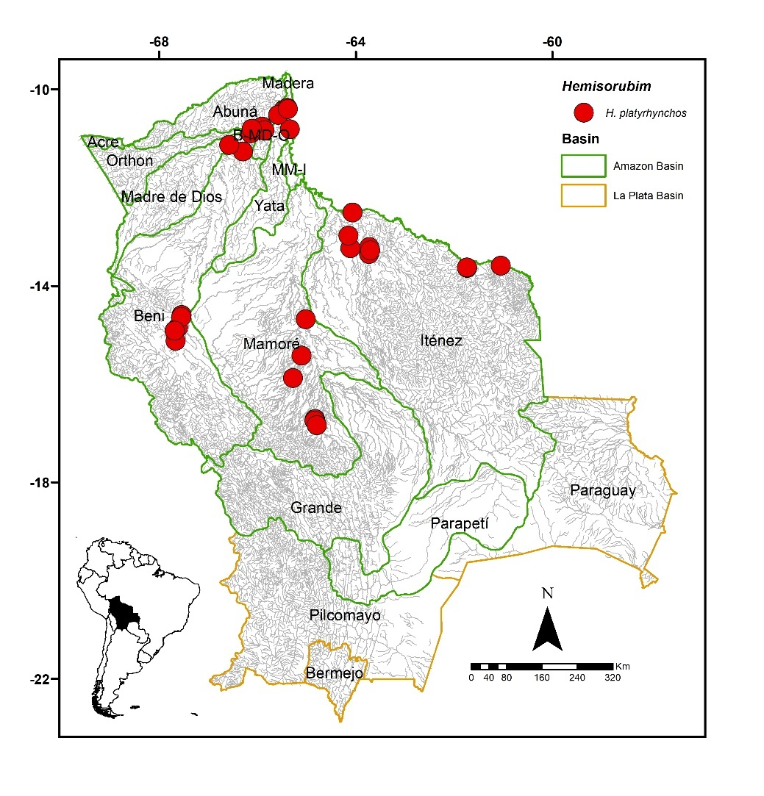
FIGURE 21. Collection sites for 55 lots of Hemisorubim platyrhynchos deposited in the Ichthyological Collection UMSS – Museo d'Orbigny (Cochabamba, Bolivia). Some symbols represent more than one lot.
Included species. Monospecific genus, with Hemisorubim platyrhynchos as the sole representative.
Comments. Genus proposed by Bleeker (1862) for Platystoma platyrhynchos Valenciennes 1840, as the type species, currently synonymous with H. platyrhynchos.
Hemisorubim platyrhynchos (Valenciennes 1840) (Figure 22)
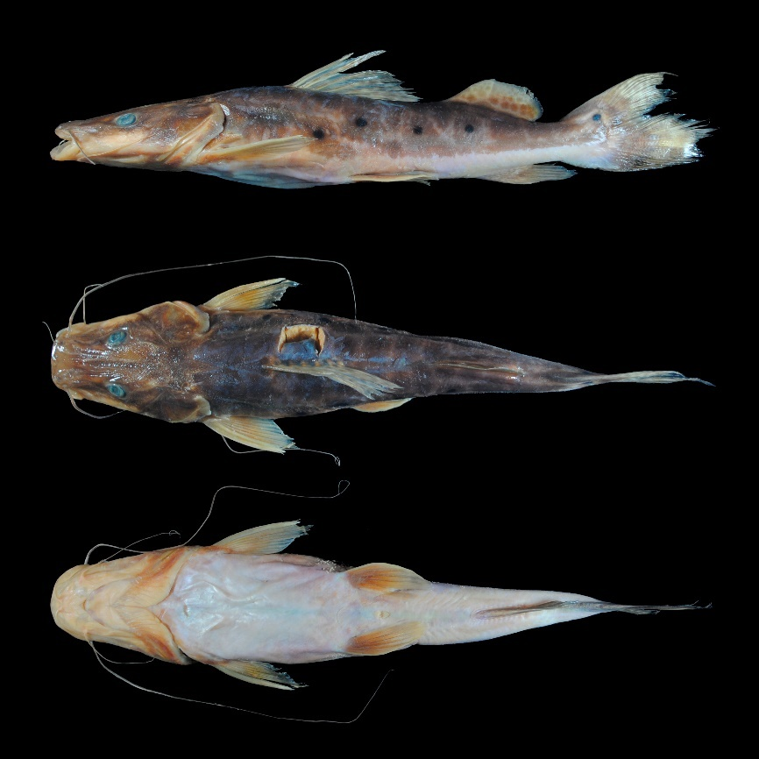
FIGURE 22. Hemisorubim platyrhynchos, UMSS 7767, 270 mm SL, Mamoré River, upstream of Villa Bella, Mamoré-Iténez sub-basin, Amazon Basin.
Examined material (19 specimens). Amazon Basin: UMSS 2317 (1, 320 mm SL), Campamento Chimoré IC Lagoon, -16.716308 -64.8281840, 1 Jun 1994, M. Maldonado, R. Zamuriano, L. Meneses; UMSS 2318 (1, 304 mm SL), same data as UMSS 2317; UMSS 2321 (1, 279.7 mm SL), same data as UMSS 2317; UMSS 2322 (1, 277.4 mm SL), same data as UMSS 2317; UMSS 2324 (1, 338 mm SL), same data as UMSS 2317; UMSS 2764 (1, 271.8 mm SL), Blanco River, Amasa Bay, -13.210570 -63.7243253, 16 Dec 2004, J. Camacho, L. Córdova, M. Pouilly; UMSS 4029 (1, 358 mm SL), Ichilo River, Boca Chimoré ICH 12, -16.746503 -64.8411056, 18 Nov 2006, F. Carvajal, E. De La Barra, C. Flores; UMSS 6170 (1, 315 mm SL), Ichilo River, Puerto Villarroel ICH 5A, -16.838889 -64.7916667, 19 Sept 2007, F. Carvajal; UMSS 7168 (1, 279.1 mm SL), Beni River, Cachueriña, Villa Bella, -10.424455 -65.4703710, 24 Jul 2007, F. Carvajal; UMSS 7210 (1, 326 mm SL), same data as UMSS 6170; UMSS 7211 (1, 279.5 mm SL), same data as UMSS 6170; UMSS 7243 (1, 324 mm SL), same data as UMSS 6170; UMSS 7742 (1, 259.4 mm SL), Madeira River, Villa Bella, -10.379891 -65.3918990, 30 Mar 2008, F. Carvajal; UMSS 7776 (1, 359 mm SL), Beni River, Villa Bella, -10.424455 -65.4703710, 26 Jan 2009, F. Carvajal; UMSS 13437 (1, 333 mm SL), Paraguá River, Piso Firme, -13.628116 -61.7359114, 27 Sep 2005, L. Córdova, J. Camacho; UMSS 16077 (1, 352 mm SL), Beni River between Hondo and Quiquibey, -14.636460 -67.5542100, 11 Sep 2015, L. Córdova, M. Jaldin, C. Rocabado; UMSS 16079 (1, 368 mm SL), Beni River between Kaka and Tuichi, -14.637010 -67.5541900, 5 Sep 2015, L. Córdova, M. Jaldin, C. Rocabado; UMSS 17404 (1, 287.8 mm SL), Paucerna River, Campo Alfeld, -13.591944 -61.0452780, 11 Sep 2009, M. Jégu; UMSS 17710 (1, 291.4 mm SL), Mamoré River, upstream of Villa Bella, -10.403147 -65.3813550, 3 May 2008, R. Palacios.
Common name. Brazo de moza in Puerto Rico and Cobija (Pando); seferino and estevan in Rurrenabaque (Beni); conservero in Puerto Villarroel (Cochabamba) (Carvajal-Vallejos et al. 2011).
Diagnosis. Same as the genus.
Description. Morphometric data presented in Table 14. Straight profile from the tip of the snout to the height of the posterior edge of the operculum, then slightly convex to the origin of the dorsal fin. Head longer than wide and dorsoventrally depressed; large eyes in a dorsal position. Wide and strongly depressed snout with a wide mouth; lower jaw longer than the upper. Premaxillary patch narrower in the central part; vomerian patch wider than the premaxillary and in contact with the palatine patches, which are elongated. Posterior supraoccipital process in the form of a spine and in contact with the nuchal plate. Thin and pointed humeral process. Pectoral fin extending beyond the midpoint between its origin and the pelvic fin; ossified, thick spine, serrated on the inner margin. Pelvic fin extending beyond the midpoint between its origin and the anal fin. Pectoral and pelvic fins of similar size. Dorsal fin with a strong and pointed spine. Relatively short adipose fin. Elongated anal fin, reaching the base of the caudal fin. Base of the adipose fin longer than the base of the anal fin. Forked caudal fin; upper lobe pointed; lower lobe rounded. Maxillary barbels reaching the tip of the pelvic fin; mental barbels shorter. Dorsal fin rays I+6; anal fin rays iii-iv+6-7; pectoral fin rays I+9; pelvic fin rays i+5; caudal fin rays 15-18.
TABLE 14. Morphometric data of Hemisorubim platyrhynchos. N: Number of individuals, SD: Standard deviation, Min: Minimum value, Max: Maximum value.
Measurements | N | Mean | SD | Min | Max
SL (mm) | 19 | 311.7 | 33.7 | 259.4 | 368
Percents of head length (% HL)
Nuchal plate length | 19 | 18.7 | 0.9 | 17.0 | 20.4
Interorbital distance | 19 | 22.2 | 1.0 | 20.7 | 24.4
Left posterior nostril to right posterior nostril | 19 | 17.8 | 1.0 | 16.3 | 20.8
Left anterior nostril to right anterior nostril | 19 | 22.9 | 1.0 | 20.8 | 24.6
Left anterior nostril to left posterior nostril | 19 | 10.7 | 0.6 | 9.70 | 12.0
Posterior nostril to anterior margin of orbit | 19 | 23.2 | 0.8 | 21.8 | 25.2
Snout length | 19 | 40.4 | 0.7 | 39.4 | 41.5
Postorbital length | 19 | 45.8 | 1.5 | 43.3 | 50.5
Orbital diameter | 19 | 14.5 | 0.5 | 13.7 | 15.6
Head depth | 19 | 47.8 | 4.0 | 39.9 | 53.6
Mouth width | 19 | 45.4 | 1.6 | 42.1 | 48.5
Distance between internal mental barbels | 19 | 3.20 | 1.1 | 1.70 | 5.70
Distance between external mental barbels | 19 | 29.0 | 2.4 | 23.1 | 33.1
Distance between internal and external mental barbel | 19 | 18.3 | 1.0 | 16.5 | 21.1
Percents of standard length (% SL)
Predorsal length | 19 | 44.0 | 1.4 | 40.6 | 46.1
Internal mental barbel length | 19 | 14.2 | 1.3 | 11.9 | 16.5
External mental barbel length | 19 | 29.0 | 2.9 | 21.6 | 33.0
Maxillary barbel length | 17 | 62.7 | 7.1 | 52.4 | 74.4
Body width | 19 | 23.3 | 1.0 | 20.7 | 25.6
Body depth | 19 | 18.6 | 1.6 | 15.4 | 21.8
Head length | 19 | 32.6 | 0.8 | 30.5 | 33.9
Pectoral fin origin to dorsal fin insertion | 19 | 34.4 | 1.0 | 31.9 | 35.9
Dorsal fin origin to pelvic fin origin | 19 | 21.4 | 1.0 | 20.0 | 23.6
Dorsal fin origin to anal fin origin | 19 | 40.5 | 2.2 | 32.3 | 42.7
Pectoral fin origin to pelvic fin origin | 19 | 26.8 | 1.6 | 24.0 | 29.9
Pelvic fin origin to anal fin origin | 19 | 26.6 | 1.1 | 24.8 | 28.1
Pectoral spine length | 18 | 19.2 | 1.3 | 16.7 | 21.5
Distance between pelvic fins | 19 | 15.8 | 0.7 | 14.3 | 16.8
Pelvic fin length | 19 | 18.0 | 1.1 | 15.5 | 20.2
Dorsal spine length | 15 | 14.7 | 1.0 | 12.7 | 16.1
Dorsal fin base length | 19 | 15.3 | 0.7 | 14.2 | 16.5
Dorsal fin insertion to adipose fin origin | 19 | 16.6 | 1.3 | 14.7 | 19.5
Adipose fin base length | 19 | 16.7 | 1.0 | 14.5 | 18.2
Anal fin base length | 19 | 10.4 | 0.8 | 8.40 | 11.5
Anal fin origin to adipose fin insertion | 19 | 15.2 | 0.8 | 13.8 | 16.7
Caudal peduncle height | 19 | 7.30 | 0.4 | 6.70 | 8.30
Dorsal fin origin to anterior caudal base | 19 | 57.3 | 1.7 | 54.7 | 60.3
Adipose fin origin to anterior caudal base | 19 | 25.7 | 1.1 | 23.6 | 28.0
Anal fin origin to anterior caudal base | 19 | 20.8 | 1.2 | 18.2 | 23.3
Caudal peduncle length | 19 | 10.2 | 0.8 | 8.90 | 12.1
Coloration in alcohol. Light-colored body with large color spots; space between spots reduced, giving the appearance of a uniformly brown background. Some small, round black spots on the flanks. Dorsal head brown. Ventral region of the head and body cream or whitish. Pectoral, pelvic, and anal fins yellowish; dorsal, adipose, and caudal fins have some brown spots; the base of the upper lobe of the caudal fin has a small, round black spot.
Coloration in life. Adult individuals exhibit the same color pattern described above. Some juvenile individuals uniformly yellowish in body, head, and fins, with some round black spots on the flanks.
Distribution. Present in the Madeira, Orthon, Madre de Dios, Beni, Mamoré, Iténez, B-MD-O and MM-I sub-basins (Amazon Basin). Also recorded in the Pilcomayo (Maldonado et al. 2019) and Bermejo sub-basins (La Plata Basin) (Sarmiento et al. 2019).
Importance. Commercial and subsistence fishing trade in Puerto Rico, Cobija, Riberalta, Rurrenabaque and Puerto Villarroel (Carvajal-Vallejos et al. 2011).
Ecological notes. A carnivorous species that feeds on fish and benthic invertebrates. Inhabits the deeper parts of rivers and lagoons (Sarmiento et al. 2014). Nocturnal habits and engages in reproductive migrations (Magalhães et al. 2009).
Hypophthalmus Cuvier 1829
Diagnosis. Body highly compressed; short head, 22-31% of standard length (SL); eyes positioned lateroventrally; soft jaws without teeth; humeral process absent; short and lobulated adipose fin; long anal fin with numerous rays, 58-73; laterosensory branches complexly branched and overlapped (Littmann et al. 2021).
Distribution. Amazon and La Plata basins (Figure 23).
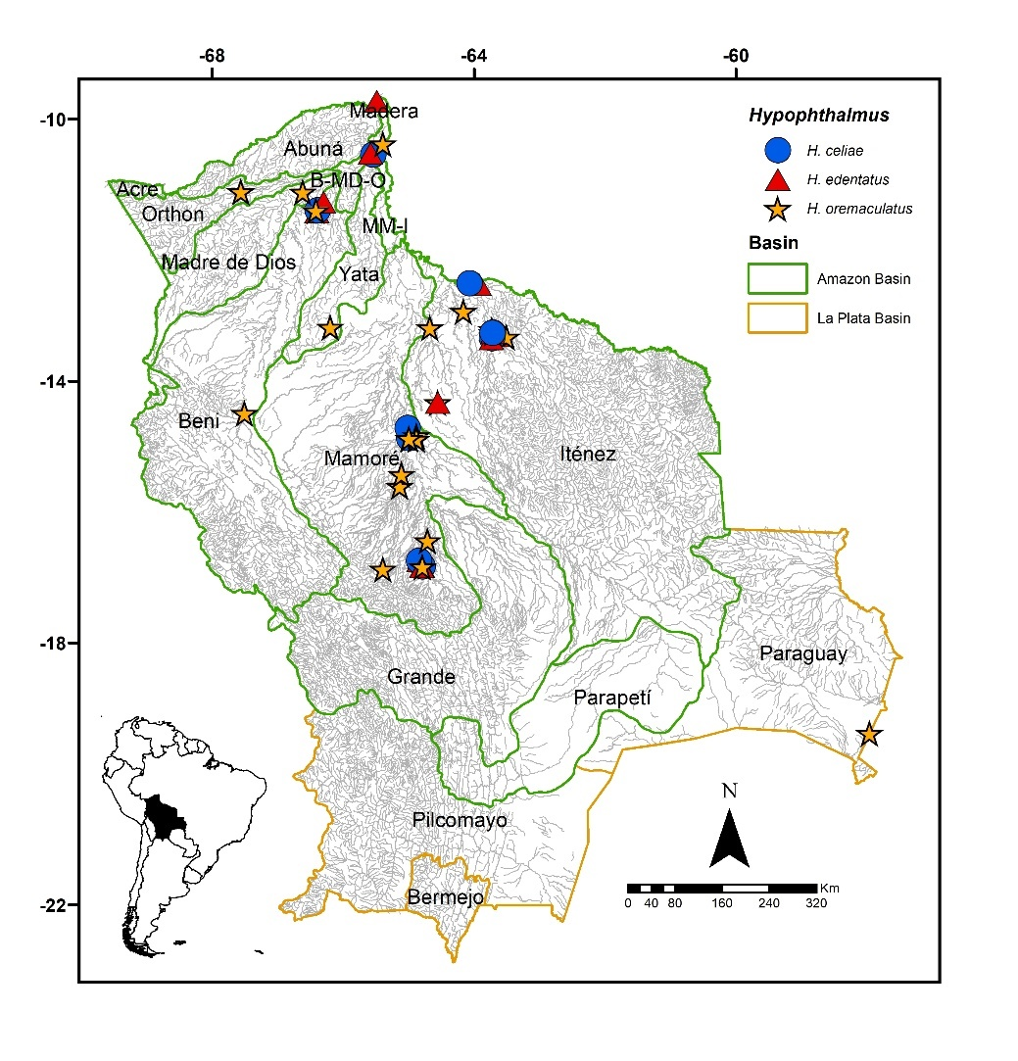
FIGURE 23. Collection sites of 11 lots of Hypophthalmus celiae, 12 of H. edentatus, and 32 of H. oremaculatus deposited in the Ichthyological Collection UMSS – d'Orbigny Museum (Cochabamba, Bolivia). Some symbols represent more than one lot.
Comments. Genus proposed by Cuvier (1829) for Hypophthalmus edentatus Spix & Agassiz 1829 as the type species. This genus was reviewed by Littmann et al. (2021), who validated four of the six available species names, in addition to describing two new species. Currently, six species are known: H. celiae Littmann, Lundberg & Rocha 2021 and H. donascimientoi Littmann, Lundberg & Rocha 2021 in the Amazon and Orinoco basins; H. edentatus Spix & Agassiz and H. fimbriatus Kner 1858 in the Amazon Basin; H. marginatus Valenciennes 1840 in the Orinoco basin and coastal plains of the Guyanas; H. oremaculatus Nani & Fuster de Plaza 1947 in the Paraná, Amazon, Orinoco, and Essequibo basins (Fricke et al. 2023). Of the six valid species known, H. edentatus, H. fimbriatus, H. oremaculatus, and H. celiae are present in Bolivia.
It is important to note that the coloration pattern is not a useful character for differentiating species, as there are no significant differences. Therefore, a general description of the species present in Bolivia will be provided below.
Coloration: Individuals with a strongly shaded body, dorsally black to dark gray with silver flanks; some individuals completely silver along the entire flank from the dorsal to the ventral edge; dorsal head dark. Ventral region of the body and head cream or white. Fins light or gray, with dark margins. Barbels range from black to lighter gray. When alive, they exhibit metallic blue or purple reflections.
Hypophthalmus celiae Littmann, Lundberg & Rocha 2021 (Figure 24)
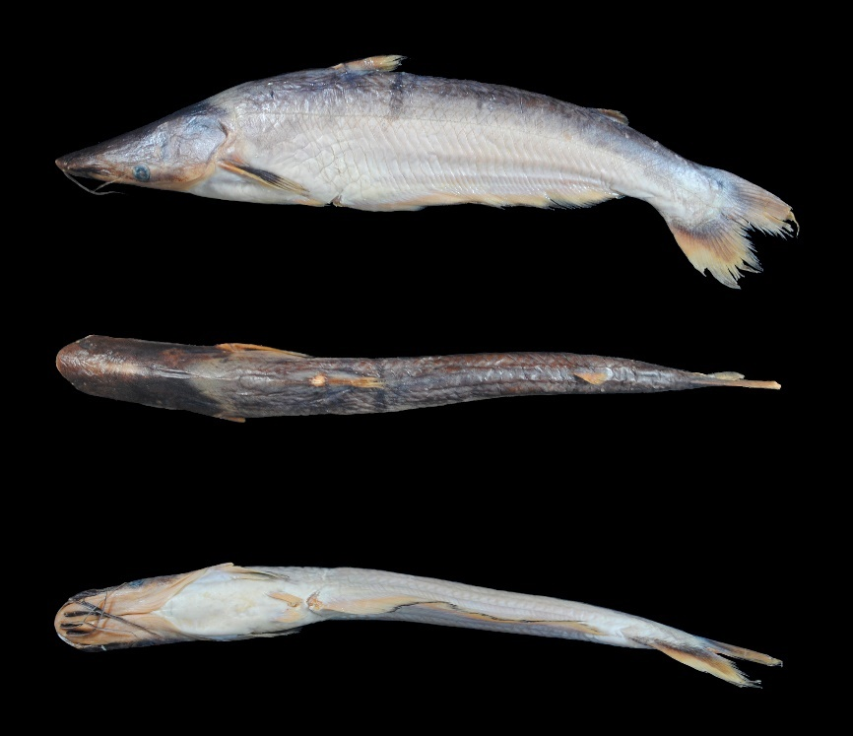
FIGURE 24. Hypophthalmus celiae, UMSS 17402, 265 mm SL, Iténez River, Armazón Bay, Iténez sub-basin, Amazon Basin.
Examined material (seven specimens). Amazon Basin: UMSS 4030 (1, 257.2 mm SL), Ichilo River, Chimoré River Mouth ICH 12, -16.746503 -64.8411056, 18 Nov 2006, F. Carvajal, E. De La Barra, C. Flores; UMSS 5124 (1, 213.1 mm SL), Blanco River, Bibosi, -13.346237 -63.7248253, 15 Aug 2005, J. Camacho, L. Córdova, M. Pouilly; UMSS 16982 (1, 224.9 mm SL), Beni River, Cachuela Esperanza, -10.541983 -65.5387100, 23 Sep 2015, Daniel Barrozo; UMSS 16926.3 (1, 248.6 mm SL), Mamoré River, Tiuco Lagoon, -14.721000 -65.0131670, 19 May 1999; UMSS 17402 (1, 262.4 mm SL), Iténez River, Armazón Bay, -12.505603 -64.06637551, 23 Oct 2005, J. Camacho, A. Vallejos, M. Pouilly; UMSS 17431 (2, 225-236.8 mm SL), Blanco River, Amasa Bay, -13.264722 -63.7158330, 8 May 2006, J. Camacho, L. Córdova, M. Pouilly.
Diagnosis. Hypophthalmus celiae differs from its congeners in the following: from H. edentatus by the snout length (51.1-52.7% HL vs. 50.4-56.2%), orbital diameter (10.3-11.2% HL vs. 7.6-10.7%), body width (11.2-12.4% SL vs. 10.3-11.4%), pectoral fin origin to pelvic fin origin (10.7-12.5% SL vs. 9.7-11.1%), predorsal length (44.9-47% SL vs. 45.2-50.1%), vertically dorsal fin origin approximately in line with anal fin origin (vs. dorsal fin origin posterior to anal fin origin); from H. fimbriatus by a pelvic fin without a urogenital membrane (vs. membrane present), X-shaped lateral sensory branches reaching the back and anal musculature (vs. S-shaped branches curved away from the back and anal musculature), thin internal mental barbels reaching the pectoral fin (vs. widely membranous barbels reaching the anal fin), vertically dorsal fin origin approximately in line with anal fin origin (vs. dorsal fin origin posterior to anal fin origin); from H. oremaculatus by interorbital distance (32.1-39.4% HL vs. 41-53.1%), left posterior nostril to right posterior nostril (19.9-22.1% HL vs. 24.2-27.9%), postorbital length (42.2-43.9% HL vs. 44-48.2%), head depth (53.8-58% HL vs. 63.2-81.8%), distance between external mental barbels (10.3-11.8% HL vs. 12.2-17.1%), head length (28.4-30.3% SL vs. 24.5-27.3%), pectoral spine length (15-17.7% SL vs. 18.3-19.9%), anal fin origin to adipose fin insertion (44-45.4% SL vs. 47.4-50.4%), bifurcated caudal fin with pointed lobes (vs. emarginated caudal fin), pelvic fin without a urogenital membrane (vs. membrane present), lateral sensory branches reaching the back and anal musculature (vs. branches away from the back and anal musculature).
Description. Morphometric data presented in Table 15. Convex profile on the upper lip, then straight to the origin of the dorsal fin; the portion posterior to the operculum with a less pronounced slope. Body and head laterally compressed; head much longer than wide. Eyes located lateroventrally, observable from below. Mouth in terminal position. Jaws soft; premaxillary, vomerian, and palatine teeth absent. Elongated lateral sensory branches reaching the dorsal midline and extending over the anal musculature. Posterior supraoccipital process not visible. Humeral process absent. Pectoral fin reaching the origin of the anal fin; long and flexible spine. Pelvic fin small, reaching the origin of the anal fin. Pectoral fin three times longer than the pelvic fin. Dorsal fin with an elongated, pointed spine, with a flexible and serration-free tip; vertically dorsal fin origin approximately in line with anal fin origin. Very short adipose fin. Very long anal fin. Bifurcated caudal fin with pointed lobes. Barbels of similar size, extending over the pectoral fin or slightly beyond the tip. Dorsal fin rays I+6; anal fin rays 45-60; pectoral fin rays I+13-14, pelvic fin rays i+5, caudal fin rays 14-15.
TABLE 15. Morphometric data of Hypophthalmus celiae. N: Number of individuals, SD: Standard deviation, Min: Minimum value, Max: Maximum value.
Measurements | N | Mean | SD | Min | Max
SL (mm) | 7 | 238.3 | 18.4 | 213.1 | 262.4
Percents of head length (% HL)
Interorbital distance | 7 | 35.1 | 2.9 | 32.1 | 39.4
Left posterior nostril to right posterior nostril | 7 | 20.9 | 0.8 | 19.9 | 22.1
Left anterior nostril to right anterior nostril | 7 | 23.4 | 0.8 | 22.5 | 24.3
Left anterior nostril to left posterior nostril | 7 | 9.0 | 0.7 | 8.10 | 10.1
Posterior nostril to anterior margin of orbit | 7 | 30.5 | 0.6 | 29.7 | 31.1
Snout length | 7 | 51.9 | 0.6 | 51.1 | 52.7
Postorbital length | 7 | 42.8 | 0.6 | 42.2 | 43.9
Orbital diameter | 7 | 10.6 | 0.3 | 10.3 | 11.2
Head depth | 7 | 55.4 | 1.5 | 53.8 | 58.0
Mouth width | 7 | 27.8 | 1.4 | 26.3 | 30.4
Distance between internal mental barbels | 6 | 1.30 | 0.3 | 1.0 | 1.80
Distance between external mental barbels | 6 | 10.9 | 0.6 | 10.3 | 11.8
Distance between internal and external mental barbel | 6 | 3.30 | 0.5 | 2.70 | 4.0
Percents of standard length (% SL)
Predorsal length | 7 | 45.9 | 0.6 | 44.9 | 47.0
Internal mental barbel length | 7 | 24.9 | 2.0 | 21.4 | 27.4
External mental barbel length | 7 | 22.7 | 2.3 | 19.3 | 25.7
Maxillary barbel length | 7 | 29.0 | 2.8 | 25.1 | 32.0
Body width | 7 | 11.8 | 0.4 | 11.2 | 12.4
Body depth | 7 | 20.7 | 1.1 | 18.7 | 22.0
Head length | 7 | 29.4 | 0.7 | 28.4 | 30.3
Pectoral fin origin to dorsal fin insertion | 7 | 27.5 | 1.8 | 23.8 | 29.0
Dorsal fin origin to pelvic fin origin | 7 | 21.4 | 1.1 | 19.7 | 23.2
Dorsal fin origin to anal fin origin | 7 | 20.7 | 0.9 | 19.0 | 22.0
Pectoral fin origin to pelvic fin origin | 7 | 11.6 | 0.6 | 10.7 | 12.5
Pelvic fin origin to anal fin origin | 7 | 6.20 | 0.4 | 5.70 | 6.80
Pectoral spine length | 4 | 16.4 | 1.2 | 15.0 | 17.7
Distance between pelvic fins | 7 | 4.20 | 0.4 | 3.90 | 4.80
Pelvic fin length | 7 | 5.90 | 0.7 | 4.80 | 6.80
Dorsal spine length | 5 | 11.6 | 1.0 | 10.6 | 12.8
Dorsal fin base length | 7 | 5.90 | 0.3 | 5.40 | 6.30
Dorsal fin insertion to adipose fin origin | 7 | 31.4 | 1.6 | 29.4 | 33.5
Adipose fin base length | 7 | 3.80 | 0.5 | 3.30 | 4.40
Anal fin base length | 7 | 45.6 | 1.9 | 43.9 | 49.0
Anal fin origin to adipose fin insertion | 7 | 44.9 | 0.5 | 44.0 | 45.4
Caudal peduncle height | 7 | 8.80 | 0.6 | 8.10 | 9.70
Dorsal fin origin to anterior caudal base | 7 | 56.2 | 1.8 | 54.2 | 58.6
Adipose fin origin to anterior caudal base | 7 | 19.9 | 0.8 | 19.1 | 21.0
Anal fin origin to anterior caudal base | 7 | 57.3 | 1.5 | 55.7 | 60.0
Caudal peduncle length | 7 | 12.2 | 0.3 | 11.7 | 12.5
Distribution. Present in the Beni, Mamoré, Iténez, and B-MD-O sub-basins (Amazon Basin).
Importance. There is no available information.
Ecological notes. Inhabits lowland rivers and open lakes of the Amazon Basin (Littmann et al. 2021).
Hypophthalmus edentatus Spix & Agassiz 1829 (Figure 25)
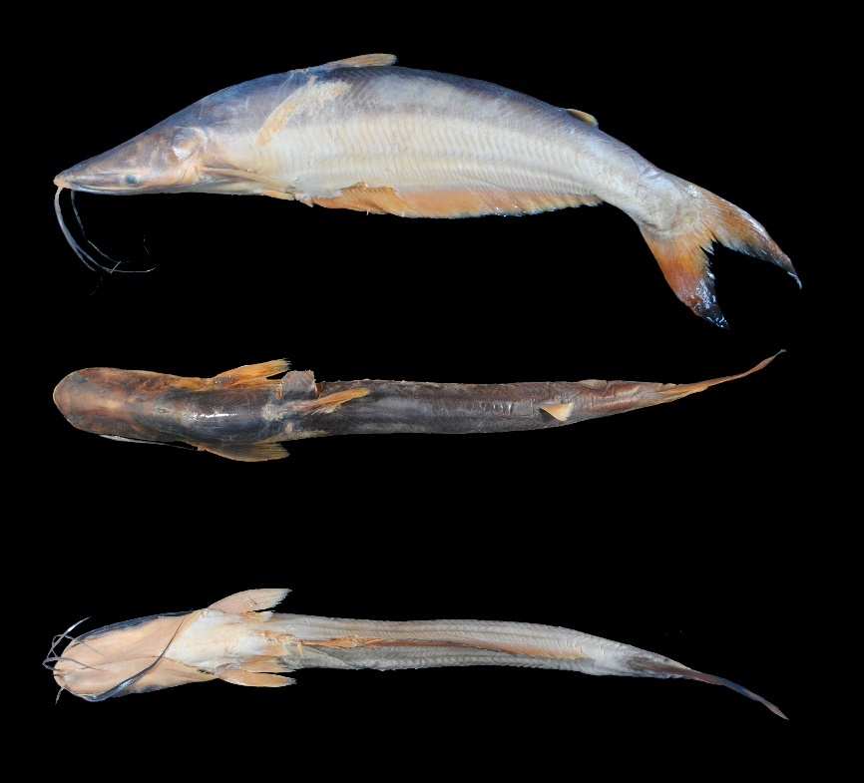
FIGURE 25. Hypophthalmus edentatus, UMSS 17284, 340 mm SL, Beni River, Cachuela Esperanza, B-MD-O sub-basin, Amazon Basin.
Examined material (nine specimens). Amazon Basin: UMSS 2344 (1, 275.6 mm SL), Rio Viejo Lagoon, in front of Puerto Villarroel, -16.833624 -64.7852660, 1 Aug 1994, M. Maldonado; UMSS 2682 (1, 221.1-246.2 mm SL), San Martin River, Boca San Joaquin, -13.307070 -63.5726585, 12 Dec 2004, J. Camacho, L. Córdova, M. Pouilly; UMSS 4013 (1, 425 mm SL), Ichilo River, Chimoré River Mouth ICH 12, -16.746503 -64.8411056, 17 Nov 2006, F. Carvajal, E. De La Barra, C. Flores; UMSS 6293 (1, 378 mm SL), Iténez River, Curichá Confluence, -12.521861 -63.9220830, 29 Oct 2005, J. Camacho, A. Vallejos, M. Pouilly; UMSS 9960 (1, 279.4 mm SL), Blanco River, Cachuela La Punta, -13.354872 -63.7277028, 19 Dec 2010, C. Valverde, C. Flores; UMSS 10242 (1, 267.8 mm SL), Abuná River, Abuná Stream, -9.751572 -60.0080721, 15 May 2009, L. Córdova, M. Arraya, E. De La Barra; UMSS 16974 (1, 251.7 mm SL), Ichilo River, Puerto Villarroel ICH 5A, -16.838889 -64.7916667, 16 Aug 2006, F. Carvajal; UMSS 17284 (1, 339.5 mm SL), Beni River, Cachuela Esperanza, -10.521983 -65.5787100, 23 Sep 2015, D. Barrozo.
Common name. Mapará in Puerto Rico and Cobija (Pando); vela in Puerto Villarroel (Cochabamba) (Carvajal-Vallejos et al. 2011).
Diagnosis. Hypophthalmus edentatus differs from its congeners in the following: from H. celiae by the snout length (50.4-56.2% HL vs. 51.1-52.7%), orbital diameter (7.6-10.7% HL vs. 10.3-11.2%), body width (10.3-11.4% SL vs. 11.2-12.4%), pectoral fin origin to pelvic fin origin (9.7-11.1% SL vs. 10.7-12.5%), predorsal length (45.2-50.1% SL vs. 44.9-47%), vertically dorsal fin origin posterior to anal fin origin (vs. dorsal fin origin approximately in line with anal fin origin); from H. fimbriatus by a pelvic fin without a urogenital membrane (vs. membrane present), X-shaped lateral sensory branches reaching the back and anal musculature (vs. S-shaped branches curved away from the back and anal musculature), thin internal mental barbels reaching the pectoral fin (vs. widely membranous barbels reaching the anal fin); from H. oremaculatus by the left posterior nostril to right posterior nostril (19.2-23.8% HL vs. 24.2-27.9%), orbital diameter (7.6-10.7% HL vs. 11.5-14.6%), head depth (47.2-60.2% HL vs. 63.2-81.8%), body width (10.3-11.4% SL vs. 12.8-15.1%), pectoral spine length (13.1-17.2% SL vs. 18.3-19.9%), bifurcated caudal fin with pointed lobes (vs. emarginated caudal fin), pelvic fin without a urogenital membrane (vs. membrane present), lateral sensory branches reaching the back and anal musculature (vs. branches away from the back and anal musculature), vertically dorsal fin origin posterior to anal fin origin (vs. dorsal fin origin approximately in line with anal fin origin).
Description. Morphometric data presented in Table 16. Convex profile in the upper lip, then straight to the origin of the dorsal fin; the portion posterior to the operculum with a less pronounced slope. Body and head flattened laterally; head much longer than wide. Eyes located lateroventrally, observable from below. Mouth in terminal position. Jaws soft; premaxillary, vomerian, and palatine teeth absent. Lateral sensory branches elongated, reaching the dorsal midline and musculature; in this latter region, branches may curve or be straight. Posterior supraoccipital process not visible. Humeral process absent. Pectoral fin reaching the origin of the anal fin; long and flexible spine. Pelvic fin small, surpassing the origin of the anal fin. Pectoral fin three times longer than the pelvic fin. Dorsal fin with elongated, pointed spine, flexible at the tip and without serrations; vertically dorsal fin origin posterior to anal fin origin. Very short adipose fin. Anal fin very long with approximately branched rays. Caudal fin strongly bifurcated with pointed lobes. Barbels of similar size, reaching the eye or pectoral fin. Dorsal fin rays I+6; anal fin rays 49-67; pectoral fin rays I+12-15; pelvic fin rays i+5; caudal fin rays 15.
TABLE 16. Morphometric data of Hypophthalmus edentatus. N: Number of individuals, SD: Standard deviation, Min: Minimum value, Max: Maximum value.
Measurements | N | Mean | SD | Min | Max
SL (mm) | 9 | 298.2 | 67.8 | 221.1 | 425
Percents of head length (% HL)
Interorbital distance | 9 | 35.4 | 3.9 | 29.5 | 41.4
Left posterior nostril to right posterior nostril | 9 | 21.6 | 1.7 | 19.2 | 23.8
Left anterior nostril to right anterior nostril | 9 | 24.3 | 1.3 | 22.7 | 26.4
Left anterior nostril to left posterior nostril | 9 | 10.0 | 0.9 | 8.80 | 11.4
Posterior nostril to anterior margin of orbit | 9 | 30.8 | 1.2 | 28.4 | 31.9
Snout length | 9 | 53.2 | 2.3 | 50.4 | 56.2
Postorbital length | 9 | 43.2 | 0.7 | 42.3 | 44.5
Orbital diameter | 9 | 9.60 | 1.1 | 7.60 | 10.7
Head depth | 9 | 52.1 | 4.3 | 47.2 | 60.2
Mouth width | 9 | 27.3 | 2.8 | 21.8 | 30.3
Distance between internal mental barbels | 9 | 1.60 | 0.4 | 0.80 | 2.10
Distance between external mental barbels | 9 | 11.8 | 1.3 | 10.0 | 13.7
Distance between internal and external mental barbel | 9 | 3.60 | 0.4 | 2.90 | 4.40
Percents of standard length (% SL)
Predorsal length | 9 | 46.9 | 1.5 | 45.2 | 50.1
Internal mental barbel length | 8 | 25.1 | 3.2 | 21.4 | 30.6
External mental barbel length | 8 | 24.5 | 3.0 | 21.6 | 30.5
Maxillary barbel length | 9 | 29.4 | 3.0 | 23.6 | 34.7
Body width | 9 | 10.9 | 0.4 | 10.3 | 11.4
Body depth | 9 | 18.8 | 2.1 | 16.7 | 22.3
Head length | 9 | 28.6 | 1.5 | 26.5 | 30.5
Pectoral fin origin to dorsal fin insertion | 9 | 28.4 | 2.1 | 25.6 | 32.1
Dorsal fin origin to pelvic fin origin | 9 | 20.6 | 2.3 | 17.6 | 24.7
Dorsal fin origin to anal fin origin | 9 | 19.5 | 2.1 | 17.2 | 22.7
Pectoral fin origin to pelvic fin origin | 9 | 10.4 | 0.6 | 9.70 | 11.1
Pelvic fin origin to anal fin origin | 9 | 5.40 | 0.7 | 4.20 | 6.40
Pectoral spine length | 6 | 15.6 | 1.4 | 13.1 | 17.2
Distance between pelvic fins | 9 | 3.80 | 0.5 | 2.70 | 4.70
Pelvic fin length | 9 | 6.10 | 0.6 | 5.10 | 6.90
Dorsal spine length | 5 | 11.2 | 1.7 | 8.60 | 13.1
Dorsal fin base length | 9 | 5.70 | 0.5 | 5.10 | 6.40
Dorsal fin insertion to adipose fin origin | 9 | 30.5 | 2.6 | 26.5 | 34.9
Adipose fin base length | 9 | 4.10 | 0.5 | 3.60 | 5.20
Anal fin base length | 9 | 48.2 | 3.0 | 42.7 | 54.0
Anal fin origin to adipose fin insertion | 9 | 46.3 | 1.8 | 42.8 | 48.8
Caudal peduncle height | 9 | 7.80 | 0.7 | 6.90 | 8.80
Dorsal fin origin to anterior caudal base | 9 | 56.1 | 1.8 | 53.6 | 58.9
Adipose fin origin to anterior caudal base | 9 | 20.7 | 1.1 | 19.1 | 22.7
Anal fin origin to anterior caudal base | 9 | 59.7 | 2.1 | 56.7 | 64.1
Caudal peduncle length | 9 | 11.8 | 0.8 | 10.7 | 13.3
Distribution. Present in the Beni, Iténez, Mamoré, and B-MD-O sub-basins (Amazon Basin). Also recorded in the Madeira, Madre de Dios (Carvajal-Vallejos & Fernández 2011), and Acre (Torrico et al. 2020) sub-basins (Amazon Basin).
Importance. Commercial and subsistence fishing trade in Puerto Rico, Cobija, Riberalta, Rurrenabaque, and Puerto Villarroel (Carvajal-Vallejos et al. 2011).
Ecological notes. It primarily feeds on zooplankton (López-Fernández & Winemiller 2000). It inhabits the middle and surface zones of the main channels of rivers and open water lakes. They undertake reproductive migrations (Littmann et al. 2021).
Hypophthalmus fimbriatus Kner 1858 (Figure 26)
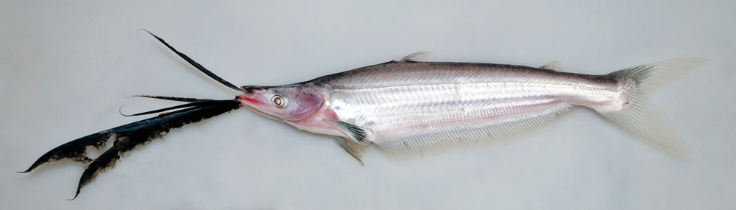
FIGURE 26. Hypophthalmus fimbriatus. Photograph: Leandro Sousa, Source: Südamerikafans – Welsfans, retrieved from https://www.suedamerikafans.de/es/wels-datenbank/welsart/?art=1890
Diagnosis. Hypophthalmus fimbriatus differs from its congeners in the following: from H. celiae by a pelvic fin with a urogenital membrane (vs. membrane absent), laterosensory branches curved in an S-shape and distant from the dorsum and anal musculature (vs. branches in an X-shape reaching the dorsum and anal musculature), internal mental barbels widely membranous and reaching the anal fin (vs. thin barbels reaching the pectoral fin), vertically dorsal fin origin posterior to anal fin origin (vs. dorsal fin origin approximately in line with anal fin origin); from H. edentatus by a pelvic fin with a urogenital membrane (vs. membrane absent), laterosensory branches curved in an S-shape and distant from the dorsum and anal musculature (vs. branches in an X-shape reaching the dorsum and anal musculature), internal mental barbels widely membranous and reaching the anal fin (vs. thin barbels reaching the pectoral fin); from H. oremaculatus by laterosensory branches curved in an S-shape (vs. branches in an X-shape), bifurcated caudal fin with pointed lobes (vs. emarginated caudal fin), internal mental barbels widely membranous and reaching the anal fin (vs. thin barbels reaching the pectoral fin), vertically dorsal fin origin posterior to anal fin origin (vs. dorsal fin origin approximately in line with anal fin origin).
Description. Orbital diameter contained 5.4-9.8 times in head length, snout length contained 1.8-2.1 times in head length; predorsal length contained 2.2-2.4 times in standard length; adipose fin separated from the dorsal fin by a distance contained 2.7-3.1 times in standard length; anal fin contained 1.8-2.1 times in standard length; maxillary and external mental barbels with margins having a very thin and dark membrane; internal mental barbels widely membranous. Anal fin rays 66-74; pectoral fin rays I+13-16; pelvic fin rays I+5, caudal fin rays 15 (Littmann et al. 2021).
Distribution. Recorded in the Yata sub-basin (Amazon Basin) (Careaga et al. 2020).
Importance. There is no available information.
Ecological notes. Feeds on zooplankton (López-Fernández & Winemiller 2000). Inhabits lowland rivers and open water lakes of the Amazon Basin (Littmann et al. 2021).
Hypophthalmus oremaculatus Nani & Fuster de Plaza 1947 (Figure 27)
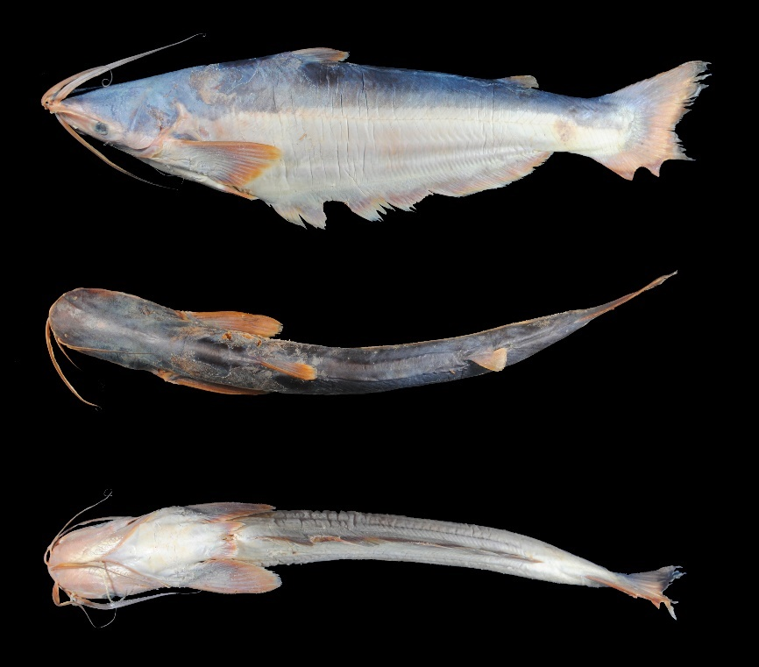
FIGURE 27. Hypophthalmus oremaculatus, UMSS 11220, 340 mm SL, El Mentiroso Lagoon, Madre de Dios sub-basin, Amazon Basin.
Examined material (11 specimens). Amazon Basin: UMSS 2343 (1, 280.4 mm SL), Viejo River Lagoon, near Puerto Villarroel, -16.833624 -64.7852660, 1 Aug 1994, M. Maldonado; UMSS 5539 (1, 246.3 mm SL), Blanco River, Amasa Bay, -13.210570 -63.7243253, 17 Aug 2005, J. Camacho, L. Córdova, M. Pouilly; UMSS 5951 (1, 224.8 mm SL), Orthon River, Puerto Rico Community, -11.103443 -67.5586640, 20 Jun 2007, H. Muñoz; UMSS 7269 (1, 227.9 mm SL), Ichilo River, Bufeos Lagoon, -16.435278 -64.7055556, 13 Apr 2005, M. Pouilly, D. Rejas, E. Araujo, L. Córdova, E. Antoine; UMSS 11517 (1, 282.9 mm SL), Beni River, 27 de Mayo Lagoon, -11.394520 -66.4095300, 12 Mar 2012, F. Machicao; UMSS 11518 (1, 264.9 mm SL), same data as UMSS 11517; UMSS 16940.2 (1, 214.8 mm SL), Blanco River, La Granja Lagoon, -13.260587 -63.094919, 22 Feb 2007, J. Camacho, L. Córdova, M. Pouilly; UMSS 17489 (1, 221.3 mm SL), Mamoré River, Suárez Lagoon, -14.882000 -64.8750000, 16 Aug 2007, A. Parada, T. Yunoki; UMSS 17490 (1, 243.5 mm SL), same data as UMSS 17489; UMSS 18571 (1, 302.9 mm SL), Chipiriri River, -16.485036 -71.1915900, 20 Sep 2002, J. Zubieta, C. Ibañes, R. Bigorne; La Plata Basin; UMSS 13424 (1, 293.6 mm SL), Pelada Lagoon, -19.378579 -57.9601800, 7 Nov 2012, E. De La Barra, J. Coronel, H. Muñoz.
Diagnosis. Hypophthalmus oremaculatus differs from its congeners in the following: from H. celiae by the interorbital distance (41-53.1% HL vs. 32.1-39.4%), left posterior nostril to right posterior nostril (24.2-27.9% HL vs. 19.9-22.1%), postorbital length (44-48.2% HL vs. 42.2-43.9%), head depth (63.2-81.8% HL vs. 53.8-58%), distance between external mental barbels (12.2-17.1% HL vs. 10.3-11.8%), head length (24.5-27.3% SL vs. 8.4-30.3%), pectoral spine length (18.3-19.9% SL vs. 15-17.7%), anal fin origin to adipose fin insertion (47.4-50.4% SL vs. 44-45.4%), emarginated caudal fin (vs. caudal fin bifurcated with pointed lobes), pelvic fin with a urogenital membrane (vs. membrane absent), lateral line branches distant from the dorsum and anal musculature (vs. reaching dorsum and anal musculature); from H. edentatus by the left posterior nostril to right posterior nostril (24.2-27.9% HL vs. 19.2-23.8%), orbital diameter (11.5-14.6% HL vs. 7.6-10.7%), head depth (63.2-81.8% HL vs. 47.2-60.2%), body width (12.8-15.1% SL vs. 10.3-11.4%), pectoral spine length (18.3-19.9% SL vs. 13.1-17.2%), emarginated caudal fin (vs. caudal fin bifurcated with pointed lobes), pelvic fin with a urogenital membrane (vs. membrane absent), lateral line branches distant from the dorsum and anal musculature (vs. reaching dorsum and anal musculature), vertically dorsal fin origin approximately in line with anal fin origin (vs. dorsal fin origin posterior to anal fin origin); from H. fimbriatus by lateral line branches in an X shape (vs. curved branches in an S shape), emarginated caudal fin (vs. caudal fin bifurcated with pointed lobes), thin internal mental barbels reaching the pectoral fin (vs. broadly membranous barbels reaching the anal fin), vertically dorsal fin origin approximately in line with the anal fin origin (vs. dorsal fin origin posterior to anal fin origin).
Description. Morphometric data presented in Table 17. Convex profile on the upper lip, then straight until the origin of the dorsal fin; the portion posterior to the operculum with a less pronounced slope. Body and head laterally compressed; head much longer than wide. Eyes situated lateroventrally, observable from below. Terminal mouth position. Soft jaws; premaxillary, vomerine, and palatine teeth absent. Short lateral line branches, remote from the dorsal midline and anal musculature. Posterior supraoccipital process not visible. Humeral process absent. Pectoral fin approaching the origin of the anal fin; long and flexible spine. Small pelvic fin, approaching the origin of the anal fin. Pectoral fin two times longer than the pelvic fin. Dorsal fin with elongated, pointed spine, with a flexible and serrate tip; vertically dorsal fin origin approximately in line with the anal fin origin. Very short adipose fin. Very long anal fin with approximately 53-68 branched rays. Emarginated caudal fin with the lower lobe often rounded. Barbels of similar size, reaching the pectoral fin or slightly beyond the tip. Dorsal fin rays I+6; anal fin rays 59-68; pectoral fin rays I+13-16; pelvic fin rays i+5, caudal fin rays 15-17.
TABLE 17. Morphometric data of Hypophthalmus oremaculatus. N: Number of individuals, SD: Standard deviation, Min: Minimum value, Max: Maximum value.
Measurements | N | Mean | SD | Min | Max
SL (mm) | 11 | 254.9 | 31.5 | 214.8 | 308.9
Percents of head length (% HL)
Interorbital distance | 11 | 45.8 | 3.6 | 41.0 | 53.1
Left posterior nostril to right posterior nostril | 11 | 26.4 | 1.3 | 24.2 | 27.9
Left anterior nostril to right anterior nostril | 11 | 27.0 | 1.3 | 24.6 | 29.0
Left anterior nostril to left posterior nostril | 11 | 8.90 | 0.6 | 8.20 | 10.0
Posterior nostril to anterior margin of orbit | 11 | 30.0 | 0.5 | 29.4 | 31.0
Snout length | 11 | 50.4 | 1.5 | 47.9 | 53.1
Postorbital length | 11 | 45.5 | 1.2 | 44.0 | 48.2
Orbital diameter | 11 | 12.9 | 0.8 | 11.5 | 14.6
Head depth | 11 | 70.6 | 5.1 | 63.2 | 81.8
Mouth width | 11 | 32.0 | 2.5 | 27.5 | 35.8
Distance between internal mental barbels | 11 | 2.10 | 0.8 | 0.80 | 3.70
Distance between external mental barbels | 11 | 14.6 | 1.4 | 12.2 | 17.1
Distance between internal and external mental barbel | 11 | 4.10 | 0.7 | 3.10 | 5.30
Percents of standard length (% SL)
Predorsal length | 11 | 43.4 | 1.0 | 41.4 | 44.6
Internal mental barbel length | 10 | 33.5 | 5.0 | 22.2 | 41.6
External mental barbel length | 11 | 25.1 | 2.3 | 21.6 | 29.2
Maxillary barbel length | 11 | 33.1 | 2.6 | 30.2 | 38.1
Body width | 11 | 13.8 | 0.7 | 12.8 | 15.1
Body depth | 11 | 24.1 | 1.7 | 21.5 | 26.9
Head length | 11 | 26.2 | 0.9 | 24.5 | 27.3
Pectoral fin origin to dorsal fin insertion | 11 | 29.3 | 1.4 | 26.9 | 31.9
Dorsal fin origin to pelvic fin origin | 11 | 25.1 | 1.7 | 22.8 | 28.5
Dorsal fin origin to anal fin origin | 11 | 24.4 | 1.7 | 21.9 | 27.7
Pectoral fin origin to pelvic fin origin | 11 | 12.5 | 1.2 | 10.9 | 14.6
Pelvic fin origin to anal fin origin | 11 | 7.0 | 1.1 | 5.40 | 9.30
Pectoral spine length | 4 | 19.0 | 0.6 | 18.3 | 19.9
Distance between pelvic fins | 11 | 5.30 | 0.5 | 4.40 | 6.0
Pelvic fin length | 11 | 7.40 | 0.5 | 6.60 | 8.40
Dorsal spine length | 3 | 12.1 | 0.6 | 11.6 | 12.8
Dorsal fin base length | 11 | 5.50 | 0.6 | 4.40 | 6.40
Dorsal fin insertion to adipose fin origin | 11 | 32.7 | 1.2 | 30.8 | 34.7
Adipose fin base length | 11 | 4.70 | 0.6 | 4.20 | 5.90
Anal fin base length | 11 | 50.3 | 1.6 | 47.4 | 53.2
Anal fin origin to adipose fin insertion | 11 | 48.8 | 0.9 | 47.4 | 50.4
Caudal peduncle height | 11 | 9.40 | 0.6 | 8.20 | 10.6
Dorsal fin origin to anterior caudal base | 11 | 58.9 | 2.0 | 56.5 | 62.6
Adipose fin origin to anterior caudal base | 11 | 22.0 | 1.2 | 20.7 | 23.9
Anal fin origin to anterior caudal base | 11 | 61.4 | 1.4 | 59.7 | 65.1
Caudal peduncle length | 11 | 11.3 | 0.9 | 9.60 | 13.2
Distribution. Present in the Madre de Dios, Beni, Iténez, Madeira, Mamoré, Orthon, Yata sub-basins (Amazon Basin), and in the Paraguay sub-basin (La Plata Basin).
Importance. There is no available information.
Ecological notes. Feeds on zooplankton (Silva & Bialetzki 2019). Inhabits lowland rivers and open-water lakes in the Amazon Basin (Littmann et al. 2021).
Iheringichthys Eigenmann & Norris 1900
Diagnosis. Ventral suction mouth with strongly developed fleshy lips, the upper lip curved upwards; granular and pointed head, triangular in dorsal view; long maxillary barbels reaching the caudal fin; first ray of the pectoral and dorsal fin converted into a strong spine; gill rakers present only on the first arch (Eigenmann & Norris 1900, Azpelicueta & Britski 2012).
Distribution. La Plata Basin (Figure 28).
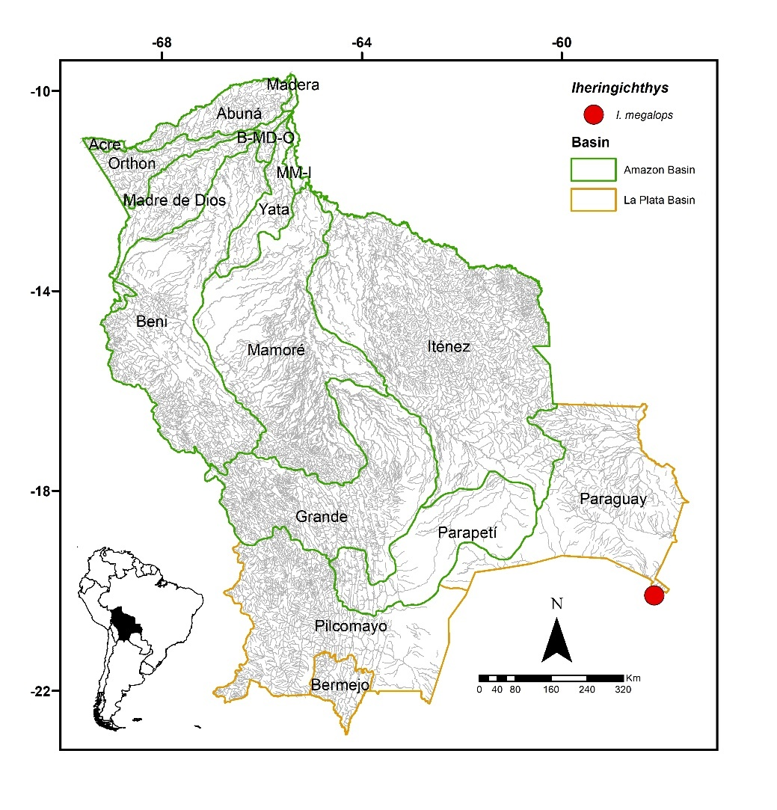
FIGURE 28. Collection site of one lot of Iheringichthys megalops deposited in the Ichthyological Collection UMSS – Museo d'Orbigny (Cochabamba, Bolivia).
Included species. Iheringichthys megalops.
Comments. Genus proposed by Eigenmann & Norris (1900) for Pimelodus labrosus Lütken 1874 as the type species, currently synonymous with I. labrosus.
Currently, three species are known: I. labrosus (Lütken 1874) in La Plata Basin (Argentina, Brazil, Paraguay, and Uruguay), I. megalops Eigenmann & Ward 1907 in the upper Paraguay River (Paraguay and Argentina), and I. syi Azpelicueta & Britski 2012 in the upper Paraná River (Brazil) (Fricke et al. 2023). Of the three valid species known, I. megalops is present in Bolivia.
Iheringichthys megalops Eigenmann & Ward 1907 (Figure 29)
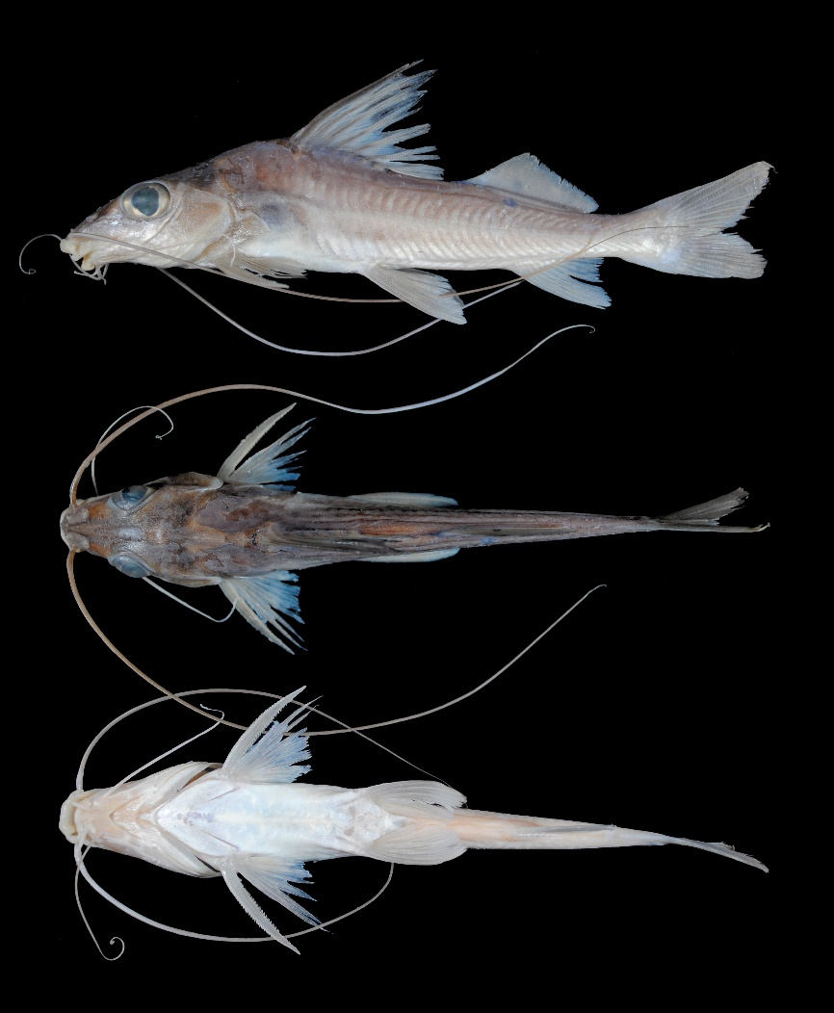
FIGURE 29. I. megalops, UMSS 13378, 117.5 mm SL, Negro River, Paraguay sub-basin, La Plata Basin.
Examined material (one specimen). La Plata Basin: UMSS 13378 (1, 115.6 mm SL), Paraguay River, Negro River, -20.090680 -58.1516720, 8 Nov 2012, E. De La Barra, J. Coronel, H. Muñoz.
Diagnosis. Same as the genus.
Description. Morphometric data presented in Table 18. Profile from the snout tip to the eye slightly convex, concave from the eye to the supraoccipital process, and slightly convex from the supraoccipital process to the origin of the dorsal fin. Head longer than wide, dorsally triangular; very large eyes in laterodorsal position. Mouth in ventral position with highly developed and backward-folded lips; maxillary and dentary patches narrow, without vomerine or palatine teeth. Humeral process wide. Supraoccipital process long and in contact with the nuchal plate. Pectoral fin extending very close to the origin of the pelvic fin; dorsally flattened, ossified, pungent, and serrated spine on both margins. Pelvic fin extending very close to the origin of the anal fin. Pectoral and pelvic fins of similar size. Dorsal fin with a strong, pungent, and serrated spine on the posterior margin. Relatively short adipose fin. Adipose fin base twice as long as the anal fin base. Bifurcated caudal fin. Maxillary barbels extending beyond the caudal fin; mental barbels shorter. Dorsal fin rays I+6; anal fin rays iii+7; pectoral fin rays I+10; pelvic fin rays i+5; caudal fin rays 15.
TABLE 18. Morphometric data of Iheringichthys megalops. N: Number of individuals.
Measurement | N | Value
SL (mm) | 1 | 115.6
Percents of head length (% HL)
Nuchal plate length | 1 | 12.7
Interorbital distance | 1 | 18.4
Left posterior nostril to right posterior nostril | 1 | 14.2
Left anterior nostril to right anterior nostril | 1 | 6.70
Left anterior nostril to left posterior nostril | 1 | 11.9
Posterior nostril to anterior margin of orbit | 1 | 19.4
Snout length | 1 | 44.9
Postorbital length | 1 | 28.7
Orbital diameter | 1 | 29.8
Head depth | 1 | 63.3
Mouth width | 1 | 19.3
Distance between internal mental barbels | 1 | 4.20
Distance between external mental barbels | 1 | 18.4
Distance between internal and external mental barbel | 1 | 8.70
Percents of standard length (% SL)
Predorsal length | 1 | 42.4
Internal mental barbel length | 1 | 8.70
External mental barbel length | 1 | 32.2
Maxillary barbel length | 1 | 117.7
Body width | 1 | 17.0
Body depth | 1 | 21.5
Head length | 1 | 31.4
Pectoral fin origin to dorsal fin insertion | 1 | 32.4
Dorsal fin origin to pelvic fin origin | 1 | 25.4
Dorsal fin origin to anal fin origin | 1 | 43.7
Pectoral fin origin to pelvic fin origin | 1 | 24.1
Pelvic fin origin to anal fin origin | 1 | 27.9
Pectoral spine length | 1 | 20.6
Distance between pelvic fins | 1 | 10.7
Pelvic fin length | 1 | 19.7
Dorsal spine length | 1 | 23.8
Dorsal fin base length | 1 | 16.9
Dorsal fin insertion to adipose fin origin | 1 | 12.5
Adipose fin base length | 1 | 23.1
Anal fin base length | 1 | 9.50
Anal fin origin to adipose fin insertion | 1 | 15.7
Caudal peduncle height | 1 | 7.20
Dorsal fin origin to anterior caudal base | 1 | 63.9
Adipose fin origin to anterior caudal base | 1 | 34.9
Anal fin origin to anterior caudal base | 1 | 23.3
Caudal peduncle length | 1 | 15.0
Coloration in alcohol. Body grayish with the upper region and head dorsally darker; supraoccipital region with a faint black band. Ventral region whitish. Dorsal fin slightly dark in the spine and the basal part of the first soft rays; the rest of the fins whitish.
Distribution. Present in the Paraguay sub-basin (La Plata Basin).
Importance. There is no available information.
Leiarius Bleeker 1862
Diagnosis. Palatine patches very small and widely separated from the larger vomerian patches; a high number of rays in the dorsal fin 10-11 (Eigenmann & Eigenmann 1890).
Distribution. Amazon Basin (Figure 30).
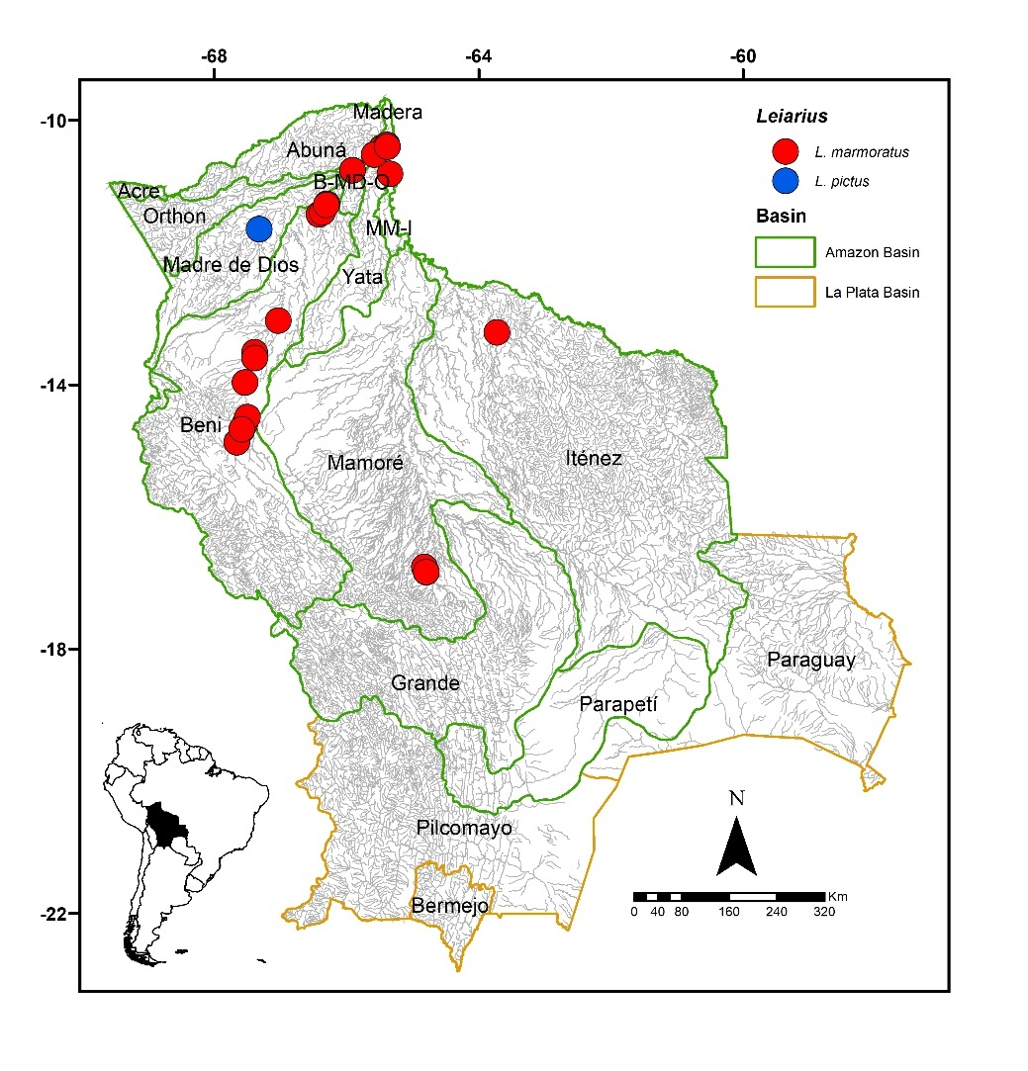
FIGURE 30. Collection sites of 58 lots of Leiarius marmoratus deposited in the Ichthyological Collection UMSS – Museo d'Orbigny (Cochabamba, Bolivia). Some symbols represent more than one lot. Collection site of L. pictus according to Carvajal-Vallejos & Fernández (2011).
Included species. Leiarius marmoratus, L. pictus.
Comments. Genus proposed by Bleeker (1862) for Arius longibarbis Castelnau 1855 as the type species, currently synonymous with L. longibarbis. Currently, four species are known: L. longibarbis (Castelnau 1855) in the Amazon Basin; L. pictus (Müller & Troschel 1849) in the Amazon and Orinoco basins; L. marmoratus (Gill 1870) in the Amazon, Essequibo, and Orinoco basins, and L. perruno (Schultz 1944) in the Maracaibo Lake basin (Colombia and Venezuela) (Fricke et al. 2023). Of the four valid species known, L. marmoratus and L. pictus are present in Bolivia.
Leiarius marmoratus (Gill 1870) (Figure 31)
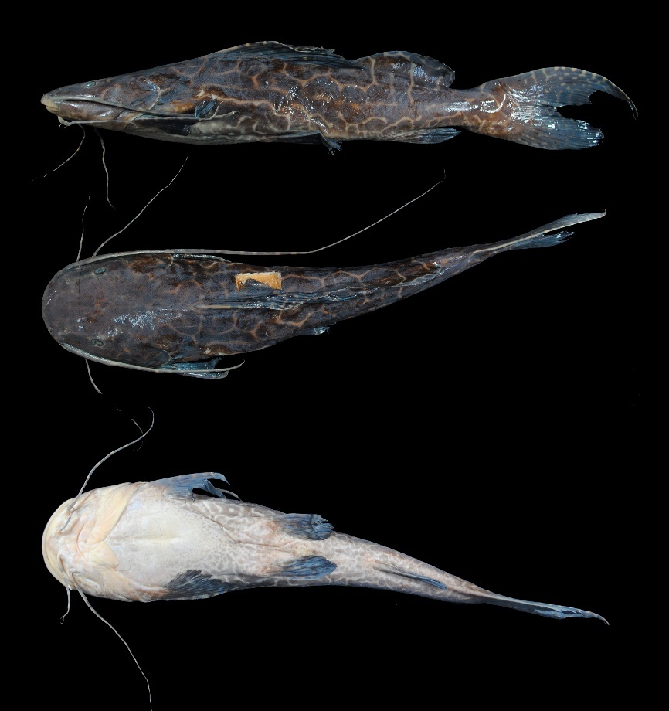
FIGURE 31. Leiarius marmoratus, UMSS 7758, 232 mm SL, Mamoré River, upstream from Villa Bella, Mamoré-Iténez sub-basin, Amazon Basin.
Examined material (20 specimens). Amazon Basin: UMSS 2771 (1, 320 mm SL), Blanco River, Amasa Bay, -13.210570 -63.7243253, 16 Dec 2004, J. Camacho, L. Córdova, M. Pouilly; UMSS 6152 (1, 357 mm SL), Ichilo River, Puerto Villarroel ICH 5A, -16.838889 -64.7916667, 19 Sep 2007, F. Carvajal; UMSS 6153 (1, 337 mm SL), same data as UMSS 6152; UMSS 6154 (1, 323 mm SL), same data as UMSS 6152; UMSS 6173 (1, 360 mm SL), same data as UMSS 6152; UMSS 6177 (1, 326 mm SL), same data as UMSS 6152; UMSS 6178 (1, 334 mm SL), same data as UMSS 6152; UMSS 7212 (1, 336 mm SL), same data as UMSS 6152; UMSS 7228 (1, 316 mm SL), same data as UMSS 6152; UMSS 7229 (1, 345 mm SL), same data as UMSS 6152; UMSS 7230 (1, 346 mm SL), same data as UMSS 6152; UMSS 7231 (1, 350 mm SL), same data as UMSS 6152; UMSS 7232 (1, 333 mm SL), same data as UMSS 6152; UMSS 7233 (1, 341 mm SL), same data as UMSS 6152; UMSS 7234 (1, 310 mm SL), same data as UMSS 6152; UMSS 7244 (1, 351 mm SL), same data as UMSS 6152; UMSS 7245 (1, 330 mm SL), same data as UMSS 6152; UMSS 7761 (1, 355 mm SL), Mamoré River, upstream from Villa Bella, -10.403147 -65.3813550, May 7, 2008, F. Carvajal; UMSS 11354 (1, 327 mm SL), Beni River, Portachuelo Lake, -11.267070 -66.2974200, May 6, 2012, A. Argote; UMSS 17730 (1, 312 mm SL), same data as UMSS 7761.
Common name. Tujuno in Puerto Rico (Pando), Riberalta, Rurrenabaque, and Cachuela Esperanza (Beni); pira in Puerto Villarroel (Cochabamba); bagre pintado in Trinidad (Beni) (Lauzanne & Loubens 1985, Carvajal-Vallejos et al. 2011).
Diagnosis. It can be differentiated from L. pictus by a lower dorsal fin (vs. high) and the absence of a whitish arched band in the anterior region of the body (vs. band present).
Description. Morphometric data presented in Table 19. Straight profile slightly ascending from the snout to the origin of the dorsal fin. Head two times longer than high and flattened dorsoventrally, with small eyes in a laterodorsal position. Mouth in a subterminal position. Premaxillary patch broad, with the central part thinner; vomerian patches oval-shaped and separated from the premaxilla; palatine patches much smaller than the vomerian ones and distant from the latter (Appendix 2). Posterior supraoccipital process with a broad base, narrowing on the sides and in contact with the nuchal plate. Humeral process wide. Pectoral fin extending very close to the origin of the pelvic fin. Pelvic fin extending approximately halfway between its origin and the anal fin origin. Pectoral fin longer than the pelvic fin. Long adipose fin originating very close to the dorsal fin. Base of the adipose fin three times longer than the base of the anal fin. Forked caudal fin with pointed lobes. Maxillary barbels reaching the base of the caudal fin; internal mental barbels extending beyond the origin of the pectoral fin; shorter mental barbels. Dorsal fin rays I+10-12; anal fin rays iii-iv+7-8; pectoral fin rays I+9-11, pelvic fin rays i+5; caudal fin rays 15.
TABLE 19. Morphometric data of Leiarius marmoratus. N: Number of individuals, SD: Standard deviation, Min: Minimum value, Max: Maximum value.
Measurement | N | Mean | SD | Min | Max
SL (mm) | 20 | 335.5 | 15.1 | 310 | 360
Percents of head length (% HL)
Interorbital distance | 20 | 41.3 | 1.3 | 39.2 | 43.0
Left posterior nostril to right posterior nostril | 20 | 31.6 | 0.6 | 30.2 | 32.4
Left anterior nostril to right anterior nostril | 20 | 32.4 | 0.8 | 31.1 | 34.2
Left anterior nostril to left posterior nostril | 20 | 12.3 | 0.4 | 11.6 | 13.1
Posterior nostril to anterior margin of orbit | 20 | 20.3 | 0.7 | 18.6 | 21.4
Snout length | 20 | 47.5 | 0.7 | 46.4 | 49.0
Postorbital length | 20 | 43.0 | 0.7 | 41.1 | 44.4
Orbital diameter | 20 | 11.7 | 0.8 | 10.7 | 13.9
Head depth | 20 | 56.5 | 3.9 | 51.3 | 66.8
Mouth width | 20 | 61.8 | 1.8 | 57.4 | 64.9
Distance between internal mental barbels | 20 | 14.5 | 1.0 | 12.6 | 16.3
Distance between external mental barbels | 20 | 39.8 | 1.8 | 35.1 | 43.1
Distance between internal and external mental barbel | 20 | 11.4 | 0.9 | 8.60 | 12.7
Percents of standard length (% SL)
Predorsal length | 20 | 36.1 | 1.1 | 34.6 | 37.9
Internal mental barbel length | 19 | 24.4 | 3.1 | 17.1 | 30.9
External mental barbel length | 20 | 37.1 | 4.8 | 27.6 | 46.6
Maxillary barbel length | 20 | 82.3 | 14.0 | 59.1 | 110.9
Body width | 20 | 24.7 | 0.8 | 23.2 | 26.4
Body depth | 20 | 18.8 | 1.0 | 16.8 | 20.9
Head length | 20 | 28.6 | 0.9 | 27.5 | 30.1
Pectoral fin origin to dorsal fin insertion | 20 | 36.6 | 1.2 | 33.7 | 39.8
Dorsal fin origin to pelvic fin origin | 20 | 24.8 | 1.6 | 21.9 | 28.3
Dorsal fin origin to anal fin origin | 20 | 44.1 | 1.3 | 41.2 | 46.5
Pectoral fin origin to pelvic fin origin | 20 | 27.9 | 1.7 | 25.3 | 32.6
Pelvic fin origin to anal fin origin | 20 | 25.7 | 0.9 | 23.9 | 26.9
Pectoral spine length | 20 | 21.3 | 1.3 | 19.3 | 23.1
Distance between pelvic fins | 20 | 14.7 | 0.4 | 13.8 | 15.4
Pelvic fin length | 20 | 16.6 | 0.7 | 15.4 | 17.9
Dorsal spine length | 18 | 23.1 | 3.1 | 18.3 | 29.6
Dorsal fin base length | 20 | 20.2 | 1.0 | 18.3 | 22.0
Dorsal fin insertion to adipose fin origin | 20 | 7.30 | 1.3 | 4.30 | 10.0
Adipose fin base length | 20 | 30.4 | 3.2 | 20.0 | 36.3
Anal fin base length | 20 | 10.7 | 0.8 | 9.50 | 12.7
Anal fin origin to adipose fin insertion | 20 | 20.7 | 1.0 | 18.9 | 23.0
Caudal peduncle height | 20 | 8.40 | 0.5 | 6.70 | 8.90
Dorsal fin origin to anterior caudal base | 20 | 66.5 | 1.5 | 62.2 | 68.5
Adipose fin origin to anterior caudal base | 20 | 39.3 | 1.7 | 34.7 | 41.4
Anal fin origin to anterior caudal base | 20 | 26.3 | 1.2 | 24.1 | 28.8
Caudal peduncle length | 20 | 15.6 | 1.1 | 13.7 | 17.5
Coloration in alcohol. Body with a cream or brown background and irregular dark brown spots, with a narrow space between the spots. Head with the same spotted pattern as the body. Ventral region cream-colored with diffuse brown spots. All fins and barbels with the same spotted pattern as the body.
Coloration in life. Coloration similar to that of individuals preserved in alcohol.
Distribution. Present in the Beni, Iténez, Madeira, Mamoré, B-MD-O, and MM-I sub-basins (Amazon Basin). Also recorded in the Madre de Dios (Carvajal-Vallejos & Fernández 2011), Grande (Maldonado et al. 2020), Orthon, and Parapetí sub-basins (Amazon Basin) (Torrico et al. 2020).
Importance. Commercial fishing trade in Riberalta, Rurrenabaque, Cachuela Esperanza, Puerto Villarroel, San Borja and Guayaramerín. Subsistence fishing in Trinidad, Guayaramerín, San Borja, Villa Bella, Puerto Rico, Cobija, Riberalta, Rurrenabaque, Cachuela Esperanza and Puerto Villarroel (Carvajal-Vallejos et al. 2011).
Ecological notes. Omnivorous species with a carnivorous tendency, feeding on fish, crustaceans, seeds, and fruits. Inhabits deep areas of the main river channels, lagoons, and/or streams; juveniles may enter floodplain areas. Species with crepuscular and nocturnal habits, during the day they are often found resting on rocks or logs (Sarmiento et al. 2014).
Leiarius pictus (Müller & Troschel 1849) (Figure 32)
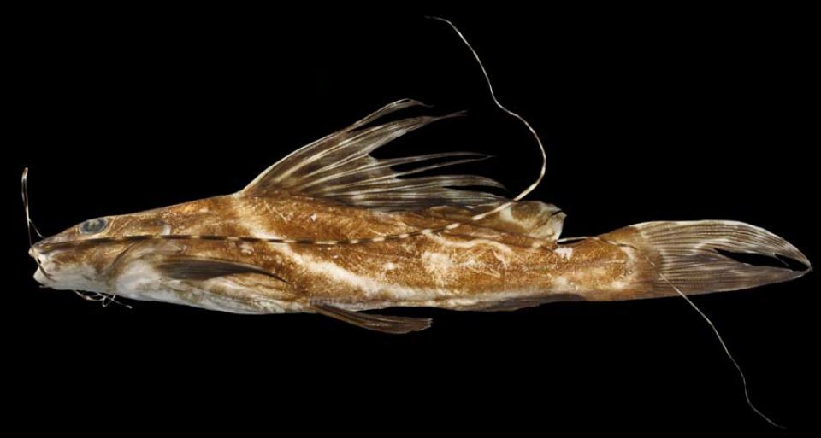
FIGURE 32. Leiarius pictus, 164 mm SL (Photograph: Tiago Pires, Source: Rocha 2012).
Diagnosis. Review the diagnosis of L. marmoratus.
Description. Narrow and flattened head. Mouth in subterminal position. Vomerian patches separated and occasionally fused in adult individuals, widely separated from the oval palatine patches. Strongly forked caudal fin. Maxillary barbels extending beyond the caudal fin in individuals of 280 mm SL and beyond the dorsal fin in specimens of 600 mm SL; internal mental barbels reaching the base of the pectoral fin or slightly beyond; external mental barbels extending beyond the origin of the pelvic fin in small individuals or up to the midpoint of the pectoral fin in adults. Dorsal fin rays I+9-10, anal fin rays 11 (Eigenmann & Eigenmann 1890).
Distribution. Recorded in the Madre de Dios sub-basin (Amazon Basin) (Carvajal-Vallejos & Fernández 2011).
Importance. There is no available information.
Luciopimelodus Eigenmann & Eigenmann 1888
Diagnosis. First ray of the pectoral and dorsal fins non-spiny, flexible, and longer than the subsequent rays; elongated spatula-shaped snout; slender posterior supraoccipital process not in contact with the nuchal plate; strongly bifurcated caudal fin with pointed lobes; body ranging from silver to brown with spots (Eigenmann & Eigenmann 1890).
Included species. Monospecific genus, with Luciopimelodus pati as the sole representative.
Comments. Genus proposed by Eigenmann & Eigenmann (1888) for Pimelodus pati Valenciennes 1835 as the type species, currently synonymous with L. pati. Only one species is known, L. pati (Valenciennes 1835).
Luciopimelodus pati (Valenciennes 1835) (Figure 33)
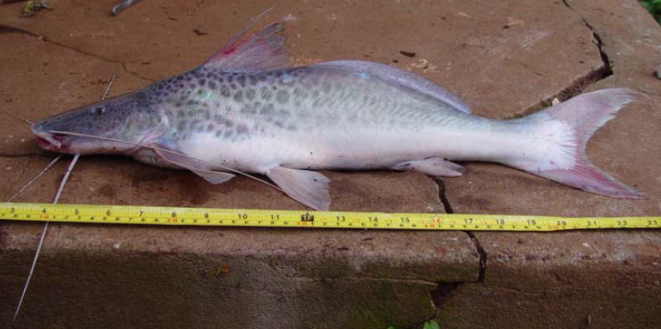
FIGURE 33. Luciopimelodus pati. (Photograph: John Lundberg, Source: Rocha 2012).
Diagnosis. Same as the genus.
Description. Elongated and robust body. Upper jaw surpassing the lower jaw. Flattened barbels; maxillary barbels extending beyond the origin of the adipose fin. Tip of the dorsal fin reaching the adipose fin; pectoral fin not reaching the pelvic fin (Britski et al. 2007). Strongly bifurcated caudal fin with pointed lobes (Eigenmann & Eigenmann 1890).
Coloration in life. Light gray body with dark spots, mainly in the anterior region. Head slightly darker than the body with small dark dots. Whitish ventral region. Fins gray; caudal fin with clear margins (Carvalho et al. 2022).
Distribution. Recorded in the Bermejo sub-basin (La Plata Basin) (Torrico et al. 2020).
Importance. There is no available information.
Ecological notes. Omnivorous species with a carnivorous preference, feeding on fish, mollusks, and crustaceans. Inhabits deep, turbid waters with moderate currents (Nadalin & López 2010).
Megalonema Eigenmann 1912
Diagnosis. Vomerian patch absent; pectoral and dorsal fins without spines, with the first ray flexible and long; supraoccipital process not in contact with the nuchal plate; strongly bifurcated caudal fin; humeral process absent; caudal fin with a dark spot embedded within the rays of the base of the upper lobe, also present in the lower lobe but very inconspicuous (Eigenmann 1912, Lundberg & Dahdul 2008).
The dark spot on the caudal fin can also be found in Hemisorubim, Platysilurus, and Platystomatichthys. However, in these species, pigmentation occurs directly on the skin, not internally.
Distribution. Amazon Basin (Figure 34).
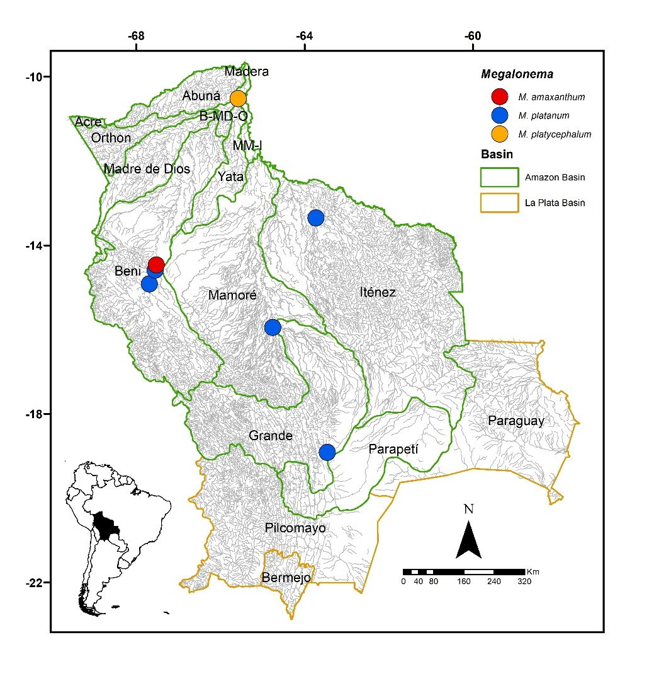
FIGURE 34. Collection sites of one lot of Megalonema amaxanthum, six of M. platanum, and two of M. platycephalum deposited in the UMSS Ichthyological Collection – Museo d'Orbigny (Cochabamba, Bolivia). Some symbols represent more than one lot.
Included species. Megalonema amaxanthum, M. platanum, M. platycephalum.
Comments. Genus proposed by Eigenmann in 1912 for Megalonema platycephalum Eigenmann as the type species. Currently, seven species are known: M. amaxanthum Lundberg & Dahdul 2008 in the Amazon Basin; M. pauciradiatum Eigenmann 1919 in the Paraná Basin; M. platanum (Günther 1880) in the Paraná Basin; M. platycephalum Eigenmann 1912 in the Amazon, Essequibo, and Orinoco Basins; M. psammium Schultz 1944 in the Maracaibo Lake Basin; M. orixanthum Lundberg & Dahdul 2008 in the Orinoco Basin, and M. xanthum Eigenmann 1912 in the Magdalena Basin (Fricke et al. 2023). Salles & Zuanon (2013) indicate the presence of M. platanum in the Madeira Basin, expanding its distribution range, as according to the "Eschmeyer's Catalog of Fishes" database, it is only found in the Paraná Basin.
Of the seven valid species known, M. amaxanthum, M. platanum, and M. platycephalum are present in Bolivia. Although M. pauciradiatum is included in the ichthyofauna of Bolivia for La Plata Basin (Fricke et al. 2023), it could be a case of misidentification since one of the records corresponds to the B-MD-O sub-basin, Amazon Basin (Torrico et al. 2020), while the other does not specify which sub-basin or basin this species is reported for (Carvajal-Vallejos et al. 2014).
Megalonema amaxanthum Lundberg & Dahdul 2008 (Figure 35)
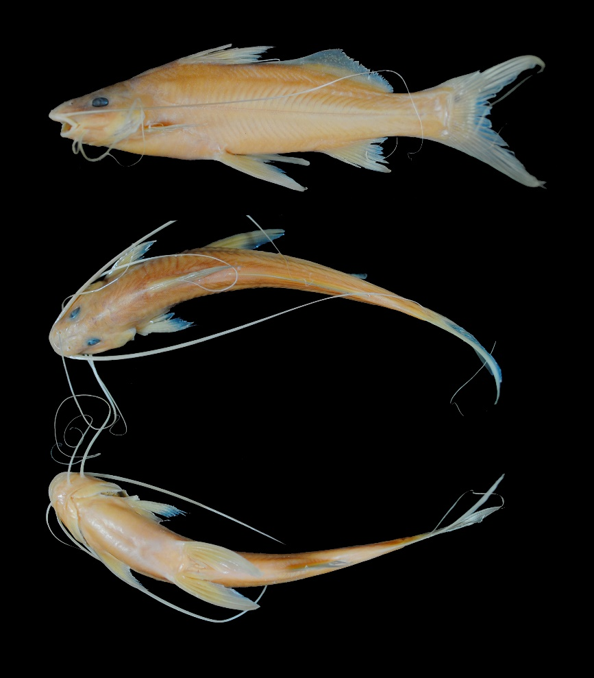
FIGURE 35. Megalonema amaxanthum, UMSS 18511, 99.7 mm SL, Beni River, 3 km above Rurrenabaque, Beni sub-basin, Amazon Basin.

Examined material (one specimen). Amazon Basin: UMSS 18511 (1, 96.5 mm SL), Beni River, 3 km above Rurrenabaque, -14.468774 -67.5233990, 6 Apr 2017, E. de la Barra, L. Córdova, F. Claure.
Diagnosis. Megalonema amaxanthum differs from its congeners in the following: from M. platanum by the distance between anterior nostrils (15% HL vs. 18.1-20.6%), head depth (80.3% HL vs. 58-67%), body width (14.9% SL vs. 18.1-20.5%), body depth (25.2% SL vs. 17.7-21.3%), head length (23.4% SL vs. 27.2-29%), pelvic fin length (25.2% SL vs. 16.1-20.3%), dorsal fin insertion to adipose fin origin (7.6% SL vs. 13.8-17.3%), adipose fin base length (35.3% SL vs. 25.3-28.8%), posterior supraoccipital process wide and bell-shaped (vs. elongated and spine-shaped); from M. platycephalum by the distance between anterior nostrils (15% HL vs. 21.5-21.9%), posterior nostril to anterior margin of orbit (19.3% HL vs. 24-24.1%), snout length (45.8% HL vs. 49.8-50.3%), orbital diameter (20.5% HL vs. 11.3-13.1%), head depth (80.3% HL vs. 56.6-61.7%), mouth width (47.7% HL vs. 51.1-53.5%), distance between external mental barbels (48% HL vs. 40.1-40.4%), body width (14.9% SL vs. 18.4-19%), body depth (25.2% SL vs. 19.2-20.2%), head length (23.4% SL vs. 28.7-28.8%), pelvic fin length (25.2% SL vs. 17.5%), dorsal fin insertion to adipose fin origin (7.6% SL vs. 14.5-14.8%), adipose fin base length (35.3% SL vs. 26-28.5%), posterior supraoccipital process wide and bell-shaped (vs. elongated and spine-shaped).
Description. Morphometric data presented in Table 20. The snout exhibits a slightly convex profile, then straight to the origin of the dorsal fin. Head longer than wide, large eyes located laterally. Mouth subterminal; upper jaw slightly longer with most of the premaxillary patch exposed. Premaxillary patch thin. Posterior supraoccipital process short, bell-shaped, and distant from the nuchal plate. Humeral process absent. Pectoral fin approaches the origin of the pelvic fin; first ray flexible, and without serrations. Pelvic fin approaches the origin of the anal fin; the first three outer rays elongated and thickened. Pelvic fin longer than the pectoral fin. Dorsal fin with the first ray unmodified, flexible, and without serrations. Adipose fin long, approximately three times longer than the anal fin. Caudal fin strongly bifurcated; upper lobe pointed with the main ray filamentous. Maxillary barbels reach the caudal fin; mental barbels shorter. Dorsal fin rays I+6, anal fin rays V+9; pectoral fin rays I+11; pelvic fin rays i+5; caudal fin rays 15.
TABLE 20. Morphometric data of Megalonema amaxanthum. N: Number of individuals.
Measurement | N | Value
SL (mm) | 1 | 96.5
Percents of head length (% HL)
Interorbital distance | 1 | 26.3
Left posterior nostril to right posterior nostril | 1 | 17.5
Left anterior nostril to right anterior nostril | 1 | 15.0
Left anterior nostril to left posterior nostril | 1 | 18.1
Posterior nostril to anterior margin of orbit | 1 | 19.3
Snout length | 1 | 45.8
Postorbital length | 1 | 37.2
Orbital diameter | 1 | 20.5
Head depth | 1 | 80.3
Mouth width | 1 | 47.7
Distance between internal mental barbels | 1 | 20.2
Distance between external mental barbels | 1 | 48.0
Distance between internal and external mental barbel | 1 | 13.8
Percents of standard length (% SL)
Predorsal length | 1 | 36.4
Internal mental barbel length | 1 | 49.2
External mental barbel length | 1 | 93.4
Maxillary barbel length | 1 | 118.9
Body width | 1 | 14.9
Body depth | 1 | 25.2
Head length | 1 | 23.4
Pectoral fin origin to dorsal fin insertion | 1 | 32.3
Dorsal fin origin to pelvic fin origin | 1 | 26.4
Dorsal fin origin to anal fin origin | 1 | 44.7
Pectoral fin origin to pelvic fin origin | 1 | 23.3
Pelvic fin origin to anal fin origin | 1 | 28.2
Pectoral spine length | 1 | 20.0
Distance between pelvic fins | 1 | 10.5
Pelvic fin length | 1 | 25.2
Dorsal fin base length | 1 | 12.9
Dorsal fin insertion to adipose fin origin | 1 | 7.60
Adipose fin base length | 1 | 35.3
Anal fin base length | 1 | 13.6
Anal fin origin to adipose fin insertion | 1 | 24.0
Caudal peduncle height | 1 | 10.5
Dorsal fin origin to anterior caudal base | 1 | 65.8
Adipose fin origin to anterior caudal base | 1 | 45.7
Anal fin origin to anterior caudal base | 1 | 29.4
Caudal peduncle length | 1 | 15.5
Coloration in alcohol. Body and head completely yellowish; all fins yellowish. Upper lobe of the caudal fin with a dark spot at its base.
Distribution. Present in the Beni sub-basin (Amazon Basin). Also recorded in the Madre de Dios (Carvajal-Vallejos & Fernández 2011) and Orthon sub-basins (Amazon Basin) (Torrico et al. 2020).
Importance. There is no available information.
Megalonema platanum (Günther 1880) (Figure 36)
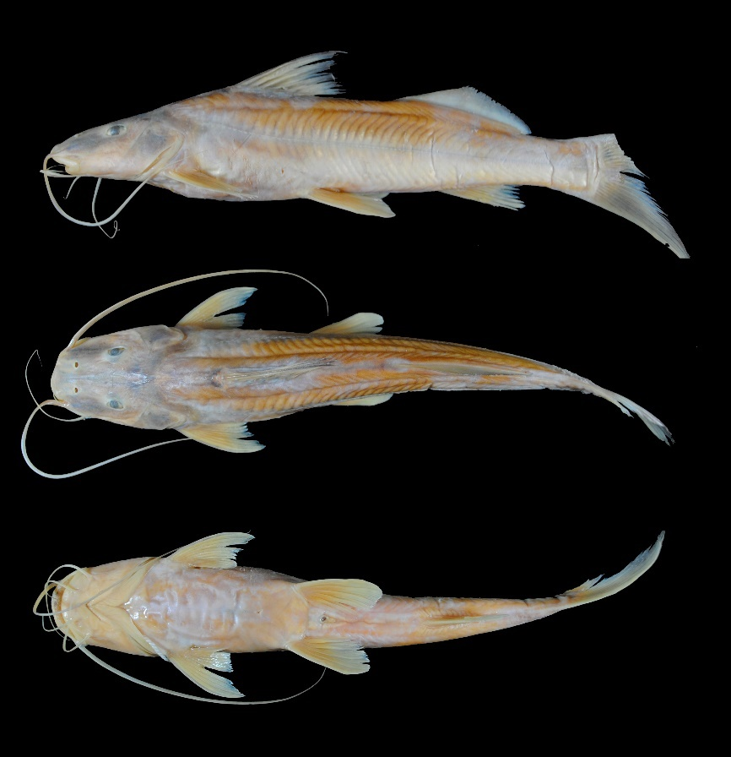
FIGURE 36. Megalonema platanum, UMSS 14850, 161.2 mm SL, Grande River, Grande sub-basin, Amazon Basin.
Examined material (five specimens). Amazon Basin: UMSS 9968 (1, 98.9 mm SL), Blanco River, La Punta rapids, -13.354872 -63.7277028, 19 Dec 2010, C. Valverde, C. Flores; UMSS 14850 (1, 154.3 mm SL), Grande River, -18.917500 -63.460000, 9 Jul 2015, D. Barrozo; UMSS 16938 (1, 167.5 mm SL), Ichilo River, Chapare mouth ICH23, -15.950196 -64.7588020, 12 Apr 2002; UMSS 18508 (1, 134.5 mm SL), Tuichi River, -14.591456 -67.5536780, 4 Apr 2017, E. de la Barra, L. Córdova, F. Claure; UMSS 18510 (1, 110 mm SL), same data as UMSS 18508.
Diagnosis. Megalonema platanum differs from its congeners in the following: from M. amaxanthum by the distance between anterior nostrils (18.1-20.6% HL vs. 15%), head depth (58-67% HL vs. 80.3%), body width (18.1-20.5% SL vs. 14.9%), body depth (17.7-21.3% SL vs. 25.2%), head length (27.2-29% SL vs. 23.4%), pelvic fin length (16.1-20.3% SL vs. 25.2%), dorsal fin insertion to adipose fin origin (13.8-17.3% SL vs. 7.6%), adipose fin base length (25.3-28.8% SL vs. 35.3%), posterior supraoccipital process elongated and spine-like (vs. wide and bell-shaped); from M. platycephalum by the orbital diameter (15.1-18.2% HL vs. 11.3-13.1%), mouth width (49.7-58.3% HL vs. 51.1-53.5%).
Description. Morphometric data presented in Table 21. Head longer than wide; small eyes located laterodorsally. Mouth subterminal; upper jaw slightly longer with the premaxillary patch exposed. Premaxillary patch wide. Posterior supraoccipital process elongated, spine-like, not in contact with the nuchal plate. Humeral process absent. Pectoral fin extends beyond the midpoint between its origin and the pelvic fin; first ray flexible, and without serrations. Pelvic fin extends beyond the midpoint between its origin and the anal fin. Pectoral and pelvic fins of the same size. Dorsal fin with the first ray unmodified, flexible, and without serrations. Adipose fin long, twice as long as the anal fin. Caudal fin strongly bifurcated. Maxillary barbels reach the origin of the adipose fin; mental barbels shorter. Dorsal fin rays I+6; anal fin rays iv-v+9; pectoral fin rays I+12-13; pelvic fin rays i+5; caudal fin rays 15.
TABLE 21. Morphometric data of Megalonema platanum. N: Number of individuals, SD: Standard deviation, Min: Minimum value, Max: Maximum value.
Measurements | N | Mean | SD | Min | Max
SL (mm) | 5 | 153 | 33.6 | 110 | 199
Percents of head length (% HL)
Interorbital distance | 5 | 21.7 | 1.4 | 20.4 | 23.5
Left posterior nostril to right posterior nostril | 5 | 14.1 | 0.6 | 13.1 | 14.5
Left anterior nostril to right anterior nostril | 5 | 19.4 | 0.9 | 18.1 | 20.6
Left anterior nostril to left posterior nostril | 5 | 17.2 | 1.2 | 16.0 | 18.8
Posterior nostril to anterior margin of orbit | 5 | 20.0 | 1.8 | 18.3 | 22.8
Snout length | 5 | 46.9 | 1.8 | 45.4 | 49.7
Postorbital length | 5 | 36.9 | 1.3 | 35.8 | 39.0
Orbital diameter | 5 | 17.1 | 1.3 | 15.1 | 18.2
Head depth | 5 | 61.3 | 3.8 | 58.0 | 67.0
Mouth width | 5 | 54.7 | 4.0 | 49.7 | 58.3
Distance between internal mental barbels | 5 | 18.7 | 2.7 | 14.9 | 21.7
Distance between external mental barbels | 5 | 43.0 | 3.3 | 38.5 | 47.0
Distance between internal and external mental barbel | 5 | 12.3 | 0.9 | 11.5 | 13.7
Percents of standard length (% SL)
Predorsal length | 5 | 36.4 | 0.5 | 36.0 | 37.3
Internal mental barbel length | 5 | 16.9 | 2.7 | 13.6 | 20.0
External mental barbel length | 5 | 33.4 | 6.0 | 27.2 | 40.5
Maxillary barbel length | 5 | 84.3 | 16.9 | 66.2 | 105.0
Body width | 5 | 19.0 | 0.9 | 18.1 | 20.5
Body depth | 5 | 19.3 | 1.3 | 17.7 | 21.3
Head length | 5 | 28.2 | 0.6 | 27.2 | 29.0
Pectoral fin origin to dorsal fin insertion | 5 | 27.5 | 2.1 | 25.2 | 29.9
Dorsal fin origin to pelvic fin origin | 5 | 23.8 | 0.8 | 23.1 | 24.9
Dorsal fin origin to anal fin origin | 5 | 44.2 | 0.8 | 43.3 | 45.0
Pectoral fin origin to pelvic fin origin | 5 | 23.9 | 2.0 | 21.9 | 26.8
Pelvic fin origin to anal fin origin | 5 | 27.0 | 0.9 | 26.2 | 28.4
Pectoral spine length | 5 | 19.3 | 0.6 | 18.5 | 20.1
Distance between pelvic fins | 5 | 12.7 | 0.3 | 12.3 | 13.2
Pelvic fin length | 5 | 18.2 | 1.7 | 16.1 | 20.3
Dorsal spine length | 4 | 25.1 | 1.3 | 23.6 | 26.8
Dorsal fin base length | 5 | 13.9 | 0.3 | 13.5 | 14.3
Dorsal fin insertion to adipose fin origin | 5 | 15.3 | 1.4 | 13.8 | 17.3
Adipose fin base length | 5 | 26.7 | 1.5 | 25.3 | 28.8
Anal fin base length | 5 | 12.4 | 0.9 | 11.3 | 13.2
Anal fin origin to adipose fin insertion | 5 | 19.5 | 0.8 | 18.2 | 20.4
Caudal peduncle height | 5 | 8.40 | 0.4 | 7.80 | 8.90
Dorsal fin origin to anterior caudal base | 5 | 65.8 | 0.8 | 64.8 | 66.8
Adipose fin origin to anterior caudal base | 5 | 37.0 | 0.6 | 36.5 | 37.8
Anal fin origin to anterior caudal base | 5 | 26.0 | 0.6 | 25.1 | 26.7
Caudal peduncle length | 5 | 13.4 | 1.2 | 12.3 | 15.1
Coloration in alcohol. Body yellowish; dorsal head portion with pale gray color. Nuchal plate slightly dark. Ventral region of the body yellowish. Caudal fin yellow with a small dark spot on the upper lobe, and the rest of the fins yellowish.
Distribution. Present in the Beni, Mamoré, Grande, and Iténez sub-basins (Amazon Basin). Also recorded in the Pilcomayo (Maldonado et al. 2019) and Bermejo sub-basins (La Plata Basin) (Torrico et al. 2020).
Importance. There is no available information.
Ecological notes. Inhabits areas with currents and floodplains (Carvalho et al. 2022).
Megalonema platycephalum Eigenmann 1912 (Figure 37)
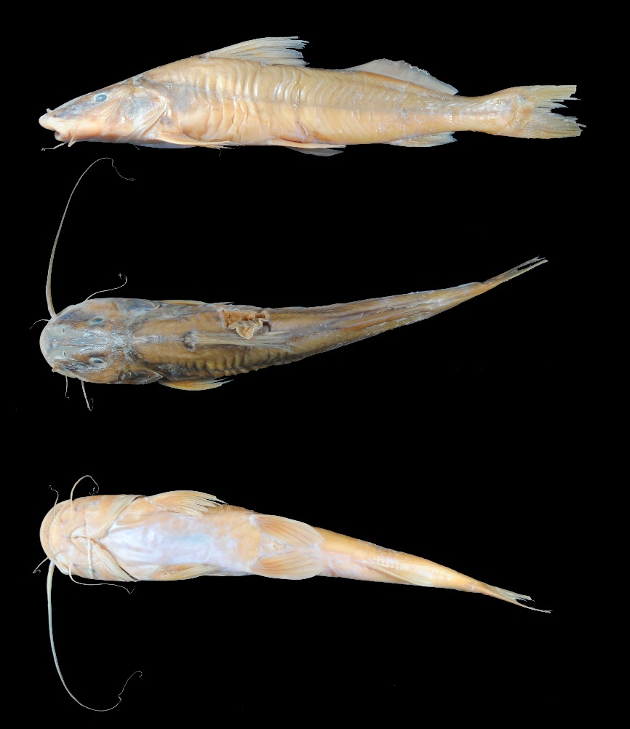
FIGURE 37. Megalonema platycephalum, UMSS 18572, 263.2 mm SL, Beni River, Cachuela Esperanza, B-MD-O sub-basin, Amazon Basin.
Examined material (two specimens). Amazon Basin: UMSS 17297 (1, 229.2 mm SL), Beni River, Cachuela Esperanza, -10.521983 -65.5787100, 23 Sep 2015, D. Barrozo; UMSS 18572 (1, 263.2 mm SL), Beni River, Cachuela Esperanza, -10.521983 -65.5787100, 29 Aug 2015, M. Mercado.
Diagnosis. Megalonema platycephalum differs from its congeners in the following: from M. amaxanthum by the distance between anterior nostrils (21.5-21.9% HL vs. 15%), posterior nostril to anterior margin of orbit (24-24.1% HL vs. 19.3%), snout length (49.8-50.3% HL vs. 45.8%), orbital diameter (11.3-13.1% HL vs. 20.5%), head depth (56.6-61.7% HL vs. 80.3%), mouth width (51.1-53.5% HL vs. 47.7%), distance between external mental barbels (40.1-40.4% HL vs. 48%), body width (18.4-19% SL vs. 14.9%), body depth (19.2-20.2% SL vs. 25.2%), head length (28.7-28.8% SL vs. 23.4%), pelvic fin length (17.5% SL vs. 25.2%), dorsal fin insertion to adipose fin origin (14.5-14.8% SL vs. 7.6%), adipose fin base length (26-28.5% SL vs. 35.3%), elongated and spine-like supraoccipital process (vs. wide and bell-shaped); from M. platanum by the orbital diameter (11.3-13.1% HL vs. 15.1-18.2%), mouth width (51.1-53.5% HL vs. 49.7-58.3%).
Description. Morphometric data presented in Table 22. Head longer than wide with small eyes located laterodorsally. Mouth subterminal; upper jaw slightly longer with the premaxillary patch exposed. Premaxillary patch wide. Posterior supraoccipital process elongated, spine-like, and does not contact the nuchal plate. Humeral process absent. Pectoral fin extends beyond the midpoint between its origin and the pelvic fin; first ray flexible, and without serrations. Pelvic fin reaches halfway between its origin and the anal fin origin. Pectoral and pelvic fins of the same size. Dorsal fin with the first ray unmodified, flexible, and without serrations. Adipose fin long, twice as long as the anal fin. Caudal fin strongly bifurcated. Maxillary barbels reach the tip of the anal fin; mental barbels shorter. Dorsal fin rays I+6; anal fin rays iv-v+9; pectoral fin rays I+13; pelvic fin rays i+5; caudal fin rays 15.
TABLE 22. Morphometric data of Megalonema platycephalum. N: Number of individuals, SD: Standard deviation, Min: Minimum value, Max: Maximum value.
Measurements | N | Mean | SD | Min | Max
SL (mm) | 2 | 246.2 | 24 | 229.2 | 263.2
Percents of head length (% HL)
Interorbital distance | 2 | 23.7 | 1.4 | 22.7 | 24.8
Left posterior nostril to right posterior nostril | 2 | 15.2 | 0.3 | 15.0 | 15.4
Left anterior nostril to right anterior nostril | 2 | 21.7 | 0.3 | 21.5 | 21.9
Left anterior nostril to left posterior nostril | 2 | 14.9 | 0.6 | 14.5 | 15.3
Posterior nostril to anterior margin of orbit | 2 | 24.0 | 0.1 | 24.0 | 24.1
Snout length | 2 | 50.1 | 0.4 | 49.8 | 50.3
Postorbital length | 2 | 40.7 | 1.1 | 39.9 | 41.4
Orbital diameter | 2 | 12.2 | 1.3 | 11.3 | 13.1
Head depth | 2 | 59.2 | 3.6 | 56.6 | 61.7
Mouth width | 2 | 52.3 | 1.8 | 51.1 | 53.5
Distance between internal mental barbels | 2 | 18.0 | 1.6 | 16.9 | 19.1
Distance between external mental barbels | 2 | 40.3 | 0.2 | 40.1 | 40.4
Distance between internal and external mental barbel | 2 | 11.9 | 1.5 | 10.8 | 12.9
Percents of standard length (% SL)
Predorsal length | 2 | 38.1 | 0.5 | 37.8 | 38.5
Internal mental barbel length | 2 | 15.0 | 1.2 | 14.2 | 15.9
External mental barbel length | 2 | 29.8 | 1.8 | 28.6 | 31.1
Maxillary barbel length | 2 | 69.6 | 11.2 | 61.6 | 77.5
Body width | 2 | 18.7 | 0.4 | 18.4 | 19.0
Body depth | 2 | 19.7 | 0.7 | 19.2 | 20.2
Head length | 2 | 28.7 | 0.1 | 28.7 | 28.8
Pectoral fin origin to dorsal fin insertion | 2 | 29.3 | 0.1 | 29.2 | 29.4
Dorsal fin origin to pelvic fin origin | 2 | 24.0 | 0.9 | 23.4 | 24.7
Dorsal fin origin to anal fin origin | 2 | 43.5 | 0.5 | 43.1 | 43.8
Pectoral fin origin to pelvic fin origin | 2 | 23.3 | 1.5 | 22.2 | 24.3
Pelvic fin origin to anal fin origin | 2 | 26.2 | 0.5 | 25.9 | 26.5
Pectoral spine length | 2 | 19.6 | 0.6 | 19.2 | 20.0
Distance between pelvic fins | 2 | 13.3 | 0.5 | 12.9 | 13.6
Pelvic fin length | 2 | 17.5 | 0.0 | 17.5 | 17.5
Dorsal spine length | 1 | 23.4 | * | 23.4 | 23.4
Dorsal fin base length | 2 | 14.6 | 1.2 | 13.7 | 15.4
Dorsal fin insertion to adipose fin origin | 2 | 14.6 | 0.2 | 14.5 | 14.8
Adipose fin base length | 2 | 27.2 | 1.8 | 26.0 | 28.5
Anal fin base length | 2 | 12.1 | 1.3 | 11.2 | 13.1
Anal fin origin to adipose fin insertion | 2 | 19.3 | 1.6 | 18.2 | 20.5
Caudal peduncle height | 2 | 7.20 | 0.2 | 7.10 | 7.30
Dorsal fin origin to anterior caudal base | 2 | 65.3 | 0.6 | 64.8 | 65.7
Adipose fin origin to anterior caudal base | 2 | 37.1 | 0.7 | 36.6 | 37.5
Anal fin origin to anterior caudal base | 2 | 26.5 | 0.6 | 26.1 | 26.9
Caudal peduncle length | 2 | 14.0 | 1.2 | 13.2 | 14.8
Coloration in alcohol. Body yellowish; dorsal head portion of pale gray color. Nuchal plate slightly dark. Ventral region of body yellowish. Caudal fin yellow with a small dark spot on the upper lobe, and the rest of the fins yellowish.
Distribution. Present in the B-MD-O sub-basin (Amazon Basin). Also recorded in the Madre de Dios (Carvajal-Vallejos & Fernández 2011), Acre and Beni sub-basins (Amazon Basin) (Torrico et al. 2020).
Importance. There is no available information.
Phractocephalus Spix & Agassiz 1829
Diagnosis. Body relatively short with a very wide head; dermal bones of the skull and fin spines have ornamentations formed by thick, elongated, or grooved ridges; supraoccipital process wide with a rounded posterior part; nuchal plate reniform; vomerian patch large, pentagonal, or triangular; adipose fin with the upper portion usually transformed into true rays; caudal fin strong red or orange in life (Eigenmann & Eigenmann 1890, Eigenmann & Allen 1942, Lundberg & Aguilera 2003).
Distribution. Amazon Basin (Figure 38).
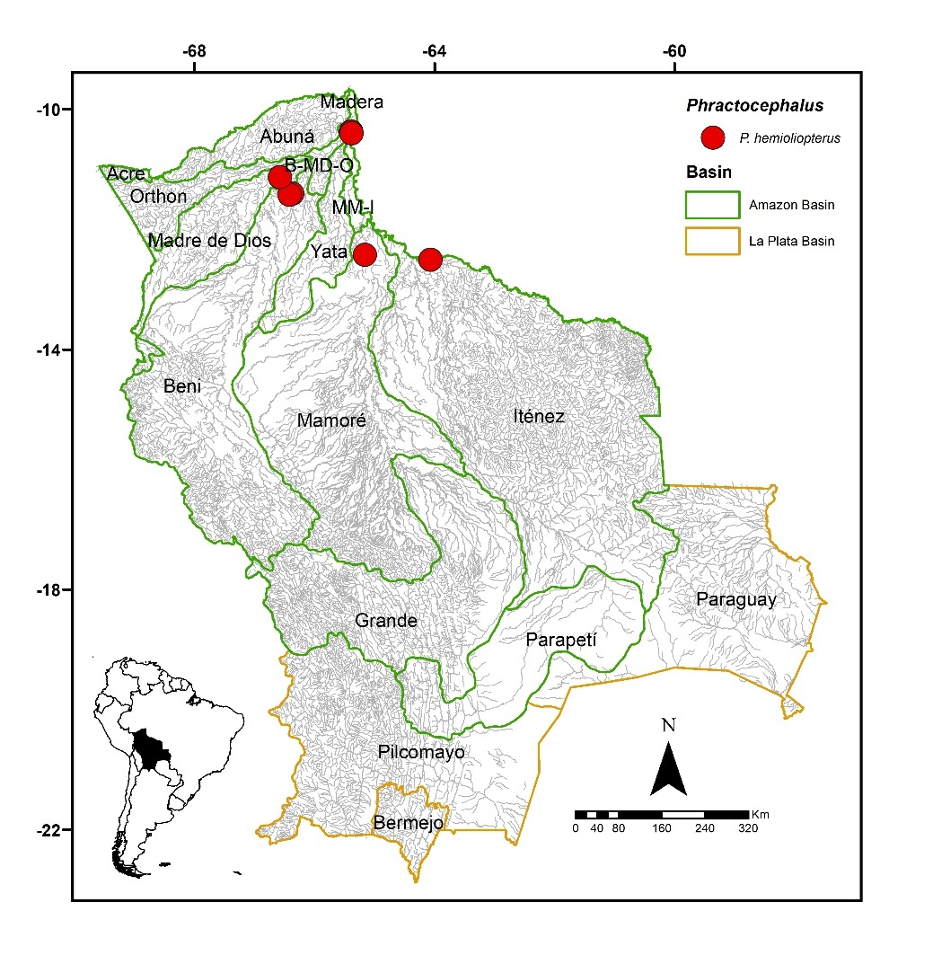
FIGURE 38. Collection sites of 13 lots of Phractocephalus hemioliopterus deposited in the Ichthyological Collection UMSS – Museo d'Orbigny (Cochabamba, Bolivia). Some symbols represent more than one lot.
Included species. Monospecific genus, with Phractocephalus hemioliopterus as the sole representative.
Comments. Genus proposed by Spix & Agassiz (1829) for Phractocephalus bicolor Spix & Agassiz as the type species, currently synonymous of P. hemioliopterus.
Currently, there is only one living species and two fossils: P. hemioliopterus (Bloch & Schneider 1801) in the Amazon and Orinoco basins, †P. nassi Lundberg & Aguilera 2003 in the state of Falcón (Venezuela), and †P. acreornatus Aguilera et al. (2008) in Acre (Brazil) and the Madre de Dios province (Peru) (Lundberg & Aguilera 2003; Aguilera et al. 2008).
Phractocephalus hemioliopterus (Bloch & Schneider 1801) (Figure 39)
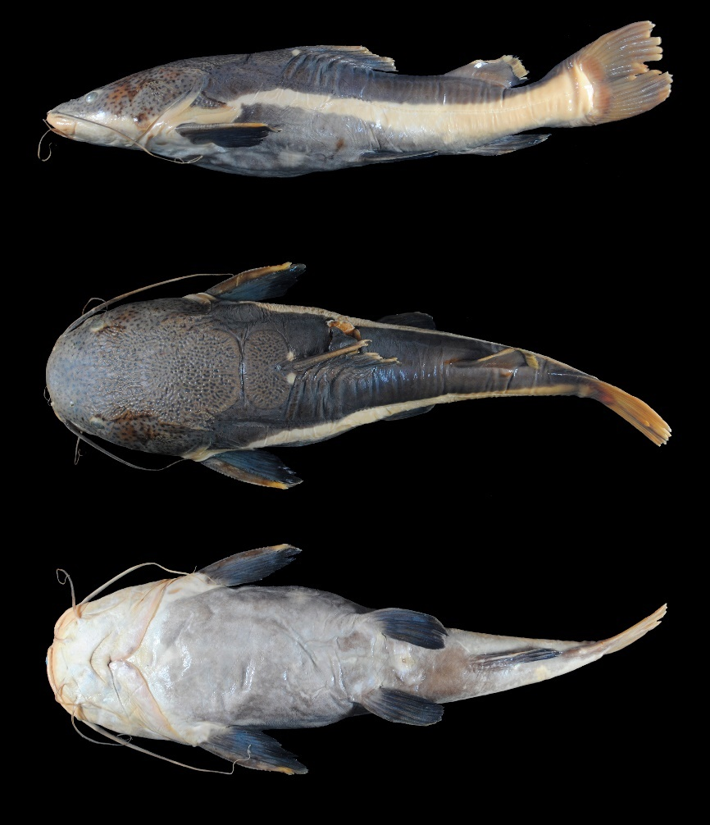
FIGURE 39. Phractocephalus hemioliopterus, UMSS 11059, 365 mm SL, Verde Lagoon, 27 de Mayo community, Beni sub-basin, Amazon Basin.
Examined material (11 specimens). Amazon Basin: UMSS 10991 (1, 320 mm SL), San Luis stream, Flor de Octubre, -11.405817 -66.3684194, 13 Oct 2011, F. Carvajal, F. Machicao; UMSS 11059 (1, 347 mm SL), Verde Lagoon, 27 de Mayo Community, -11.425560 -66.4140100, 22 Oct 2011, F. Machicao; UMSS 12732 (1, 226.5 mm SL), El Mentiroso Lagoon, Pascana El Tabo, -11.133580 -66.5758400, 27 Jul 2012, D. Barrozo, F. Carvajal, S. Villafan; UMSS 17401 (1, 262 mm SL), Iténez River, Armazón Bay, -12.509222 -64.0661940, 25 Oct 2005, J. Camacho, A. Vallejos, M. Pouilly; UMSS 17475 (1, 319 mm SL), Mamoré River, Warnes Ranch, -12.42508056 -65.159925, 9 Sep 2006, F. Carvajal; UMSS 17479 (1, 300.5 mm SL), same data as UMSS 17401; UMSS 17714 (1, 261 mm SL), Madeira River, Villa Bella, -10.373000 -65.3884450, 13 Jun 2008; UMSS 17715 (1, 271 mm SL), same data as UMSS 17714; UMSS 17716 (1, 296 mm SL), same data as UMSS 17714; UMSS 17717 (1, 295 mm SL), same data as UMSS 17714; UMSS 17718 (1, 262 mm SL), Mamoré River, above Villa Bella, -10.403147 -65.3813550, 20 May 2008, R. Palacios.
Common name. General in Puerto Rico, Cobija (Pando), Riberalta, Trinidad, Cachuela Esperanza (Beni), and Puerto Villaroel (Cochabamba); coronel in Rurrenabaque (Beni) and Cachuela Esperanza (Beni); banzer in Rurrenabaque (Beni) and Riberalta (Beni) (Lauzanne & Loubens 1985, Carvajal-Vallejos et al. 2011).
Diagnosis. Same as the genus.
Description. Morphometric data presented in Table 23. Straight ascending profile from the tip of the snout to the origin of the dorsal fin. Head very wide, almost as long as wide; granular surface. Eyes small in laterodorsal position. Snout short; mouth in a subterminal position with a very small portion of the premaxillary patch exposed. Premaxillary patch wider than the dentary; vomerian patch separate from the premaxillary patch; palatine patches short and continuous with the vomerian patch (Appendix 2). Posterior supraoccipital process wide and rounded at its posterior margin, not in contact with the nuchal plate, the latter being reniform. Humeral process large and pointed. Pectoral fin extends approximately to the midpoint between its origin and the pelvic fin; spine strongly ossified. Pelvic fin extends very close to the origin of the anal fin. Pectoral and ventral fins of similar size. Adipose fin short with the upper portion transformed into rays. Adipose fin base longer than the base of the anal fin. Caudal fin emarginated. Maxillary barbels reach the tip of the pectoral fin; mental barbels shorter. Dorsal fin rays I+7; anal fin rays iii+5-6; pectoral fin rays I+9; pelvic fin rays i+5; caudal fin rays 15.
TABLE 23. Morphometric data of Phractocephalus hemioliopterus. N: Number of individuals, SD: Standard deviation, Min: Minimum value, Max: Maximum value.
Measurements | N | Mean | SD | Min | Max
SL (mm) | 11 | 287.3 | 34.5 | 226.4 | 347
Percents of head length (% HL)
Nuchal plate length | 11 | 13.5 | 1.9 | 10.6 | 17.1
Interorbital distance | 11 | 46.9 | 1.6 | 44.5 | 49.6
Left posterior nostril to right posterior nostril | 11 | 32.8 | 1.3 | 30.8 | 36.2
Left anterior nostril to right anterior nostril | 11 | 29.3 | 1.1 | 27.4 | 30.8
Left anterior nostril to left posterior nostril | 11 | 13.7 | 1.1 | 12.5 | 15.8
Posterior nostril to anterior margin of orbit | 11 | 13.1 | 1.0 | 10.8 | 14.2
Snout length | 11 | 41.2 | 1.6 | 38.4 | 43.3
Postorbital length | 11 | 51.2 | 1.4 | 49.4 | 54.2
Orbital diameter | 11 | 12.6 | 1.2 | 10.6 | 14.1
Head depth | 11 | 58.8 | 3.8 | 51.4 | 63.6
Mouth width | 11 | 62.6 | 3.1 | 56.9 | 68.0
Distance between internal mental barbels | 11 | 19.9 | 1.7 | 17.2 | 22.1
Distance between external mental barbels | 11 | 43.1 | 2.8 | 39.6 | 49.5
Distance between internal and external mental barbel | 11 | 11.5 | 1.5 | 9.90 | 14.8
Percents of standard length (% SL)
Predorsal length | 11 | 48.0 | 1.2 | 46.3 | 49.6
Internal mental barbel length | 11 | 19.0 | 1.9 | 16.0 | 22.6
External mental barbel length | 11 | 28.8 | 2.9 | 23.7 | 32.4
Maxillary barbel length | 10 | 56.2 | 6.3 | 45.3 | 66.9
Body width | 11 | 33.2 | 1.0 | 31.3 | 34.8
Body depth | 11 | 23.4 | 2.0 | 19.0 | 26.4
Head length | 11 | 35.6 | 1.2 | 33.5 | 37.7
Pectoral fin origin to dorsal fin insertion | 11 | 40.3 | 1.2 | 37.7 | 42.4
Dorsal fin origin to pelvic fin origin | 11 | 26.1 | 1.4 | 24.0 | 28.3
Dorsal fin origin to anal fin origin | 11 | 38.4 | 1.5 | 36.7 | 41.8
Pectoral fin origin to pelvic fin origin | 11 | 32.9 | 2.0 | 29.3 | 35.6
Pelvic fin origin to anal fin origin | 11 | 20.9 | 2.9 | 13.4 | 23.8
Pectoral spine length | 11 | 18.8 | 1.7 | 16.2 | 21.0
Distance between pelvic fins | 11 | 16.0 | 0.7 | 14.5 | 16.8
Pelvic fin length | 11 | 17.1 | 0.7 | 16.3 | 18.5
Dorsal spine length | 11 | 15.2 | 1.1 | 13.1 | 16.5
Dorsal fin base length | 11 | 16.6 | 1.1 | 14.7 | 18.5
Dorsal fin insertion to adipose fin origin | 11 | 11.0 | 2.5 | 7.40 | 17.1
Adipose fin base length | 11 | 15.4 | 1.3 | 13.1 | 17.2
Anal fin base length | 11 | 9.40 | 0.8 | 7.90 | 10.6
Anal fin origin to adipose fin insertion | 11 | 16.0 | 1.1 | 14.8 | 17.6
Caudal peduncle height | 11 | 8.40 | 0.4 | 7.70 | 9.10
Dorsal fin origin to anterior caudal base | 11 | 53.2 | 5.2 | 40.4 | 62.1
Adipose fin origin to anterior caudal base | 11 | 26.6 | 1.3 | 24.0 | 28.1
Anal fin origin to anterior caudal base | 11 | 22.2 | 1.4 | 19.9 | 24.5
Caudal peduncle length | 11 | 13.0 | 0.8 | 11.7 | 14.6
Coloration in alcohol. Upper half of the body and dorsal head portion dark gray; dorsal head portion and anterior portion of body with small black spots; lower flank region cream-colored. Ventral region near the pectoral and pelvic fins gray. Margins of dorsal and adipose fins, and the caudal fin light red to orange. Pectoral, pelvic, and anal fins dark gray.
Coloration in life. Upper half of the body and dorsal head navy blue; dorsal head, base of the dorsal and pectoral fins, and the anterosuperior region of the body with small irregular dark spots. Tips of the dorsal and adipose fins, and the caudal fin intense red or orange; edges of the pectoral, pelvic, and anal fins also red or orange.
Distribution. Present in the Beni, Iténez, Madeira, Madre de Dios, MM-I, and Mamoré sub-basins (Amazon Basin). Also recorded in the Orthon sub-basin (Amazon Basin) (Torrico et al. 2020).
Importance. Commercial and subsistence fishing trade in Puerto Rico, Cobija, Riberalta, Rurrenabaque, Cachuela Esperanza, and Puerto Villarroel (Carvajal-Vallejos et al. 2011).
Ecological notes. Mainly carnivorous, feeding on fish, shrimp, and crabs; during flood seasons, it feeds on fruits and seeds. Inhabits the bottom of the main channels of large rivers and streams, and can also be found in rapids. They undertake reproductive migrations (Sarmiento et al. 2014).
Pimelodina Steindachner 1877
Diagnosis. Premaxillary patch wide and rectangular, with small conical teeth; humeral process absent; pectoral spine flexible with saws on the anterior and posterior margins; dorsal spine; body has small irregular spots on the flanks (Stewart 1986).
Distribution. Amazon Basin (Figure 40).
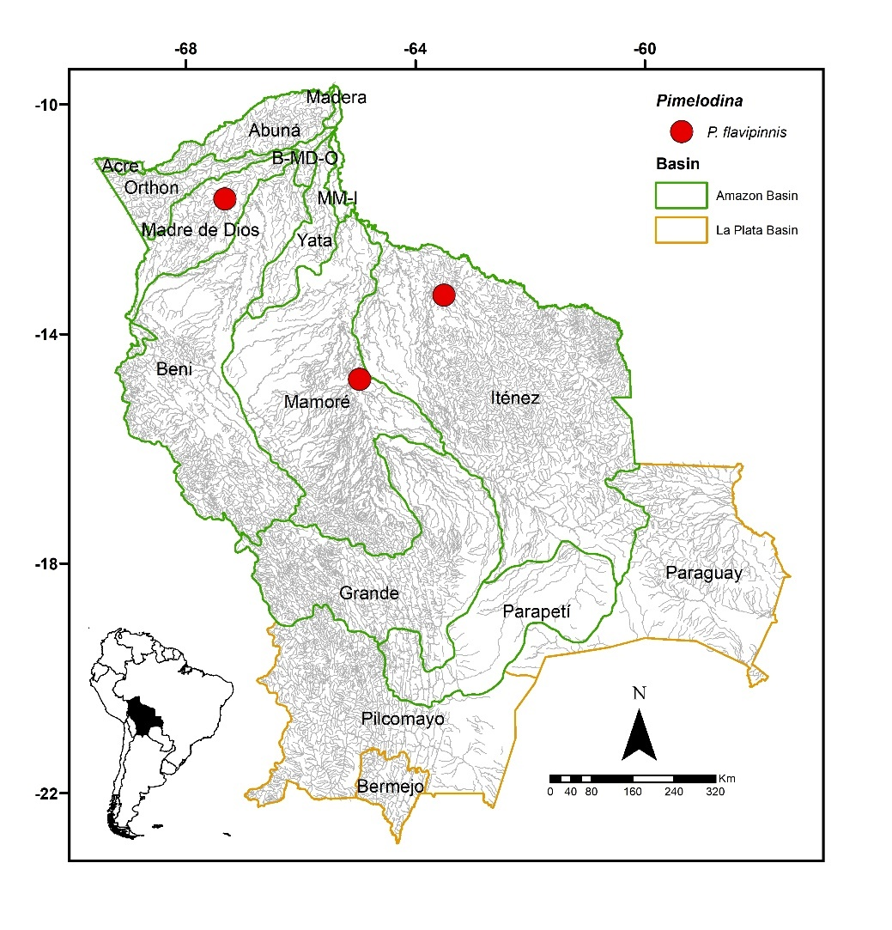
Figure 40. Collection sites of Pimelodina flavipinnis according to Carvajal-Vallejos & Fernández (2011).
Included species. Monospecific genus, with Pimelodina flavipinnis as the sole representative.
Comments. Genus proposed by Steindachner 1876 for Pimelodina flavipinnis Steindachner as the type species. Stewart 1986 conducted a review of the genus, where it was redefined based on characters such as the shape of the swim bladder, stomach, Weberian apparatus, and premaxillary teeth. In the same work, P. nasus Eigenmann & Eigenmann became a junior synonym of P. flavipinnis. Currently, only one species is known, P. flavipinnis, which is present in Bolivia.
Pimelodina flavipinnis Steindachner 1876 (Figure 41)
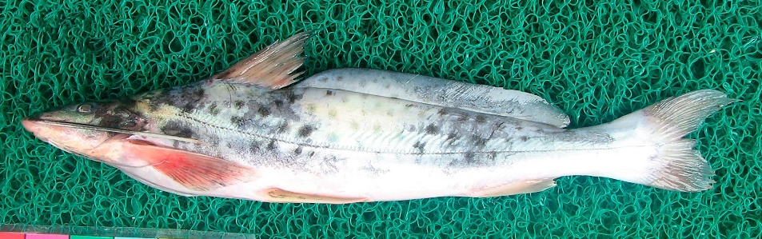
FIGURE 41. Pimelodina flavipinnis, Photograph: Fernando M. Carvajal-Vallejos. Specimen from the Iquitos market, Perú.
Common name. Blanquillo in Puerto Villarroel (Cochabamba) and Trinidad (Beni) (Lauzanne & Loubens 1985, Carvajal-Vallejos et al. 2011).
Diagnosis. Same as the genus.
Description. Convex profile from the tip of the snout to the anterior margin of the eye, then relatively straight to the origin of the dorsal fin. Relatively elongated head, eyes slightly in a superolateral position. Posterior supraoccipital process elongated without contacting the nuchal plate. Humeral process absent. Pectoral fin slightly extending beyond the origin of the pelvic fin. Dorsal fin long and pointed; thin and flexible dorsal spine, without saws on the posterior margin and longer than the first branched ray. Adipose fin with a very long base, originating very close to the dorsal fin. Strongly bifurcated caudal fin with the upper lobe longer than the lower. Maxillary barbels extending beyond the caudal fin in specimens <150 mm, and up to adipose fin insertion in larger specimens; inner mental barbels reaching or surpassing the origin of the pelvic fin; inner mental barbels surpassing the origin of the pectoral fin. Dorsal fin rays I+6; anal fin rays iv-vi+6-8, pectoral fin rays I+12-13; pelvic fin rays i+5; caudal fin rays 15 (Stewart 1986).
Coloration in life. Dorsal head and body background color ranging from light gray to olive with dark spots of similar size to the eye. Dorsal, anal, and caudal fins light gray; adipose fin gray with dark spots.
Distribution. Recorded in the in the Madre de Dios, Mamoré, and Iténez sub-basins (Amazon Basin) (Carvajal-Vallejos & Fernández 2011).
Importance. Subsistence fishing in Puerto Villarroel and Trinidad (Carvajal-Vallejos et al. 2011).
Ecological notes. The type of dentition suggests that it is a species with benthic habits (Stewart 1986).
Pimelodus La Cepède 1803
Diagnosis. Head with granular texture; vomerian patches small or absent; fontanel not extending beyond the eyes; posterior supraoccipital process contacting the nuchal plate; wide humeral process; strong and sharp dorsal and pectoral spines (Eigenmann & Eigenmann 1890).
Distribution. Amazon and La Plata basins (Figure 42 and 43).
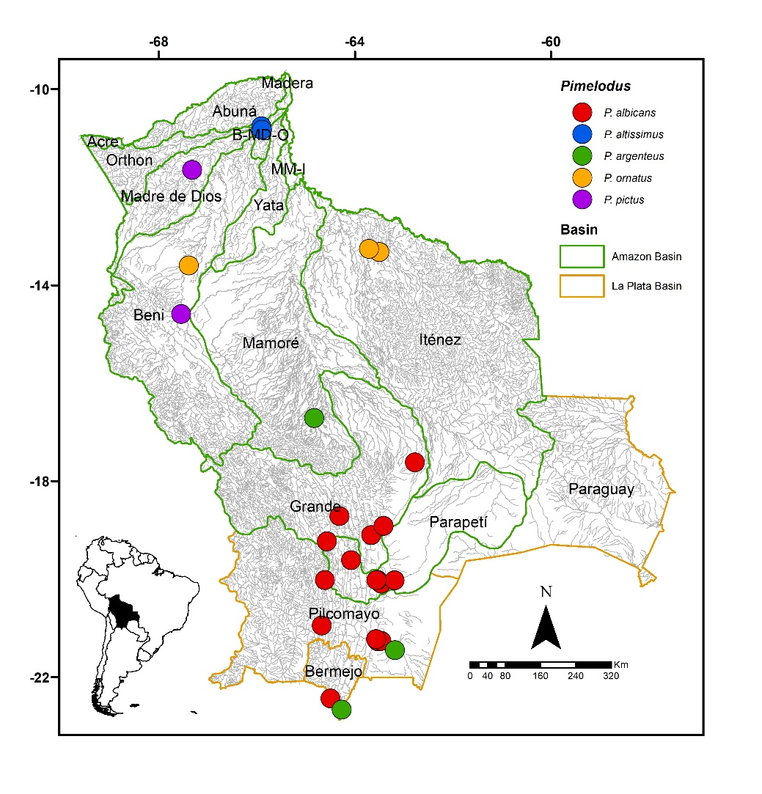
FIGURE 42. Collection sites of 29 lots of Pimelodus albicans, two of P. altissimus, and four of P. ornatus deposited in the Ichthyological Collection UMSS – Museo d'Orbigny (Cochabamba, Bolivia). Some symbols represent more than one lot. Collection sites of P. argenteus and P. pictus according to Carvajal-Vallejos & Fernández (2011), Baigún & Minotti (2019) and Torrico et al. (2020).
Included species. Pimelodus albicans, P. altissimus, P. argenteus, P. gr. blochii, P. gr. maculatus, P. ornatus, P. pictus.
Comments. Genus proposed by La Cepède (1803) for Pimelodus maculatus La Cepède as the type species. Pimelodus includes 36 valid species (Carvalho et al. 2022), with an increase of 12-13 species since the last lists compiled by Lundberg & Littmann (2003) (24 spp.) and Ferraris (2007) (23 spp.). This genus is known to be polyphyletic, leading to numerous taxonomic problems, with many similar species and significant intra-specific variations (Carvalho et al. 2022). As a consequence, the genus over the years has been characterized by a combination of traits. Some of these include a wide humeral process, granular-textured head, small or absent vomerian patches, occasionally present palatine patches, fontanel not extending beyond the eyes, robust dorsal and pectoral spines, dorsal fin with one spine and six branched rays (Eigenmann & Eigenmann 1890), the latter being shared with a majority of pimelodids.
Within Pimelodus, P. maculatus is one of the taxonomically challenging species, as many species within this genus share the same spotted pattern, more or less pronounced (e.g., P. absconditus, P. britskii, P. pantaneiro, P. heraldoi, P. mysterius, among others) (Azpelicueta et al. 2008).
In Bolivia, P. albicans, P. altissimus, P. argenteus, P. blochii, P. maculatus, P. ornatus, and P. pictus are present. Some species like P. albicans, P. ornatus, and P. altissimus are easily recognizable, as their diagnostic characters are quite clear. However, other species like P. blochii and P. maculatus share characteristics, making their correct identification challenging. Therefore, all species of Pimelodus with a spotted pattern were placed within Pimelodus gr. maculatus, and all uniformly colored species without spots in Pimelodus gr. blochii. Within Pimelodus gr. maculatus, different forms could be observed. Some individuals had a more elongated body vs. more robust bodies, large eyes vs. smaller eyes, elongated vs. short humeral processes. Small individuals with a spotted pattern were also observed, which in adults appeared as dark bands (Figure 48).
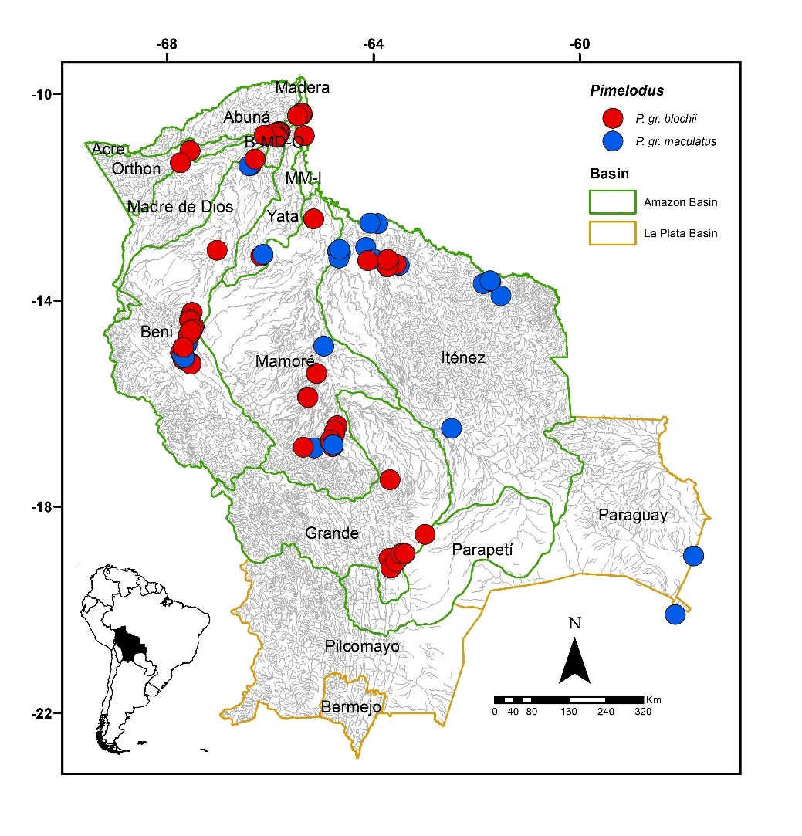
FIGURE 43. Collection sites of 205 lots of Pimelodus gr. blochii and 64 lots of P. gr. maculatus deposited in the Ichthyological Collection UMSS – Museo d'Orbigny (Cochabamba, Bolivia). Some symbols represent more than one lot.
Pimelodus albicans (Valenciennes 1840) (Figure 44)
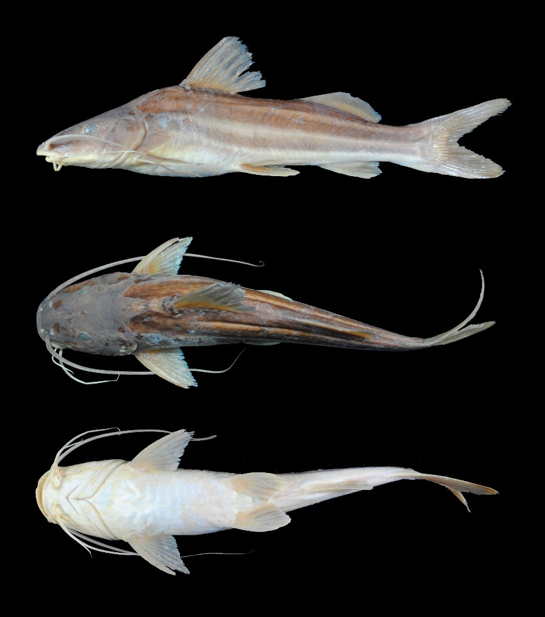
FIGURE 44. Pimelodus albicans, UMSS 13800.1, 180.8 mm SL, Parapetí River, San Antonio, Parapetí sub-basin, Amazon Basin.
Examined material (20 specimens). Amazon Basin: UMSS 13800 (4, 131.8-180.8 mm SL), Parapetí River, San Antonio, -20.021000 -63.1900000, 23 Aug 2013, E. de La Barra, J. Zubieta, S. Villafan; UMSS 13805 (2, 141.5-156 mm SL), same data as UMSS 13800; UMSS 13951 (1, 207.3 mm SL), Parapetí River, below Camiri, -20.09047 -63.4576, 11 Oct 2013, E. de La Barra, J. Zubieta, C. Jezequiel, M. Arraya, H. Delgadillo; UMSS 14272 (2, 212-205.1 mm SL), Parapetí River, above Camiri, -20.01398 -63.54276, 12 May 2014, E. de La Barra, J. Zubieta, D. Barrozo, M. Ochoa, C. Jezequiel; UMSS 14758 (1, 141.0 mm SL), same data as UMSS 13800; UMSS 16994 (9, 102.2-130.5 mm SL), Ñancahuazú III River, -19.106139 -63.6651111, 7 Jun 2006, M. Maldonado, E. Goitia, M. Arraya, C. Flores; La Plata Basin: UMSS 16531 (1, 182.2 mm SL), Pilaya River, -20.9448480 -64.6765960, 1 Dec 2016, E. de La Barra, L. Argote, G. Huarcacho.
Diagnosis. Pimelodus albicans differs from its congeners in the following: from P. altissimus by the distance between external mental barbels (29.8-37.1% HL vs. 51.6-52.7%), distance between internal and external mental barbel (7.4-10.7% HL vs. 18.7-19.2%), predorsal length (40.2-43.9% SL vs. 33.4-33.7%), internal mental barbel length (18.1-27.3% SL vs. 53.9-55.7%), external mental barbel length (33.3-46.8% SL vs. 122.8-132.9%), maxillary barbel length (56.1-97.7% SL vs. 159.9-172.7%), head length (28.4-31.2% SL vs. 21.4-22.5%), dorsal fin insertion to adipose fin origin (9.5-18.3% SL vs. 3.5%), adipose fin base length (20.1-26% SL vs. 44.3-44.8%), body with two dark bands interspersed with two thinner white bands running longitudinally along the body (vs. body without bands, uniform in color); from P. argenteus by a dorsal spine not reaching the adipose fin when depressed (vs. dorsal spine reaching the adipose fin when depressed), body with two dark bands interspersed with two thinner white bands running longitudinally along the body (vs. body without bands, silver-colored sometimes with very diffuse spots), mostly whitish fins (vs. fins with dark coloration); from P. gr. blochii by the left posterior nostril to right posterior nostril (20.8-24.2% HL vs. 15.4-18.6%), postorbital length (36.7-39.9% HL vs. 29.5-33.5%), orbital diameter (13.8-17.2% HL vs. 22.1-26%), adipose fin base length (20.1-26% SL vs. 16.6-20.9%), body with two dark bands interspersed with two thinner white bands running longitudinally along the body (vs. body without bands, uniform grayish color); from P. gr. maculatus by postorbital length (36.7-39.9% HL vs. 30.1-37.3%), orbital diameter (13.8-17.2% HL vs. 20.9-28.6%), internal mental barbel length (18.1-27.3% SL vs. 30.5-38.2%), body with two dark bands interspersed with two thinner white bands running longitudinally along the body (vs. body without bands, brown or yellowish with brown spots); from P. ornatus by the distance between anterior nostrils (14.4-19.2% HL vs. 21.1-22.1%), distance between internal mental barbels (8.4-14.3% HL vs. 18.4-20.6%), internal mental barbel length (18.1-27.3% SL vs. 13-16.6%), external mental barbel length (33.3-46.8% SL vs. 25.8-27.6%), whitish dorsal fin (vs. dorsal fin with a dark spot in the anterosuperior region), uniform-colored caudal fin (vs. caudal fin with two dark bands arranged longitudinally, one in each lobe); from P. pictus by a body with two dark bands interspersed with two thinner white bands running longitudinally along the body (vs. body without longitudinal bands, silver with black spots on the flanks and fins).
Description. Morphometric data presented in Table 24. Straight profile from the tip of the snout to just before the operculum, then slightly convex to the origin of the dorsal fin. Head longer than wide; small eyes in a laterodorsal position. Mouth in a subterminal position; small and separate vomerine patches, palatine patches absent. Posterior supraoccipital process broad-based, with sides narrowing and in contact with the nuchal plate. Humeral process wide and pointed. Pectoral fin surpassing halfway between its origin and the pelvic fin origin; strong spine shorter than the subsequent rays. Pelvic fin surpassing halfway between its origin and the anal fin. Pectoral fin longer than the pelvic fin. Dorsal fin with the spine shorter than the subsequent rays. Relatively long adipose fin. Adipose fin base twice as long as the anal fin base. Forked caudal fin with rounded lobe tips. Maxillary barbels reaching the origin of the anal fin; internal mental barbels reaching the origin of the pectoral fin, external mental barbels reaching halfway of the pectoral fin. Dorsal fin rays I+6; anal fin rays iii-iv +8-9; pectoral fin rays I+9-11; pelvic fin rays i+5; caudal fin rays 15.
TABLE 24. Morphometric data of Pimelodus albicans. N: Number of individuals, SD: Standard deviation, Min: Minimum value, Max: Maximum value.
Measurements | N | Mean | SD | Min | Max
SL (mm) | 20 | 146.9 | 34.3 | 102.2 | 212
Percents of head length (% HL)
Nuchal plate length | 20 | 14.4 | 1.3 | 12.5 | 17.1
Interorbital distance | 20 | 31.1 | 1.3 | 28.6 | 33.9
Left posterior nostril to right posterior nostril | 20 | 22.4 | 1.0 | 20.8 | 24.2
Left anterior nostril to right anterior nostril | 20 | 17.2 | 1.0 | 14.4 | 19.2
Left anterior nostril to left posterior nostril | 20 | 12.9 | 1.0 | 9.20 | 14.1
Posterior nostril to anterior margin of orbit | 20 | 22.6 | 1.4 | 20.5 | 25.1
Snout length | 20 | 48.8 | 0.9 | 46.9 | 50.4
Postorbital length | 20 | 38.2 | 0.9 | 36.7 | 39.9
Orbital diameter | 20 | 15.6 | 0.8 | 13.8 | 17.2
Head depth | 20 | 67.2 | 5.0 | 58.1 | 76.1
Mouth width | 20 | 46.7 | 1.8 | 42.7 | 49.6
Distance between internal mental barbels | 20 | 11.3 | 1.8 | 8.40 | 14.3
Distance between external mental barbels | 20 | 33.9 | 2.1 | 29.8 | 37.1
Distance between internal and external mental barbel | 20 | 9.20 | 0.7 | 7.40 | 10.7
Percents of standard length (% SL)
Predorsal length | 20 | 41.5 | 1.1 | 40.2 | 43.9
Internal mental barbel length | 19 | 22.7 | 2.6 | 18.1 | 27.3
External mental barbel length | 20 | 39.4 | 3.8 | 33.3 | 46.8
Maxillary barbel length | 19 | 85.1 | 12.1 | 56.1 | 97.7
Body width | 20 | 21.4 | 1.0 | 19.8 | 23.7
Body depth | 20 | 23.3 | 2.5 | 19.6 | 28.5
Head length | 20 | 29.8 | 0.9 | 28.4 | 31.2
Pectoral fin origin to dorsal fin insertion | 20 | 34.4 | 1.5 | 32.3 | 38.2
Dorsal fin origin to pelvic fin origin | 17 | 26.7 | 1.5 | 24.0 | 29.2
Dorsal fin origin to anal fin origin | 20 | 44.0 | 1.3 | 41.9 | 48.0
Pectoral fin origin to pelvic fin origin | 17 | 28.0 | 1.2 | 26.0 | 30.4
Pelvic fin origin to anal fin origin | 17 | 24.0 | 1.1 | 21.9 | 25.8
Pectoral spine length | 19 | 20.0 | 1.6 | 17.4 | 23.4
Distance between pelvic fins | 17 | 12.7 | 0.8 | 11.4 | 13.9
Pelvic fin length | 20 | 18.4 | 1.3 | 16.4 | 20.8
Dorsal spine length | 17 | 23.1 | 1.9 | 19.1 | 25.9
Dorsal fin base length | 20 | 16.0 | 0.7 | 14.7 | 17.3
Dorsal fin insertion to adipose fin origin | 20 | 14.1 | 2.2 | 9.50 | 18.3
Adipose fin base length | 20 | 23.5 | 1.7 | 20.1 | 26.0
Anal fin base length | 20 | 11.5 | 1.0 | 9.50 | 13.2
Anal fin origin to adipose fin insertion | 20 | 19.4 | 0.9 | 17.2 | 21.6
Caudal peduncle height | 20 | 9.40 | 0.6 | 8.40 | 10.5
Dorsal fin origin to anterior caudal base | 20 | 63.2 | 1.9 | 60.7 | 67.9
Adipose fin origin to anterior caudal base | 20 | 33.5 | 1.7 | 30.2 | 36.2
Anal fin origin to anterior caudal base | 20 | 24.5 | 1.2 | 21.5 | 26.9
Caudal peduncle length | 20 | 13.7 | 1.7 | 11.0 | 17.4
Coloration in alcohol. Body with a cream background and two to three bands of gray or brown color, interspersed with white bands running longitudinally along the body; dorsal head of the same color as the dark bands. Ventral region whitish. Fins ranging from yellowish to cream color.
Distribution. Present in the Grande and Parapetí sub-basins (Amazon Basin), and in the Pilcomayo and Bermejo sub-basins (La Plata Basin).
Importance. Commercial fishing trade in Tarija (Navia et al. 2019).
Ecological notes. Bentopelagic in habit, it undergoes reproductive migrations (Vergara et al. 2008).
Pimelodus altissimus Eigenmann & Pearson 1942 (Figure 45)
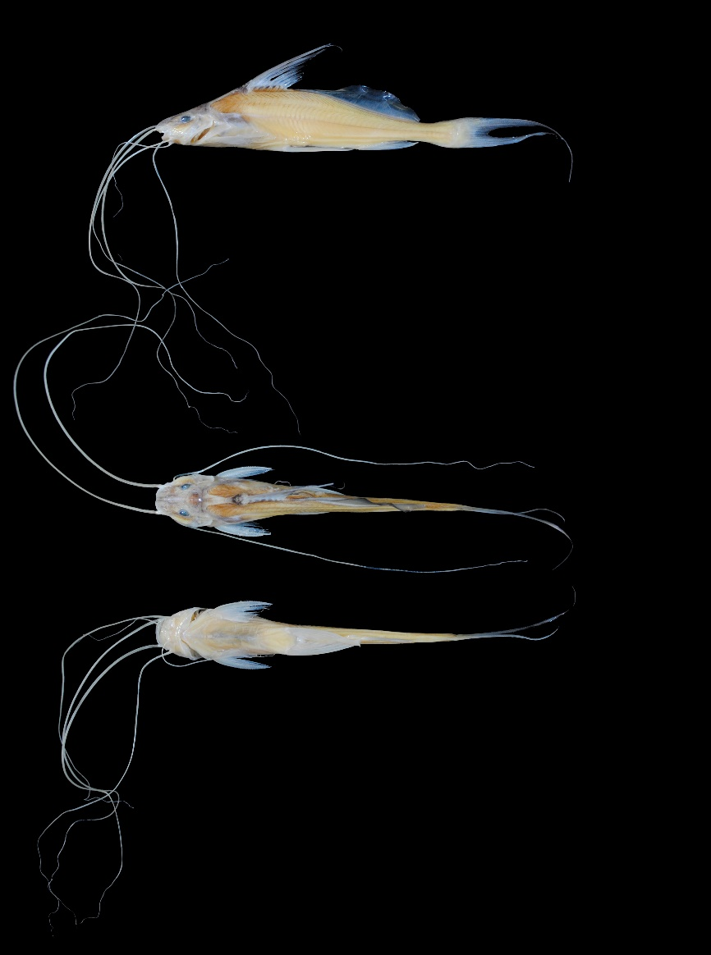
FIGURE 45. Pimelodus altissimus, UMSS 11263, 101.3 mm SL, Beni River, Florida, B-MD-O sub-basin, Amazon Basin.
Examined material (two specimens). Amazon Basin: UMSS 10815 (1, 68.6 mm SL), Beni River, Florida stream, -10.756444 -65.9073889, 14 Jun 2011, F. Carvajal, T. Pérez, A. Argote, F. Vieira; UMSS 11263 (1, 101.3 mm SL), Beni River, Florida, -10.832840 -65.8930600, 30 Oct 2011, F. Carvajal, T. Pérez, A. Argote, F. Machicao.
Diagnosis. Pimelodus altissimus differs from its congeners in the following: from P. albicans by the distance between external mental barbels (51.6-52.7 HL vs. 29.8-37.1%), distance between internal and external mental barbel (18.7-19.2% HL vs. 7.4-10.7%), predorsal length (33.4-33.7% SL vs. 40.2-43.9%), internal mental barbel length (53.9-55.7% SL vs. 18.1-27.3%), external mental barbel length (122.8-132.9% SL vs. 33.3-46.8%), maxillary barbel length (159.9-172.7% SL vs. 56.1-97.7%), head length (21.4-22.5% SL vs. 28.4-31.2%), dorsal fin insertion to adipose fin origin (3.5% SL vs. 9.5-18.3%), adipose fin base length (44.3-44.8% SL vs. 20.1-26%), uniform body color (vs. body with two dark bands interspersed with two thinner white bands running longitudinally along the body); from P. argenteus by a long adipose fin inserted immediately behind the dorsal fin (vs. small, triangular adipose fin), mostly translucent fins (vs. fins with a dark coloration); from P. gr. blochii by the distance between internal mental barbels (15-15.2% HL vs. 6.6-9.7%), distance between external mental barbels (51.6-52.7% HL vs. 29.4-34.2%), distance between internal and external mental barbel (18.7-19.2% HL vs. 9.2-11.3%), predorsal length (33.4-33.7% SL vs. 41.3-45.3%), internal mental barbel length (53.9-55.7% SL vs. 28.4-43.2%), external mental barbel length (122.8-132.9% SL vs. 41.2-66%), maxillary barbel length (159.9-172.7% SL vs. 84.4-142%), body width (17.6-17.7% SL vs. 20.1-22.5%), head length (21.4-22.5% SL vs. 27.9-30.4%), dorsal fin insertion to adipose fin origin (3.5% SL vs. 12.1-16.6%), adipose fin base length (44.3-44.8% SL vs. 16.6-20.9%), anal fin origin to adipose fin insertion (23.3-25.1% SL vs. 18-19.8%); from P. gr. maculatus by the distance between external mental barbels (51.6-52.7% HL vs. 30.8-35%), distance between internal and external mental barbel (18.7-19.2% HL vs. 8.7-11.3%), predorsal length (33.4-33.7% SL vs. 40.6-48.1%), internal mental barbel length (53.9-55.7% SL vs. 30.5-38.2%), external mental barbel length (122.8-132.9% SL vs. 44.6-61.4%), maxillary barbel length (159.9-172.7% SL vs. 85.2-139.9%), dorsal fin insertion to adipose fin origin (3.5% SL vs. 14-17.2%), adipose fin base length (44.3-44.8% SL vs. 16.9-20%), uniform body color (vs. brown or yellowish body with brown spots); from P. ornatus by the distance between external mental barbels (51.6-52.7% HL vs. 35.1-40.4%), distance between internal and external mental barbel (18.7-19.2% HL vs. 9.9-11.5%), predorsal length (33.4-33.7% SL vs. 43.2-45.2%), internal mental barbel length (53.9-55.7% SL vs. 13-16.6%), external mental barbel length (122.8-132.9% SL vs. 25.8-27.6%), maxillary barbel length (159.9-172.7% SL vs. 56.8-62.6%), body width (17.6-17.7% SL vs. 23.3-26.1%), head length (21.4-22.5% SL vs. 32.6-32.9%), pectoral fin origin to pelvic fin origin (22.8-23.1% SL vs. 29-30.9%), pelvic fin length (24.8-26.1% SL vs. 16.8-19.6%), dorsal spine length (28.3-35.3% SL vs. 17.4%), dorsal fin insertion to adipose fin origin (3.5% SL vs. 14.5-17.5%), adipose fin base length (44.3-44.8% SL vs. 19.7-21.9%), anal fin origin to adipose fin insertion (23.3-25.1% SL vs. 15.9-17.4%), uniform body color (vs. body with two dark bands running longitudinally along the body); from P. pictus by a whitish body without spots (vs. silvery body with black spots on flanks and fins and an unpigmented band between the origins of dorsal and pelvic fins).
Description. Morphometric data presented in Table 25. Profile slightly convex from the tip of the snout to just before the anterior edge of the eye, then straight to the origin of the dorsal fin. Head longer than wide; small, elliptical eyes in a laterodorsal position. Mouth in a subterminal position; vomerine patches absent. Posterior supraoccipital process elongated and in contact with the nuchal plate. Humeral process wide and pointed. Pectoral fin reaching close to the origin of the pelvic fin; strong and serrated spine on both margins. Pelvic fin reaching the origin of the anal fin. Pelvic fin longer than the pectoral fin. Dorsal fin very long and pointed, posterior margin with poorly developed serrations. Adipose fin very long and high, originating behind the base of the dorsal fin. Adipose fin base four times longer than the anal fin base. Caudal fin strongly forked; upper lobe with an elongated filament. Maxillary barbels very long, surpassing the standard length; internal mental barbels reaching the origin of the ventral fin, external mental barbels surpassing the standard length. Dorsal fin rays I+6-7; anal fin rays iii+8-9; pectoral fin rays I+12; pelvic fin rays i+5; caudal fin rays 15.
TABLE 25. Morphometric data of Pimelodus altissimus. N: Number of individuals, SD: Standard deviation, Min: Minimum value, Max: Maximum value.
Measurements | N | Mean | SD | Min | Max
SL (mm) | 2 | 84.9 | 23.1 | 101.2 | 68.6
Percents of head length (% HL)
Nuchal plate length | 2 | 15.0 | 2.5 | 13.2 | 16.8
Interorbital distance | 2 | 29.4 | 1.0 | 28.7 | 30.1
Left posterior nostril to right posterior nostril | 2 | 21.0 | 0.8 | 20.5 | 21.6
Left anterior nostril to right anterior nostril | 2 | 19.3 | 1.0 | 18.6 | 20.0
Left anterior nostril to left posterior nostril | 2 | 16.7 | 1.1 | 15.9 | 17.4
Posterior nostril to anterior margin of orbit | 2 | 19.9 | 1.5 | 18.9 | 21.0
Snout length | 2 | 48.2 | 0.4 | 47.9 | 48.5
Postorbital length | 2 | 34.6 | 2.7 | 32.7 | 36.5
Orbital diameter | 2 | 18.9 | 2.9 | 16.9 | 21.0
Head depth | 2 | 74.8 | 0.6 | 74.4 | 75.2
Mouth width | 2 | 50.1 | 0.1 | 50.1 | 50.2
Distance between internal mental barbels | 2 | 15.1 | 0.2 | 15.0 | 15.2
Distance between external mental barbels | 2 | 52.2 | 0.8 | 51.6 | 52.7
Distance between internal and external mental barbel | 2 | 18.9 | 0.4 | 18.7 | 19.2
Percents of standard length (% SL)
Predorsal length | 2 | 33.5 | 0.3 | 33.4 | 33.7
Internal mental barbel length | 2 | 54.8 | 1.3 | 53.9 | 55.7
External mental barbel length | 2 | 127.8 | 7.2 | 122.8 | 132.9
Maxillary barbel length | 2 | 166.3 | 9.0 | 159.9 | 172.7
Body width | 2 | 17.6 | 0.1 | 17.6 | 17.7
Body depth | 2 | 21.7 | 0.5 | 21.4 | 22.0
Head length | 2 | 21.9 | 0.8 | 21.4 | 22.5
Pectoral fin origin to dorsal fin insertion | 2 | 33.3 | 0.5 | 33.0 | 33.7
Dorsal fin origin to pelvic fin origin | 2 | 25.7 | 1.0 | 25.0 | 26.5
Dorsal fin origin to anal fin origin | 2 | 44.6 | 2.0 | 43.1 | 46.0
Pectoral fin origin to pelvic fin origin | 2 | 23.0 | 0.2 | 22.8 | 23.1
Pelvic fin origin to anal fin origin | 2 | 26.0 | 0.2 | 25.9 | 26.1
Pectoral spine length | 2 | 19.1 | 2.0 | 17.8 | 20.5
Distance between pelvic fins | 2 | 9.30 | 0.0 | 9.30 | 9.30
Pelvic fin length | 2 | 25.5 | 0.9 | 24.8 | 26.1
Dorsal spine length | 2 | 31.8 | 4.9 | 28.3 | 35.3
Dorsal fin base length | 2 | 15.8 | 0.6 | 15.4 | 16.2
Dorsal fin insertion to adipose fin origin | 2 | 3.50 | 0.0 | 3.50 | 3.50
Adipose fin base length | 2 | 44.6 | 0.3 | 44.3 | 44.8
Anal fin base length | 2 | 11.2 | 1.5 | 10.2 | 12.2
Anal fin origin to adipose fin insertion | 2 | 24.2 | 1.3 | 23.3 | 25.1
Caudal peduncle height | 2 | 6.70 | 0.5 | 6.40 | 7.0
Dorsal fin origin to anterior caudal base | 2 | 73.4 | 3.3 | 71.1 | 75.7
Adipose fin origin to anterior caudal base | 2 | 55.2 | 1.3 | 54.2 | 56.1
Anal fin origin to anterior caudal base | 2 | 32.0 | 2.1 | 30.5 | 33.5
Caudal peduncle length | 2 | 21.0 | 0.6 | 20.6 | 21.4
Coloration in alcohol. Body yellowish with the anterosuperior region visibly darker in contrast. Dorsal head yellowish with the snout and supraoccipital region slightly dark gray; nuchal plate dark gray. Ventral region yellowish. Pectoral, pelvic, anal, and caudal fins translucent; dorsal fin with the tips of the rays dark gray, adipose fin with dark gray edges.
Distribution. Present in the B-MD-O sub-basin (Amazon Basin). Also recorded in the Madre de Dios (Carvajal-Vallejos & Fernández 2011), Acre, Abuná, Orthon, Mamoré, and MM-I sub-basins (Amazon Basin) (Torrico et al. 2020).
Importance. There is no available information.
Pimelodus argenteus Perugia 1891 (Figure 46)
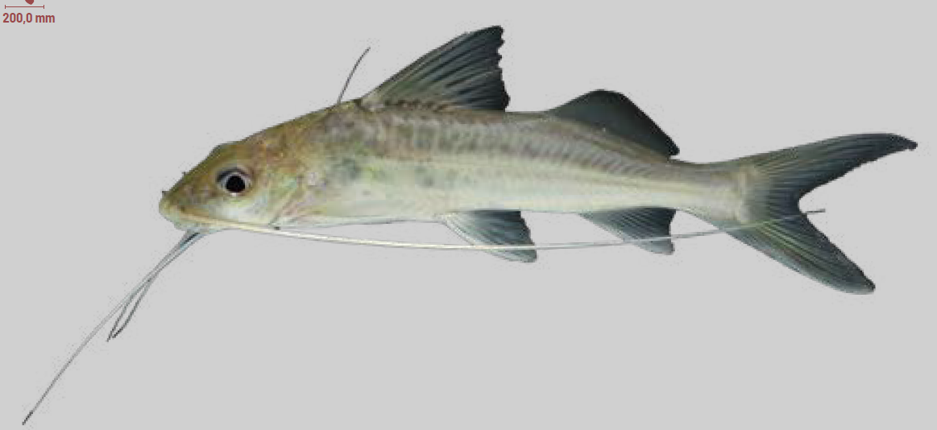
FIGURE 46. Pimelodus argenteus. (Photograph: Luiz Fernando Caserta, Source: Carvalho et al. 2022).
Diagnosis. Pimelodus argenteus differs from its congeners in the following: from P. albicans by a dorsal spine reaching the adipose fin when depressed (vs. dorsal spine not reaching the adipose fin when depressed), body silver sometimes with very diffuse spots (vs. body with two dark bands interspersed with two thinner white bands running longitudinally along the body), fins with a dark coloration (vs. whitish fins); from P. altissimus by a small, triangular adipose fin (vs. adipose fin long and inserted immediately behind the dorsal fin), fins with a dark coloration (vs. translucent fins); from P. gr. blochii by dark coloration in the fins (vs. whitish fins), moreover, this species is found in La Plata Basin (vs. Amazon Basin); from P. gr. maculatus by a body with silver color sometimes with diffuse spots (vs. yellowish or brown body with sharp brown spots); from P. ornatus by a body with silver color sometimes with diffuse spots (vs. body with two dark bands running longitudinally along the body), dorsal fin dark in color (vs. whitish dorsal fin with a black spot in the anterosuperior region), caudal fin uniformly dark in color (vs. caudal fin with two dark bands arranged longitudinally, one in each lobe); from P. pictus by a body with silver color sometimes with diffuse spots (vs. body with sharp black spots), fins of dark color (vs. fins with black spots).
Description. Body slightly elongated, head tall with a long snout. Maxillary barbels reaching the base of the caudal fin or occasionally surpassing it. Dorsal fin with a well-developed spine reaching the adipose fin when depressed (Souza-Filho & Shibatta 2007).
Coloration in life. Body of uniform silver color or with very diffuse spots. Head slightly darker on the dorsal part. All fins dark (Souza-Filho & Shibatta 2007).
Distribution. Recorded in the Mamoré sub-basin (Amazon Basin) (Carvajal-Vallejos & Fernández 2011), and in the Bermejo (Torrico et al. 2020) and Pilcomayo sub-basins (La Plata Basin) (Baigún & Minotti 2019).
Importance. There is no available information.
Pimelodus gr. blochii Valenciennes 1840 (Figure 47)
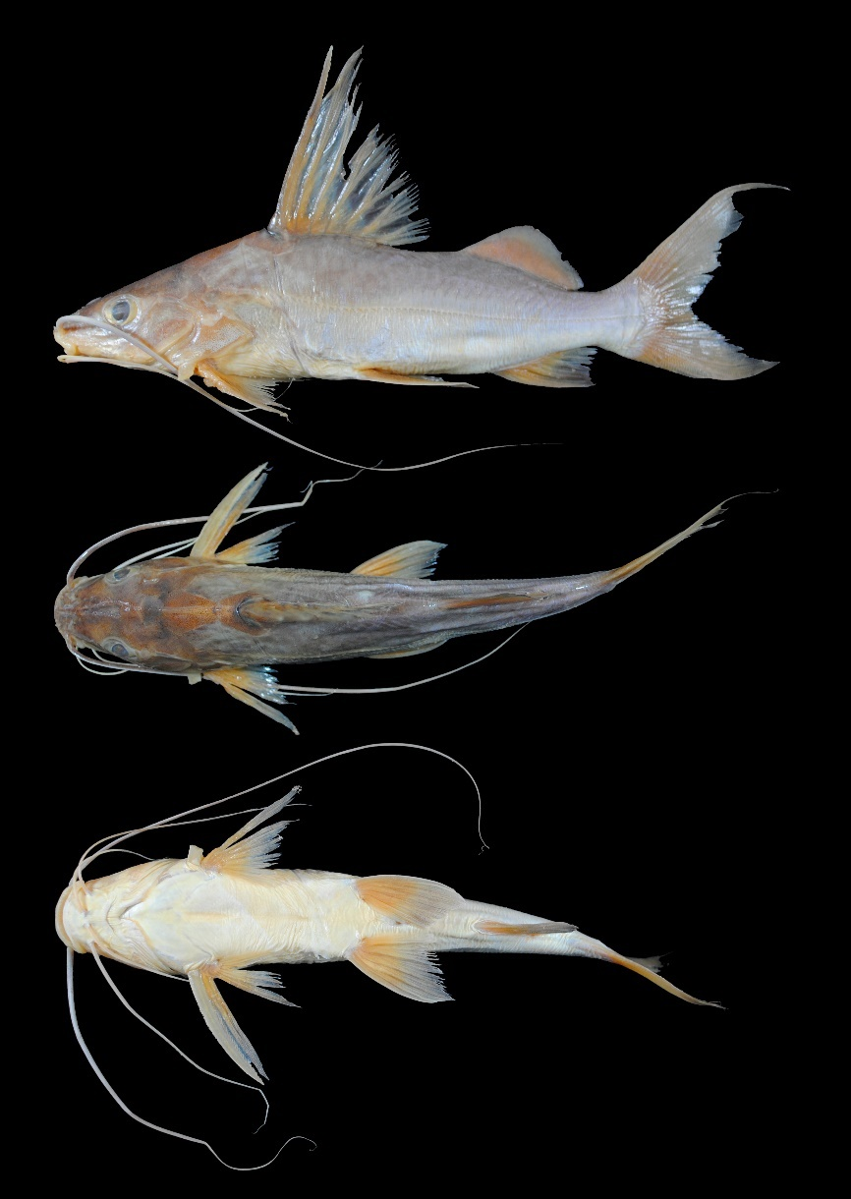
FIGURE 47. Pimelodus gr. blochii, UMSS 16930.2, 139.2 mm SL, Ichilo River, Yuca Lagoon, Mamoré sub-basin, Amazon Basin.
Examined material (13 specimens). Amazon Basin: UMSS 4004 (1, 144.8 mm SL), Ichilo River, mouth of Chimoré River ICH 12, -16.746503 -64.8411056, 16 Nov 2006, F. Carvajal, E. De La Barra, C. Flores; UMSS 4064 (1, 138.7 mm SL), Ichilo River, El Peligro, -16.599444 -64.7571389, 20 Nov 2006, F. Carvajal, E. De La Barra, C. Flores; UMSS 16371 (2, 119.8-124.3 mm SL), Yata River (Puerto Victoria), -13.14498889 -66.18185556, 23 Apr 2017, M. Careaga, C. Ergueta, E. Gutiérrez; UMSS 16901 (4, 128.2-143.4 mm SL), Campamento Chimoré IC Lagoon, -16.716308 -64.8281840, 1 Mar 1994, M. Maldonado, L. Meneses; UMSS 16930 (2, 139.2-144.3 mm SL), Ichilo River IB2, Yuca Lagoon, -16.795220 -64.7823040, 12 Aug 2004, F. Carvajal, M. Pouilly; UMSS 16943.1 (1, 145.9 mm SL), San Martín River, California, -13.300890 -63.5589876, 10 Oct 2002, F. Carvajal; UMSS 16968.1 (1, 134.5 mm SL), Blanco River, Amasa bay, -13.210570 -63.7243253, 17 Aug 2005, J. Camacho, L. Córdova, M. Pouilly. La Plata Basin: UMSS 12525 (1, 160.5 mm SL), Cáceres Lagoon, -18.958609 -57.7929300, 1 Apr 2006, C. Navia.
Common name. Mandín in Puerto Rico and Cobija (Pando); chupa in Riberalta and Cachuela Esperanza (Beni); bagre chupa in Puerto Villarroel (Cochabamba); griso in Rurrenabaque (Beni) (Carvajal-Vallejos et al. 2011).
Diagnosis. Pimelodus gr. blochii differs from its congeners in the following: from P. albicans by the left posterior nostril to right posterior nostril (15.4-18.6% HL vs. 20.8-24.2%), postorbital length (29.5-33.5% HL vs. 36.7-39.9%), orbital diameter (22.1-26% HL vs. 13.8-17.2%), adipose fin base length (16.6-20.9% SL vs. 20.1-26%), uniformly grayish body color (vs. body with two dark bands interspersed with two thinner white bands running longitudinally along the body); from P. altissimus by the distance between internal mental barbels (6.6-9.7% HL vs. 15-15.2%), distance between the external mental barbels (29.4-34.2% SL vs. 51.6-52.7%), distance between internal and external mental barbel (9.2-11.3% SL vs. 18.7-19.2%), predorsal length (41.3-45.3% SL vs. 33.4-33.7%), internal mental barbel length (28.4-43.2% SL vs. 53.9-55.7%), external mental barbel length (41.2-66% SL vs. 122.8-132.9%), maxillary barbel length (84.4-142% SL vs. 159.9-172.7%), body width (20.1-22.5% SL vs. 17.6-17.7%), head length (27.9-30.4% SL vs. 21.4-22.5%), dorsal fin insertion to adipose fin origin (12.1-16.6% SL vs. 3.5%), adipose fin base length (16.6-20.9% SL vs. 44.3-44.8%), anal fin origin to adipose fin insertion (18-19.8% SL vs. 23.3-25.1%); from P. argenteus by whitish coloration in the fins (vs. dark-colored fins), moreover, this species inhabits in the Amazon Basin (vs. La Plata Basin); from P. gr. maculatus by a uniformly grayish body color without spots (vs. yellowish or brown body with brown spots); from P. ornatus by the left posterior nostril to right posterior nostril (15.4-18.6% HL vs. 23.6-25.2%), postorbital length (29.5-33.5% HL vs. 40.4-41.7%), orbital diameter (22.1-26% HL vs. 14.2-17.8%), distance between internal mental barbels (6.6-9.7% HL vs. 18.4-20.6%), internal mental barbel length (28.4-43.2% SL vs. 13-16.6%), external mental barbel length (41.2-66% SL vs. 25.8-27.6%), maxillary barbel length (84.4-142% SL vs. 56.8-62.6%), uniformly grayish body color (vs. body with two dark bands running longitudinally along the body), uniformly colored caudal fin (vs. caudal fin with two dark bands arranged longitudinally, one in each lobe); from P. pictus by a uniformly colored body without spots (vs. body with black spots on the flanks and fins).
Description. Morphometric data presented in Table 26. Straight profile from the tip of the snout to approximately the height of the operculum, then slightly convex to the origin of the dorsal fin. Head longer than wide, eyes relatively large in laterodorsal position. Mouth in subterminal position, vomerine and palatine teeth present or absent. Posterior supraoccipital process short, with a broad base and narrowing sides; in contact with the nuchal plate. Humeral process wide and pointed. Pectoral fin approaching the origin of the pelvic fin; strong and serrated spine on the inner margin. Pelvic fin approaching the origin of the anal fin. Pectoral and pelvic fins of similar size. Dorsal fin with a very long spine, serrated on the posterior margin. Adipose fin relatively short, more or less triangular. Base of the adipose fin longer than the base of the anal fin. Caudal fin strongly bifurcated with pointed lobes; upper lobe slightly longer. Maxillary barbels very long, occasionally extending beyond the caudal fin; inner mental barbels reaching halfway to the pectoral spine, outer mental barbels reaching the tip of the pelvic fin. Dorsal fin rays I+6; anal fin rays iii+9-10; pectoral fin rays I+9-11; pelvic fin rays i+5; caudal fin rays 15.
TABLE 26. Morphometric data of Pimelodus gr. blochii. N: Number of individuals, SD: Standard deviation, Min: Minimum value, Max: Maximum value.
Measurements | N | Mean | SD | Min | Max
SL (mm) | 13 | 139 | 10.7 | 119.8 | 160.5
Percents of head length (% HL)
Nuchal plate length | 13 | 16.1 | 1.3 | 13.4 | 18.2
Interorbital distance | 13 | 34.1 | 1.1 | 31.9 | 36.0
Left posterior nostril to right posterior nostril | 13 | 17.1 | 1.0 | 15.4 | 18.6
Left anterior nostril to right anterior nostril | 13 | 18.3 | 1.2 | 16.7 | 20.0
Left anterior nostril to left posterior nostril | 13 | 15.2 | 0.9 | 14.0 | 17.0
Posterior nostril to anterior margin of orbit | 13 | 24.6 | 1.3 | 22.3 | 26.9
Snout length | 13 | 48.0 | 0.9 | 46.9 | 50.5
Postorbital length | 13 | 32.2 | 1.1 | 29.5 | 33.5
Orbital diameter | 13 | 24.0 | 1.2 | 22.1 | 26.0
Head depth | 13 | 76.5 | 7.2 | 69.4 | 94.3
Mouth width | 13 | 41.8 | 2.8 | 36.2 | 47.5
Distance between internal mental barbels | 13 | 8.40 | 1.0 | 6.60 | 9.70
Distance between external mental barbels | 13 | 31.5 | 1.7 | 29.4 | 34.2
Distance between internal and external mental barbel | 13 | 10.4 | 0.7 | 9.20 | 11.3
Percents of standard length (% SL)
Predorsal length | 13 | 43.4 | 1.1 | 41.3 | 45.3
Internal mental barbel length | 13 | 35.3 | 4.9 | 28.4 | 43.2
External mental barbel length | 13 | 58.1 | 7.0 | 41.2 | 66.0
Maxillary barbel length | 13 | 110.6 | 16.8 | 84.4 | 142.0
Body width | 13 | 21.5 | 0.7 | 20.1 | 22.5
Body depth | 13 | 26.2 | 1.3 | 24.9 | 29.4
Head length | 13 | 29.0 | 0.8 | 27.9 | 30.4
Pectoral fin origin to dorsal fin insertion | 13 | 39.0 | 1.0 | 36.9 | 40.4
Dorsal fin origin to pelvic fin origin | 13 | 29.8 | 1.7 | 27.7 | 34.0
Dorsal fin origin to anal fin origin | 13 | 45.5 | 1.3 | 44.0 | 48.2
Pectoral fin origin to pelvic fin origin | 13 | 29.3 | 1.3 | 26.7 | 31.3
Pelvic fin origin to anal fin origin | 13 | 24.6 | 1.5 | 22.0 | 27.7
Pectoral spine length | 13 | 22.2 | 2.1 | 19.5 | 26.4
Distance between pelvic fins | 13 | 14.2 | 0.5 | 13.5 | 15.3
Pelvic fin length | 13 | 21.5 | 1.0 | 20.3 | 23.5
Dorsal spine length | 11 | 29.5 | 3.7 | 24.3 | 36.7
Dorsal fin base length | 13 | 17.8 | 0.8 | 16.6 | 18.9
Dorsal fin insertion to adipose fin origin | 13 | 14.7 | 1.2 | 12.1 | 16.6
Adipose fin base length | 13 | 19.4 | 1.2 | 16.6 | 20.9
Anal fin base length | 13 | 12.3 | 0.6 | 11.2 | 13.2
Anal fin origin to adipose fin insertion | 13 | 19.4 | 0.6 | 18.0 | 19.8
Caudal peduncle height | 13 | 9.10 | 0.5 | 8.20 | 9.80
Dorsal fin origin to anterior caudal base | 13 | 62.3 | 2.5 | 56.6 | 65.9
Adipose fin origin to anterior caudal base | 13 | 30.6 | 1.6 | 28.1 | 33.0
Anal fin origin to anterior caudal base | 13 | 24.7 | 1.4 | 22.9 | 27.1
Caudal peduncle length | 13 | 12.2 | 1.7 | 8.20 | 14.2
Coloration in alcohol. Body light gray with the dorsal region slightly darker; ventral region whitish. Head with the supraoccipital and the posterior region of the nuchal plate in dark gray. Fins yellowish to cream-colored.
Coloration in life. Body grayish to olive with some metallic green or golden reflections. Fins whitish to grayish.
Distribution. Present in the Madeira, Orthon, Beni, Yata, Mamoré, Grande, Iténez, B-MD-O, MM-I sub-basins (Amazon Basin), and in the Paraguay sub-basin (La Plata Basin). Also recorded in the Madre de Dios sub-basin (Amazon Basin) (Carvajal-Vallejos & Fernández 2011).
Importance. There is no available information.
Ecological notes. Omnivorous species, feeds on fish, insects, fruits, seeds, plant material, and detritus. Inhabits the banks of large rivers; occasionally found in streams and/or lagoons. This species can be active both during the day and at night, is gregarious, and tends to seek refuge among rocks and logs (Sarmiento et al. 2014). Additionally, it undertakes reproductive migrations (Keith et al. 2000).
Pimelodus gr. maculatus La Cepède 1803 (Figure 48)
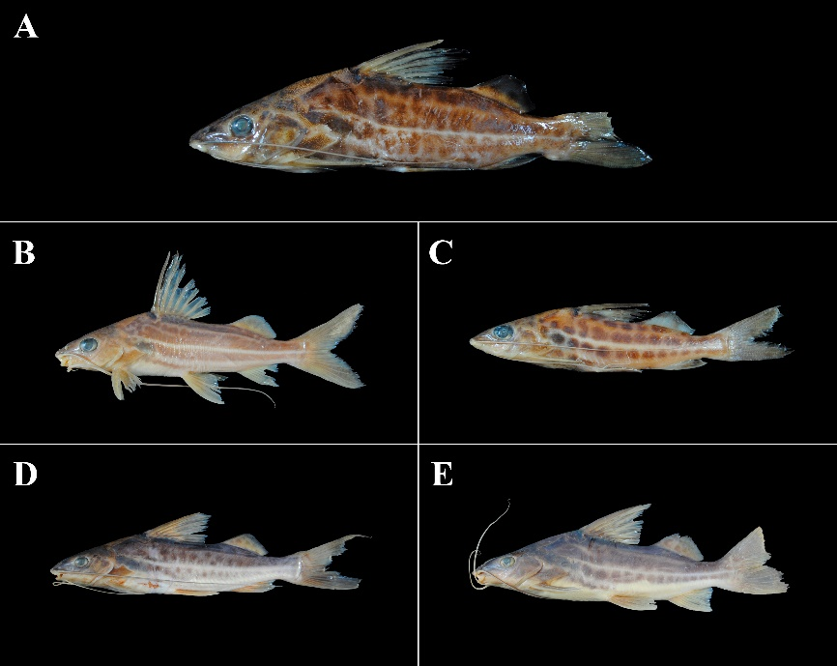
FIGURE 48. Pimelodus gr. maculatus, (A) UMSS 4562.2, 99.1mm SL, San Martín River, El Cerro Bay, Iténez sub-basin, Amazon Basin; (B) UMSS 16952, 111.9 mm SL, Paraguá River, Firme floor, Iténez sub-basin, Amazon Basin; (C) UMSS 16907, 73.1 mm SL, same data as (B); (D) UMSS 17579, 128.4 mm SL, Beni River, Apichana stream, Beni sub-basin, Amazon Basin; (E) UMSS 13385.1, 147.6 mm SL, Paraguay River, Negro River, Paraguay sub-basin, La Plata Basin.
Examined material (11 specimens). Amazon Basin: UMSS 4553 (1, 132.4 mm SL), San Martín River, Redonda Lagoon, -13.306111 -63.5552780, 13 Aug 2005, J. Camacho, L. Córdova, M. Pouilly; UMSS 4565 (2, 95.4-99.3 mm SL), San Martín River, El Cerro Bay, -13.325413 -63.500727, 10 Aug 2005, J. Camacho, L. Córdova, M. Pouilly; UMSS 15424 (2, 112.6-117.7 mm SL), Beni River between Kaka and Tuichi, -14.637010 -67.5541900, 5 Sep 2015, L. Córdova, M. Jaldin, C. Rocabado; UMSS 16952 (2, 110.2-114.6 mm SL), Paraguá River, Firme floor, -13.628116 -61.7359114, 26 Sep 2005, J. Camacho, L. Córdova, M. Pouilly; UMSS 16954 (1, 105.5 mm SL), same data as UMSS 16952; UMSS 16957 (1, 106.1 mm SL), Madeira River, Villa Bella, -10.379891 -65.3918990, 8 Oct 2009, L. Córdova, E. de la Barra, M. Arraya; UMSS 17579 (1, 128.4 mm SL), Apichana stream, -15.115078 -67.6657320, 10 Nov 2014, F. Carvajal, H. Delgadillo. La Plata Basin: UMSS 13385 (1, 147.6 mm SL), Paraguay River, Negro River, -20.090680 -58.1516720, 8 Nov 2012, E. De La Barra, J. Coronel, H. Muñoz.
Diagnosis. Pimelodus gr. maculatus differs from its congeners in the following: from P. albicans by the postorbital length (30.1-37.3% HL vs. 36.7-39.9%), orbital diameter (20.9-28.6% HL vs. 3.8-17.2%), internal mental barbel length (30.5-38.2% SL vs. 18.1-27.3%), body color yellowish or brown with brown spots (vs. body with two dark bands interspersed with two thinner white bands running longitudinally); from P. altissimus by the distance between external mental barbels (30.8-35% HL vs. 51.6-52.7%), distance between internal and external mental barbel (8.7-11.3% HL vs. 18.7-19.2%), predorsal length (40.6-48.1% SL vs. 33.4-33.7%), internal mental barbel length (30.5-38.2% SL vs. 53.9-55.7%), external mental barbel length (44.6-61.4% SL vs. 122.8-132.9%), maxillary barbel length (85.2-139.9% SL vs. 159.9-172.7%), dorsal fin insertion to adipose fin origin (14-17.2% SL vs. 3.5%), adipose fin base length (16.9-20% SL vs. 44.3-44.8%), body color brown or yellowish with brown spots (vs. uniform-colored body); from P. argenteus by a yellowish or brown body with distinct brown spots (vs. body with a silvery color sometimes with diffuse spots); from P. gr. blochii by a yellowish or brown body with brown spots (vs. uniformly grayish body without spots); from P. ornatus by the distance between internal mental barbels (7.3-13% HL vs. 18.4-20.6%), internal mental barbel length (30.5-38.2% SL vs. 13-16.6%), external mental barbel length (44.6-61.4% SL vs. 25.8-27.6%), maxillary barbel length (85.2-139.9% SL vs. 56.8-62.6%), dorsal spine length (24.8-28.9% SL vs. 17.4%), yellowish or brown body with brown spots (vs. body without spots, with two dark bands running longitudinally); from P. pictus by a yellowish or brown body with brown spots (vs. silvery body with black spots).
Description. Morphometric data presented in Table 27. Head longer than wide; large eyes in laterodorsal position. Mouth in subterminal position; vomerine and palatine patches present or absent. Posterior supraoccipital process with a broad base, narrowing sides, and in contact with the nuchal plate. Pectoral fin approaching the origin of the pelvic fin; strong and serrated spine on the inner margin. Pelvic fin approaching the origin of the anal fin. Pectoral fin slightly longer than the pelvic fin. Dorsal fin with the spine shorter than the subsequent ray; spine with poorly developed serrations on the posterior margin. Adipose fin short and triangular. Base of the adipose fin longer than the base of the anal fin. Bifurcated caudal fin. Maxillary barbels reaching the caudal fin; inner mental barbels approaching the origin of the pectoral fin; outer mental barbels reaching the tip of the pectoral spine. Dorsal fin rays I+6; anal fin rays iii-iv +8-10; pectoral fin rays I+9-10; pelvic fin rays i+5; caudal fin rays 15.
TABLE 27. Morphometric data of Pimelodus gr. maculatus. N: Number of individuals, SD: Standard deviation, Min: Minimum value, Max: Maximum value.
Measurements | N | Mean | SD | Min | Max
SL (mm) | 11 | 115.4 | 15.4 | 95.4 | 147.6
Percents of head length (% HL)
Nuchal plate length | 11 | 15.2 | 1.4 | 13.1 | 17.6
Interorbital distance | 11 | 34.1 | 3.6 | 26.6 | 38.6
Left posterior nostril to right posterior nostril | 11 | 18.2 | 1.2 | 16.4 | 20.2
Left anterior nostril to right anterior nostril | 11 | 17.9 | 1.2 | 16.4 | 19.8
Left anterior nostril to left posterior nostril | 11 | 15.5 | 1.4 | 12.9 | 18.0
Posterior nostril to anterior margin of orbit | 11 | 23.2 | 2.3 | 19.7 | 26.9
Snout length | 11 | 47.9 | 1.7 | 45.9 | 50.9
Postorbital length | 11 | 33.4 | 2.5 | 30.1 | 37.3
Orbital diameter | 11 | 23.7 | 2.2 | 20.9 | 28.6
Head depth | 11 | 78.0 | 8.3 | 73.0 | 96.7
Mouth width | 11 | 42.5 | 3.0 | 38.5 | 47.7
Distance between internal mental barbels | 11 | 9.20 | 1.8 | 7.30 | 13.0
Distance between external mental barbels | 11 | 32.7 | 1.5 | 30.8 | 35.0
Distance between internal and external mental barbel | 11 | 9.90 | 0.9 | 8.70 | 11.3
Percents of standard length (% SL)
Predorsal length | 11 | 44.8 | 2.2 | 40.6 | 48.1
Internal mental barbel length | 11 | 33.5 | 4.1 | 30.5 | 38.2
External mental barbel length | 10 | 52.9 | 5.2 | 44.6 | 61.4
Maxillary barbel length | 11 | 110.1 | 15.4 | 85.2 | 139.9
Body width | 11 | 22.3 | 2.3 | 18.2 | 25.3
Body depth | 11 | 27.1 | 1.3 | 25.1 | 29.1
Head length | 11 | 29.8 | 1.8 | 26.8 | 32.4
Pectoral fin origin to dorsal fin insertion | 11 | 38.7 | 1.7 | 35.4 | 41.0
Dorsal fin origin to pelvic fin origin | 11 | 30.3 | 1.5 | 27.3 | 32.7
Dorsal fin origin to anal fin origin | 11 | 45.3 | 1.6 | 43.2 | 48.6
Pectoral fin origin to pelvic fin origin | 11 | 29.0 | 1.6 | 25.7 | 31.7
Pelvic fin origin to anal fin origin | 11 | 23.9 | 1.9 | 20.6 | 26.2
Pectoral spine length | 10 | 23.2 | 1.7 | 19.6 | 25.5
Distance between pelvic fins | 11 | 13.7 | 0.8 | 12.5 | 15.4
Pelvic fin length | 11 | 21.2 | 1.1 | 18.5 | 22.4
Dorsal spine length | 9 | 27.2 | 1.2 | 24.8 | 28.9
Dorsal fin base length | 11 | 17.2 | 0.7 | 15.7 | 17.7
Dorsal fin insertion to adipose fin origin | 11 | 15.5 | 1.1 | 14.0 | 17.2
Adipose fin base length | 11 | 18.5 | 0.9 | 16.9 | 20.0
Anal fin base length | 11 | 12.3 | 1.2 | 10.5 | 14.9
Anal fin origin to adipose fin insertion | 11 | 19.8 | 1.0 | 18.8 | 21.9
Caudal peduncle height | 11 | 9.40 | 0.4 | 8.80 | 9.90
Dorsal fin origin to anterior caudal base | 11 | 62.2 | 2.3 | 59.7 | 66.1
Adipose fin origin to anterior caudal base | 11 | 28.1 | 8.5 | 26.6 | 32.7
Anal fin origin to anterior caudal base | 11 | 25.0 | 1.7 | 22.9 | 27.5
Caudal peduncle length | 11 | 12.1 | 0.9 | 9.0 | 13.2
Coloration in alcohol. Body with a background of brown or cream with dark brown or gray spots distributed in rows or irregularly on the flanks. Dorsal head with dark tones, brown, or gray. Ventral region whitish. Fins with or without spots, sometimes dark, faint gray, or yellowish.
Coloration in life. Body with metallic reflections of green, golden, or silver colors. Fins mostly gray with spots.
Distribution. Present in the Madeira, Orthon, Beni, Yata, Mamoré, Iténez, B-MD-O, and MM-I sub-basins (Amazon Basin), and in the Paraguay sub-basin (La Plata Basin). Also recorded in the Grande (Maldonado et al. 2020) and Madre de Dios sub-basins (Amazon Basin), and in the Bermejo sub-basin (La Plata Basin) (Torrico et al. 2020).
Importance. There is no available information.
Ecological notes. Omnivorous species, feeds on fish, plant material (seeds, fruits, algae), and invertebrates (mollusks, crustaceans, worms). Inhabits the bottom and is considered to undertake migrations (Kuczynski et al. 2015).
Pimelodus ornatus Kner 1858 (Figure 49)
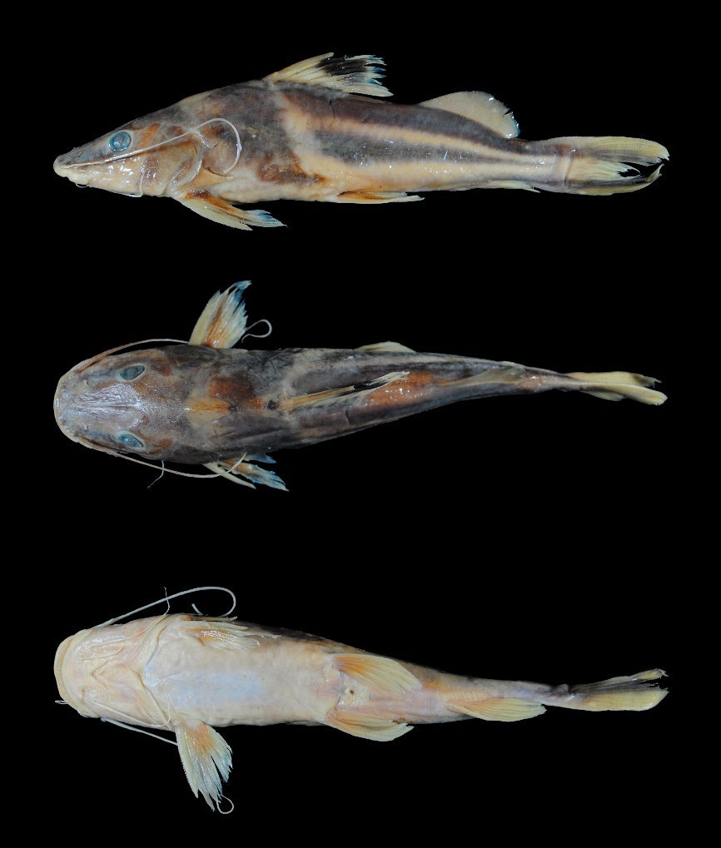
FIGURE 49. Pimelodus ornatus, UMSS 16932, 174 mm SL, Blanco River, La Granja Lagoon, Iténez sub-basin, Amazon Basin.
Common name. Griso in Rurrenabaque (Beni) (Carvajal-Vallejos et al. 2011).
Examined material (three specimens). Amazon Basin: UMSS 2935 (1, 166.6 mm SL), San Martín River, El Cerro Bay, -13.325413 -63.500727, 10 Aug 2005, J. Camacho, L. Córdova, M. Pouilly; UMSS 7136 (1, 348.5 mm SL), Beni River, Napurera stream, -13.601385 -67.3893550, 30 Jun 2008, F. Carvajal; UMSS 16932 (1, 183.3 mm SL), Blanco River, La Granja Lagoon, -13.260587 -63.7094919, 22 Feb 2007, J. Camacho, L. Córdova, M. Pouilly.
Diagnosis. Pimelodus ornatus differs from its congeners in the following: from P. albicans by the distance between anterior nostrils (21.1-22.1% HL vs. 14.4-19.2%), distance between internal mental barbels (18.4-20.6% HL vs. 8.4-14.3%), internal mental barbel length (13-16.6% SL vs. 18.1-27.3%), external mental barbel length (25.8-27.6% SL vs. 33.3-46.8%), dorsal fin with a dark spot in the anterosuperior region (vs. dorsal fin whitish without a spot), caudal fin with two dark bands arranged longitudinally, one in each lobe (vs. caudal fin uniformly colored); from P. altissimus by the distance between external mental barbels (35.1-40.4% HL vs. 51.6-52.7%), distance between internal and external mental barbel (9.9-11.5% HL vs. 18.7-19.2%), predorsal length (43.2-45.2% SL vs. 33.4-33.7%), internal mental barbel length (13-16.6% SL vs. 53.9-55.7%), external mental barbel length (25.8-27.6% SL vs. 122.8-132.9%), maxillary barbel length (56.8-62.6% SL vs. 159.9-172.7%), body width (23.3-26.1% SL vs. 17.6-17.7%), head length (32.6-32.9% SL vs. 21.4-22.5%), pectoral fin origin to pelvic fin origin (29-30.9% SL vs. 22.8-23.1%), pelvic fin length (16.8-19.6% SL vs. 24.8-26.1%), dorsal spine length (17.4% SL vs. 28.3-35.3%), dorsal fin insertion to adipose fin origin (14.5-17.5% SL vs. 3.5%), adipose fin base length (19.7-21.9% SL vs. 44.3-44.8%), anal fin origin to adipose fin insertion (15.9-17.4% SL vs. 23.3-25.1%), body with two dark bands running longitudinally (vs. uniformly colored body); from P. argenteus by a body with two dark bands running longitudinally (vs. body with a silver color sometimes with diffuse spots), whitish dorsal fin with a black spot in the anterosuperior region (vs. dark-colored dorsal fin), caudal fin with two dark bands arranged longitudinally, one in each lobe (vs. uniformly dark-colored caudal fin); from P. gr. blochii by the left posterior nostril to right posterior nostril (23.6-25.2% HL vs. 15.4-18.6%), postorbital length (40.4-41.7% HL vs. 29.5-33.5%), orbital diameter (14.2-17.8% HL vs. 22.1-26%), distance between internal mental barbels (18.4-20.6% HL vs. 6.6-9.7%), internal mental barbel length (13-16.6% SL vs. 28.4-43.2%), external mental barbel length (25.8-27.6% SL vs. 41.2-66%), maxillary barbel length (56.8-62.6% SL vs. 84.4-142%), body with two dark bands running longitudinally (vs. uniformly grayish-colored body), caudal fin with two dark bands arranged longitudinally, one in each lobe (vs. uniformly colored caudal fin); from P. gr. maculatus by the distance between internal mental barbels (18.4-20.6% HL vs. 7.3-13%), internal mental barbel length (13-16.6% SL vs. 30.5-38.2%), external mental barbel length (25.8-27.6% SL vs. 44.6-61.4%), maxillary barbel length (56.8-62.6% SL vs. 85.2-139.9%), dorsal spine length (17.4% SL vs. 24.8-28.9%), body with two dark bands running longitudinally (vs. yellowish or brownish body with brown spots); from P. pictus body with two dark bands running longitudinally (vs. body without bands, silver-colored with black spots).
Description. Morphometric data presented in Table 28. Straight profile from the tip of the snout to the beginning of the posterior supraoccipital process, then slightly convex to the origin of the dorsal fin. Head longer than wide; eyes in a laterodorsal position; mouth in a subterminal position with the premaxillary patch partially exposed. Posterior supraoccipital process with a broad base, tapering sides without contacting the nuchal plate. Elongated and pointed humeral process. Pectoral fin reaching halfway between its origin and the pelvic fin origin; strong and serrated spine on both margins. Pelvic fin surpassing halfway between its origin and the anal fin origin. Pectoral spine shorter than the ventral fin. Relatively long adipose fin. Adipose fin base twice as long as the anal fin base. Forked caudal fin. Maxillary barbels reaching just over half of the body; internal mental barbels surpassing the gill membranes, external mental barbels surpassing the origin of the pectoral fin. Dorsal fin rays I+6; anal fin rays ii-iii+9; pectoral fin rays I+10; pelvic fin rays i+5; caudal fin rays 15.
TABLE 28. Morphometric data of Pimelodus ornatus. N: Number of individuals, SD: Standard deviation, Min: Minimum value, Max: Maximum value.
Measurements | N | Mean | SD | Min | Max
SL (mm) | 3 | 232.8 | 100.5 | 166.6 | 348.5
Percents of head length (% HL)
Nuchal plate length | 3 | 18.3 | 0.5 | 17.8 | 18.7
Interorbital distance | 3 | 32.8 | 4.4 | 28.6 | 37.4
Left posterior nostril to right posterior nostril | 3 | 24.4 | 0.8 | 23.6 | 25.2
Left anterior nostril to right anterior nostril | 3 | 21.8 | 0.6 | 21.1 | 22.1
Left anterior nostril to left posterior nostril | 3 | 13.0 | 0.6 | 12.7 | 13.7
Posterior nostril to anterior margin of orbit | 3 | 21.5 | 0.9 | 20.4 | 22.2
Snout length | 3 | 48.3 | 1.6 | 46.7 | 49.9
Postorbital length | 3 | 41.0 | 0.7 | 40.4 | 41.7
Orbital diameter | 3 | 16.3 | 1.9 | 14.2 | 17.8
Head depth | 3 | 68.5 | 0.6 | 68.0 | 69.2
Mouth width | 3 | 51.3 | 2.5 | 48.9 | 53.9
Distance between internal mental barbels | 3 | 19.2 | 1.2 | 18.4 | 20.6
Distance between external mental barbels | 3 | 37.0 | 2.9 | 35.1 | 40.4
Distance between internal and external mental barbel | 3 | 10.6 | 0.8 | 9.90 | 11.5
Percents of standard length (% SL)
Predorsal length | 3 | 44.4 | 1.0 | 43.2 | 45.2
Internal mental barbel length | 3 | 15.0 | 1.8 | 13.0 | 16.6
External mental barbel length | 3 | 26.7 | 0.9 | 25.8 | 27.6
Maxillary barbel length | 3 | 59.4 | 2.9 | 56.8 | 62.6
Body width | 3 | 24.3 | 1.6 | 23.3 | 26.1
Body depth | 3 | 24.5 | 0.7 | 23.7 | 25.1
Head length | 3 | 32.8 | 0.1 | 32.6 | 32.9
Pectoral fin origin to dorsal fin insertion | 3 | 38.6 | 1.3 | 37.1 | 39.4
Dorsal fin origin to pelvic fin origin | 3 | 28.5 | 0.8 | 27.5 | 29.1
Dorsal fin origin to anal fin origin | 3 | 44.4 | 0.6 | 43.9 | 45.1
Pectoral fin origin to pelvic fin origin | 3 | 29.8 | 1.0 | 29.0 | 30.9
Pelvic fin origin to anal fin origin | 3 | 23.4 | 1.1 | 22.1 | 24.2
Pectoral spine length | 3 | 15.5 | 1.1 | 14.2 | 16.2
Distance between pelvic fins | 3 | 14.6 | 0.8 | 14.0 | 15.5
Pelvic fin length | 3 | 18.5 | 1.5 | 16.8 | 19.6
Dorsal spine length | 1 | 17.4 | * | 17.4 | 17.4
Dorsal fin base length | 3 | 17.2 | 0.5 | 16.8 | 17.8
Dorsal fin insertion to adipose fin origin | 3 | 16.2 | 1.6 | 14.5 | 17.5
Adipose fin base length | 3 | 20.7 | 1.1 | 19.7 | 21.9
Anal fin base length | 3 | 11.2 | 1.4 | 9.70 | 12.3
Anal fin origin to adipose fin insertion | 3 | 16.9 | 0.8 | 15.9 | 17.4
Caudal peduncle height | 3 | 7.90 | 0.4 | 7.50 | 8.20
Dorsal fin origin to anterior caudal base | 3 | 62.2 | 1.1 | 61.0 | 63.2
Adipose fin origin to anterior caudal base | 3 | 29.6 | 1.0 | 28.6 | 30.5
Anal fin origin to anterior caudal base | 3 | 22.2 | 0.4 | 21.9 | 22.7
Caudal peduncle length | 3 | 10.3 | 1.3 | 9.0 | 11.5
Coloration in alcohol. Body with a yellowish background and two black bands on the flanks, one on the dorsum and another at the level of the lateral line, both separated by an unpigmented region; anterior region of the body behind the operculum to the beginning of the dorsal and pelvic fins in black; yellowish band extending from the origin of the dorsal fin to the origin of the pelvic fin. Dorsal fin with a dark spot in the middle region. Adipose and anal fins yellowish; pectoral and pelvic fins yellowish with some dark areas; caudal fin with both lobes having a dark longitudinal band, the upper one contiguous to the dorsal band.
Coloration in life. Yellowish areas of the body silvery, the rest of the coloration pattern similar to that of individuals preserved in alcohol.
Distribution. Present in the Beni and Iténez sub-basins (Amazon Basin). Also recorded in Mamoré (Carvajal-Vallejos & Fernández 2011), Orthon and Madre de Dios sub-basins (Amazon Basin) (Torrico et al. 2020), and in the Pilcomayo (Maldonado et al. 2019), Bermejo (Sarmiento et al. 2019), and Paraguay sub-basins (La Plata Basin) (Torrico et al. 2020).
Importance. Subsistence fishing in Rurrenabaque (Carvajal-Vallejos et al. 2011).
Ecological notes. Piscivorous species with crepuscular habits. Inhabits areas of rapids or rocky bottoms of pools with logs. Emits loud sounds, and its spines have a certain mucosity that is toxic and painful when causing wounds (Keith et al. 2000).
Pimelodus pictus Steindachner 1876 (Figure 50)
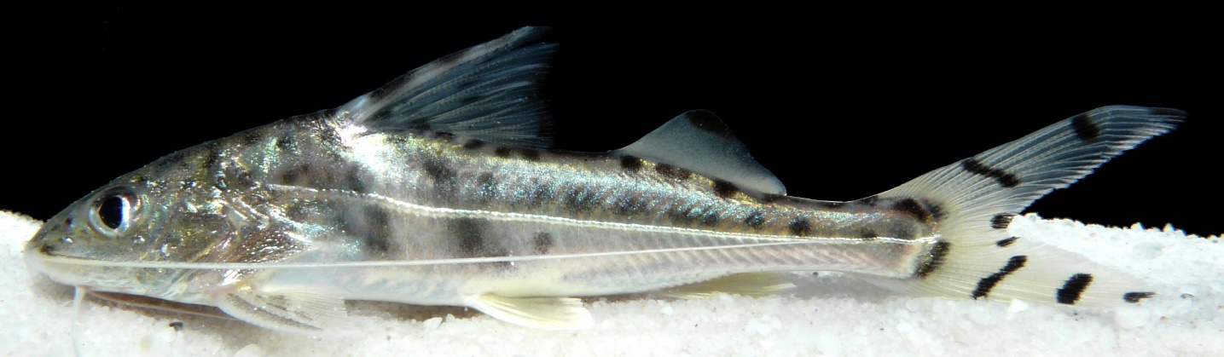
FIGURE 50. Pimelodus pictus, Photograph: Fernando M. Carvajal-Vallejos. Specimen from an aquarium in Iquitos, Perú.
Diagnosis. Pimelodus pictus differs from its congeners in the following: from P. albicans by a silvery body with black spots on the flanks and fins (vs. body with two dark bands interspersed with two thinner white bands running longitudinally along the body); from P. altissimus by a silvery body with black spots on the flanks and fins (vs. whitish body without spots); from P. argenteus by a body with sharp black spots (vs. body sometimes with diffuse spots), translucent fins with black spots (vs. fins of dark coloration without spots); from P. gr. blochii silver-colored body with black spots (vs. uniformly gray body without spots); translucent fins with black spots (vs. whitish fins without spots); from P. gr. maculatus silver-colored body with black spots on the flanks and fins (vs. yellowish or brownish body with brown spots); from P. ornatus silver-colored body with black spots (vs. body with two dark bands running longitudinally along the body).
Description. Convex profile; maxilla longer than the mandible with premaxillary teeth projecting completely. Caudal fin strongly forked (Eigenmann & Eigenmann 1890). Small fish with large eyes in a superior position. Posterior supraoccipital process in contact with the nuchal plate. Humeral process quite large. Maxillary barbels reaching the caudal fin. Spines of the pectoral and dorsal fins strong, sharp, and serrated. Dorsal fin rays I+6, anal fin rays 11, pectoral fin rays I+9, caudal fin rays 17 (Galvis et al. 2006).
Coloration in life. Intensely silver body and head with many black spots on the flanks and head, some sharp and others diffuse. Body with a spotless band extending from the origin of the dorsal fin to above the origin of the pelvic fin. Whitish fins or black spots; caudal fin with spots or bands.
Distribution. Recorded in the Beni (Carvajal-Vallejos & Fernández 2011) and Madre de Dios sub-basins (Amazon Basin) (Torrico et al. 2020).
Importance. Aquarium trade.
Ecological notes. Omnivorous species, feeding on insects, fish remains, and highly decomposed material (Pérez et al. 2001). Has crepuscular and semi-nocturnal habits, quite territorial; in areas with high food availability, they grow quickly and prey on smaller individuals (Burguess 1989).
Pinirampus Bleeker 1858
Diagnosis. Wide and flattened barbels; first pectoral ray flexible and flattened; first dorsal ray flexible with an elongated filament surpassing the subsequent ray; long adipose fin; very narrow supraoccipital process, extending near the nuchal plate; strongly forked caudal fin; body color grayish to brown (Eigenmann & Eigenmann 1890).
Distribution. Amazon and La Plata basins (Figure 51).

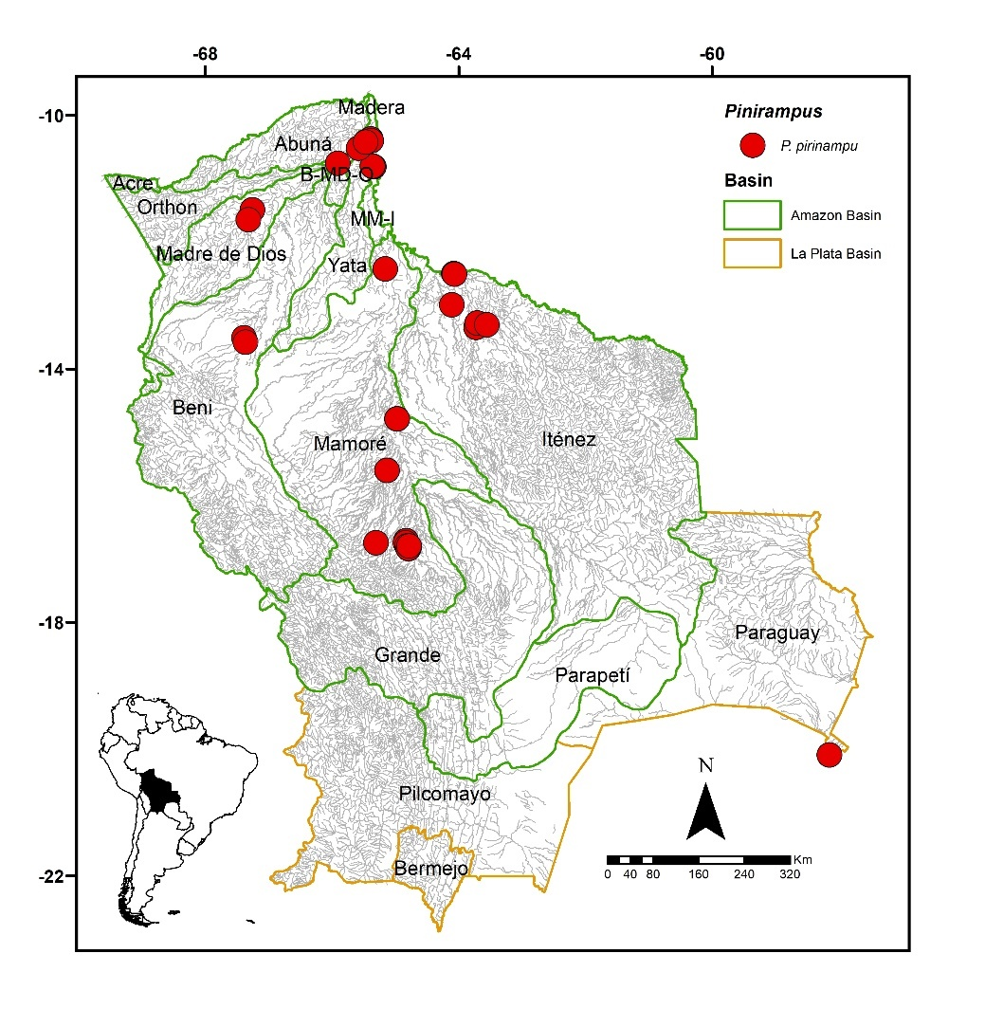
FIGURE 51. Collection sites of 213 lots of Pinirampus pirinampu deposited in the Ichthyological Collection UMSS – Museo d'Orbigny (Cochabamba, Bolivia). Some symbols represent more than one lot. Some symbols represent more than one lot.
Included species. Pinirampus pirinampu.
Comments. Genus proposed by Bleeker (1858) for Pimelodus pirinampu Spix & Agassiz 1829 as the type species, currently a synonym of P. pirinampu. Currently, two species are known: P. pirinampu (Spix & Agassiz 1829) in the Amazon, Orinoco, Essequibo, and Paraná basins, and P. argentina (MacDonagh 1938) in the Paraná basin (Fricke et al. 2023). Of the two valid species known, P. pirinampu is present in Bolivia.
Pinirampus pirinampu (Spix & Agassiz 1829) (Figure 52)
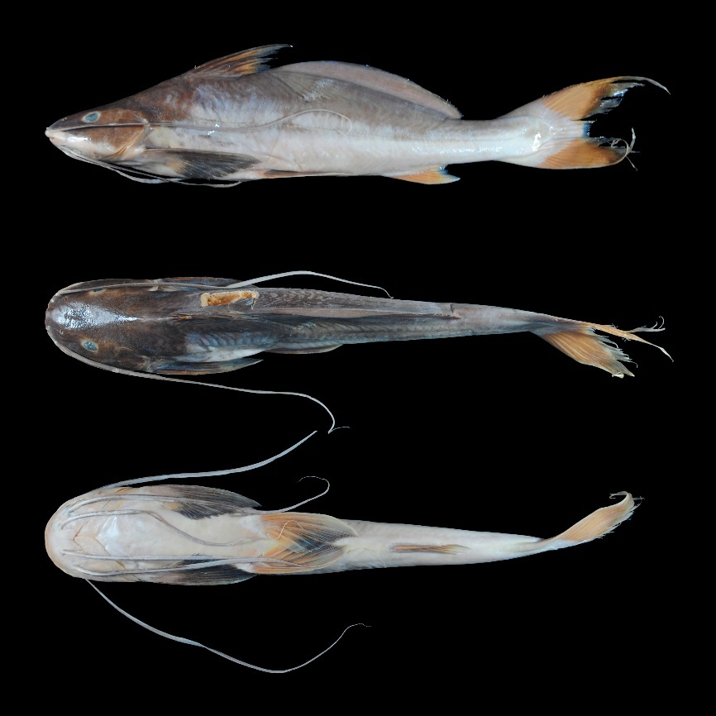
FIGURE 52. Pinirampus pirinampu, UMSS 17728, 270 mm SL, Mamoré River, upstream of Villa Bella, Mamoré-Iténez sub-basin, Amazon Basin.
Examined material (20 specimens). Amazon Basin: UMSS 6135 (1, 327 mm SL), Ichilo River, Puerto Villarroel ICH 5A, -16.838889 -64.7916667, 19 Sep 2007, F. Carvajal; UMSS 6136 (1, 347 mm SL), same data as UMSS 6135; UMSS 6137 (1, 34 mm SL), same data as UMSS 6135; UMSS 6138 (1, 318 mm SL), same data as UMSS 6135; UMSS 6141 (1, 324 mm SL), same data as UMSS 6135; UMSS 6893 (1, 310.4 mm SL), Beni River, Cachueriña, Villa Bella, -10.424455 -65.4703710, 24 Jul 2007, F. Carvajal; UMSS 7239 (1, 310 mm SL), same data as UMSS 6135; UMSS 7240 (1, 353 mm SL), same data as UMSS 6135; UMSS 7241 (1, 315.1 mm SL), same data as UMSS 6135; UMSS 7548 (1, 320 mm SL), same data as UMSS 6135; UMSS 7549 (1, 313.7 mm SL), same data as UMSS 6135; UMSS 7558 (1, 310.1 mm SL), same data as UMSS 6135; UMSS 7559 (1, 317 mm SL), same data as UMSS 6135; UMSS 7546 (1, 351 mm SL), same data as UMSS 6135; UMSS 7550 (1, 340 mm SL), same data as UMSS 6135; UMSS 7551 (1, 333 mm SL), same data as UMSS 6135; UMSS 7555 (1, 343 mm SL), same data as UMSS 6135; UMSS 7557 (1, 336 mm SL), same data as UMSS 6135; UMSS 7567 (1, 317 mm SL), same data as UMSS 6135; UMSS 16980 (1, 313.9 mm SL), Mamoré River, Villa Bella, -10.403147 -65.3813550, 26 Oct 2007, R. Palacios.
Common name. Piranambú and barba chata in Puerto Rico and Cobija (Pando); blanquillo in Riberalta, Trinidad, Rurrenabaque, Cachuela Esperanza (Beni), and Puerto Villarroel (Cochabamba); blanquillo blanco in Puerto Villarroel (Cochabamba) (Lauzanne & Loubens 1985, Carvajal-Vallejos et al. 2011).
Diagnosis. Same as the genus.
Description. Morphometric data presented in Table 29. Straight ascending profile from the snout to the origin of the dorsal fin; the last portion with a steeper slope. Head longer than wide; eyes in a laterodorsal position. Mouth in a subterminal position; premaxillary patch arched. Posterior supraoccipital process not visible. Small and pointed humeral process. Pectoral fin reaching the origin of the pelvic fin; first ray simple and flexible. Pelvic fin extending beyond the midpoint between its origin and the anal fin. Pectoral fin longer than the pelvic fin. Dorsal fin with the first ray flexible and elongated. Very long adipose fin, originating very close behind the dorsal fin. Anal fin with a concave posterior margin. Base of the adipose fin four times longer than the base of the anal fin. Caudal fin strongly forked with pointed lobes. Thick and flattened barbels; maxillaries reaching the insertion of the adipose fin; shorter mental barbels. Dorsal fin rays I+6; anal fin rays iii-iv+8-9, pectoral fin rays I+13-14; pelvic fin rays i+5; caudal fin rays 15.
TABLE 29. Morphometric data of Pinirampus pirinampu. N: Number of individuals, SD: Standard deviation, Min: Minimum value, Max: Maximum value.
Measurements | N | Mean | SD | Min | Max
SL (mm) | 20 | 327 | 14.6 | 310 | 353
Percents of head length (% HL)
Nuchal plate length | 20 | 11.0 | 1.0 | 8.10 | 12.9
Interorbital distance | 20 | 40.3 | 1.1 | 38.1 | 42.4
Left posterior nostril to right posterior nostril | 20 | 26.4 | 0.9 | 24.8 | 28.2
Left anterior nostril to right anterior nostril | 20 | 23.0 | 1.4 | 20.9 | 25.8
Left anterior nostril to left posterior nostril | 20 | 14.7 | 0.9 | 12.5 | 15.8
Posterior nostril to anterior margin of orbit | 20 | 23.3 | 0.9 | 21.9 | 25.0
Snout length | 20 | 50.3 | 0.7 | 48.7 | 51.3
Postorbital length | 20 | 40.5 | 1.5 | 38.9 | 45.3
Orbital diameter | 20 | 13.1 | 1.4 | 10.7 | 15.8
Head depth | 20 | 72.3 | 2.3 | 68.4 | 76.9
Mouth width | 20 | 62.6 | 1.9 | 58.8 | 65.3
Distance between internal mental barbels | 20 | 19.5 | 2.0 | 16.3 | 23.2
Distance between external mental barbels | 20 | 46.3 | 2.5 | 43.0 | 51.2
Distance between internal and external mental barbel | 20 | 12.0 | 1.0 | 10.5 | 14.2
Percents of standard length (% SL)
Predorsal length | 20 | 31.5 | 1.2 | 29.7 | 35.6
Internal mental barbel length | 20 | 44.9 | 4.1 | 39.2 | 55.4
External mental barbel length | 20 | 55.3 | 5.7 | 45.3 | 71.9
Maxillary barbel length | 20 | 62.2 | 6.0 | 55.5 | 80.3
Body width | 20 | 20.5 | 0.9 | 18.2 | 22.5
Body depth | 20 | 22.2 | 0.9 | 21.0 | 24.3
Head length | 20 | 24.4 | 0.7 | 22.1 | 25.5
Pectoral fin origin to dorsal fin insertion | 20 | 27.0 | 0.8 | 25.2 | 28.8
Dorsal fin origin to pelvic fin origin | 20 | 27.6 | 1.2 | 25.5 | 30.2
Dorsal fin origin to anal fin origin | 20 | 48.4 | 0.7 | 47.0 | 50.1
Pectoral fin origin to pelvic fin origin | 20 | 23.9 | 1.1 | 22.6 | 25.9
Pelvic fin origin to anal fin origin | 20 | 28.2 | 2.0 | 20.3 | 30.4
Pectoral spine length | 20 | 24.4 | 0.9 | 22.1 | 25.7
Distance between pelvic fins | 20 | 11.5 | 0.8 | 9.60 | 12.8
Pelvic fin length | 20 | 20.2 | 2.2 | 18.2 | 28.1
Dorsal spine length | 14 | 32.7 | 2.3 | 28.6 | 35.6
Dorsal fin base length | 20 | 12.1 | 0.2 | 11.5 | 12.4
Dorsal fin insertion to adipose fin origin | 20 | 3.60 | 1.1 | 1.50 | 5.70
Adipose fin base length | 20 | 45.1 | 1.8 | 40.8 | 49.1
Anal fin base length | 20 | 11.0 | 0.6 | 9.70 | 12.2
Anal fin origin to adipose fin insertion | 20 | 20.7 | 0.7 | 19.7 | 22.3
Caudal peduncle height | 20 | 9.10 | 0.4 | 8.30 | 9.70
Dorsal fin origin to anterior caudal base | 20 | 72.3 | 1.4 | 69.8 | 75.5
Adipose fin origin to anterior caudal base | 20 | 57.5 | 1.6 | 54.1 | 60.6
Anal fin origin to anterior caudal base | 20 | 29.3 | 0.8 | 27.7 | 31.2
Caudal peduncle length | 20 | 18.0 | 0.6 | 16.8 | 19.2
Coloration in alcohol: Body with a light gray background, dorsum and head dorsally darker. Ventral region cream or whitish. Dorsal, pectoral, and pelvic fins dark gray; anal and caudal fins yellowish; adipose fin light gray.
Coloration in life. Body with metallic green reflections. The rest of the coloration similar to individuals preserved in alcohol.
Distribution. Present in the Madeira, Madre de Dios, Beni, Mamoré, Iténez, B-MD-O, MM-I sub-basins (Amazon Basin), and the Paraguay sub-basin (La Plata Basin). Also recorded in the Acre and Orthon sub-basins (Amazon Basin) (Torrico et al. 2020).
Importance. Commercial and subsistence fishing trade in Puerto Rico, Cobija, Riberalta, Rurrenabaque, Cachuela Esperanza, and Puerto Villarroel (Carvajal-Vallejos et al. 2011).
Ecological notes. Carnivorous species, feeding on shrimp, fish, and insects. Inhabits the bottom of the main river channels and lagoons, occasionally found in flood areas. Diurnal and quite voracious, forming schools. Undertakes long reproductive migrations (Sarmiento et al. 2014).
Platynematichthys Bleeker 1858
Diagnosis. Dorsal fin with a dark elongated filament; no serrations on the posterior margin of the dorsal spine; caudal fin with a dark spot on the lower lobe; flattened barbels; posterior supraoccipital process in contact with the nuchal plate; skull surface covered with skin; vomerian patches in a wide band; palatine patches absent; body white with a silver sheen and small dark spots on the body (Eigenmann & Eigenmann 1890, Guzmán 2011).
Distribution. Amazon Basin (Figure 53).
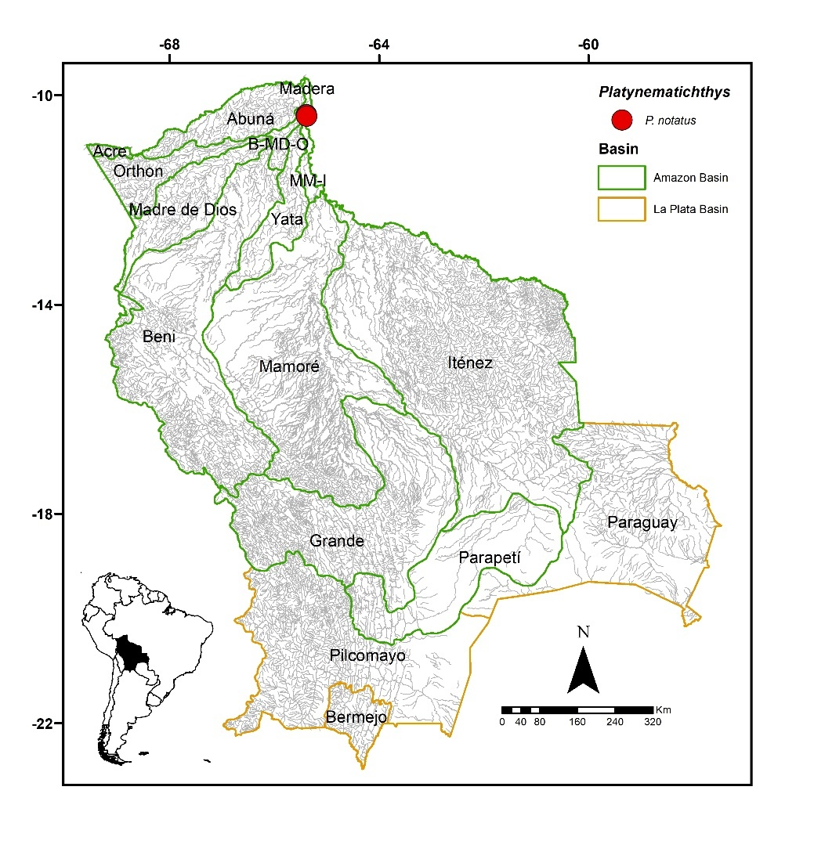
FIGURE 53. Collection sites of nine lots of Platynematichthys notatus deposited in the Ichthyological Collection UMSS – d'Orbigny Museum (Cochabamba, Bolivia). Some symbols represent more than one lot.
Included species. Monospecific genus, with Platynematichthys notatus as the sole representative.
Comments. Genus proposed by Bleeker (1858) for Bagrus punctulatus Kner 1857 as the type species, currently synonymous with P. notatus. Only one species is known, P. notatus (Jardine 1841).
Platynematichthys notatus (Jardine 1841) (Figure 54)
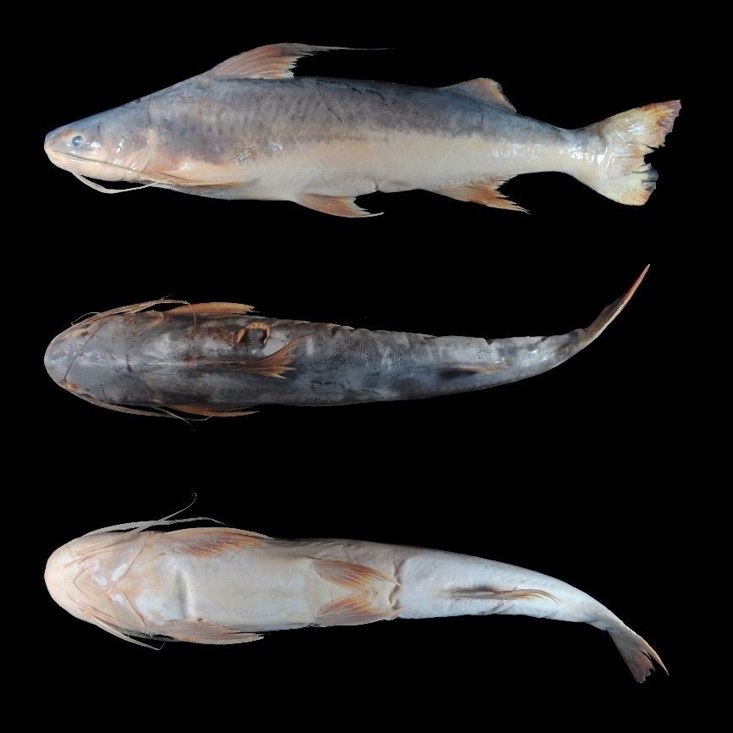
FIGURE 54. Platynematichthys notatus, UMSS 7193, 410 mm SL, Mamoré River, Villa Bella, Madeira sub-basin, Amazon Basin.
Examined material (two specimens). Amazon Basin: UMSS 7614 (1, 433 mm SL), Mamoré River, upstream from Villa Bella, -10.403147 -65.3813550, 21 Oct 2007, F. Carvajal; UMSS 7622 (1, 502 mm SL), same data as UMSS 7614.
Common name. Peshi rey in Cachuela Esperanza (Beni) (Carvajal-Vallejos et al. 2011).
Diagnosis. Same as the genus.
Description. Morphometric data presented in Table 30. Straight profile ascending from the tip of the snout to the origin of the dorsal fin. Head longer than wide; eyes in a laterodorsal position. Mouth wide and in a subterminal position. Vomerine patch broad; palatine patch absent. Posterior supraoccipital process with a broad base, tapering sides, and in contact with the nuchal plate. Humeral process absent. Pectoral fin extending to more than halfway between its origin and the pelvic fin origin; ossified spine. Pelvic fin extending to more than halfway between its origin and the anal fin origin. Pectoral fin longer than pelvic fin. Dorsal fin with a very long filament on the first ray. Adipose fin small and triangular. Anal fin with a concave posterior margin. Base of the adipose fin of similar size to the base of the anal fin. Forked caudal fin. Maxillary barbel extending near the tip of the pectoral fin; mental barbels shorter. Dorsal fin rays I+6; anal fin rays ii+11; pectoral fin rays I+9-10; caudal fin rays 15.
TABLE 30. Morphometric data of Platynematichthys notatus. N: Number of individuals, SD: Standard deviation, Min: Minimum value, Max: Maximum value.
Measurements | N | Mean | SD | Min | Max
SL (mm) | 2 | 467.5 | 48.8 | 433 | 502
Percents of head length (% HL)
Interorbital distance | 2 | 43.8 | 0.8 | 43.3 | 44.4
Left posterior nostril to right posterior nostril | 2 | 40.4 | 0.6 | 39.9 | 40.8
Left anterior nostril to right anterior nostril | 2 | 30.4 | 1.5 | 29.4 | 31.4
Left anterior nostril to left posterior nostril | 2 | 17.2 | 1.5 | 16.1 | 18.2
Posterior nostril to anterior margin of orbit | 2 | 7.20 | 0.5 | 6.80 | 7.60
Snout length | 2 | 41.3 | 1.5 | 40.3 | 42.3
Postorbital length | 2 | 48.1 | 0.7 | 47.6 | 48.6
Orbital diameter | 2 | 15.7 | 0.9 | 15.0 | 16.4
Head depth | 2 | 71.3 | 5.4 | 67.5 | 75.2
Mouth width | 2 | 60.7 | 2.1 | 59.3 | 62.2
Distance between internal mental barbels | 2 | 19.6 | 0.5 | 19.2 | 20.0
Distance between external mental barbels | 2 | 39.9 | 0.4 | 39.6 | 40.1
Distance between internal and external mental barbel | 2 | 13.3 | 0.6 | 12.8 | 13.7
Percents of standard length (% SL)
Predorsal length | 2 | 33.3 | 1.4 | 32.3 | 34.3
Internal mental barbel length | 2 | 14.8 | 2.3 | 13.2 | 16.5
External mental barbel length | 2 | 25.9 | 0.1 | 25.8 | 26.0
Maxillary barbel length | 2 | 38.2 | 0.1 | 38.2 | 38.3
Body width | 2 | 19.0 | 1.3 | 18.1 | 19.9
Body depth | 2 | 23.4 | 2.0 | 22.0 | 24.8
Head length | 2 | 24.2 | 0.8 | 23.7 | 24.8
Pectoral fin origin to dorsal fin insertion | 2 | 28.8 | 1.3 | 27.9 | 29.8
Dorsal fin origin to pelvic fin origin | 2 | 29.5 | 2.0 | 28.1 | 30.9
Dorsal fin origin to anal fin origin | 2 | 45.6 | 0.3 | 45.4 | 45.8
Pectoral fin origin to pelvic fin origin | 2 | 28.1 | 1.5 | 27.0 | 29.1
Pelvic fin origin to anal fin origin | 2 | 23.3 | 0.2 | 23.2 | 23.5
Pectoral spine length | 2 | 20.4 | 0.1 | 20.3 | 20.4
Distance between pelvic fins | 2 | 11.7 | 0.4 | 11.4 | 12.0
Pelvic fin length | 1 | 16.9 | * | 16.9 | 16.9
Dorsal spine length | 1 | 37.1 | * | 37.1 | 37.1
Dorsal fin base length | 2 | 11.3 | 0.9 | 10.7 | 11.9
Dorsal fin insertion to adipose fin origin | 2 | 31.5 | 0.1 | 31.4 | 31.6
Adipose fin base length | 2 | 14.8 | 0.7 | 14.4 | 15.3
Anal fin base length | 2 | 15.1 | 1.9 | 13.8 | 16.5
Anal fin origin to adipose fin insertion | 2 | 21.9 | 0.7 | 21.3 | 22.4
Caudal peduncle height | 2 | 8.0 | 0.5 | 7.60 | 8.30
Dorsal fin origin to anterior caudal base | 2 | 72.3 | 0.0 | 72.3 | 72.3
Adipose fin origin to anterior caudal base | 2 | 30.0 | 0.2 | 29.9 | 30.2
Anal fin origin to anterior caudal base | 2 | 31.0 | 0.1 | 31.0 | 31.1
Caudal peduncle length | 2 | 15.8 | 1.7 | 14.7 | 17.0
Coloration in alcohol. Body with a white background, with the upper half and dorsal head in gray; anterior body region with small diffuse dark spots. Ventral body and head whitish. Pectoral, pelvic, and anal fins yellowish; dorsal fin with dark gray margins and filament; adipose fin the same color as the back; lower lobe of the caudal fin with a black spot.
Coloration in life. Silvery body with a darker dorsal contrast. Head with the tip of the snout having a diffuse black spot.
Distribution. Present in the Madeira and MM-I sub-basins (Amazon Basin). Also recorded in the Madre de Dios, Iténez, Beni (Carvajal-Vallejos & Fernández 2011) and Mamoré sub-basins (Amazon Basin) (Torrico et al. 2020).
Importance. Commercial and subsistence fishing trade in Cachuela Esperanza (Carvajal-Vallejos et al. 2011).
Ecological notes. Inhabits the main channels of rivers (Salles & Zuanon 2013).
Platysilurus Haseman 1911
Diagnosis. Upper jaw slightly longer; long fontanel, starting on snout and extending along the mid-dorsal line to the area behind the eye, where it transforms into a narrow groove in the supraoccipital process; nuchal plate fused to the posterior supraoccipital process; maxillary barbels very long, extending beyond the caudal fin and ossified in their proximal third; strong and wide pectoral spine; slender caudal peduncle; strongly bifurcated caudal fin, with the base of the upper lobe having an external dark spot; caudal fin with filaments; dark spots of various sizes on the lateral region of the body (Schultz 1944).
Distribution. Amazon Basin (Figure 55).
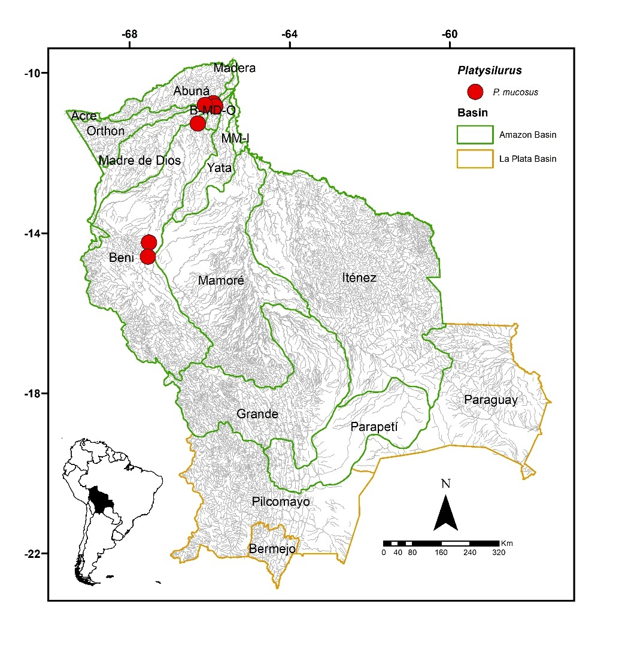
FIGURE 55. Collection sites of 15 lots of Platysilurus mucosus deposited in the Ichthyological Collection UMSS – Museo d'Orbigny (Cochabamba, Bolivia). Some symbols represent more than one lot.
Included species. Platysilurus mucosus.
Comments. Genus proposed by Haseman (1911) for Platysilurus barbatus Haseman as the type species, currently synonymous with P. mucosus. Currently, three species are known: P. mucosus (Vaillant 1880) in the Amazon and Orinoco basins, P. malarmo Schultz 1944 in the Maracaibo Lake basin (Colombia and Venezuela), and P. olallae (Orcés 1977) in the Amazon Basin (Ecuador) (Fricke et al. 2023). Of the three valid species known, P. mucosus is present in Bolivia.
Platysilurus mucosus (Vaillant 1880) (Figure 56)
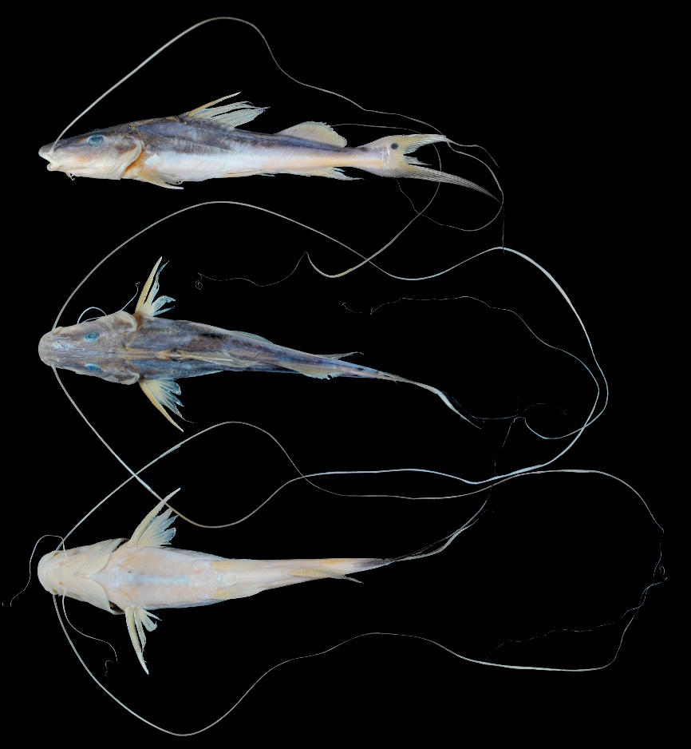
FIGURE 56. Platysilurus mucosus, UMSS 17472, 143.7 mm SL, Tuichi River, confluence of Beni River, Beni sub-basin, Amazon Basin.
Examined material (21 specimens). Amazon Basin: UMSS 7696 (1, 160.44 mm SL), Beni River, Copaina, -14.241324 -67.5143300, 9 Dec 2007, F. Carvajal; UMSS 10630 (1, 84.77 mm SL), Beni River, Florida stream, -10.756444 -65.9073889, 14 Jun 2011, F. Carvajal, T. Pérez, A. Argote, F. Vieira; UMSS 10696 (1, 70.91 mm SL), same data as UMSS 10630; UMSS 10697 (1, 59.22 mm SL), same data as UMSS 10630; UMSS 10751 (3, 87.62-90.09 mm SL), same data as UMSS 10630; UMSS 10762 (6, 90.45-96.62 mm SL), same data as UMSS 10630; UMSS 10861 (1, 109.32 mm SL), same data as UMSS 10630; UMSS 11081 (1, 104.64 mm SL), Beni River, Florida, 10.837330 -65.8581000, 27 Oct 2001, F. Carvajal, T. Pérez, A. Argote, F. Machicao; UMSS 11304 (2, 85.04-95.9 mm SL), same data as UMSS 11081; UMSS 11296 (1, 68.21 mm SL), Beni River, Florida, 10.837330 -65.8581000, 27 Oct 2001, F. Carvajal, T. Pérez, A. Argote, F. Machicao; UMSS 11396 (1, 152.33 mm SL), Beni River, Portachuelo Lake, -11.267070 -66.2974200, 6 May 2012, A. Argote; UMSS 13322 (1, 90.86 mm SL), Orthon River, -10.802622 -66.1166667, 6 Nov 2012, T. Oberdorff, J. Zubieta, F. Carvajal, A. Argote, D. Barrozo; UMSS 17472 (1, 154.95 mm SL), Tuichi River, confluence of Beni River, -14.59274 -67.54237, 13 Nov 2014, F. Carvajal, H. Delgadillo.
Diagnosis. Same as the genus.
Description. Morphometric data presented in Table 31. Straight profile from the tip of the snout to the origin of the dorsal fin. Head longer than wide; eyes in a laterodorsal position. Mouth in a subterminal position. Posterior supraoccipital process elongated and grooved, in contact with the nuchal plate. Humeral process short and pointed. Pectoral fin extending very close to the origin of the pelvic fin; ossified and dorsoventrally flattened spine, serrated on both margins. Pelvic fin extending very close to the origin of the anal fin. Pectoral fin slightly longer than pelvic fin. Dorsal fin with a strong and sharp spine. Short adipose fin. Base of the adipose fin slightly longer than the base of the anal fin. Caudal fin strongly bifurcated with long filaments in both lobes, formed by the first simple ray plus the first three branched rays. Maxillary barbels very long, exceeding the body length; mental barbels shorter. Dorsal fin rays I+6; anal fin rays iii-v+9-10; pectoral fin rays I+9-10; pelvic fin rays i+5; caudal fin rays 12-14.
TABLE 31. Morphometric data of Platysilurus mucosus. N: Number of individuals, SD: Standard deviation, Min: Minimum value, Max: Maximum value.
Measurements | N | Mean | SD | Min | Max
SL (mm) | 21 | 98.7 | 26.6 | 59.2 | 160.4
Percents of head length (% HL)
Nuchal plate length | 21 | 15.0 | 1.2 | 13.3 | 17.9
Interorbital distance | 21 | 22.3 | 1.0 | 20.0 | 23.9
Left posterior nostril to right posterior nostril | 21 | 16.9 | 1.7 | 13.4 | 18.9
Left anterior nostril to right anterior nostril | 21 | 20.2 | 1.6 | 17.4 | 23.0
Left anterior nostril to left posterior nostril | 21 | 18.1 | 1.6 | 14.8 | 22.0
Posterior nostril to anterior margin of orbit | 21 | 26.9 | 1.4 | 24.6 | 29.6
Snout length | 21 | 52.0 | 1.5 | 48.5 | 54.5
Postorbital length | 21 | 33.9 | 1.3 | 30.1 | 36.4
Orbital diameter | 21 | 16.3 | 1.0 | 14.9 | 18.5
Head depth | 21 | 54.0 | 4.1 | 45.2 | 61.4
Mouth width | 21 | 38.7 | 2.4 | 34.0 | 43.2
Distance between internal mental barbels | 21 | 12.8 | 2.6 | 8.40 | 17.4
Distance between external mental barbels | 21 | 27.5 | 3.3 | 20.9 | 33.6
Distance between internal and external mental barbel | 21 | 10.0 | 0.8 | 8.50 | 11.4
Percents of standard length (% SL)
Predorsal length | 21 | 43.2 | 1.2 | 41.3 | 46.6
Internal mental barbel length | 18 | 11.2 | 1.4 | 8.80 | 13.5
External mental barbel length | 21 | 40.4 | 3.0 | 34.9 | 48.4
Maxillary barbel length | 15 | 250.1 | 30.2 | 205.3 | 315.5
Body width | 21 | 23.3 | 1.1 | 21.3 | 25.5
Body depth | 21 | 19.1 | 1.5 | 16.2 | 21.6
Head length | 21 | 32.7 | 1.4 | 30.8 | 35.8
Pectoral fin origin to dorsal fin insertion | 21 | 33.1 | 1.3 | 31.3 | 36.2
Dorsal fin origin to pelvic fin origin | 21 | 22.2 | 1.4 | 19.3 | 24.6
Dorsal fin origin to anal fin origin | 21 | 38.5 | 1.5 | 36.0 | 42.1
Pectoral fin origin to pelvic fin origin | 21 | 24.7 | 1.5 | 22.0 | 27.1
Pelvic fin origin to anal fin origin | 21 | 22.2 | 1.3 | 18.9 | 24.5
Pectoral spine length | 21 | 22.7 | 0.9 | 21.1 | 24.9
Distance between pelvic fins | 21 | 10.0 | 0.5 | 8.90 | 10.8
Pelvic fin length | 21 | 19.6 | 1.4 | 17.4 | 22.6
Dorsal spine length | 18 | 20.9 | 1.5 | 16.9 | 23.4
Dorsal fin base length | 21 | 17.6 | 1.0 | 16.5 | 21.0
Dorsal fin insertion to adipose fin origin | 21 | 13.3 | 1.5 | 10.3 | 16.2
Adipose fin base length | 21 | 19.6 | 1.1 | 17.7 | 21.5
Anal fin base length | 21 | 11.8 | 1.6 | 10.6 | 18.3
Anal fin origin to adipose fin insertion | 21 | 17.0 | 0.9 | 15.6 | 19.3
Caudal peduncle height | 21 | 5.60 | 0.3 | 4.90 | 6.40
Dorsal fin origin to anterior caudal base | 21 | 61.1 | 1.8 | 59.0 | 65.5
Adipose fin origin to anterior caudal base | 21 | 30.5 | 1.7 | 26.8 | 33.7
Anal fin origin to anterior caudal base | 21 | 26.0 | 1.9 | 22.2 | 29.9
Caudal peduncle length | 21 | 14.9 | 1.9 | 11.8 | 21.2
Coloration in alcohol. Body with a white background, with the upper half and dorsal head in gray; some black spots on the flanks. Ventral body and head whitish. Adipose fin base dark. Dorsal, adipose, pectoral, pelvic, and anal fins yellowish. Caudal fin with the outer half of the lower lobe dark; dark caudal filaments; base of the upper lobe with a dark spot.
Coloration in life. Similar to individuals preserved in alcohol.
Distribution. Present in the Beni, Iténez, B-MD-O and Orthon sub-basins (Amazon Basin). Also recorded in the Madre de Dios, Mamoré, Madeira (Carvajal-Vallejos & Fernández 2011) and Acre sub-basins (Amazon Basin) (Torrico et al. 2020).
Importance. There is no available information.
Platystomatichthys Bleeker 1862
Diagnosis. Head highly depressed anteriorly; long and pointed snout, with the upper jaw projecting much beyond the lower jaw; maxillary barbels extending beyond the length of the body and ossified in their proximal third; strongly bifurcated caudal fin, with pointed lobes; caudal fin with filaments (Eigenmann & Eigenmann 1890).
Distribution. Amazon Basin (Figure 57).
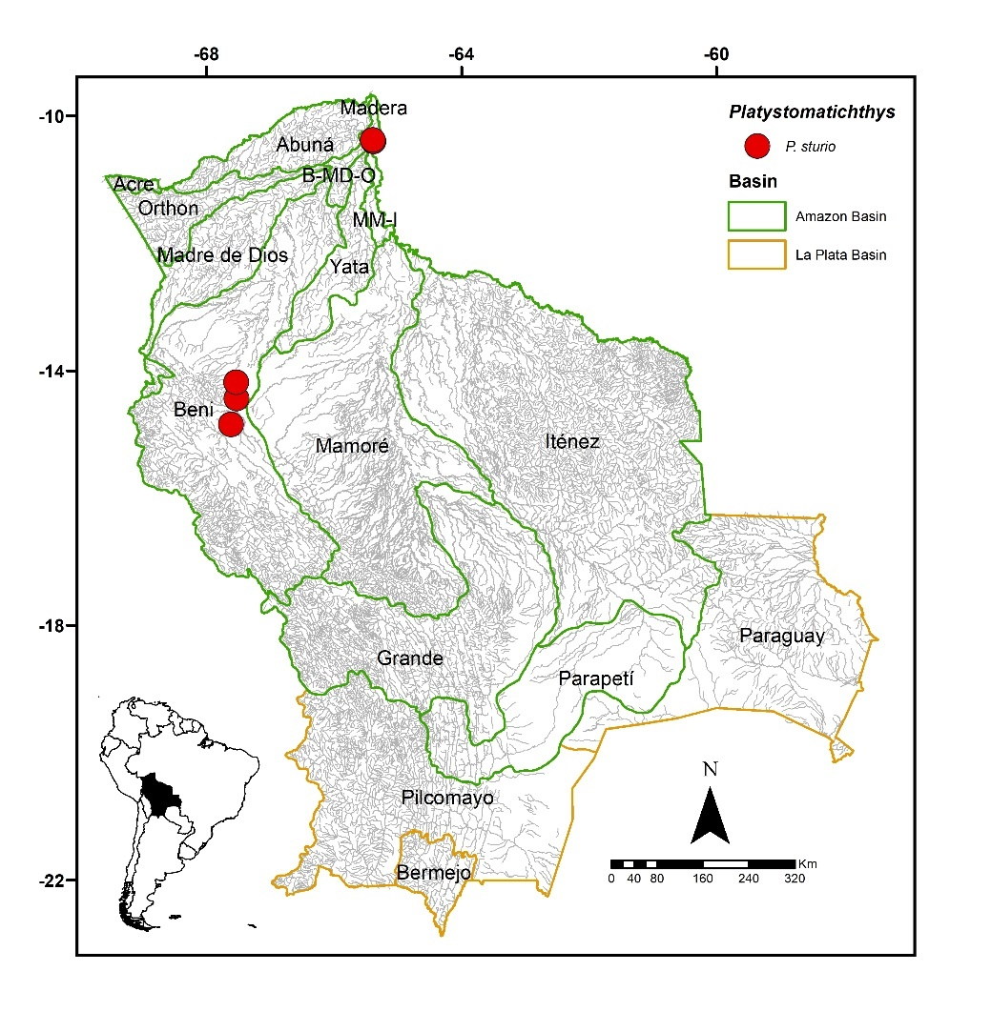
FIGURE 57. Collection sites of seven lots of Platystomatichthys sturio deposited in the Ichthyological Collection UMSS – Museo d'Orbigny (Cochabamba, Bolivia). Some symbols represent more than one lot.
Included species. Monospecific genus, with Platystomatichthys sturio as the sole representative.
Comments. Genus proposed by Bleeker (1862) for Platystoma sturio Kner 1858 as the type species, currently synonymous with P. sturio. Only one species is known, P. sturio (Kner 1858).
Platystomatichthys sturio (Kner 1858) (Figure 58)
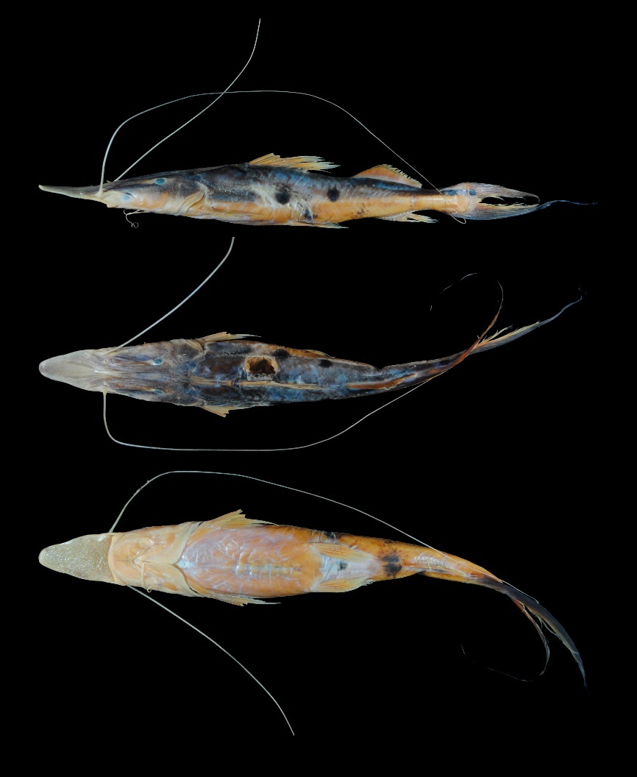
FIGURE 58. Platystomatichthys sturio, UMSS 7668, 335 mm SL, Beni River, Rurrenabaque, Beni sub-basin, Amazon Basin.
Examined material (seven specimens). Amazon Basin: UMSS 7668 (1, 330 mm SL), Beni River, Rurrenabaque, -14.440752 -67.5308970, 2 Dec 2007, F. Carvajal; UMSS 7669 (1, 413 mm SL), Beni River, Limón, -14.185022 -67.5365470, 3 Dec 2007, F. Carvajal; UMSS 7713 (1, 199.2 mm SL), Mamoré River, above Villa Bella, -10.403147 -65.3813550, 26 Mar 2008, F. Carvajal; UMSS 7724 (1, 202 mm SL), same data as UMSS 7713; UMSS 7728 (1, 318 mm SL), same data as UMSS 7713; UMSS 7743 (1, 189.2 mm SL), Madeira River, Villa Bella, -10.379891 -65.3918990, Mar 31, 2008, F. Carvajal; UMSS 16049 (1, 366 mm SL), Beni River, above Suapi, -14.846300 -67.6176500, Sep 15, 2015, L. Córdova, M. Jaldin, C. Rocabado.
Common name. Carachupa in Rurrenabaque (Beni) (Carvajal-Vallejos et al. 2011).
Diagnosis. Same as the genus.
Description. Morphometric data presented in Table 32. Head dorsoventrally flattened with a long, pointed, and very flattened snout; upper jaw projecting much beyond the lower jaw and covered with teeth. Eyes in a superolateral position. Premaxillary patch arrow-shaped and exposed over almost its entire length; vomerian patches circular and fused; palatine patches larger, oval, and well-separated from the vomerian. Posterior supraoccipital process thin, long, and grooved, in contact with the nuchal plate. Humeral process very small and almost imperceptibly pointed. Pectoral fin extending beyond the midpoint between its origin and the pelvic fin; ossified and serrated spine on both margins. Pelvic fin extending just beyond the midpoint between its origin and the anal fin. Pectoral fin longer than the pelvic fin. Dorsal fin with a strong, sharp, and serrated spine on the posterior margin. Adipose fin moderately long. Base of the adipose fin longer than the base of the anal fin. Caudal fin strongly bifurcated with filaments in both lobes, formed by the first simple ray plus the first three branched rays. Maxillary barbels long, extending beyond the caudal fin; mental barbels shorter. Dorsal fin rays I+6; anal fin rays iv+9; pectoral fin rays I+9; pelvic fin rays i+5; caudal fin rays 15.
TABLE 32. Morphometric data of Platystomatichthys sturio. N: Number of individuals, SD: Standard deviation, Min: Minimum value, Max: Maximum value.
Measurements | N | Mean | SD | Min | Max
SL (mm) | 7 | 288.2 | 90.8 | 189.2 | 413
Percents of head length (% HL)
Nuchal plate length | 7 | 8.70 | 0.8 | 7.50 | 9.80
Interorbital distance | 7 | 14.4 | 0.6 | 13.4 | 15.5
Left posterior nostril to right posterior nostril | 7 | 12.7 | 0.8 | 12.0 | 14.3
Left anterior nostril to right anterior nostril | 7 | 19.8 | 1.0 | 18.4 | 21.3
Left anterior nostril to left posterior nostril | 7 | 12.6 | 0.7 | 11.7 | 13.6
Posterior nostril to anterior margin of orbit | 7 | 29.9 | 1.2 | 28.0 | 31.5
Snout length | 7 | 70.7 | 1.6 | 69.2 | 72.7
Postorbital length | 7 | 22.3 | 0.8 | 21.3 | 23.6
Orbital diameter | 7 | 8.30 | 1.0 | 7.10 | 10.0
Head depth | 7 | 30.5 | 3.0 | 27.5 | 35.0
Mouth width | 6 | 29.0 | 2.3 | 27.0 | 33.0
Distance between internal mental barbels | 7 | 12.9 | 1.0 | 10.7 | 13.8
Distance between external mental barbels | 7 | 23.0 | 1.7 | 21.3 | 25.8
Distance between internal and external mental barbel | 7 | 6.40 | 0.5 | 5.80 | 7.30
Percents of standard length (% SL)
Predorsal length | 7 | 48.5 | 0.5 | 47.7 | 49.1
Internal mental barbel length | 7 | 12.7 | 1.7 | 10.2 | 14.8
External mental barbel length | 7 | 20.5 | 1.9 | 17.8 | 23.1
Maxillary barbel length | 4 | 142.7 | 14.4 | 127.7 | 161.6
Body width | 7 | 17.9 | 0.6 | 17.0 | 19.0
Body depth | 7 | 13.7 | 1.2 | 12.3 | 15.8
Head length | 7 | 39.6 | 0.7 | 38.3 | 40.2
Pectoral fin origin to dorsal fin insertion | 7 | 28.3 | 0.8 | 27.2 | 29.5
Dorsal fin origin to pelvic fin origin | 7 | 18.7 | 1.1 | 17.4 | 20.5
Dorsal fin origin to anal fin origin | 7 | 35.6 | 3.2 | 33.6 | 42.7
Pectoral fin origin to pelvic fin origin | 7 | 22.6 | 0.9 | 21.5 | 24.3
Pelvic fin origin to anal fin origin | 7 | 20.5 | 0.8 | 19.8 | 21.9
Pectoral spine length | 4 | 16.9 | 0.4 | 16.5 | 17.5
Distance between pelvic fins | 7 | 10.5 | 0.5 | 9.70 | 11.1
Pelvic fin length | 7 | 13.8 | 0.8 | 12.3 | 14.8
Dorsal fin base length | 7 | 15.4 | 0.6 | 15.0 | 16.5
Dorsal fin insertion to adipose fin origin | 7 | 11.3 | 0.6 | 10.4 | 12.0
Adipose fin base length | 7 | 17.5 | 0.5 | 16.7 | 18.1
Anal fin base length | 7 | 10.8 | 0.7 | 9.80 | 11.7
Anal fin origin to adipose fin insertion | 7 | 13.7 | 0.3 | 13.4 | 14.0
Caudal peduncle height | 7 | 4.90 | 0.4 | 4.40 | 5.50
Dorsal fin origin to anterior caudal base | 7 | 53.2 | 1.4 | 51.6 | 55.2
Adipose fin origin to anterior caudal base | 7 | 27.0 | 0.9 | 26.1 | 28.6
Anal fin origin to anterior caudal base | 7 | 21.3 | 1.0 | 19.6 | 22.6
Caudal peduncle length | 7 | 10.5 | 0.9 | 9.0 | 11.5
Coloration in alcohol. Body with a white background, and the dorsal back and head dark gray. Some rounded black spots of similar size to the eye or larger arranged on the flanks. Ventral body and head whitish. Dorsal, adipose, pectoral, pelvic, and anal fins yellowish. Caudal fin with the outer half of the lower lobe black; dark filaments; round black spot at the base of the upper lobe.
Coloration in life. Body with some iridescent reflections, the rest of the color pattern similar to individuals preserved in alcohol.
Distribution. Present in the Madeira, MM-I and Beni sub-basins (Amazon Basin). Also recorded in the Mamoré (Carvajal-Vallejos & Fernández 2011) and Madre de Dios sub-basins (Amazon Basin) (Torrico et al. 2020).
Importance. Subsistence fishing in Rurrenabaque and Puerto Villarroel (Carvajal-Vallejos et al. 2011).
Propimelodus Lundberg & Parisi 2002
Diagnosis. Adipose fin long, contained 2.3-2.9 times in standard length; small head, contained 4.3-5 times in standard length; premaxillary and dentary patches with slender, conical, and slightly depressible teeth; small eyes, contained 2.6-5.8 times snout and 1.2-2.9 times in interorbital; posterior nostrils oval-shaped; moderately wide posterior supraoccipital process in contact with the nuchal plate (Lundberg & Parisi 2002).
Comments. Genus proposed by Lundberg & Parisi (2002) for Pimelodus eigenmanni Van der Stigchel (1946) as the type species, currently synonymous with Propimelodus eigenmanni.
Currently, three species are recognized: P. eigenmanni in the Amazon, Approuague, Kourou, and Oyapock basins (French Guiana); P. caesius in the Amazon River channels and its tributaries, and P. araguayae in the middle part of the Araguaya River (Lundberg & Parisi 2002, Parisi et al. 2006, Rocha et al. 2007, Fricke et al. 2023). In this study, two potential new species are listed, Propimelodus nov. sp. 1 and Propimelodus nov. sp. 2 (Figure 72).
Pseudoplatystoma Bleeker 1862
Diagnosis. Head strongly depressed; upper jaw slightly longer than the lower jaw; adipose fin shorter than the anal fin; vomerian and palatine patches confluent, both forming a comma-shaped area on each side of the palate; caudal fin with rounded and speckled lobes; body with dark vertical bands, reticulated or large spots (Eigenmann & Eigenmann 1890, Eigenmann & Allen 1942, Mees 1974).
Distribution. Amazon and La Plata basins (Figure 59).
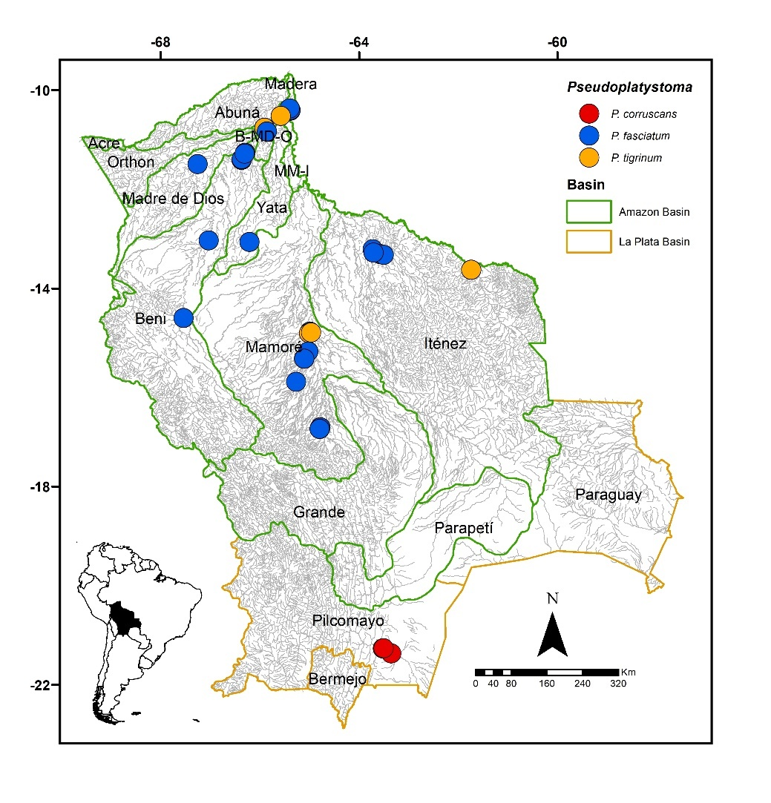
FIGURE 59. Collection sites of five lots of Pseudoplatystoma corruscans, 83 of P. fasciatum, and nine of P. tigrinum deposited in the Ichthyological Collection UMSS – Museo d’Orbigny (Cochabamba, Bolivia). Some symbols represent more than one lot.
Included species. Pseudoplatystoma corruscans, P. fasciatum, and P. tigrinum.
Comments. Genus proposed by Bleeker (1862) for Silurus fasciatus Linnaeus 1766 as the type species, currently a synonym of P. fasciatum.
For a long time, only three species were recognized within Pseudoplatystoma: P. corruscans (Spix and Agassiz 1829) in the Paraná and San Francisco basins; P. fasciatum (Linnaeus 1766) widely distributed in the Paraná, Amazon, Orinoco, Corentín, Essequibo, and Magdalena basins; P. tigrinum (Valenciennes 1840) in the Amazon and Orinoco basins (Lundberg & Littmann 2003, Ferraris 2007).
Buitrago-Suárez & Burr (2007) conducted a systematic review of Pseudoplatystoma where they recognized eight species, based on the anatomy of the skeleton, vertebral counts, and geographical distribution. According to Buitrago-Suárez & Burr (2007), the previously recognized species now correspond to the following: in the Guianas and Suriname basins, P. fasciatum remains unchanged and is restricted to this area; in the Amazon Basin, P. fasciatum becomes P. punctifer; in the Paraná basin and in the central part of the Amazon River (near Manaus), P. fasciatum becomes P. reticulatum; in the Magdalena basin, P. fasciatum becomes P. magdaleniatum Buitrago-Suárez & Burr 2007; in the Orinoco basin, P. fasciatum becomes P. oriconoense Buitrago-Suárez & Burr 2007; in the Orinoco drainage, P. tigrinum becomes P. metaense Buitrago-Suárez & Burr 2007, restricting P. tigrinum to the Amazon Basin. The geographical distribution of P. corruscans remains unchanged. It is worth noting that the distribution of P. reticulatum according to Buitrago-Suárez & Burr (2007) includes the central Amazon Basin and the Paraná basin. However, in their examined material, they do not include any species from the Amazon besides the holotype.
Following the review by Buitrago-Suárez & Burr (2007), some authors conducted molecular analyses for Pseudoplatystoma. Torrico et al. (2009), based on mitochondrial DNA, differentiated P. tigrinum, P. reticulatum, P. corruscans, and P. magdaleniatum. However, they could not to separate either P. fasciatum from P. punctifer, and P. oriconoense from P. metaense at the genetic level, suggesting synonyms for these species. Two years later, Carvalho-Costa et al. (2011), based on mitochondrial and nuclear DNA, suggest that P. punctifer, P. reticulatum, P. fasciatum, and P. oriconoense constitute a single taxon (P. fasciatum) widely distributed, as was considered before the review by Buitrago-Suárez & Burr (2007). For these authors, only P. magdaleniatum is a distinct species from P. fasciatum. Also, Carvalho-Costa et al. (2011) mentioned that the status of P. metaense (previously considered P. tigrinum in the Orinoco basin) should be invalidated. Later, García-Dávila et al. (2013) conducted a molecular analysis based on mitochondrial DNA and microsatellites for Pseudoplatystoma spp. in Peru. According to Buitrago-Suárez & Burr (2007), only two species are present in Peru, P. punctifer (previously P. fasciatum and now restricted to the Guianas) and P. tigrinum. However, the results of García-Dávila et al. (2013) showed that Buitrago-Suárez & Burr (2007) might have mistakenly restricted P. fasciatum to the Guianas. This could be the reason why various authors (Torrico et al. 2009, Carvalho-Costa et al. 2011, García-Dávila et al. 2013) find no genetic differences between what Buitrago-Suárez & Burr (2007) considers as P. fasciatum and P. punctifer. Furthermore, García-Dávila et al. (2013) revealed the existence of a cryptic species resembling what Castelnau (1855) called Platystoma punctifer (a synonym of P. punctifer), showing the peculiarity of not having black stripes on the flanks.
Of the current eight species recognized as valid, P. fasciatum, P. tigrinum, and P. corruscans are present in Bolivia. Although P. reticulatum is listed for Bolivia (Buitrago-Suárez & Burr 2007), it was not considered in this study since Carvalho-Costa et al. (2011) suggested that this species is a natural variation of P. fasciatum due to the low genetic distance between P. reticulatum and the species they designate as the "P. fasciatum sensu lato" clade (P. fasciatum, P. punctifer, P. reticulatum, and P. oriconoense). On the other hand, the species identified in this study as P. fasciatum (P. punctifer according to Buitrago-Suárez & Burr 2007) was kept as such due to the discrepancy between morphological and molecular analyses.
Pseudoplatystoma corruscans (Spix & Agassiz 1829) (Figure 60)
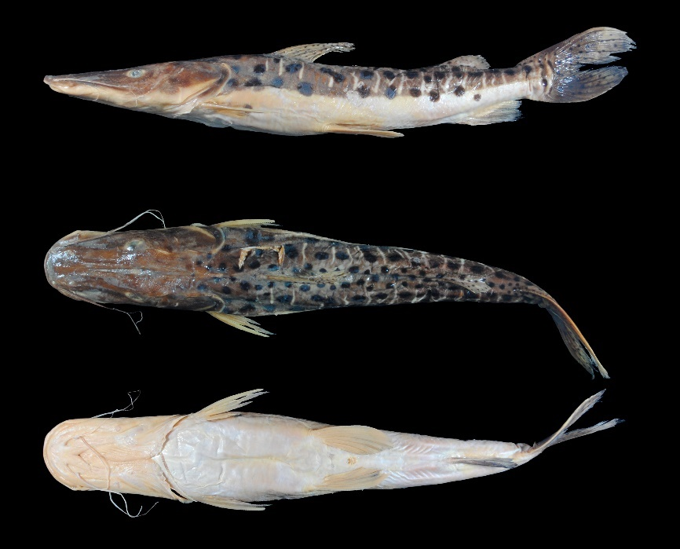
FIGURE 60. Pseudoplatystoma corruscans, UMSS 12606, 347 mm SL, Pilcomayo River, Villa Montes, Pilcomayo sub-basin, La Plata Basin.
Examined material (one specimen). La Plata Basin: UMSS 12606 (1, 321 mm SL), Pilcomayo River, Villa Montes, -21.259649 -63.5138400, 17 Jul 2012, A. Argote.
Diagnosis. Pseudoplatystoma corruscans differs from its congeners in the following: from P. fasciatum by the distance between internal mental barbels (9.4% HL vs. 11.2-14.6%), distance between external mental barbels (19.2% HL vs. 21.3-27.1%), body width (17% SL vs. 19.7-22.2%), adipose fin base length (13.2% SL vs. 8.4-11.2%), body with black spots arranged in rows and white bands (vs. body without black spots, with white and black bands); from P. tigrinum by the mouth width (36.4% HL vs. 31.6-34.7%), predorsal length (44.8% SL vs. 47.5-48.3%), head length (37.1% SL vs. 39.4-40.4%), dorsal spine length (11.7% SL vs. 14.2-16.1%), adipose fin base length (13.2% SL vs. 7.6-11.8%), body with black spots and white bands (vs. body with black loop-shaped bands forming a tiger-striped pattern).
Description. Morphometric data presented in Table 33. Head twice as long as wide and strongly depressed; eyes in dorsal position. Premaxillary patch wide with a notch at the rear. Posteriorly elongated supraoccipital process in contact with the nuchal plate. Very small and pointed humeral process, almost imperceptible. Pectoral fin extending beyond the midpoint between it and the pelvic fin; spine strongly ossified. Pelvic fin extending beyond the midpoint between it and the anal fin. Pelvic fin slightly longer than the pectoral fin. Short adipose fin. Base of the adipose and anal fins of similar size. Bifurcated caudal fin with rounded lobes. Dorsal fin rays I+6; anal fin rays iii+11; pectoral fin rays I+7; pelvic fin rays i+5; caudal fin rays 15.
TABLE 33. Morphometric data of Pseudoplatystoma corruscans. N: Number of individuals.
Measurement | N | Value
SL (mm) | 1 | 321
Percents of head length (% HL)
Interorbital distance | 1 | 22.9
Left posterior nostril to right posterior nostril | 1 | 14.8
Left anterior nostril to right anterior nostril | 1 | 16.8
Left anterior nostril to left posterior nostril | 1 | 11.0
Posterior nostril to anterior margin of orbit | 1 | 31.9
Snout length | 1 | 50.4
Postorbital length | 1 | 40.9
Orbital diameter | 1 | 9.70
Head depth | 1 | 39.2
Mouth width | 1 | 36.4
Distance between internal mental barbels | 1 | 9.40
Distance between external mental barbels | 1 | 19.2
Distance between internal and external mental barbel | 1 | 7.80
Percents of standard length (% SL)
Predorsal length | 1 | 44.8
Internal mental barbel length | 1 | 16.0
External mental barbel length | 1 | 27.0
Maxillary barbel length | 1 | 31.9
Body width | 1 | 17.0
Body depth | 1 | 15.9
Head length | 1 | 37.1
Pectoral fin origin to dorsal fin insertion | 1 | 25.8
Dorsal fin origin to pelvic fin origin | 1 | 20.5
Dorsal fin origin to anal fin origin | 1 | 40.5
Pectoral fin origin to pelvic fin origin | 1 | 25.6
Pelvic fin origin to anal fin origin | 1 | 25.9
Pectoral spine length | 1 | 15.9
Distance between pelvic fins | 1 | 11.9
Pelvic fin length | 1 | 16.6
Dorsal spine length | 1 | 11.7
Dorsal fin base length | 1 | 10.0
Dorsal fin insertion to adipose fin origin | 1 | 23.2
Adipose fin base length | 1 | 13.2
Anal fin base length | 1 | 12.7
Anal fin origin to adipose fin insertion | 1 | 13.7
Caudal peduncle height | 1 | 6.30
Dorsal fin origin to anterior caudal base | 1 | 56.4
Adipose fin origin to anterior caudal base | 1 | 24.7
Anal fin origin to anterior caudal base | 1 | 20.4
Caudal peduncle length | 1 | 7.80
Coloration in alcohol. The upper half of the body and the dorsal head gray. The flank region with black spots, similar in size or smaller than the eye, distributed in rows, with some white bands arranged vertically. The ventral region of the body and head cream or whitish. All fins with small black spots.
Distribution. Present in the Pilcomayo sub-basin (La Plata Basin). Also recorded in the Bermejo sub-basin (La Plata Basin) (Sarmiento et al. 2019).
Importance. Commercial, subsistence and recreational fishing in the upper Bermejo basin (Sarmiento et al. 2019). In the Pantanal, it is one of the most important species, representing 30% of annual commercial catches (Santander et al. 2008).
Ecological notes. Piscivorous species, with a preference for species of the Curimatidae family (Osinaga et al. 2009); nocturnal habits. Inhabits deep areas and pools in large rivers (Magalhães et al. 2009), and can also be found in lagoons and secondary channels. In the Bolivian Pantanal, it undergoes reproductive migrations to the headwaters of rivers between November and February (Osinaga et al. 2009).
Pseudoplatystoma fasciatum (Linnaeus 1766) (Figure 61)
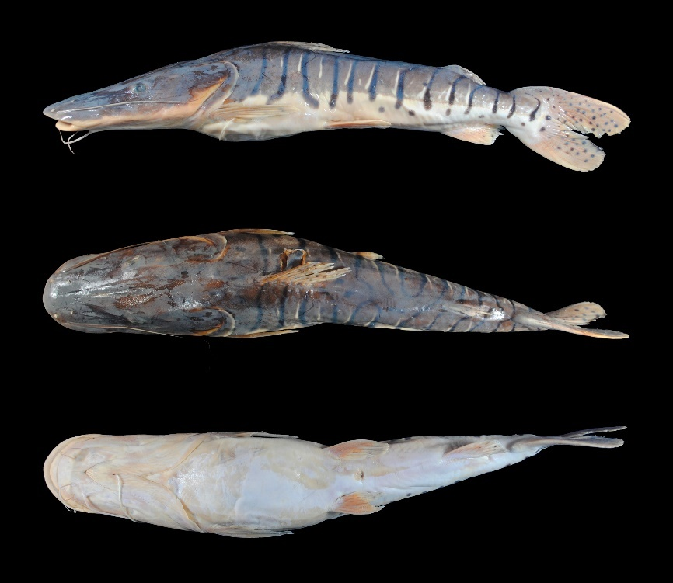
FIGURE 61. Pseudoplatystoma fasciatum, UMSS 7216, 330 mm SL, Ichilo River, Puerto Villarroel, Mamoré sub-basin, Amazon Basin.
Examined material (20 specimens). Amazon Basin: UMSS 6126 (1, 404 mm SL), Ichilo River, Puerto Villarroel ICH 5A, -16.838889 -64.7916667, 18 Sep 2007, F. Carvajal; UMSS 6127 (1, 364 mm SL), same data as UMSS 6126; UMSS 6129 (1, 375 mm SL), same data as UMSS 6126; UMSS 6143 (1, 380 mm SL), same data as UMSS 6126; UMSS 6148 (1, 364 mm SL), same data as UMSS 6126; UMSS 6149 (1, 393 mm SL), same data as UMSS 6126; UMSS 6158 (1, 367 mm SL), same data as UMSS 6126; UMSS 6161 (1, 386 mm SL), same data as UMSS 6126; UMSS 6163 (1, 364 mm SL), same data as UMSS 6126; UMSS 6164 (1, 383 mm SL), same data as UMSS 6126; UMSS 6165 (1, 355 mm SL), same data as UMSS 6126; UMSS 6166 (1, 383 mm SL), same data as UMSS 6126; UMSS 7215 (1, 364 mm SL), same data as UMSS 6126; UMSS 7216 (1, 335 mm SL), same data as UMSS 6126; UMSS 7222 (1, 351 mm SL), same data as UMSS 6126; UMSS 7224 (1, 363 mm SL), same data as UMSS 6126; UMSS 7225 (1, 334 mm SL), same data as UMSS 6126; UMSS 7226 (1, 384 mm SL), same data as UMSS 6126; UMSS 11445 (1, 381 mm SL), Beni River, Portachuelo Lake, -11.267070, -66.2974200, 7 May 2012, A. Argote; UMSS 13427 (1, 356 mm SL), Paraguá River, Piso Firme, -13.628116 -61.7359114, 27 Sep 2005, L. Córdova, J. Camacho.
Common name. Pintado in Puerto Rico, Cobija (Pando), Riberalta, Rurrenabaque, and Cachuela Esperanza (Beni); surubí in Riberalta and Trinidad (Beni) and Puerto Villarroel (Cochabamba) (Lauzanne & Loubens 1985, Carvajal-Vallejos et al. 2011).
Diagnosis. Pseudoplatystoma fasciatum differs from its congeners in the following: from P. corruscans by the distance between internal mental barbels (11.2-14.6% HL vs. 9.4%), distance between external mental barbels (21.3-27.1% HL vs. 19.2%), body width (19.7-22.2% SL vs. 17%), adipose fin base length (8.4-11.2% SL vs. 13.2%), body without black spots, with white and black bands (vs. body with black spots arranged in rows and white bands); from P. tigrinum by mouth width (36.8-41.8% HL vs. 31.6-34.7%), distance between internal mental barbels (11.2-14.6% HL vs. 7.2-9.6), distance between external mental barbels (21.3-27.1% HL vs. 15-19.2%), body width (19.7-22.2% SL vs. 17.3-18.8%), body with vertically arranged white and black bands (vs. body with black bands in the form of loops forming a tiger-striped pattern).
Description. The morphometric data presented in Table 34. Head twice as long as wide and strongly depressed; eyes in dorsal position. Premaxillary patch wide with a notch at the posterior part; vomerian patches very close together and large; palatine patches elongated and pointed, confluent with the vomerian patches (Appendix 3). Posterior supraoccipital process broad-based and in contact with the nuchal plate. Humeral process small and pointed. Pectoral fin extending beyond the midpoint between it and the pelvic fin; spine strongly ossified. Pelvic fin extending beyond the midpoint between it and the anal fin. Pectoral fin slightly longer than the pelvic fin. Short adipose fin. Base of adipose and anal fins of similar size. Forked caudal fin with rounded lobes. Maxillary barbels reaching halfway to the pectoral fin; mental barbels shorter. Dorsal fin rays I+6; anal fin rays iii-iv+7-9; pectoral fin rays I+9-10; pelvic fin rays i+5; caudal fin rays 15.
TABLE 34. Morphometric data of Pseudoplatystoma fasciatum. N: Number of individuals, SD: Standard deviation, Min: Minimum value, Max: Maximum value.
Measurements | N | Mean | SD | Min | Max
SL (mm) | 20 | 369.3 | 18.1 | 334 | 404
Percents of head length (% HL)
Interorbital distance | 20 | 23.9 | 0.8 | 21.9 | 25.1
Left posterior nostril to right posterior nostril | 20 | 14.9 | 0.5 | 13.9 | 15.9
Left anterior nostril to right anterior nostril | 20 | 17.2 | 0.5 | 15.9 | 18.1
Left anterior nostril to left posterior nostril | 20 | 11.0 | 0.5 | 10.2 | 11.9
Posterior nostril to anterior margin of orbit | 20 | 31.3 | 0.7 | 29.9 | 32.3
Snout length | 20 | 51.0 | 0.7 | 50.0 | 52.6
Postorbital length | 20 | 41.4 | 0.8 | 40.2 | 43.3
Orbital diameter | 20 | 8.60 | 0.4 | 8.10 | 9.50
Head depth | 20 | 42.3 | 3.4 | 34.2 | 47.5
Mouth width | 20 | 39.3 | 1.3 | 36.8 | 41.8
Distance between internal mental barbels | 20 | 12.9 | 1.0 | 11.2 | 14.6
Distance between external mental barbels | 20 | 24.1 | 1.3 | 21.3 | 27.1
Distance between internal and external mental barbel | 20 | 7.40 | 0.5 | 6.40 | 8.50
Percents of standard length (% SL)
Predorsal length | 20 | 46.5 | 0.8 | 44.7 | 48.2
Internal mental barbel length | 20 | 22.7 | 3.8 | 18.0 | 30.9
External mental barbel length | 20 | 32.1 | 6.0 | 22.8 | 47.7
Maxillary barbel length | 19 | 43.3 | 3.7 | 35.9 | 52.2
Body width | 20 | 20.8 | 0.8 | 19.7 | 22.2
Body depth | 20 | 18.3 | 1.3 | 15.0 | 20.3
Head length | 20 | 39.1 | 0.8 | 37.7 | 40.9
Pectoral fin origin to dorsal fin insertion | 20 | 26.7 | 0.5 | 25.8 | 27.6
Dorsal fin origin to pelvic fin origin | 20 | 22.2 | 0.7 | 20.7 | 23.4
Dorsal fin origin to anal fin origin | 20 | 41.1 | 0.9 | 39.5 | 42.8
Pectoral fin origin to pelvic fin origin | 20 | 26.2 | 1.0 | 24.2 | 28.1
Pelvic fin origin to anal fin origin | 20 | 24.4 | 0.7 | 23.1 | 26.0
Pectoral spine length | 19 | 16.4 | 0.7 | 14.5 | 17.7
Distance between pelvic fins | 20 | 12.9 | 0.3 | 12.2 | 13.5
Pelvic fin length | 20 | 13.6 | 1.0 | 11.6 | 15.7
Dorsal spine length | 12 | 12.2 | 0.9 | 10.9 | 13.7
Dorsal fin base length | 20 | 9.80 | 0.4 | 9.0 | 10.5
Dorsal fin insertion to adipose fin origin | 20 | 26.6 | 1.0 | 25.0 | 28.3
Adipose fin base length | 20 | 9.50 | 0.7 | 8.40 | 11.2
Anal fin base length | 20 | 10.8 | 0.7 | 9.30 | 11.8
Anal fin origin to adipose fin insertion | 20 | 13.4 | 0.6 | 11.9 | 14.5
Caudal peduncle height | 20 | 6.70 | 0.2 | 6.20 | 7.0
Dorsal fin origin to anterior caudal base | 20 | 56.2 | 1.2 | 54.2 | 58.2
Adipose fin origin to anterior caudal base | 20 | 20.4 | 0.7 | 18.4 | 21.9
Anal fin origin to anterior caudal base | 20 | 19.0 | 0.7 | 17.7 | 20.2
Caudal peduncle length | 20 | 8.20 | 0.5 | 7.50 | 9.20
Coloration in alcohol. Upper half of body and dorsal portion of head gray. The flank region has black bands interspersed with thinner white bands, both arranged vertically, with some black spots similar in size to the eye or smaller. The ventral region of the body and head cream or whitish in color. All fins have small black spots.
Coloration in life. Dorsal region of body and dorsal region of head dark gray, with the rest of the color pattern similar to individuals preserved in alcohol.
Distribution. Present in the Madeira, Madre de Dios, Beni, Yata, Mamoré, Iténez, B-MD-O and MM-I sub-basins (Amazon Basin). Also recorded in the Grande (Maldonado et al. 2020) and Orthon sub-basins (Amazon Basin) (Torrico et al. 2020), and in the Bermejo sub-basin (La Plata Basin) (Sarmiento et al. 2019).
Importance. Commercial and subsistence fishing trade in Puerto Rico, Cobija, Riberalta, Rurrenabaque, Cachuela Esperanza, and Puerto Villaroel (Carvajal-Vallejos et al. 2011).
Ecological notes. Feeds on fish (loricariids, cichlids, and characids) as well as crabs; its feeding activity is restricted to the riverbed. Inhabits the main channels of rivers but can occasionally be found in floodplain areas, with a preference for shady streams. Females reach larger sizes (Burguess 1989). Engages in upstream reproductive migrations. During low-water periods, it prefers lotic environments. Males are more numerous in rivers, while females are more common in lagoons (Loubens & Panfili 2000).
Pseudoplatystoma tigrinum (Valenciennes 1840) (Figure 62)
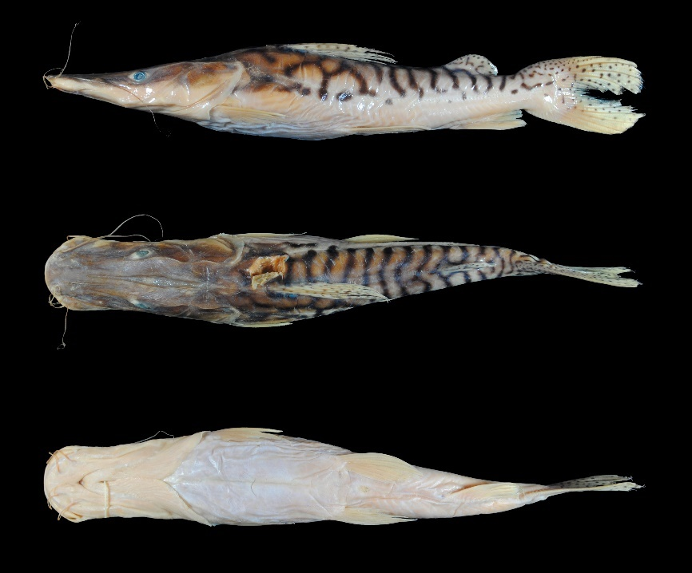
FIGURE 62. Pseudoplatystoma tigrinum, UMSS 10605, 302 mm SL, Beni River, Florida stream, B-MD-O sub-basin, Amazon Basin.
Examined material (six specimens). Amazon Basin: UMSS 10605 (1, 278.6 mm SL), Beni River, Florida stream, -10.756444 -65.9073889, 14 Jun 2011, F. Carvajal, T. Pérez, A. Argote, F. Vieira; UMSS 10618 (1, 294.5 mm SL), same data as UMSS 10605; UMSS 13429 (1, 326 mm SL), Paraguá River, Piso Firme, -13.628116 -61.7359114, 27 Sep 2005, L. Córdova, J. Camacho; UMSS 17486 (1, 359 mm SL), Mamoré River, Puerto Geralda, -14.906180 -65.0071315, 12 Aug 2007, A. Parada, T. Yunoki; UMSS 17491 (1, 323 mm SL), Ibare River, Estancia Sakamoto, -14.891319 -64.9646031, 14 Aug, 2007, A. Parada, T. Yunoki; UMSS 17492 (1, 338 mm SL), Secure River, -150422603 -65.1038397, 8 Aug 2007, A. Parada, T. Yunoki.
Common name. Caparari and chuncuina in Puerto Rico, Cobija (Pando) and Trinidad (Beni); pintado in Riberalta, Rurrenabaque, and Cachuela Esperanza (Beni); semicuyo in Puerto Villaroel (Cochabamba) (Lauzanne & Loubens 1985, Carvajal-Vallejos et al. 2011).
Diagnosis. Pseudoplatystoma tigrinum differs from its congeners in the following: from P. corruscans by mouth width (31.6-34.7% HL vs. 36.4%), predorsal length (47.5-48.3% SL vs. 44.8%), head length (39.4-40.4% SL vs. 37.1%), dorsal spine length (14.2-16.1% SL vs. 11.7%), adipose fin base length (7.6-11.8% SL vs. 13.2%), body with loop-shaped black bands forming a tiger-stripe pattern (vs. body with black spots arranged in rows and white bands); from P. fasciatum by mouth width (31.6-34.7% HL vs. 36.4%), distance between internal mental barbels (7.2-9.6% HL vs. 11.2-14.6%), distance between external mental barbels (15-19.2% HL vs. 21.3-27.1%), body width (17.3-18.8% SL vs. 19.7-22.2%), body with loop-shaped black bands forming a tiger-stripe pattern (vs. body with vertically arranged black and white bands).
Description. Morphometric data presented in Table 35. Head twice as long as wide and strongly depressed; eyes in dorsal position. Wide premaxillary patch with a notch at the posterior part; vomerian patches very close together and large; elongated and pointed palatine patches, confluent with the vomerian patches. Posterior supraoccipital process broad-based, with the sides narrowing and in contact with the nuchal plate. Small, triangular, and pointed humeral process (Appendix 3). Pectoral fin extending beyond the midpoint between it and the pelvic fin; spine strongly ossified. Pelvic fin slightly longer than the pectoral fin. Short adipose fin. Base of adipose and anal fins of similar size. Forked caudal fin with rounded lobes. Maxillary barbels reaching at most the origin of the pectoral fin; external mental barbels longer than the maxillary and extending beyond the origin of the pectoral fin; internal mental barbels smaller than the external ones. Dorsal fin rays I+5; anal fin rays iii+8; pectoral fin rays I+9; pelvic fin rays i+5; caudal fin rays 15.
TABLE 35. Morphometric data of Pseudoplatystoma tigrinum. N: Number of individuals, SD: Standard deviation, Min: Minimum value, Max: Maximum value.
Measurement | N | Mean | SD | Min | Max
SL (mm) | 6 | 319.9 | 29.2 | 278.6 | 359
Percents of head length (% HL)
Nuchal plate length | 6 | 12.9 | 0.6 | 11.9 | 13.6
Interorbital distance | 6 | 20.3 | 0.6 | 19.5 | 21.1
Left posterior nostril to right posterior nostril | 6 | 13.4 | 0.7 | 12.3 | 14.1
Left anterior nostril to right anterior nostril | 6 | 14.9 | 0.7 | 14.2 | 16.1
Left anterior nostril to left posterior nostril | 6 | 10.2 | 0.5 | 9.50 | 10.9
Posterior nostril to anterior margin of orbit | 6 | 31.7 | 0.5 | 31.0 | 32.3
Snout length | 6 | 48.5 | 0.6 | 47.5 | 49.0
Postorbital length | 6 | 42.6 | 0.7 | 41.9 | 43.9
Orbital diameter | 6 | 9.50 | 0.3 | 9.0 | 9.90
Head depth | 6 | 39.1 | 1.8 | 36.9 | 41.4
Mouth width | 5 | 33.5 | 1.2 | 31.6 | 34.7
Distance between internal mental barbels | 6 | 8.70 | 0.9 | 7.20 | 9.80
Distance between external mental barbels | 6 | 17.6 | 1.5 | 15.0 | 19.2
Distance between internal and external mental barbel | 6 | 6.90 | 0.5 | 6.40 | 7.60
Percents of standard length (% SL)
Predorsal length | 6 | 47.9 | 0.3 | 47.5 | 48.3
Internal mental barbel length | 6 | 23.2 | 6.4 | 11.7 | 28.7
External mental barbel length | 6 | 36.2 | 6.3 | 27.0 | 44.6
Maxillary barbel length | 3 | 39.1 | 3.2 | 35.8 | 42.2
Body width | 6 | 18.2 | 0.6 | 17.3 | 18.8
Body depth | 6 | 17.0 | 1.6 | 15.2 | 19.0
Head length | 6 | 39.9 | 0.4 | 39.4 | 40.4
Pectoral fin origin to dorsal fin insertion | 6 | 27.4 | 0.9 | 26.1 | 28.8
Dorsal fin origin to pelvic fin origin | 6 | 21.4 | 0.9 | 20.0 | 22.6
Dorsal fin origin to anal fin origin | 6 | 39.8 | 1.3 | 38.3 | 41.3
Pectoral fin origin to pelvic fin origin | 6 | 25.4 | 1.5 | 23.5 | 26.9
Pelvic fin origin to anal fin origin | 6 | 23.8 | 1.5 | 22.0 | 25.8
Pectoral spine length | 5 | 16.3 | 0.5 | 15.7 | 17.1
Distance between pelvic fins | 6 | 12.3 | 0.4 | 11.7 | 12.8
Pelvic fin length | 6 | 15.1 | 2.1 | 13.0 | 18.0
Dorsal spine length | 5 | 15.2 | 0.7 | 14.2 | 16.1
Dorsal fin base length | 6 | 11.7 | 0.2 | 11.4 | 12.0
Dorsal fin insertion to adipose fin origin | 6 | 23.8 | 1.8 | 21.7 | 26.6
Adipose fin base length | 6 | 9.80 | 1.6 | 7.60 | 11.8
Anal fin base length | 6 | 11.1 | 0.2 | 10.9 | 11.4
Anal fin origin to adipose fin insertion | 6 | 13.2 | 0.4 | 12.7 | 13.7
Caudal peduncle height | 6 | 7.0 | 0.2 | 6.80 | 7.30
Dorsal fin origin to anterior caudal base | 6 | 53.9 | 0.9 | 52.8 | 55.5
Adipose fin origin to anterior caudal base | 6 | 19.1 | 1.1 | 17.7 | 20.5
Anal fin origin to anterior caudal base | 6 | 18.3 | 0.9 | 16.9 | 19.6
Caudal peduncle length | 6 | 7.80 | 0.7 | 6.70 | 8.70
Coloration in alcohol. Body with a cream or yellowish background, with the dorsal and dorsal head gray. The flank region has black bands forming loops or cells, giving a tiger-striped appearance, with some black spots. Ventral region of body and head cream or whitish. All fins have small black spots. Dorsal, pectoral, pelvic, anal, and caudal fins with a light background and small black spots; adipose fin with a light background and the same pattern of black bands as on the flanks, with some small spots.
Coloration in life. Similar to individuals preserved in alcohol.
Distribution. Present in the Mamoré, Iténez, and B-MD-O sub-basins (Amazon Basin). Also recorded in the Madeira, Madre de Dios, Beni, Iténez (Carvajal-Vallejos & Fernández 2011), and Grande sub-basin (Amazon Basin) (Maldonado et al. 2020).
Importance. Commercial and subsistence fishing trade in Puerto Rico, Cobija, Riberalta, Rurrenabaque, Cachuela Esperanza and Puerto Villaroel (Carvajal-Vallejos et al. 2011).
Ecological notes. A nocturnal and highly opportunistic species, it can feed on fish, shrimp, and crabs. Inhabits large rivers with clear and dark waters (Sarmiento et al. 2014), in the main bed of slow or fast areas, as well as in floodable forests (juveniles) (Keith et al. 2000). Engages in upstream reproductive migrations; males are more numerous in rivers, while females are more common in lagoons (Loubens & Panfili 2000).
Sorubim Cuvier 1829
Diagnosis. Head highly depressed dorsoventrally; eyes in lateral position, visible from below; upper jaw very long, projecting above the lower jaw; upper jaw with the premaxillary patch covered with villiform teeth that are exposed ventrally; presence of a dark stripe arranged on the lateral region, from the snout to the distal point of the most central rays in the caudal fin (Littmann 2007).
Distribution. Amazon and La Plata basins (Figure 63).
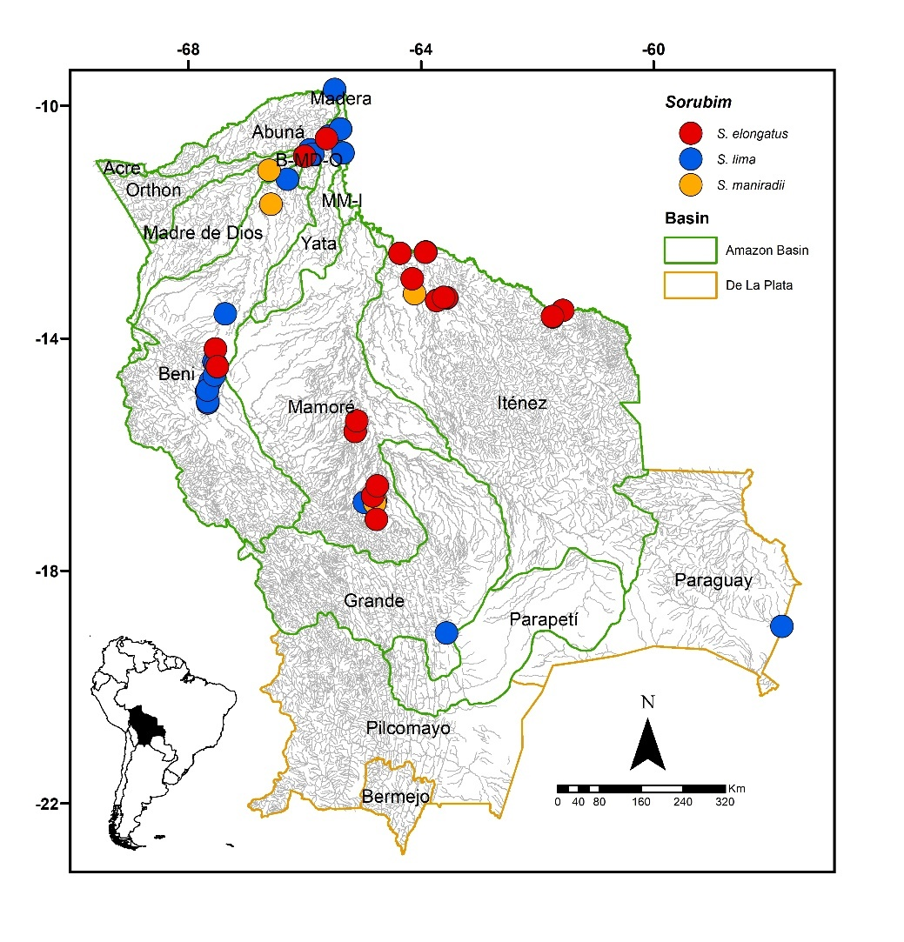
FIGURE 63. Collection sites of 34 of Sorubim elongatus, 62 of S. lima, and seven of S. maniradii deposited in the Ichthyological Collection UMSS – Museo d'Orbigny (Cochabamba, Bolivia). Some symbols represent more than one lot.
Included species. Sorubim elongatus, S. lima and S. maniradii.
Comments. Genus proposed by Cuvier (1829) for Silurus lima Bloch & Schneider 1801 as the type species, currently synonymous with S. lima. Littmann (2007) redescribed the genus Sorubim and the species S. lima (Bloch & Schneider 1801) and S. trigonocephalus Miranda-Ribeiro 1920.
Currently, five species are recognized: S. cuspicaudus Littmann et al. 2000 in the Lago Maracaibo basin and the Magdalena and Sinu rivers; S. elongatus Littmann et al. 2001b in the Amazon, Essequibo, and Orinoco basins; S. lima in the Amazon, Orinoco, Paraná, and Parnaíba basins; S. maniradii Littmann et al. 2001a in the upper and middle Amazon Basin; S. trigonocephalus in the Madeira and Tapajos rivers (Littmann 2007, Fricke et al. 2023). Of the five valid species known, S. elongatus, S. lima and S. maniradii are present in Bolivia.
It is important to highlight that the coloration pattern does not correspond to a useful character for distinguishing between species as there are no significant differences. So, only a general description will be provided for the three species present in Bolivia.
Coloration in alcohol. Body with the dorsum and dorsal head region ranging from dark brown to gray; flanks with a dark band (which may vary in thickness) approximately at the level of the lateral line that runs longitudinally from the tip of the snout to the area where the lobes of the caudal fin branch, or reaching part of the margin of the lower lobe. Region between the dorsum and the dark band separated by an area of brown or cream color. Anterosuperior region of the body with some diffuse dark spots. Ventral region of the body and head whitish. All fins yellowish or whitish.
Coloration in life. Similar to individuals preserved in alcohol.
Sorubim elongatus Littmann, Burr, Schmidt & Isern 2001 (Figure 64)
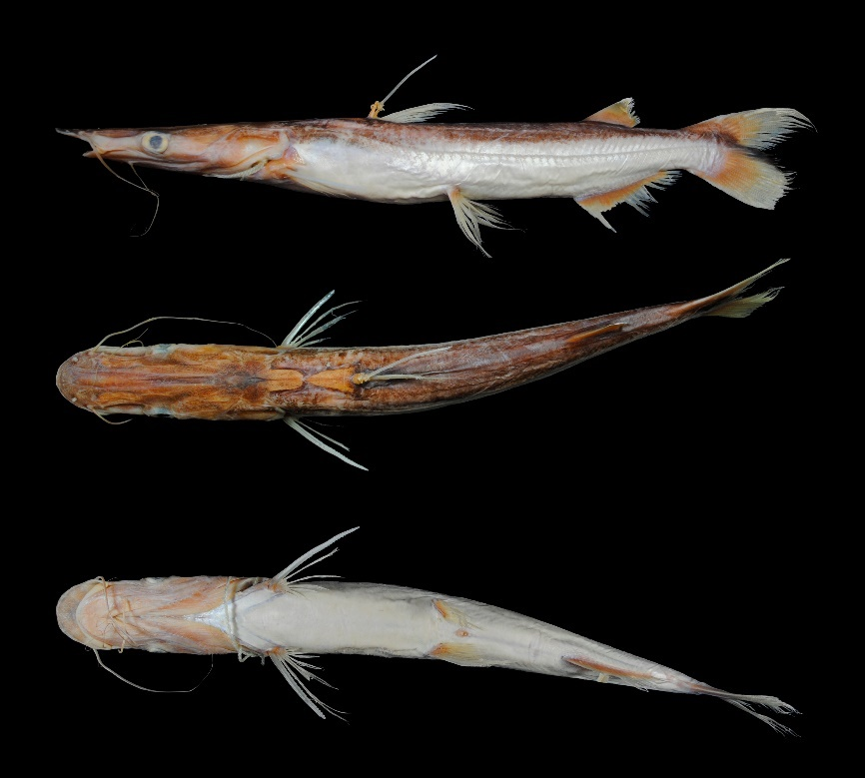
Figure 64. Sorubim elongatus, UMSS 9964.1, 232 mm SL, Blanco River, La Punta rapids, Iténez sub-basin, Amazon Basin.
Examined material (13 specimens). Amazon Basin: UMSS 2674 (1, 225.2 mm SL), San Joaquín River, -13.31233333 -63.56433333, 9 Dec 2004, J. Camacho, L. Córdova, M. Pouilly; UMSS 2676 (1, 193.2 mm SL), Blanco River, Bibosi, -13.346237 -63.7248253, 14 Dec 2004, J. Camacho, L. Córdova, M. Pouilly; UMSS 4571 (1, 213.1 mm SL), Paraguá River, Piso Firme bay, -13.635828 -61.7310530, 28 Sep 2005, J. Camacho, L. Córdova, M. Pouilly; UMSS 4582 (2, 212.8-240.3 mm SL), San Martín River, Redonda Lagoon, -13.306111 -63.5552780, 13 Aug 2005, J. Camacho, L. Córdova, M. Pouilly; UMSS 7670 (1, 256.1 mm SL), Beni River, Limón, -14.185022 -67.5365470, 4 Dec 2007, F. Carvajal; UMSS 9964 (2, 228.3-238 mm SL), Blanco River, La Punta rapids, -13.354872 -63.7277028, 19 Dec 2010, C. Valverde, C. Flores; UMSS 10232 (1, 223.2 mm SL), Beni River, San José Lagoon, -108869502 -65.9976395, 6 May 2009, L. Córdova, M. Arraya, E. De La Barra; UMSS 17498 (1, 215.5 mm SL), Cambarasal Lagoon, Bella Vista, -13.29966667 -63.61027778, 11 May 2006, J. Camacho, G. Crespo; UMSS 17499 (1, 218.2 mm SL), same data as UMSS 17498; UMSS 17751 (1, 236.7 mm SL), Paraguá River, Piso Firme, -13.628116 -61.7359114; UMSS 18301 (1, 214.1 mm SL), Campamento Chimoré IC Lagoon, -16.716308 -64.8281840, 1 May 1994, M. Maldonado, R. Zamuriano, L. Meneses; UMSS 18302 (1, 215.1 mm SL), same data as UMSS 18301.
Diagnosis. Sorubim elongatus differs from its congeners in the following: from S. lima by interorbital distance (22.4-28.9% HL vs. 33.8-40.6%), left posterior nostril to right posterior nostril (14.6-17.1% HL vs. 22.1-24.4%), distance between anterior nostrils (15-18.2% HL vs. 24.1-25.8%), mouth width (25.2-28.6% HL vs. 36-40.8%), distance between external mental barbels (10.9-15.8% HL vs. 19.7-24.5%), body width (11-13.3% SL vs. 15.3-18.5%); from S. maniradii by distance between anterior nostrils (15-18.2% HL vs. 19.7-21.2%), mouth width (25.2-28.6% HL vs. 30.6-33.5%), body width (11-13.3% SL vs. 13.6-14.7%), pectoral spine length (14.9-17.5% SL vs. 18.8-19.6%), pelvic fin length (12.8-15.2% SL vs. 16.1-17.1%), dorsal fin base length (4.9-5.9% SL vs. 6.2-6.6%), gill rakers on first arch (14-18 vs. 31-36).
Description. Morphometric data presented in Table 36. Body and head more elongated and narrower. Head approximately three times longer than wide and highly depressed; eyes laterally positioned. Upper jaw much longer than lower, projecting far beyond it; premaxillary patch exposed ventrally. Premaxillary patch wide; vomerian patches small, irregularly round, and separated (in adult individuals); palatine patches elongated and separated from vomerian. Posterior supraoccipital process wide throughout its extension, with rounded posterior tip and in contact with nuchal plate. Humeral process small and pointed. Pectoral fin surpassing halfway between its origin and pelvic fin origin; serrated pungent spine on posterior margin. Pelvic fin surpassing halfway between its origin and anal fin origin. Pectoral fin slightly longer than pelvic fin. Dorsal fin with one serrated pungent spine on posterior margin. Small adipose fin. Anal fin base longer than adipose fin base. Caudal fin forked with the upper lobe pointed and the lower one rounded. Maxillary barbels reaching the pelvic fin; mentonian barbels shorter.
TABLE 36. Morphometric data of Sorubim elongatus. N: Number of individuals, SD: Standard deviation, Min: Minimum value, Max: Maximum value.
Measurements | N | Mean | SD | Min | Max
SL (mm) | 13 | 223.6 | 15.6 | 193.2 | 256.1
Percents of head length (% HL)
Nuchal plate length | 13 | 18.2 | 1.3 | 16.3 | 19.9
Interorbital distance | 13 | 24.6 | 2.2 | 22.4 | 28.9
Left posterior nostril to right posterior nostril | 13 | 15.7 | 0.7 | 14.6 | 17.1
Left anterior nostril to right anterior nostril | 13 | 16.1 | 1.0 | 15.0 | 18.2
Left anterior nostril to left posterior nostril | 13 | 9.0 | 0.8 | 7.70 | 11.0
Posterior nostril to anterior margin of orbit | 13 | 26.1 | 0.9 | 25.3 | 27.6
Snout length | 13 | 45.6 | 1.8 | 43.4 | 49.2
Postorbital length | 13 | 45.2 | 0.8 | 44.3 | 46.9
Orbital diameter | 13 | 11.7 | 0.8 | 10.0 | 12.9
Head depth | 13 | 27.7 | 1.7 | 25.8 | 30.7
Mouth width | 13 | 27.1 | 1.0 | 25.2 | 28.6
Distance between internal mental barbels | 13 | 4.60 | 1.1 | 2.80 | 7.20
Distance between external mental barbels | 13 | 13.2 | 1.5 | 10.9 | 15.8
Distance between internal and external mental barbel | 13 | 5.60 | 0.5 | 4.80 | 6.50
Percents of standard length (% SL)
Predorsal length | 13 | 48.5 | 0.9 | 46.9 | 50.0
Internal mental barbel length | 13 | 15.3 | 1.5 | 12.7 | 18.5
External mental barbel length | 12 | 33.6 | 4.9 | 27.6 | 44.7
Maxillary barbel length | 13 | 48.7 | 5.4 | 38.3 | 58.0
Body width | 13 | 12.1 | 0.7 | 11.0 | 13.3
Body depth | 13 | 12.5 | 0.9 | 11.3 | 13.9
Head length | 13 | 36.8 | 0.8 | 35.8 | 38.4
Pectoral fin origin to dorsal fin insertion | 13 | 21.8 | 0.8 | 20.3 | 23.3
Dorsal fin origin to pelvic fin origin | 13 | 17.9 | 1.0 | 16.3 | 19.6
Dorsal fin origin to anal fin origin | 13 | 34.5 | 1.4 | 33.1 | 38.4
Pectoral fin origin to pelvic fin origin | 13 | 26.8 | 0.9 | 25.4 | 28.0
Pelvic fin origin to anal fin origin | 13 | 19.7 | 1.3 | 18.2 | 23.5
Pectoral spine length | 10 | 16.3 | 0.8 | 14.9 | 17.5
Distance between pelvic fins | 13 | 8.50 | 0.4 | 7.90 | 9.20
Pelvic fin length | 13 | 14.3 | 0.8 | 12.8 | 15.2
Dorsal spine length | 11 | 13.2 | 1.0 | 12.0 | 15.7
Dorsal fin base length | 13 | 5.40 | 0.2 | 4.90 | 5.90
Dorsal fin insertion to adipose fin origin | 13 | 28.5 | 1.0 | 26.6 | 29.8
Adipose fin base length | 13 | 7.70 | 0.8 | 6.50 | 9.10
Anal fin base length | 13 | 14.8 | 0.9 | 12.6 | 16.0
Anal fin origin to adipose fin insertion | 13 | 14.8 | 0.6 | 13.6 | 15.6
Caudal peduncle height | 13 | 6.40 | 0.3 | 5.90 | 6.90
Dorsal fin origin to anterior caudal base | 13 | 52.2 | 0.8 | 50.9 | 53.6
Adipose fin origin to anterior caudal base | 13 | 18.8 | 0.7 | 17.9 | 20.4
Anal fin origin to anterior caudal base | 13 | 21.4 | 0.7 | 19.8 | 22.3
Caudal peduncle height | 13 | 6.60 | 0.5 | 5.80 | 7.40
Distribution. Present in the Beni, B-MD-O, Iténez and Mamoré sub-basins (Amazon Basin).
Importance. There is no available information.
Ecological notes. Inhabits lakes in alluvial plains, small streams to large rivers, on sandy substrates, with mud or clay associated with vegetation. A species with nocturnal habits; during the day, it hides in shelters in groups along the stream margins (Littmann et al. 2001b).
Sorubim lima (Bloch & Schneider 1801) (Figure 65)
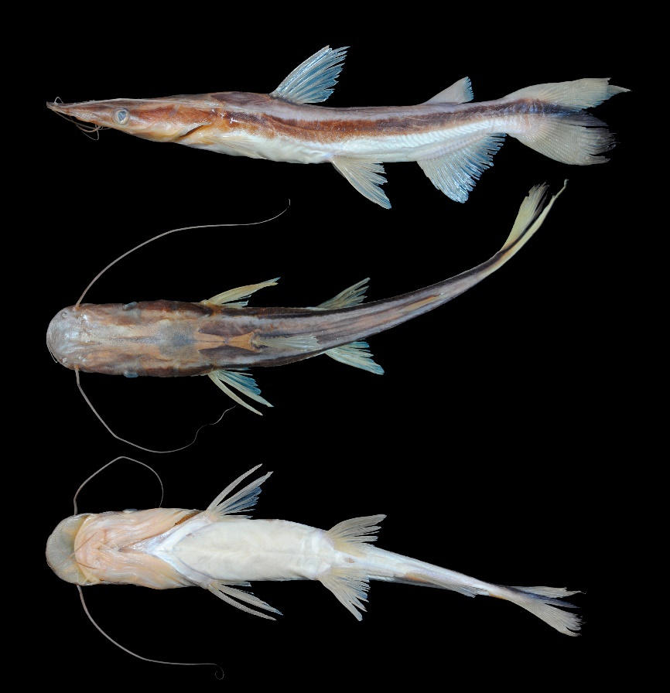
FIGURE 65. Sorubim lima, UMSS 16911, 175 mm SL, Ichilo River, Yuca Lagoon, Mamoré sub-basin, Amazon Basin.
Examined material (14 specimens). Amazon Basin: UMSS 6142 (1, 273.6 mm SL), Ichilo River, Puerto Villarroel ICH 5A, -16.838889 -64.7916667, 19 Sep 2007, F. Carvajal; UMSS 6830 (1, 280.9 mm SL), Mamoré River, Semena stream mouth, -10.813437 -65.3428282, 11 Jun 2007, A. Argote. F. Carvajal; UMSS 6832 (1, 238.6 mm SL), same data as UMSS 6830; UMSS 7218 (1, 258.3 mm SL), same data as UMSS 6142; UMSS 7756 (1, 245.5 mm SL), Mamoré River, upstream Villa Bella, -10.403147 -65.3813550, 7 May 2008, F. Carvajal; UMSS 11383 (1, 227.1 mm SL), Beni River, Portachuelo lake, -11.267070 -66.2974200, 6 May 2012, A. Argote; UMSS 15941 (1, 283.5 mm SL), Beni River, below Angosto del Bala, -14.458740 -67.5320700, 3 Oct 2015, L. Córdova, M. Jaldin, C. Rocabado; UMSS 15948 (1, 270.4 mm SL), Sawacale stream, -14.741340 -67.6200500, 12 Sep 2015, L. Córdova, M. Jaldin, C. Rocabado; UMSS 16992 (1, 252.3 mm SL), Chimoré River, Chimoré, -16.826436 -64.9717490, 1 Feb 2003, L. Córdova. M. Maldonado; UMSS 17494 (1, 221.6 mm SL), Isiboro River, Viejo River, Santa María de Junta, -15.606482 -65.1317284, 3 Aug 2007, A. Parada, T. Yunoki; UMSS 17706 (1, 251 mm SL), same data as UMSS 7756; UMSS 17707 (1, 267.7 mm SL), same data as UMSS 7756; UMSS 17708 (1, 256.9 mm SL), same data as UMSS 7756; UMSS 17709 (1, 240.7 mm SL), same data as UMSS 7756.
Common name. Pico de pato in Puerto Rico, Cobija (Pando), Riberalta, Trinidad and Cachuela Esperanza (Beni); paleta in Riberalta, Trinidad (Beni) and Puerto Villarroel (Cochabamba); tawalla in Rurrenabaque (Beni) (Lauzanne & Loubens 1985, Carvajal-Vallejos et al. 2011).
Diagnosis. Sorubim lima differs from its congeners in the following: from S. elongatus by interorbital distance (33.8-40.6% HL vs. 22.4-28.9%), left posterior nostril to right posterior nostril (22.1-24.4% HL vs. 14.6-17.1%), distance between anterior nostrils (24.1-25.8% HL vs. 15-18.2%), mouth width (36-40.8% HL vs. 25.2-28.6%), distance between external mental barbels (19.7-24.5% HL vs. 10.9-15.8%), body width (15.3-18.5% SL vs. 11-13.3%); from S. maniradii by interorbital distance (33.8-40.6% HL vs. 27.1-29%), left posterior nostril to right posterior nostril (22.1-24.4% HL vs. 18-18.9%), distance between anterior nostrils (24.1-25.8% HL vs. 19.7-21.2%), snout length (50.6-53.4% HL vs. 45-46.9%), mouth width (36-40.8% HL vs. 30.6-33.5%), pectoral spine length (14.3-16.8% SL vs. 18.8-19.6%), gill rakers on the first arch (15-19 vs. 31-36).
Description. Morphometric data presented in Table 37. Body and head more robust and wider. Head two times longer than wide and strongly depressed; eyes laterally positioned. Upper jaw much longer than lower, projecting far beyond it; premaxillary patch exposed ventrally. Wide premaxillary patch; large vomerian patches irregularly round and fused; elongated palatine patches separated from vomerian. Posterior supraoccipital process broad-based and in contact with nuchal plate. Humeral process small and pointed. Pectoral fin surpassing halfway between its origin and pelvic fin origin; serrated spine on posterior margin. Pelvic fin reaching the origin of the anal fin. Pectoral fin slightly longer than pelvic fin. Dorsal fin with a serrated spine on the posterior margin. Adipose fin quite short. Base of the anal fin longer than the base of the adipose fin. Caudal fin forked with the upper lobe pointed and the lower rounded. Maxillary barbels reaching the pelvic fin; internal mental barbels approaching the origin of the pectoral fin; shorter mental barbels. Dorsal fin rays I+6; anal fin rays v-vi +14-15; pectoral fin rays I+8-10; pelvic fin rays i+5; caudal fin rays 17-19.
TABLE 37. Morphometric data of Sorubim lima. N: Number of individuals, SD: Standard deviation, Min: Minimum value, Max: Maximum value.
Measurements | N | Mean | SD | Min | Max
SL (mm) | 14 | 254.9 | 19.1 | 221.6 | 283.5
Percents of head length (% HL)
Nuchal plate length | 14 | 14.3 | 1.3 | 12.4 | 16.3
Interorbital distance | 14 | 37.7 | 2.0 | 33.8 | 40.6
Left posterior nostril to right posterior nostril | 14 | 23.1 | 0.8 | 22.1 | 24.4
Left anterior nostril to right anterior nostril | 14 | 24.9 | 0.6 | 24.1 | 25.8
Left anterior nostril to left posterior nostril | 14 | 9.60 | 0.5 | 8.80 | 10.4
Posterior nostril to anterior margin of orbit | 14 | 26.0 | 0.6 | 25.2 | 27.4
Snout length | 14 | 51.9 | 0.8 | 50.6 | 53.4
Postorbital length | 14 | 42.6 | 0.8 | 41.1 | 44.0
Orbital diameter | 14 | 9.40 | 0.5 | 8.70 | 10.5
Head depth | 14 | 35.0 | 2.6 | 30.8 | 40.8
Mouth width | 14 | 37.9 | 1.3 | 36.0 | 40.8
Distance between internal mental barbels | 14 | 10.4 | 1.3 | 8.80 | 13.1
Distance between external mental barbels | 14 | 21.4 | 1.6 | 19.7 | 24.5
Distance between internal and external mental barbel | 14 | 6.50 | 0.4 | 5.70 | 7.10
Percents of standard length (% SL)
Predorsal length | 14 | 46.6 | 0.8 | 45.3 | 47.7
Internal mental barbel length | 14 | 14.6 | 2.0 | 9.20 | 17.4
External mental barbel length | 14 | 30.0 | 2.5 | 25.1 | 33.7
Maxillary barbel length | 14 | 53.0 | 6.1 | 41.3 | 65.3
Body width | 14 | 16.9 | 1.0 | 15.3 | 18.5
Body depth | 14 | 15.4 | 1.5 | 13.4 | 18.1
Head length | 14 | 36.7 | 0.7 | 35.3 | 37.6
Pectoral fin origin to dorsal fin insertion | 14 | 23.2 | 0.9 | 22.1 | 24.8
Dorsal fin origin to pelvic fin origin | 14 | 20.0 | 0.8 | 18.5 | 21.4
Dorsal fin origin to anal fin origin | 14 | 34.9 | 0.8 | 33.7 | 36.3
Pectoral fin origin to pelvic fin origin | 14 | 26.6 | 0.6 | 25.6 | 27.6
Pelvic fin origin to anal fin origin | 14 | 18.7 | 0.9 | 17.1 | 20.2
Pectoral spine length | 13 | 15.6 | 0.7 | 14.3 | 16.8
Distance between pelvic fins | 14 | 10.2 | 0.5 | 9.50 | 11.0
Pelvic fin length | 12 | 16.1 | 1.1 | 13.5 | 17.7
Dorsal spine length | 9 | 14.3 | 0.8 | 13.4 | 16.3
Dorsal fin base length | 14 | 7.0 | 0.3 | 6.60 | 7.80
Dorsal fin insertion to adipose fin origin | 14 | 27.2 | 1.2 | 25.1 | 29.4
Adipose fin base length | 14 | 8.0 | 0.6 | 7.30 | 9.10
Anal fin base length | 14 | 16.1 | 0.8 | 14.5 | 17.6
Anal fin origin to adipose fin insertion | 14 | 16.1 | 0.8 | 14.7 | 17.4
Caudal peduncle height | 14 | 7.0 | 0.4 | 6.50 | 7.70
Dorsal fin origin to anterior caudal base | 14 | 54.6 | 1.2 | 52.8 | 56.8
Adipose fin origin to anterior caudal base | 14 | 21.1 | 0.7 | 20.0 | 22.2
Anal fin origin to anterior caudal base | 14 | 24.0 | 0.6 | 23.0 | 24.7
Caudal peduncle length | 14 | 7.90 | 0.6 | 6.90 | 9.0
Distribution. Present in the Beni, Grande, Mamoré, B-MD-O and MM-I sub-basins (Amazon Basin), and in the Paraguay sub-basin (La Plata Basin). Also recorded in the Madeira, Madre de Dios, Iténez (Carvajal-Vallejos & Fernández 2011) and Orthon sub-basins (Amazon Basin) (Torrico et al. 2020), and in the Bermejo (Sarmiento et al. 2019) and Pilcomayo sub-basins (La Plata Basin) (Maldonado et al. 2019).
Importance. Commercial and subsistence fishing trade in the upper Bermejo basin (Sarmiento et al. 2019), in Puerto Rico, Cobija, Riberalta, Rurrenabaque, Cachuela Esperanza, Puerto Villaroel (Carvajal-Vallejos et al. 2011).
Ecological notes. A carnivorous species, it feeds on fish, crustaceans, and insects. It is primarily found along the banks of rivers and lakes. It is nocturnal, lives in schools, and undertakes moderate-sized reproductive migrations (Sarmiento et al. 2014). Juvenile individuals often rest vertically with their heads down among submerged grass stems, allowing them to go unnoticed in their surroundings (Reid 1986).
Sorubim maniradii Littmann, Burr, Buitrago-Suárez 2001 (Figure 66)
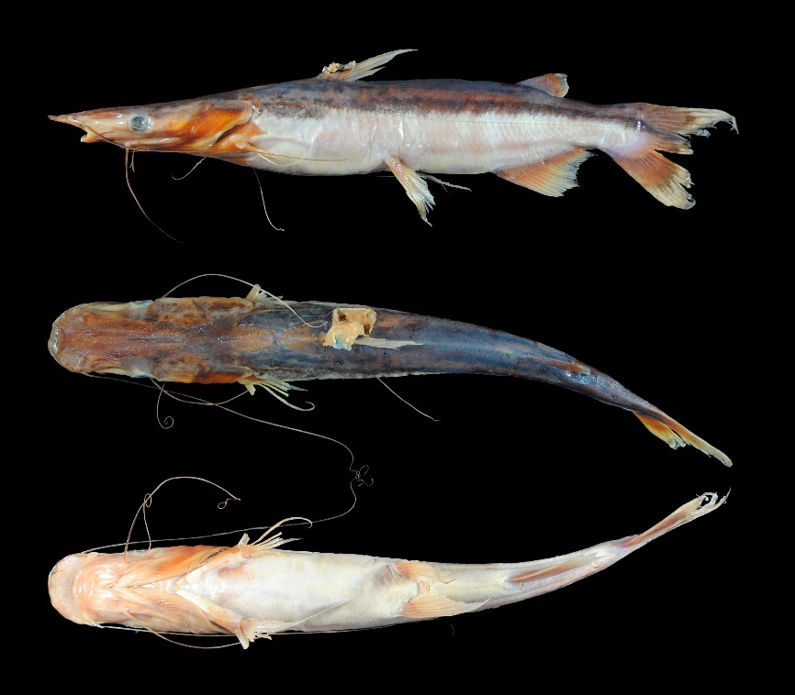
FIGURE 66. Sorubim maniradii, UMSS 11210, 295 mm SL, El Mentiroso Lagoon, Beni sub-basin, Amazon Basin.
Examined material (five specimens). Amazon Basin: UMSS 8278 (1, 157.3 mm SL), Itonamas River, -13.234194 -64.1083330, 11 Aug 2006, J. Camacho. G. Crespo. T. Yunoki; UMSS 11210 (1, 279.0 mm SL), Madre de Dios River, El Mentiroso Lagoon, -11.692330 -66.5775000, 18 Oct 2011, A. Argote; UMSS 16965 (1, 161.4 mm SL), Madre de Dios River, El Mentiroso Lagoon, -11.108970 -66.6126000, 21 Oct 2011, A. Argote; UMSS 18303(1, 154.6 mm SL), Ichilo River IB2, Yuca Lagoon, -16.795220 -64.7823040, 12 Aug 2004, F. Carvajal. M. Pouilly; UMSS 18304 (1, 163.3 mm SL), Ichilo River, Puerto Villarroel ICH 5A, -16.838889 -64.7916667, 8 Dec 2000, F. Carvajal.
Common name. Pico de pato in Puerto Rico (Pando) (Carvajal-Vallejos et al. 2011).
Diagnosis. Sorubim maniradii differs from its congeners in the following: from S. elongatus by the distance between anterior nostrils (19.7-21.2% HL vs. 15-18.2%), mouth width (30.6-33.5% HL vs. 25.2-28.6%), body width (13.6-14.7% SL vs. 11-13.3%), pectoral spine length (18.8-19.6% SL vs. 14.9-17.5%), pelvic fin length (16.1-17.1% SL vs. 12.8-15.2%), dorsal fin base length (6.2-6.6% SL vs. 4.9-5.9%), gill rakers on the first arch (31-36 vs. 14-18); from S. lima by interorbital distance (27.1-29% HL vs. 33.8-40.6%), left posterior nostril to right posterior nostril (18-18.9% HL vs. 22.1-24.4%), distance between anterior nostrils (19.7-21.2% HL vs. 24.1-25.8%), snout length (45-46.9% HL vs. 50.6-53.4%), mouth width (30.6-33.5% HL vs. 36-40.8%), pectoral spine length (18.8-19.6% SL vs. 14.3-16.8%), gill rakers on the first arch (31-36 vs. 15-19).
Description. Morphometric data presented in Table 38. Body and head intermediate between S. elongatus (elongated) and S. lima (broad). Head longer than wide and strongly depressed; eyes laterally positioned. Upper jaw much longer than lower, projecting far beyond it; premaxillary patch exposed ventrally. Wide premaxillary patch; vomerian patches intermediate between S. elongatus (fused) and S. lima (unfused). Oval and very close to the nuchal plate posterior supraoccipital process. Small and pointed humeral process. Pectoral fin surpassing halfway between its origin and pelvic fin origin; serrated spine on posterior margin. Pelvic fin approaching the origin of the anal fin. Pelvic fin slightly longer than pectoral fin. Dorsal fin with a serrated spine on the posterior margin. Adipose fin quite short. Base of the anal fin longer than the base of the adipose fin. Caudal fin forked with the upper lobe pointed and the lower rounded. Maxillary barbels approaching the origin of the pelvic fin surpassing the pelvic fin; shorter mental barbels. Dorsal fin rays I+6; anal fin rays v-vi +14-15; pectoral fin rays I+8-10; pelvic fin rays i+5; caudal fin rays 17-19.
TABLE 38. Morphometric data of Sorubim maniradii. N: Number of individuals, SD: Standard deviation, Min: Minimum value, Max: Maximum value.
Measurements | N | Mean | SD | Min | Max
SL (mm) | 5 | 183.1 | 53.7 | 154.6 | 279
Percents of head length (% HL)
Nuchal plate length | 5 | 15.5 | 0.9 | 14.5 | 16.8
Interorbital distance | 5 | 28.3 | 0.8 | 27.1 | 29.0
Left posterior nostril to right posterior nostril | 5 | 18.5 | 0.4 | 18.0 | 18.9
Left anterior nostril to right anterior nostril | 5 | 20.4 | 0.6 | 19.7 | 21.2
Left anterior nostril to left posterior nostril | 5 | 9.90 | 0.9 | 8.40 | 10.4
Posterior nostril to anterior margin of orbit | 5 | 24.3 | 0.9 | 23.6 | 25.8
Snout length | 5 | 45.8 | 0.9 | 45.0 | 46.9
Postorbital length | 5 | 44.8 | 1.0 | 43.9 | 46.4
Orbital diameter | 5 | 12.6 | 0.8 | 11.3 | 13.3
Head depth | 5 | 33.0 | 3.0 | 30.5 | 38.3
Mouth width | 5 | 32.0 | 1.2 | 30.6 | 33.5
Distance between internal mental barbels | 5 | 5.30 | 2.3 | 2.20 | 8.70
Distance between external mental barbels | 5 | 16.5 | 2.8 | 13.5 | 20.5
Distance between internal and external mental barbel | 5 | 5.60 | 0.6 | 5.0 | 6.30
Percents of standard length (% SL)
Predorsal length | 5 | 48.5 | 1.1 | 47.2 | 49.5
Internal mental barbel length | 5 | 28.3 | 2.3 | 25.7 | 31.0
External mental barbel length | 5 | 44.0 | 4.3 | 38.9 | 48.7
Maxillary barbel length | 5 | 79.1 | 29.2 | 60.1 | 130.8
Body width | 5 | 14.3 | 0.4 | 13.6 | 14.7
Body depth | 5 | 14.7 | 1.6 | 13.7 | 17.5
Head length | 5 | 36.4 | 1.0 | 35.2 | 37.5
Pectoral fin origin to dorsal fin insertion | 5 | 23.4 | 0.8 | 22.7 | 24.5
Dorsal fin origin to pelvic fin origin | 5 | 18.0 | 0.9 | 17.3 | 19.6
Dorsal fin origin to anal fin origin | 5 | 33.0 | 1.2 | 31.9 | 35.0
Pectoral fin origin to pelvic fin origin | 5 | 25.5 | 1.5 | 23.6 | 27.5
Pelvic fin origin to anal fin origin | 5 | 18.2 | 0.7 | 17.2 | 18.9
Pectoral spine length | 4 | 19.2 | 0.3 | 18.8 | 19.6
Distance between pelvic fins | 5 | 8.80 | 0.2 | 8.70 | 9.10
Pelvic fin length | 5 | 16.5 | 0.4 | 16.1 | 17.1
Dorsal spine length | 4 | 18.3 | 1.0 | 16.8 | 19.2
Dorsal fin base length | 5 | 6.40 | 0.2 | 6.20 | 6.60
Dorsal fin insertion to adipose fin origin | 5 | 27.0 | 1.0 | 25.9 | 28.2
Adipose fin base length | 5 | 8.50 | 0.7 | 7.50 | 9.20
Anal fin base length | 5 | 16.7 | 1.1 | 15.3 | 18.0
Anal fin origin to adipose fin insertion | 5 | 16.7 | 1.0 | 15.5 | 18.2
Caudal peduncle height | 5 | 7.20 | 0.4 | 7.0 | 7.90
Dorsal fin origin to anterior caudal base | 5 | 52.3 | 0.9 | 51.5 | 53.8
Adipose fin origin to anterior caudal base | 5 | 20.7 | 0.6 | 20.1 | 21.6
Anal fin origin to anterior caudal base | 5 | 23.9 | 0.8 | 23.1 | 24.8
Caudal peduncle length | 5 | 7.0 | 0.3 | 6.70 | 7.40
Distribution. Present in the Madre de Dios, Beni, Mamoré and Iténez sub-basins (Amazon Basin).
Importance. Commercial fishing trade in Puerto Rico and Cobija (Carvajal-Vallejos et al. 2011).
Sorubimichthys Bleeker 1862
Diagnosis. Head quite flattened; eyes in dorsal position; upper jaw longer than the lower; upper jaw wide with a convex anterior margin, exposing the premaxillary patch; premaxillary patch wide and deep; adipose fin shorter than the anal fin; caudal fin widely forked (Eigenmann & Eigenmann 1890, Eigenmann & Allen 1942).
Distribution. Amazon Basin (Figure 67).
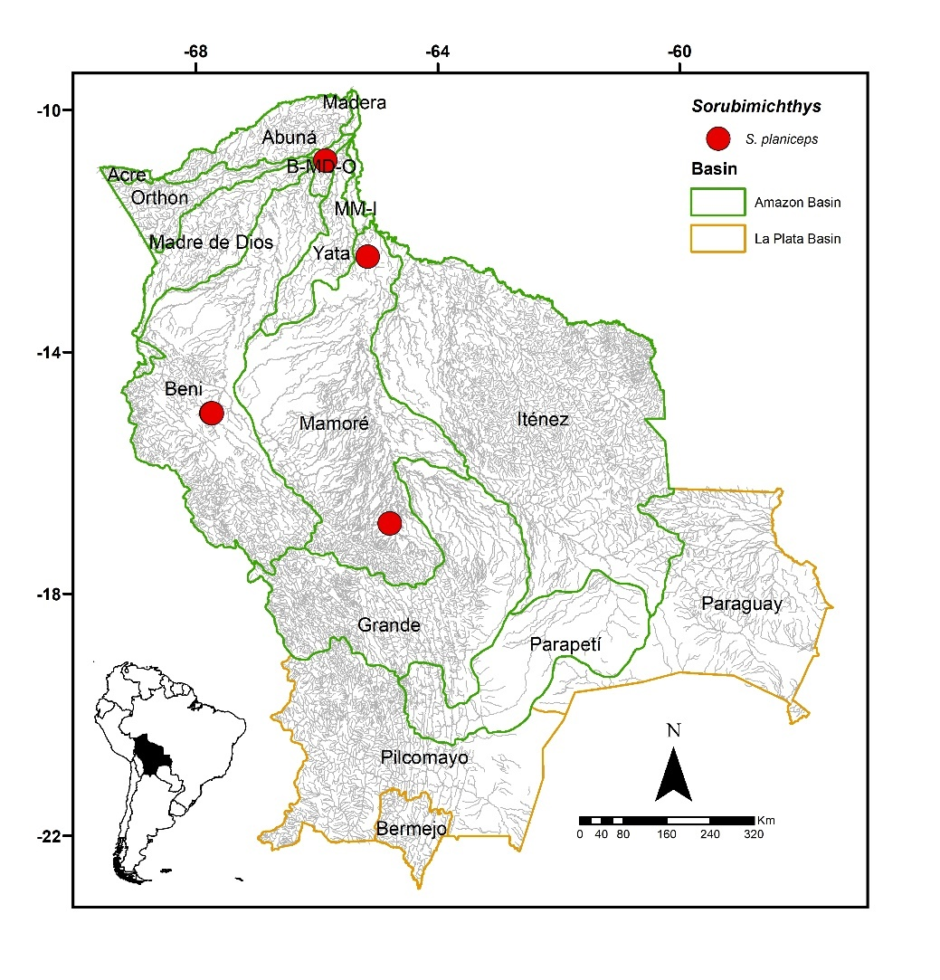
FIGURE 67. Collection sites of seven lots of Sorubimichthys planiceps deposited in the Ichthyological Collection UMSS – Museo d'Orbigny (Cochabamba, Bolivia). Some symbols represent more than one lot.
Included species. Monospecific genus, with Sorubimichthys planiceps as the sole representative.
Comments. Genus proposed by Bleeker (1862) for Sorubim jandia Spix & Agassiz 1829 as the type species, currently synonymous with Sorubimichthys planiceps. Only one species is known, S. planiceps (Spix & Agassiz 1829).
Sorubimichthys planiceps (Spix & Agassiz 1829) (Figure 68)
3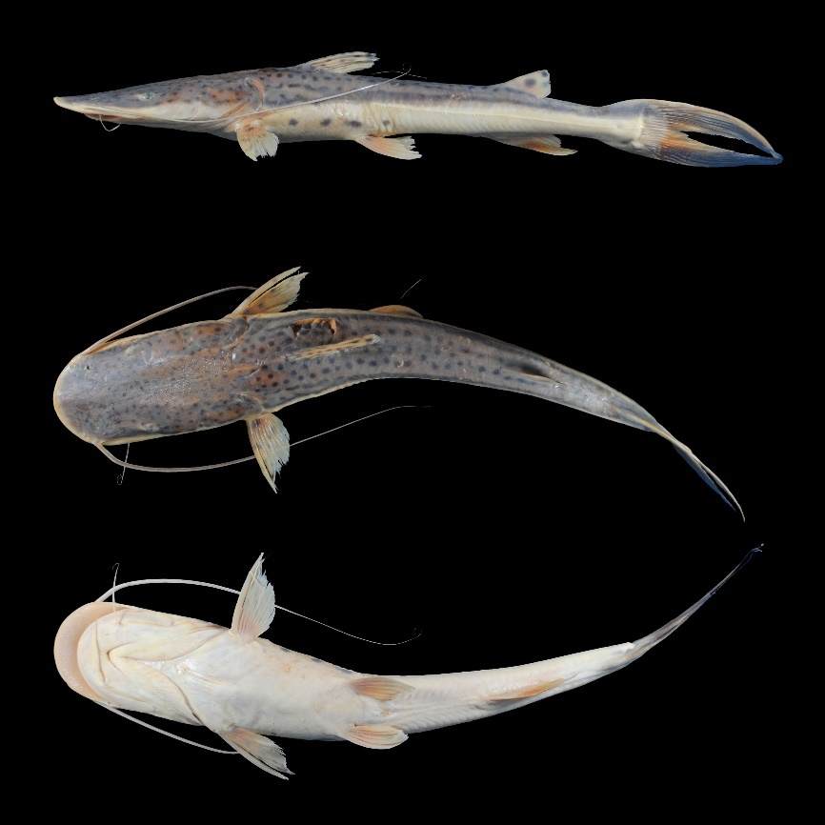
FIGURE 68. Sorubimichthys planiceps, UMSS 17476, 330 mm SL, Mamoré River, Warnes estate, Mamoré sub-basin, Amazon Basin.
Examined material (five specimens). Amazon Basin: UMSS 1086 (1, 372.4 mm SL), Beni River, Florida, -10.837330 -65.8581000, Oct 27, 2001, F. Carvajal, T. Pérez, A. Argote, F. Machicao; UMSS 6156 (1, 533 mm SL), Ichilo River, Puerto Villarroel ICH 5A, -16.838889 -64.7916667, Sep 19, 2007, F. Carvajal; UMSS 6157 (1, 537 mm SL), same data as UMSS 6156; UMSS 17476 (1, 346 mm SL), Mamoré River, Warnes estate, -12.42508056 -65.159925, Sep 9, 2006, F. Carvajal; UMSS 17477 (1, 313 mm SL), same data as UMSS 17476.
Common name. Pez leña in Puerto Rico and Cobija (Pando); paleta in Puerto Rico, Cobija (Pando), Riberalta, Trinidad, Cachuela Esperanza (Beni), and Puerto Villarroel (Cochabamba); pantalón and surubí in Rurrenabaque (Beni) (Lauzanne & Loubens 1985, Carvajal-Vallejos et al. 2011).
Diagnosis. Same as the genus.
Description. Morphometric data presented in Table 39. Head approximately nearly twice as long as wide and strongly dorsoventrally flattened. Eyes small and in laterodorsal position. Mouth in subterminal position; upper jaw extending beyond the lower, with a considerable portion of the premaxillary patch exposed. Wide premaxillary patch; vomerian patches square and fused; elongated and pointed palatine patches, fused to the vomerian patches (Annex 3). Posterior supraoccipital process with a broad base, narrowing on the sides and not contacting the nuchal plate. Small and pointed humeral process. Pectoral fin extending beyond halfway between its origin and the pelvic fin origin; pectoral spine strongly ossified. Pelvic fin extending to halfway between its origin and the anal fin origin. Pectoral fin slightly longer than the pelvic fin. Adipose fin short and high. Base of anal fin slightly longer than the base of the adipose fin. Caudal fin forked with pointed lobes. Maxillary barbels approaching the origin of the pelvic fin; mental barbels much shorter. Dorsal fin rays I+6; anal fin rays iii-v+8-9; pectoral fin rays I+10; pelvic fin rays i+5; caudal fin rays 15.
TABLE 39. Morphometric data of Sorubimichthys planiceps. N: Number of individuals, SD: Standard deviation, Min: Minimum value, Max: Maximum value.
Measurements | N | Mean | SD | Min | Max
SL (mm) | 5 | 420.3 | 106.8 | 372.4 | 533
Percents of head length (% HL)
Interorbital distance | 5 | 31.8 | 1.0 | 30.4 | 32.8
Left posterior nostril to right posterior nostril | 5 | 27.7 | 0.5 | 27.1 | 28.2
Left anterior nostril to right anterior nostril | 5 | 33.6 | 0.3 | 33.1 | 33.9
Left anterior nostril to left posterior nostril | 5 | 8.40 | 0.5 | 7.90 | 9.10
Posterior nostril to anterior margin of orbit | 5 | 23.1 | 0.4 | 22.4 | 23.4
Snout length | 5 | 48.4 | 0.4 | 48.0 | 49.0
Postorbital length | 5 | 46.0 | 1.1 | 44.9 | 47.3
Orbital diameter | 5 | 8.0 | 0.8 | 7.10 | 9.10
Head depth | 5 | 33.7 | 3.1 | 29.4 | 37.5
Mouth width | 5 | 48.2 | 1.6 | 46.6 | 49.9
Distance between internal mental barbels | 5 | 16.6 | 1.1 | 15.4 | 18.3
Distance between external mental barbels | 5 | 27.8 | 0.6 | 26.7 | 28.4
Distance between internal and external mental barbel | 5 | 7.20 | 0.5 | 6.50 | 7.80
Percents of standard length (% SL)
Predorsal length | 5 | 41.4 | 0.4 | 40.9 | 41.8
Internal mental barbel length | 5 | 4.0 | 0.5 | 3.40 | 4.50
External mental barbel length | 5 | 15.7 | 2.7 | 11.0 | 17.6
Maxillary barbel length | 5 | 57.5 | 8.7 | 46.9 | 66.3
Body width | 5 | 18.1 | 0.5 | 17.3 | 18.8
Body depth | 5 | 12.6 | 1.2 | 10.8 | 13.6
Head length | 5 | 34.0 | 0.6 | 33.2 | 34.7
Pectoral fin origin to dorsal fin insertion | 5 | 22.4 | 0.4 | 21.9 | 22.9
Dorsal fin origin to pelvic fin origin | 5 | 16.8 | 1.1 | 15.6 | 18.1
Dorsal fin origin to anal fin origin | 5 | 37.8 | 0.8 | 36.9 | 38.9
Pectoral fin origin to pelvic fin origin | 5 | 21.9 | 1.1 | 20.8 | 23.7
Pelvic fin origin to anal fin origin | 5 | 24.9 | 1.0 | 23.8 | 25.8
Pectoral spine length | 3 | 15.0 | 1.2 | 13.8 | 16.1
Distance between pelvic fins | 5 | 10.0 | 0.4 | 9.60 | 10.5
Pelvic fin length | 5 | 12.9 | 0.9 | 11.6 | 13.9
Dorsal spine length | 4 | 15.4 | 1.3 | 13.6 | 16.4
Dorsal fin base length | 5 | 8.60 | 0.3 | 8.10 | 8.90
Dorsal fin insertion to adipose fin origin | 5 | 28.0 | 1.2 | 26.9 | 29.9
Adipose fin base length | 5 | 9.70 | 0.8 | 8.40 | 10.5
Anal fin base length | 5 | 10.7 | 0.2 | 10.4 | 11.0
Anal fin origin to adipose fin insertion | 5 | 13.0 | 0.6 | 12.3 | 13.8
Caudal peduncle height | 5 | 5.40 | 0.3 | 5.0 | 5.80
Dorsal fin origin to anterior caudal base | 5 | 60.1 | 0.4 | 59.4 | 60.7
Adipose fin origin to anterior caudal base | 5 | 24.1 | 0.9 | 23.1 | 25.3
Anal fin origin to anterior caudal base | 5 | 24.4 | 0.5 | 23.7 | 24.9
Caudal peduncle length | 5 | 13.6 | 0.6 | 12.9 | 14.3
Coloration in alcohol. Body with a cream background and the dorsal region and head dorsally gray. The entire dorsal region, including the head, has round or elongated black spots, with the latter sometimes joining. Flanks with one or two black bands running longitudinally from behind the operculum to the distal ends of the caudal fin lobes; one band located where the gray color ends on the flanks, approximately above the lateral line, the other one located approximately at the height of pectoral fins, well below the lateral line, both bands considerably separated from each other. Ventral region of the body and head cream or whitish. Dorsal, adipose, pectoral, pelvic, and anal fins with black spots; caudal fin with the outer half of each lobe black.
Coloration in life. Coloration similar to that of individuals preserved in alcohol.
Distribution. Present in the Beni, Mamoré and B-MD-O sub-basins (Amazon Basin). Also recorded in the Madeira, Madre de Dios and Iténez sub-basins (Amazon Basin) (Carvajal-Vallejos & Fernández 2011).
Importance. Commercial and subsistence fishing trade in Puerto Rico, Cobija, Riberalta, Rurrenabaque, Cachuela Esperanza and Puerto Villaroel (Carvajal-Vallejos et al. 2011).
Ecological notes. Nocturnal carnivorous species, feeds on fish and invertebrates. Inhabits the main river channels, preferably beach areas; juveniles are found in rivers and lagoons (Sarmiento et al. 2014).
Zungaro Bleeker 1858
Diagnosis. Robust head, as long as wide; small eyes in an anterior position; caudal fin with perpendicular dark bands; short pectoral and dorsal spines; short supraoccipital process in contact with the nuchal plate (Eigenmann & Allen 1942).
Distribution. Amazon and La Plata basins (Figure 69).
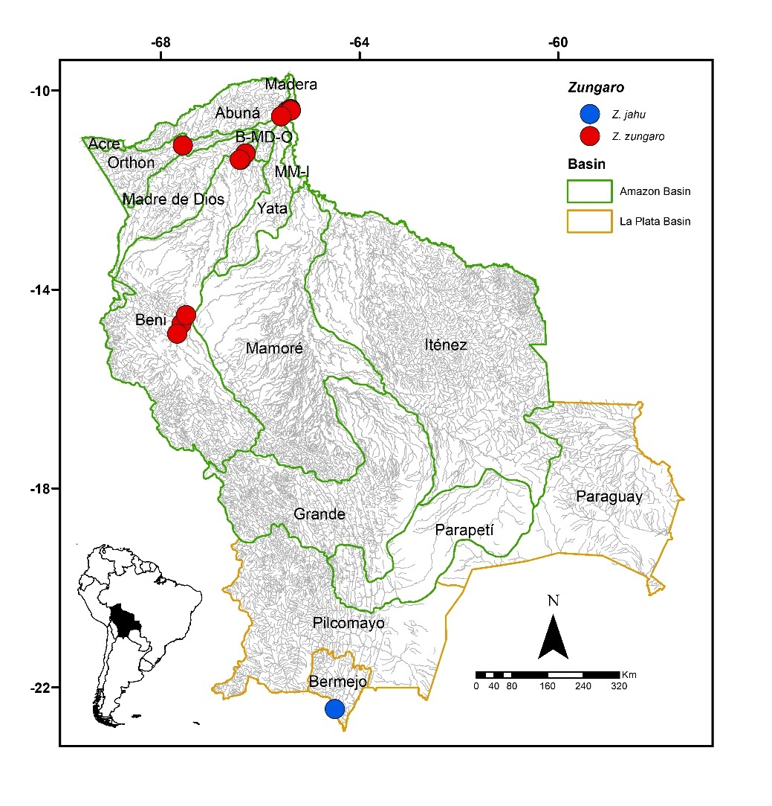
FIGURE 69. Collection sites of 28 lots of Zungaro zungaro deposited in the Ichthyological Collection UMSS – Museo d'Orbigny (Cochabamba, Bolivia). Some symbols represent more than one lot. Collection site of Z. jahu according to Sarmiento et al. (2019).
Included species. Zungaro jahu, Z. zungaro.
Comments. Genus proposed by Bleeker (1858) for Zungaro humboldtii Bleeker 1858, currently synonymous with Z. zungaro. Currently, two species are known: Z. zungaro (Humboldt 1821) in the Amazon and Orinoco basins, and Z. jahu (Ihering 1898) in the Paraná-Paraguay basin (Fricke et al. 2023).
Zungaro jahu (Ihering 1898) (Figure 70)
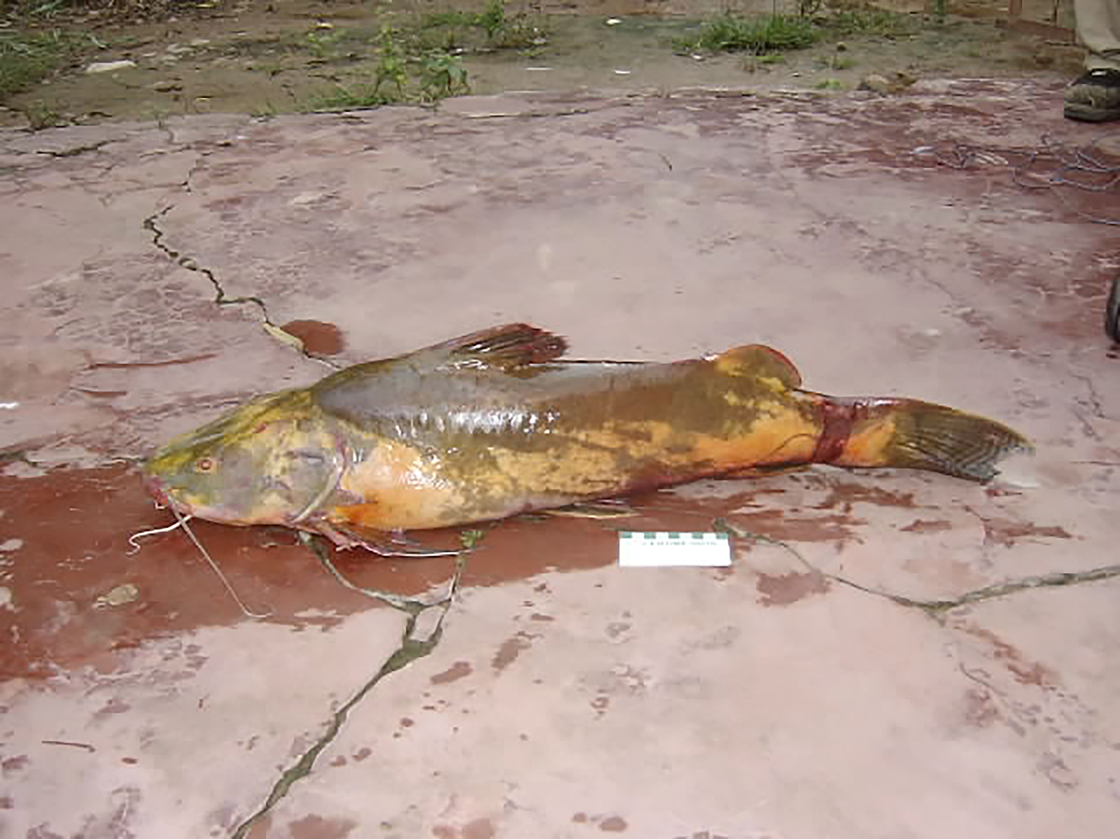
FIGURE 70. Zungaro jahu. Photograph: Soraya Barrera Maure, specimen from the Grande de Tarija River, La Plata Basin.
Diagnosis. Zungaro jahu differs from Z. zungaro in the following: a longer anal fin, contained 9.0-9.3 times in the LE (vs. 7.4-8.9), higher number of rays in the anal fin 12-15 (vs. 10-11).
Common name. Robal (Tarija) (Sarmiento & Barrera 2009).
Description. Short and robust body; wide and long head, flattened with the maxilla slightly longer than the mandible. Very small eyes. Palatine and vomerian patches fused to form a band. Supraoccipital process in contact with the nuchal plate. Pectoral spine long and wider than the dorsal spine, serrated on the posterior margin. Caudal fin emarginated. Maxillary barbels short, not extending beyond the head. Dorsal fin rays I+6, anal fin rays 14 (Carvalho et al. 2022).
Coloration in life. Dark brown or yellow body with irregular dark spots. Fins with slightly darkened posterior regions (Carvalho et al. 2022).
Distribution. Recorded in the Bermejo sub-basin (La Plata Basin) (Sarmiento et al. 2019).
Importance. Commercial, subsistence and recreational fishing in the upper Bermejo basin (Sarmiento et al. 2019).
Ecological notes. Piscivorous species, active during both day and night (Magalhães et al. 2009). Inhabits the main river channel and occasionally may enter flooded forests. Common in waterfalls during low water periods, where it feeds on migrating characids (Sarmiento & Barrera 2009). Additionally, it undergoes reproductive migrations towards the headwaters of rivers during high water periods (Sarmiento et al. 2001).
Zungaro zungaro (Humboldt 1821) (Figure 71)
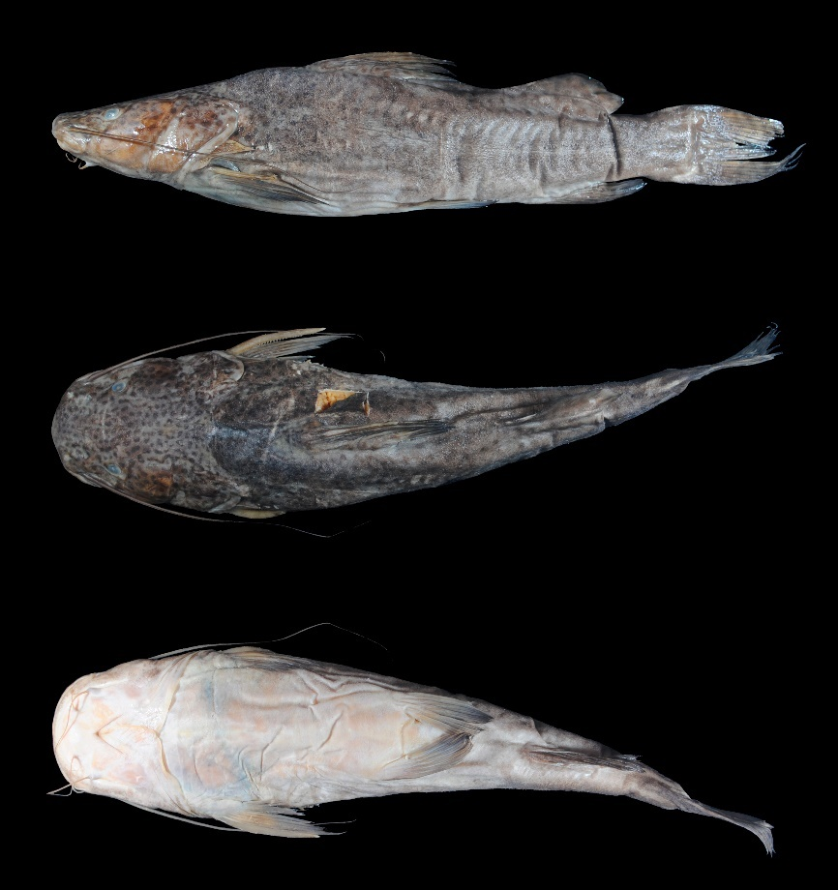
FIGURE 71. Zungaro zungaro, UMSS 7623, 314 mm LE, Madeira River, Villa Bella, Madeira sub-basin, Amazon Basin.
Examined material (18 specimens). Amazon Basin: UMSS 5959 (1, 295 mm SL), Orthon River, Puerto Rico Community, -11.103443 -67.5586640, 21 Jun 2007, H. Muñoz; UMSS 6890 (1, 274.4 mm SL), Beni River, Cachueriña, Villa Bella, -10.424455 -65.4703710, 23 Jul 2007, F. Carvajal; UMSS 7585 (1, 391 mm SL), Mamoré River, above Villa Bella, -10.403147 -65.3813550, 18 Oct 2007, F. Carvajal; UMSS 7623 (1, 333.2 mm SL), Madeira River, Villa Bella, -10.373000 -65.3884450, 22 Oct 2007, F. Carvajal; UMSS 7719 (1, 286.9 mm SL), same data as UMSS 7585; UMSS 7727 (1, 369 mm SL), Madeira River, Villa Bella, -10.379891 -65.3918990, 29 Mar 2008, F. Carvajal; UMSS 7739 (1, 354 mm SL), same data as UMSS 7727; UMSS 7740 (1, 260.6 mm SL), same data as UMSS 7727; UMSS 7741 (1, 247.3 mm SL), same data as UMSS 7727; UMSS 7751 (1, 384 mm SL), same data as UMSS 7585; UMSS 11403 (1, 311 mm SL), Beni River, Portachuelo Lake, -11.267070 -66.2974200, 6 May 2012, A. Argote; UMSS 11404 (1, 314 mm SL), same data as UMSS 11403; UMSS 11405 (1, 262.5 mm SL), same data as UMSS 11403; UMSS 11549 (1, 386 mm SL), Beni River, 27 de Mayo Lake, -11.394520 -66.4095300, 13 Mar 2012, F. Machicao; UMSS 11600 (1, 376 mm SL), El Carmen Lake, -11.393330 -66.4082900, 16 Feb 2012, F. Machicao; UMSS 16975 (1, 345.2 mm SL), Mamoré River, Villa Bella, -10.403147 -65.3813550, 24 Apr 2008, R. Palacios; UMSS 16978 (1, 314 mm SL), same data as UMSS 7585; UMSS 17732 (1, 262 mm SL), Beni River, Cachuela Esperanza, -10.521983 -65.5787100, 23 Sept 2015, D. Barrozo.
Common name. Bagre in Rurrenabaque (Beni); muturo in Puerto Villaroel (Cochabamba) and Trinidad (Beni); yaú in Cachuela Esperanza (Beni); chanana amarillo in Puerto Rico and Cobija (Pando); chanana in Puerto Rico, Cobija (Pando), Riberalta, and Cachuela Esperanza (Beni) (Lauzanne & Loubens 1985, Carvajal-Vallejos et al. 2011).
Diagnosis. Review the diagnosis of Z. jahu.
Description. Morphometric data presented in Table 40. Straight profile from the tip of the snout to the origin of the dorsal fin. Head with length and width relatively equal; wide and truncated snout; eyes in dorsal position. Mouth in subterminal position. Wide premaxillary patch; vomerian patches much thinner than the premaxillary and in one piece; elongated and fused palatine patches with vomerian patches (Annex 4). Posterior supraoccipital process not visible. Elongated and pointed humeral process. Pectoral fin extending beyond the midpoint between its origin and the pelvic fin. Pelvic fin extending beyond the midpoint between its origin and the anal fin. Pectoral fin longer than the pelvic fin. Short adipose fin. Emarginated caudal fin. Maxillary barbels extending beyond the origin of the pelvic fin; much shorter mental barbels. Dorsal fin rays I+6; anal fin rays iii+7-8; pectoral fin rays I+11-12; pelvic fin rays i+5; caudal fin rays 15.
Table 40. Morphometric data of Zungaro zungaro. N: Number of individuals, SD: Standard deviation, Min: Minimum value, Max: Maximum value.
Measurements | N | Mean | SD | Min | Max
LE (mm) | 18 | 320.3 | 48.8 | 247.3 | 391
Percents of head length (% HL)
Interorbital distance | 18 | 32.9 | 1.0 | 31.4 | 34.6
Left posterior nostril to right posterior nostril | 18 | 28.6 | 0.8 | 27.3 | 30.7
Left anterior nostril to right anterior nostril | 18 | 29.8 | 0.8 | 28.0 | 31.1
Left anterior nostril to left posterior nostril | 18 | 10.9 | 0.6 | 9.90 | 12.4
Posterior nostril to anterior margin of orbit | 18 | 11.5 | 0.6 | 10.3 | 12.2
Snout length | 18 | 38.3 | 0.8 | 37.1 | 39.8
Postorbital length | 18 | 53.6 | 1.0 | 52.1 | 55.5
Orbital diameter | 18 | 10.4 | 0.7 | 9.30 | 11.6
Head depth | 18 | 65.2 | 3.6 | 57.5 | 73.8
Mouth width | 18 | 59.6 | 1.5 | 56.7 | 61.6
Distance between internal mental barbels | 18 | 21.8 | 1.6 | 19.1 | 24.7
Distance between external mental barbels | 18 | 44.5 | 2.1 | 41.0 | 47.4
Distance between internal and external mental barbel | 18 | 11.7 | 0.7 | 10.5 | 13.1
Percents of standard length (% LE)
Predorsal length | 18 | 44.0 | 0.9 | 42.4 | 45.8
Internal mental barbel length | 16 | 10.7 | 0.9 | 9.10 | 12.3
External mental barbel length | 18 | 22.0 | 1.7 | 19.2 | 25.9
Maxillary barbel length | 18 | 57.0 | 5.0 | 45.6 | 69.4
Body width | 18 | 27.3 | 0.8 | 25.9 | 29.3
Body depth | 18 | 24.6 | 2.3 | 20.9 | 29.5
Head length | 18 | 33.0 | 0.7 | 32.0 | 34.2
Pectoral fin origin to dorsal fin insertion | 18 | 35.9 | 1.0 | 34.1 | 37.4
Dorsal fin origin to pelvic fin origin | 18 | 28.3 | 2.0 | 25.2 | 32.6
Dorsal fin origin to anal fin origin | 18 | 41.3 | 1.2 | 39.5 | 43.9
Pectoral fin origin to pelvic fin origin | 18 | 30.5 | 1.8 | 27.6 | 33.8
Pelvic fin origin to anal fin origin | 18 | 22.1 | 1.0 | 19.6 | 23.4
Pectoral spine length | 13 | 21.0 | 1.3 | 18.0 | 22.7
Distance between pelvic fins | 18 | 14.4 | 0.7 | 12.9 | 15.5
Pelvic fin length | 18 | 16.6 | 0.8 | 15.3 | 18.5
Dorsal spine length | 15 | 22.4 | 1.1 | 20.3 | 24.3
Dorsal fin base length | 18 | 14.4 | 0.8 | 12.6 | 15.9
Dorsal fin insertion to adipose fin origin | 18 | 16.5 | 2.0 | 12.2 | 19.5
Adipose fin base length | 18 | 18.2 | 1.0 | 16.4 | 20.0
Anal fin base length | 18 | 12.3 | 0.5 | 11.2 | 13.5
Anal fin origin to adipose fin insertion | 18 | 19.8 | 0.7 | 18.8 | 21.3
Caudal peduncle height | 18 | 10.1 | 0.5 | 9.30 | 10.9
Dorsal fin origin to anterior caudal base | 18 | 59.5 | 2.1 | 53.9 | 62.2
Adipose fin origin to anterior caudal base | 18 | 29.0 | 1.2 | 26.6 | 31.4
Anal fin origin to anterior caudal base | 18 | 24.8 | 1.0 | 22.6 | 27.1
Caudal peduncle length | 18 | 12.6 | 0.6 | 11.7 | 14.1
Coloration in alcohol. Dorsally, the body and head exhibit a grayish to greenish coloration with numerous small dark spots covering their entire surface. Ventral region of body and head whitish. All fins display the same spotted pattern as the body; the caudal fin may sometimes have spots forming approximately vertical bands in the lobes.
Coloration in life. Adult individuals olive-colored with almost imperceptible spots. Juvenile individuals yellowish-green with more noticeable spots.
Distribution. Present in the Madeira, Orthon, Beni, MM-I and B-MD-O sub-basins (Amazon Basin). Also recorded in the Madre de Dios, Mamoré, Iténez (Carvajal-Vallejos & Fernández 2011), Grande (Maldonado et al. 2020) and Abuná sub-basins (Amazon Basin) (Amazon Basin) (Torrico et al. 2020).
Importance. Commercial and subsistence fishing trade in Puerto Rico, Cobija, Riberalta, Rurrenabaque, Cachuela Esperanza, Puerto Villaroel (Carvajal-Vallejos et al. 2011).
Ecological notes. A carnivorous species that feeds on fish and shrimp; juveniles are omnivorous, consuming fruits, insects, and plankton. It inhabits the bottom of the main channels of large rivers, occasionally found in floodplains and rapids. It is a nocturnal species, undertaking reproductive migrations as well as longitudinal movements following schools of characids and small catfish (Sarmiento et al. 2014).
Artificial dichotomous Key for the species of the family Pimelodidae recorded in Bolivia (modified and based on Salles & Zuanon 2013)
1a. Large and kidney-shaped nuchal plate….....……Phractocephalus (P. hemioliopterus)
1b. Small and variably shaped nuchal plate, never kidney-shaped…………..…………....2
2a. Body quite compressed laterally; very long anal fin, occupying about half of the standard length; soft jaws……………………………………….…Hypophthalmus (4 spp.) 3
2b. Body slightly compressed laterally; short anal fin, occupying less than a quarter of the standard length; strong jaws…………………………….…………………………………6
3a. Internal mental barbels widely membranous and black; laterosensorial branches of the main lateral line slightly curved or S-shaped………...……...………..…….H. fimbriatus
3b. Thin, non-membranous internal mental barbels; laterosensorial branches of the main lateral line in an X or compass-shape……….…………………..…………………………….4
4a. Innermost ray of the pelvic fin fused to a membrane that joins it to the margin of the urogenital papilla; emarginated caudal fin; short laterosensorial branches, away from the dorsal midline and anal musculature.…………………………………...…H. oremaculatus
4b. Innermost ray of the pelvic fin free, without membrane; strongly bifurcated caudal fin with pointed lobes; long laterosensorial branches, reaching the back and anal musculature…………………………………………………..……………………………..…...5
5a. Origin of the dorsal fin almost vertically in line with the origin of the anal fin; snout length 51.1-52.7% HL…………………..………………………………………..…H. celiae
5b. Origin of the dorsal fin vertically posterior to the origin of the anal fin; snout length 50.4-56.2% HL……..…………………………..………………………………..…H. edentatus
6a. Dorsal fin with 10 to 12 branched rays…..............…………………...Leiarius (2 spp.) 7
6b. Dorsal fin with 6 to 7 branched rays…....…………………….……...………….….…….8
7a. Body with an arched whitish band extending from the origin of the dorsal fin to about the origin of the anal fin………………….……..………………………………………L. pictus
7b. Body without an arched whitish band……………………………...…..… L. marmoratus
8a. Upper jaw elongated, extending much beyond the lower jaw, exposing the premaxillary patch in ventral view...……..……......................................................……….9
8b. Upper jaw slightly longer than the lower jaw (sometimes leaving a very small portion of the tooth plate exposed) or shorter….……………………………………………....…..13
9a. Snout triangular in dorsal view; premaxillary patch pointed, triangular in ventral view………………………………………………………………Platystomatichthys (P. sturio)
9b. Snout convex in dorsal view; premaxillary patch convex in ventral view…….…….10
10a. Body with small dark spots mostly evident on the upper half of the body and head; caudal fin lobes with the outer half black….......................Sorubimichthys (S. planiceps)
10b. Body with a dark band on the flank, sometimes extending to the distal edge of the lower lobe of caudal fin……...……...……………………....………Sorubim (3 spp.) 11
11a. Gill rakers in the first arch 31-36…………………………………………….S. maniradii
11b. Gill rakers in the first arch 14-19………………………………………………….…….12
12a. Supraoccipital posterior process rounded in the distal extreme; small and unfused vomerian patches; interorbital distance 22.4-28.9% HL; left posterior nostril to right posterior nostril 14.6-17.1% HL; mouth width 25.2-28.6% HL; body width 11-13.3% SL.……………………………….……………………………….…………………..S. elongatus
12b. Supraoccipital posterior process pointed in the distal extreme; large and fused vomerian patches; interorbital distance 33.8-40.6% HL; left posterior nostril to right posterior nostril 22.1-24.4% HL; mouth width 36-40.8% HL; body width 15.3-18.5% SL…………..………….…………………………………………………….……………..S. lima
13a. Prognathous mandible, with the lower jaw slightly longer than the upper jaw…………………………..……………………………......Hemisorubim (H. platyrhynchos)
13b. Upper jaw slightly longer than the lower jaw, with the mouth in a subterminal position…………………...………..…………………………...……………………………….14
14a. Pectoral fin without spines, with the first ray soft and flexible……..........................15
14b. Pectoral fin with the first ray ossified and hard or with a sharp spine……………....24
15a. Premaxilla with a row of teeth with rounded cusps, never forming patches……………………………..…….……......……...…….Calophysus (C. macropterus)
15b. Premaxilla with villiform teeth arranged on a patch……………………….…...…..…16
16a. Body with dark spots arranged on the flanks or over the entire body……...…...….17
16b. Uniformly colored body, without spots..….….......….……..………....……….………20
17a. Flattened head with the snout flattened in a spatula-shape............................................................................................Luciopimelodus (L. pati)
17b. Head not very flattened with a conical snout…..........................…….……………...18
18a. Very long adipose fin, inserted immediately behind the dorsal fin; upper 2/3 of the body olive or gray with small dark spots smaller than the eye…..........................................................................................Pimelodina (P. flavipinnis)
18b. Short adipose fin, clearly separated from the dorsal fin; entire flank surface grayish or cream with dark spots of similar size to the eye…………………….…………...…………….………..………..Aguarunichthys (2 spp.) 19
19a. Cream-colored band without spots extending between the bases of the dorsal and pelvic fins; left anterior nostril to right anterior nostril 18.2-19.4% HL; mouth width 46.7-47.4% HL; body width 22.2-22.6% SL; pectoral fin origin to dorsal fin insertion 29.5-29.6% SL ………...……………………………………………………………………….A. inpai
19b. Band absent; left anterior nostril to right anterior nostril 16.8% HL; mouth width 42.5% HL; body width 20.7% SL; pectoral fin origin to dorsal fin insertion 27.4% SL …..………………………………………………………………….………………..….A. torosus
20a. Adipose fin short and clearly separated from the dorsal fin; caudal fin with a large dark spot embedded within the rays of the upper lobe base……………………………………………………………………Megalonema (3 spp.) 21
20b. Adipose fin long and originating very close to the dorsal fin; caudal fin without a spot………………………………..……………..…..………......….Pinirampus (P. pirinampu)
21a. Supraoccipital posterior process short and bell-shaped; length of the pelvic fin 25.2% SL……..….………………………………………..………………….…M. amaxanthum
21b. Supraoccipital posterior process long and spine-shaped; pelvic fin length 16.1-20.3% SL…………………………………………………..………..…………….........……22
22a. Orbital diameter 15.1-18.2% HL; mouth width 49.7-58.3% HL……...…..M. platanum
22b. Orbital diameter 11.3-13.1% HL; mouth width 51.1-53.5% HL............................................................................................................M. platycephalum
23a. Mouth in ventral position………………..………...…………........……………...…….24
23b. Mouth in subterminal position………...………………………...………….....………..25
24a. Dark band crossing the nuchal region at the origin of the dorsal fin; long adipose fin with a convex margin……………………...…………….…..…...Cheirocerus (C. eques)
24b. Dark band absent in the nuchal region; adipose fin short and triangular…………………...……………………………………...Iheringichthys (I. megalops)
25a. Pectoral spine shorter than the subsequent ray; adipose fin long and inserting immediately behind or very close to the dorsal fin……....….……….…………………...26
25b. Pectoral spine longer or of similar size to the subsequent ray; adipose fin short and clearly separated from the dorsal fin (exception: P. altissimus)………..…………….27
26a. Premaxilla with small and weak teeth; vomerian and palatine patches present and widely separated……………………………………...…………..Duopalatinus (D. peruanus)
26b. Premaxilla with large and strong teeth; vomerian patches absent; palatine patches occasionally present………...………………………………...……Exallodontus (E. aguanai)
27a. Maxillary barbels very long, surpassing the body length; body with dark spots of different sizes in the upper lateral region; caudal fin with a large dark spot at the base of the upper lobe……………………………………………….………Platysilurus (P. mucosus)
27b. Maxillary barbels short (exception: P. altissimus); body with a different coloration pattern mentioned above; caudal fin without a large dark spot at the base of the upper lobe………..………………………………………………………………..……...…………...28
28a. Emarginated caudal fin; body in a subtle gray to yellow-green color with many dark dots………………………………………………………………………..Zungaro (2 spp.) 29
28b. Bifurcated caudal fin, body with a different coloration pattern mentioned above………………………………………………………………………………………….…30
29a. Anal fin contained 9-9.3 times in SL; number of rays in the anal fin 12-15; La Plata Basin………………………………………………………………………...……………Z. jahu
29b. Anal fin contained 7.4-8.9 times in SL; number of rays in the anal fin 10-11; Amazon Basin……………………………………………………………..………….Z. zungaro
30a. Dorsal fin spine with a dark elongated filament; body gray or silver in life, with many dark spots; caudal fin with a large dark spot on the lower lobe………………………………………….….……..…...….Platynematichthys (P. notatus)
30b. Dorsal fin spine without filament or, when present, very short; body of variable coloration, uniform color, with spots or bands; caudal fin of uniform color, with small spots or bands…………………………………………………………….……………………31
31a. Individuals of small to medium size (up to 350 mm in length); body of uniform color, with longitudinal spots or bands; caudal fin with pointed lobes and without elongated filaments…………………………………………………………...……..Pimelodus (7 spp) 32
31b. Large individuals (up to 2 m in length); body of uniform color, with vertical or anastomosed bands or spots; caudal fin with pointed lobes and elongated filaments or with rounded lobes…………………………………………………………………………….39
32a. Body with distinct spots randomly distributed or in rows on the flanks…….....….33
32b. Body without spots or with very diffuse spots, uniform color, or with longitudinal bands on the flanks…………………………………………………………………………….34
33a. Silvery background with black spots arranged irregularly on the flanks; unpigmented stripe arranged between the origin of the dorsal and pelvic fins………………………………………………………………………………………P. pictus
33b. Yellowish or brown background with brown spots arranged in rows on the flanks; stripe absent...……….… …………………………..…………...………...…..P. gr. maculatus
34a. Body with dark bands arranged longitudinally on the flanks………..…….…...…..35
34b. Grayish or light-colored body with metallic sheen in life………….…………......…..36
35a. Dorsal fin with a black spot in the anterosuperior region; lobes of the caudal fin each with a black band arranged longitudinally...… ………………………………P. ornatus
35b. Dorsal fin without a spot; lobes of the caudal fin without bands, of uniform color…………..…………………..……………………………...……………….…...P. albicans
36a. Adipose fin very long and originating immediately behind the dorsal fin; barbels…………………….………………….……………….……..…………….P. altissimus
36b. Adipose fin short and approximately triangular in shape and clearly separated from the dorsal fin…………………………………...………………….…………........……………37
37a. Silvery body with dark fins; found in La Plata Basin……………………...P. argenteus
37b. Grayish body with whitish fins; found in the Amazon Basin……………..P. gr. blochii
38a. Caudal fin with both lobes pointed and with elongated filaments………………………………………………………..Brachyplatystoma (6 spp.) 39
38b. Caudal fin with both lobes rounded and without elongated filaments………………...……………………….……………..Pseudoplatystoma (3 spp.) 44
39a. Body with a coloration pattern with dark vertical or diagonal bands……..…………40
39b. Body of uniform color, without bands….……..………………...………………………41
40a. Body with wide dark bands arranged vertically, sometimes branched or interlaced; tail with small dark spots arranged irregularly….…………………...………....…B. juruense
40b. Body with thin dark bands arranged diagonally; tail with narrow bands arranged vertically………...…………...………………………………………………………...B. tigrinum
41a. Maxillary barbels short, reaching up to the origin of the pectoral fin; body with a golden to silver sheen in life……………………………………….………...….B. rousseauxii
41b. Maxillary barbels long, extending beyond the origin of the pelvic fin; body without golden or silver sheen…………………….…………………..……………….………..……..42
42a. Adipose fin base length 24-24.8% SL…........…………………...........…….B. vaillantii
42b. Adipose fin base length 13.8-19.7% SL………………………………………….…….43
43a. Thin and rounded maxillary barbels; interorbital distance 27.5% HL; internal mental barbel length 4.8% SL; external mental barbel length 17.8% SL...…………………………… ……………………………..……………B. filamentosum
43b. Wide and flattened maxillary barbels; interorbital distance 17-18.8% HL; internal mental barbel length 27.8-48.4% SL; external mental barbel length 40.3-67% SL...……………….………………………… …………………...….……… B. platynema
44a. Body with dark spots arranged in rows on the flanks………………...…P. corruscans
44b. Body with black and white bands on the flanks………………………………….….45
45a. Body with black and white bands arranged vertically on the flanks……………………………………………………………………………….P. fasciatum
45b. Body with loop-shaped black bands forming a striped pattern, white bands absent………………....…...……………………………..……………..…..…..……P. tigrinum
DISCUSSION
In this study, 47 valid species distributed across 24 valid genera are listed for Bolivia, representing an increase compared to the latest lists by Carvajal-Vallejos et al. (2014c) with 44 valid species and Torrico et al. (2020) with 46. Additionally, six new species and two new genera are listed. The Amazon Basin showed the highest species richness (44 valid spp.), adding one to the most recent list by Torrico et al. (2020) (43 valid spp). Fish in La Plata Basin remain poorly known, and last inventories are geographically limited. For the Bermejo sub-basin, six species were listed (Sarmiento et al. 2019), adding six new records with the present study. As well, for the Pilcomayo sub-basin, the number of species recorded remains the same as previously reported by Maldonado et al. (2019) (6 spp).
New records for Bolivia are Hypophthalmus celiae, H. oremaculatus, Iheringichthys megalops, two new potential species in Propimelodus genus, and four new potential species in two undescribed genera. The first species has only been reported for Brazil, Colombia, Peru, and Venezuela (Fricke et al. 2023), pending confirmation. The second species, H. oremaculatus, was recorded before by Littmann et al. (2021) in the Laguna San Luis in the Madre de Dios River (Amazon Basin). The third species, I. megalops, has not been cited for Bolivia before (Fricke et al. 2023), while I. labrosus was recorded for La Plata Basin (Torrico et al. 2020). Nevertheless, upon reevaluation of the material corresponding to I. labrosus used by Torrico et al. (2020), it was observed that this species was misidentified and correspond to I. megalops. In the genus Propimelodus two new potential species were observed, Propimelodus nov. sp. 1 and Propimelodus nov. sp. 2 (Figure 72). Specimens of the first species were captured in the Madeira and Iténez sub-basins, while the second was found in the B-MD-O sub-basin, both on the Amazon Basin. In addition, four potential new species grouped into two new genera, Pimelodidae nov. gen 1 and Pimelodidae nov. gen 2, were also identified (Figure 72). Pimelodidae nov. gen 1 comprises three species of small-size that were captured in the bottom of the Beni River channel (Amazon Basin). Two of the three species of this new genus were previously mentioned by Torrico et al. (2020). Pimelodidae nov. gen. 2 includes one species of medium-sized, whose specimens were collected in the Beni and Mamoré rivers (Amazon Basin). However, a greater number of individuals, as well as additional techniques, are required to perform a description of new genera and species.
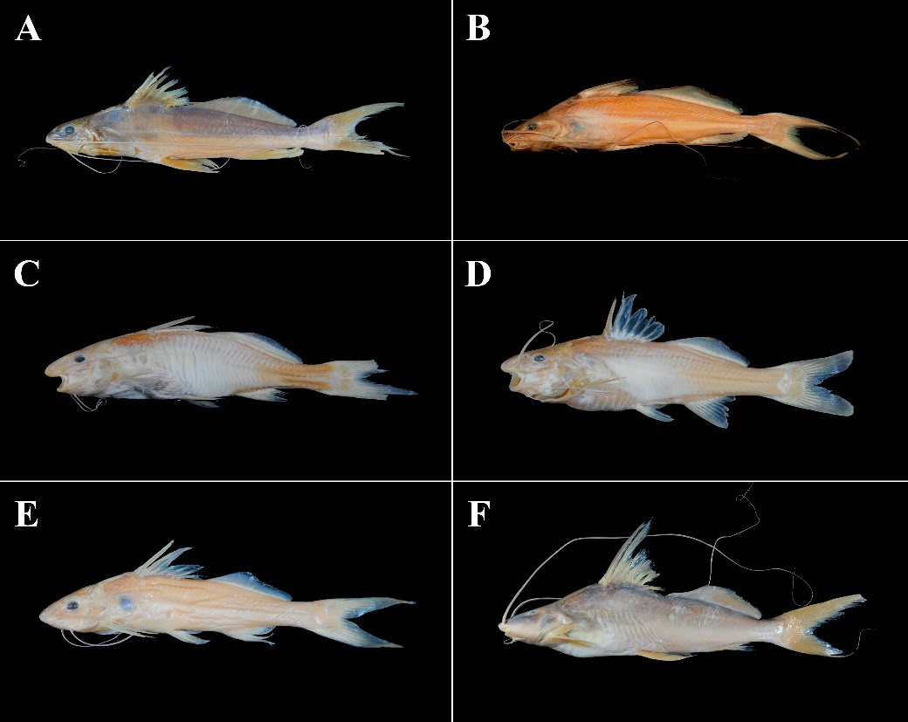
FIGURE 72. (A) Propimelodus nov. sp. 1, UMSS 3231, 109.6 mm SL, Blanco River, Iténez sub-basin, Amazon Basin; (B) Propimelodus nov. sp. 2, UMSS 10655, 99.8 mm SL, Beni River, Florida stream, B-MD-O sub-basin, Amazon Basin, Photographs by Matias Careaga; (C) Pimelodidae nov. gen. 1 nov. sp. 1, UMSS 10387, 62 mm SL, Beni River, Florida, B-MD-O sub-basin, Amazon Basin; (D) Pimelodidae nov. gen. 1 nov. sp. 2, UMSS 10457.1, 50.4 mm SL, Beni River, Florida, B-MD-O sub-basin, Amazon Basin; (E) Pimelodidae nov. gen. 1 nov. sp. 3, UMSS 18301, 50.1 mm SL, Beni River, Florida, B-MD-O sub-basin, Amazon Basin; (F) Pimelodidae nov. gen. 2 nov. sp. 1, UMSS 7781, 220 mm SL, Beni River, B-MD-O sub-basin, Amazon Basin.
In addition, three unusual specimens of S. lima with both lobes of the caudal fin pointed, instead of the lower lobe rounded, were observed. These peculiar specimens were collected in the Beni sub-basin and, compared to those with a lower lobe rounded, have a longer external mental barbel (36.8-37.5% SL vs. 25.1-33.7%) and a lower interorbital distance (29.6-32.1% HL vs. 33.8-40.6%). According to Littman et al. (2000), the only species of Sorubim with both lobes pointed is S. cuspicaudus, which is endemic to the northwestern basins of South America. This species was identified through metabarcoding in a sample of ichthyoplankton from the Beni River in the Madidi National Park (Miranda-Chumacero et al. 2022), the same system where the examined specimens were captured. Nevertheless, this record remains pending confirmation as this species is distributed in the Magdalena and Sinu Rivers basins, as well as Lago Maracaibo.
Although in previous inventories H. marginatus was cited for Bolivia (Pouilly et al. 2004, Carvajal-Vallejos & Fernández 2011, Jégu et al. 2012, Sarmiento et al. 2014, Careaga et al. 2020, Torrico et al. 2020), it seems a misidentification, due to this species is restricted to the Orinoco basin and the main rivers of the Guianas in Venezuela, Colombia, Guyana, Suriname, and French Guiana (Littmann et al. 2021, Fricke et al. 2023). Likewise, Leiarius longibarbis has been cited for Bolivia (Torrico et al. 2020), but this species is not considered by Fricke et al. (2023) within the ichthyofauna of Bolivia, and it is an inquirenda species within Leiarius (Lundberg & Littmann 2003).
The increase in some records could be associated with fish introductions caused by various human activities such as aquaculture, sport fishing, and the facilitation of species passage over natural barriers (Torrico et al. 2020). In 2012, B. juruense was recorded for the first time in the lowlands of the Bolivian Amazon (Beni sub-basin). This species was previously limited to the middle and lower portions of the Madeira River basin in Brazil, downstream from the Santo Antonio rapids. It possibly entered Bolivia from Brazil in 2011 through the fish transfer channel built in the Santo Antonio dam (Porto Velho), which became operational the same year. At that time, the Jirau dam (located kilometers upstream from the Santo Antonio dam) was not yet close, and it probably could have facilitated the movement of species capable of traversing not very turbulent rapids upstream (Carvajal-Vallejos et al. 2014d). The same may have happened with B. vaillantii, as this species was found below the rapids or fast currents in the Madeira River (Barthem & Goulding 1997). Although the first record of this species in Bolivia was in 1985 (Lauzanne & Loubens 1985), it may be an incorrect identification, as there are no other records until 2011 in the Madeira River (Carvajal-Vallejos & Zeballos 2011). Another reason that could explain the presence of some species is the manual translocation that occurs at the Jiraú dam (Van Damme et al. 2019). These events need to be highlighted as they could explain the presence of new pimelodids or other fish species that were not previously recorded in the Amazon Basin in Bolivia.
The construction of hydroelectric dams can greatly affect fish populations, especially species that undertake extensive migrations (for example Brachyplatystoma spp., Pseudoplatystoma spp.). These megadams, equipped with turbines and spillways, constitute a physical obstacle that do not allow or significantly hinders fish passage in both directions. This can lead to isolation of fish communities above and below the dams, directly affecting migratory fish (REMMAyA 2014). This is the case for the plateado or dorado (Brachyplatystoma rousseauxii), known to be of great importance in commercial fishing trade and having the longest known migration in continental waters, moving from estuaries to the Andean foothill headwaters (Carvajal-Vallejos 2013). A study by Van Damme et al. (2019) suggested that after the closure of the Jiraú and Santo Antonio dams, there was an interruption in the migratory route of dorado, causing a significant decrease in catches. This is possibly one case among many still unknown. Some species within Pimelodidae, which also migrate and can pass through rapids in the same way as dorado, include B. platynema, B. vaillantii, Pseudoplatystoma fasciatum, and P. tigrinum (Carvajal-Vallejos & Fernández 2011).
Some species such as Brachyplatystoma rousseauxii, Zungaro jahu, and Pseudoplatystoma corruscans are categorized in some classifications within the Red Book (MMAyA 2009) (vulnerable for the first and near threatened for the last two). This is due to a series of factors such as uncontrolled commercial fishing trade, intense sport fishing, subsistence fishing, contamination by heavy metals, habitat destruction, construction of hydroelectric dams, and the introduction of hybrids for aquaculture (Carvajal-Vallejos & Van Damme 2009, Sarmiento & Barrera 2009, Osinaga et al. 2009). This study reveals that taxonomic and systematic work on Pimelodidae of Bolivia is still a challenge for taxonomists. Complementary studies using different methodological approaches could be used to describe new genera and species, as well as for resolving the taxonomic identity of some species as P. gr. blochii and P. gr. maculatus. An increase in the number of valid species within Pimelodidae of Bolivia, is expected as new species were revealed in the present study.
ACKNOWLEDGMENTS
To the Unidad de Limnología y Recursos Acuáticos (ULRA), University Mayor de San Simón (UMSS) Cochabamba, for allowing access to the ichthyological material. To Soraya Barrera from the Colección Boliviana de Fauna (CBF), Museo Nacional de Historia Natural (La Paz), for her collaboration in obtaining some photographs. We thank the two anonymous reviewers for their careful reading and constructive comments on the final draft of the manuscript.
REFERENCES
Alcántara F., Chu F., Rodríguez L., Chávez C., Bernuy A., Barbarán T., Tello S., Murrieta G., García-Dávila C., Núñez J. 2009. Notas sobre la biología y pesca del zúngaro tigrinus Brachyplatystoma tigrinum (Britski, 1981) en el río amazonas, Perú. Folia Amazónica, 18: 15-22.
Azpelicueta M., Britski H. A. 2012. Iheringichthys syi (Siluriformes: Pimelodidae), a new pimelodid species from upper Paraná basin, Brazil. Neotropical Ichthyology, 10: 45-52.
Azpelicueta M., Lundberg J., Loureiro M. 2008. Pimelodus pintado (Siluriformes: Pimelodidae), a new species of catfish from affluent Rivers of Laguna Merín, Uruguay, South America. Proceedings of the Academy of Natural Sciences of Philadelphia, 157: 149-162.
Baigún C. R. M., Minotti P. G. 2019. Patrones de riqueza y distribución de peces en la cuenca Pilcomayo. p. 47-108. En: Van Damme P. A., Baigún C. R. M., Sarmiento J., Carvajal-Vallejos F. M. (Eds.). Peces y pesquerías en las cuencas Pilcomayo y Bermejo. Edit. INIA, Cochabamba, Bolivia.
Barthem R., Goulding M. 1997. The catfish connection: ecology, migration, and conservation of Amazon predators. Columbia University Press. 144 p.
Boulenger G. A. 1898. On a collection of fishes from the Rio Jurua, Brazil. Transactions of the Zoological Society of London, 14: 421-428.
Britski H. A., de Silimon K. Z., Lopes B. A. 2007. Peixes do Pantanal: manual de identificação. Embrapa Informação Tecnológica, Brasília, Brazil. 660 p.
Buitrago-Suárez U. A., Burr B. M. 2007. Taxonomy of the catfish genus Pseudoplatystoma Bleeker (Siluriformes: Pimelodidae) with recognition of eight species. Zootaxa, 1512: 1-38.
Burguess W. 1989. An atlas of freshwater and marine catfishes. T.F.H. Publications. Neptune City, Canada. 800 p.
Careaga M., Ergueta C., Gutiérrez E., Maldonado M., Carvajal-Vallejos F. M. 2020. Inventario de los peces del río Yata (Beni, Bolivia). Hidrobiología Neotropical y Conservación Acuática, 1: 69-80.
Carvajal-Vallejos F. M. Van Damme P. A. 2009. Brachyplatystoma rousseauxii. p 73. En: Ministerio de Medio Ambiente y Agua. (Eds.). Libro rojo de la fauna silvestre de vertebrados de Bolivia. La Paz, Bolivia.
Carvajal-Vallejos F. M., Fernández A. Z. 2011. Diversidad y distribución de los peces de la Amazonía boliviana. p 101-148. En: Van Damme P. A., Carvajal-Vallejos F. M., Molina Carpio J. (Eds.). Los peces y delfines de la Amazonía boliviana: hábitats, potencialidades y amenazas. Editorial Inia, Cochabamba, Bolivia.
Carvajal-Vallejos F. M., Van Damme P. A., Muñoz H. 2011. Composición de las capturas comerciales y de subsistencia en la Amazonía boliviana. p 203-234. En: Van Damme P. A., Carvajal-Vallejos F. M., Molina Carpio J. (Eds.). Los peces y delfines de la Amazonía boliviana: hábitats, potencialidades y amenazas. Editorial Inia, Cochabamba, Bolivia.
Carvajal-Vallejos F. M. 2013. Phylogeny and population genetics of the fish performing the largest migration known in freshwater, the Amazonian catfish Brachyplatystoma rousseauxii: revelations from the upper Madeira basin. Doctoral Thesis. Université Montpellier II, Sciences Et Techniques Du Languedoc. 174 p.
Carvajal-Vallejos F. M., Bigorne R., Zeballos Fernández, A. J., Sarmiento J., Barrera S., Yunoki T., Pouilly M., Zubieta J., de la Barra E., Jégu M. 2014a. Fish-AMAZBOL: a database on freshwater fishes of the Bolivian Amazon. Hydrobiologia, 732: 19-27.
Carvajal-Vallejos F. M., Duponchelle F., Desmarais E., Cerqueira F., Quérouil S., Núñez J., García C., Renno J. F. 2014b. Genetic structure in the Amazonian catfish Brachyplatystoma rousseauxii: influence of life history strategies. Genetica, 142: 323-336.
Carvajal-Vallejos F. M., Fernández A. J., Sarmiento J., Bigorne R. 2014c. Especies registradas en Bolivia. p 183-193. En: Sarmiento J., Bigorne R., Carvajal-Vallejos F. M., Maldonado M., Leciak E., Oberdorff T. (Eds.). Peces de Bolivia. IRD-BioFresh (EU), Plural editores, Bolivia.
Carvajal-Vallejos F. M., Zeballos A., Van Damme P. 2014d. Peces introducidos en la Amazonia Boliviana: distribución y evaluación del estado del conocimiento. p. 179-195. En: MREMMAyA (Eds.). Sistema de monitoreo de los impactos de las represas hidroeléctricas Jirau y Santo Antônio en territorio boliviano: línea base sobre ecosistemas y recursos acuáticos en la Amazonia Boliviana. Editorial Inia, Cochabamba, Bolivia.
Carvalho-Costa L. F., Piorsk, N. M., Willis S. C., Galetti P. M., Ortí G. 2011. Molecular systematics of the neotropical shovelnose catfish genus Pseudoplatystoma Bleeker 1862 based on nuclear and mtDNA markers. Molecular Phylogenetics and Evolution, 59: 177-194.
Carvalho G., Gimênes G., Rech R. 2022. Pimelodidae. p. 396-413. En: Gimênes H., Rech R. (Eds.). Guia ilustrado dos peixes do Pantanal e entorno. Julien Design. Campo Grande, Brasil.
Caserta L. F. (s.f.). Pimelodus argenteus [Figure 46]. En G. Carvalho, G. Gimênes, R. Rech, Guia ilustrado dos peixes do Pantanal e entorno (p. 217). Campo Grande, Brasil, 2022.
Duarte C., Magurran A. E., Zuanon J., Deus C. P. 2019. Trophic ecology of benthic fish assemblages in a lowland River in the Brazilian Amazon. Aquatic Ecology, 53: 707-718.
Eigenmann C. H. Eigenmann R. S. 1888. Preliminary notes on South American Nematognathi. Proceedings of the California Academy of Sciences, Series 2, 1: 119-172.
Eigenmann C. H., Eigenmann R. S. 1890. A revision of the South American Nematognathi or Cat-Fishes. California Academy of Sciences. San Francisco, United States. 508 p.
Eigenmann C. H., Norris A. A. 1900. Sobre alguns peixes de S. Paulo, Brazil. Revista do Museu Paulista, 4: 349-362.
Eigenmann C. H. 1912. The freshwater fishes of British Guiana, including a study of the ecological grouping of species and the relation of the fauna of the plateau to that of the lowlands (Vol. 5). Carnegie Institute. Pittsburgh, United States. 554 p.
Eigenmann C. H., Allen W. R. 1942. Fishes of Western South America. Waverly Press INC. Baltimore, United States. 494 p.
Ferraris C. J. 2007. Checklist of catfishes, recent and fossil (Osteichthyes: Siluriformes), and catalogue of siluriform primary types. Zootaxa, 1418: 1-628.
Fricke R., Eschmeyer W. N., Fong, J. D. 2023. Eschmeyer's Catalog of Fishes: Genera/Species by family/Subfamily. http://researcharchive.calacademy.org/research/ichthyology/catalog/SpeciesByFamily.asp
Gálvis G., Mojica J. I., Camargo M. 1997. Peces del Catatumbo. Comité Editorial Ecopetrol. Santafé de Bogotá, Colombia. 118 p.
García-Dávila C., Duponchelle F., Castro-Ruiz D., Villacorta J., Quérouil S., Chota-Macuyama W., Núñez J., Römer U, Carvajal-Vallejos F., Renno, J-F. 2013. Molecular identification of a cryptic species in the Amazonian predatory catfish genus Pseudoplatystoma (Bleeker, 1962) from Peru. Genetica, 141: 347-358.
Jégu M., de Queiroz L. J. D., Camacho Terrazas J., Torrente-Vilara G., Carvajal-Vallejos F. M., Poully M., Yunoki T., Zuanon J. 2012. Catálogo de los peces de la cuenca Iténez (Bolivia y Brasil). p 111-156. En: Van Damme P. A., Maldonado M., Pouilly M., Doria C. (Eds.). Aguas del Iténez o Guaporé: recursos hidrobiológicos de un patrimonio binacional (Bolivia y Brasil). Editorial INIA, Cochabamba, Bolivia.
Kuczynski D., Musa J. C., Mejias C. L., D’Alessandro M. F. 2015. Food characterization of the spotted pimelodid fish Pimelodus maculatus from a polluted urban River in Argentina. Journal of Tropical Life Science, 2: 102-107.
Lauzanne L., Loubens G. 1985. Peces del río Mamoré. Éditions de I´ORSTOM. 116 p.
Lauzanne L., Loubens G., Le Guennec B. 1991. Liste commentée des poissons de l'Amazonie bolivienne. Revue d'Hydrobiologie Tropicale, 24: 61-76.
Littmann M. W., Burr B. M., Nass P. 2000. Sorubim cuspicaudus, a new long-whiskered catfish from northwestern South America (Siluriformes: Pimelodidae). Proceedings of the Academy of Natural Sciences of Washington, 113: 900-917.
Littmann M. W., Burr B. M., Buitrago-Suarez U. A. 2001a. A new cryptic species of Sorubim Cuvier (Siluriformes: Pimelodidae) from the upper and middle Amazon Basin. Proceedings of the Academy of Natural Sciences of Philadelphia, 151: 87-93.
Littmann M. W., Burr B. M., Schmidt R. E., Isern E. R. 2001b. Sorubim elongatus, a new species of catfish from tropical South America syntopic with S. lima. Ichthyological Exploration of Freshwaters, 12: 1-16.
Littmann M. W. 2007. Systematic review of the neotropical shovelnose catfish genus Sorubim Cuvier (Siluriformes: Pimelodidae). Zootaxa, 1422: 1-29.
Littmann M. W., Lundberg J. G., Rocha M. S. 2021. Revision of the South American catfish genus Hypophthalmus (Siluriformes, Pimelodidae) with descriptions of two new species from the Amazon and Orinoco Basins. Proceedings of the Academy of Natural Sciences of Philadelphia, 167: 171-223.
López-Fernández H., Winemiller K. O. 2000. A review of Venezuelan species of Hypophthalmus (Siluriformes: Pimelodidae). Ichthyological. Exploration of Freshwaters, 11: 35-46.
Loubens G., Panfili J. 2000. Biologie de Pseudoplatystoma fasciatum et P. tigrinum (Teleostei: Pimelodidae) du bassin du Mamoré (Amazonie Bolivienne). Ichthyological Exploration of Freshwaters, 11: 13-34.
Lundberg J. G., McDade L. A. 1986. On the South American catfish Brachyrhamdia imitator Myers (Siluriformes, Pimelodidae) with phylogenetic evidence for a large intrafamilial lineage. Notulae Naturae, 463.
Lundberg J., Mago-Leccia F., Nass P. 1991. Exallodontus aguanai, a new genus and species of Pimelodidae (Pisces: Siluriformes) from deep River channels of South America, and delimitation of the subfamily Pimelodinae. Proceedings of the Biological Society of Washington, 104: 840-869.
Lundberg J. G., Parisi B. M. 2002. Propimelodus, new genus, and redescription of Pimelodus eigenmanni Van der Stigchel 1946, a long-recognized yet poorly-known South American catfish (Pimelodidae: Siluriformes). Proceedings of the Academy of Natural Sciences of Philadelphia, 152: 75-88.
Lundberg J. G., Aguilera O. 2003. The late Miocene Phractocephalus catfish (Siluriformes: Pimelodidae) from Urumaco, Venezuela: additional specimens and reinterpretation as a distinct species. Neotropical Ichthyology, 1: 97-109.
Lundberg J. G., Littmann M. W. 2003. Family Pimelodidae. p. 432-446. En: R. Reis E., Kullander S. O., Ferraris C. J. (Eds.). Check list of the freshwater fishes of South and Central America. EDIPUCRS, Porto Alegre, Brazil.
Lundberg J. G., Akama A. 2005. Brachyplatystoma capapretum: a new species of goliath catfish from the Amazon Basin, with a reclassification of allied catfishes (Siluriformes: Pimelodidae). Copeia, 2005: 492-516.
Lundberg J. G., Dahdul W. M. 2008. Two new cis-Andean species of the South American catfish genus Megalonema allied to trans-Andean Megalonema xanthum, with description of a new subgenus (Siluriformes: Pimelodidae). Neotropical Ichthyology, 6: 439-454.
Lundberg J. (s.f.). Luciopimelodus pati [Figure 33]. En M. Rocha, Sistemática da família Pimelodidae Swainson 1838 (p. 217). Tesis Doctoral, 2012.
Magalhães P., Martins M. C., Sugieda A. M. 2009. Fauna ameaçada de extinção no estado de São Paulo: Vertebrados. Fundação Parque Zoológico de São Paulo: Secretaria do Meio Ambiente. São Paulo, Brasil. 645 p.
Maldonado M., Goitia E., Carvajal-Vallejos F. M. 2019. La cuenca Pilcomayo en Bolivia: caracterización ecológica y biodiversidad acuática. p. 1-46. En: Van Damme P. A., Baigún C. R. M., Sarmiento J., Carvajal-Vallejos F. M. (Eds.). Peces y pesquerías en las cuencas Pilcomayo y Bermejo. Edit. INIA, Cochabamba, Bolivia.
Maldonado M., de La Barra E., Arraya M., Zubieta J., Machicao F., Carvajal-Vallejos F. M. 2020. Patrones de distribución, composición y riqueza de la ictiofauna en los Andes de Bolivia. Hidrobiología Neotropical y Conservación Acuática, 1: 139-160.
Mees G. F. 1974. The Auchenipteridae and Pimelodidae of Suriname (Pisces, Nematognathi). Zoologische Verhandelingen, 132:1-246.
Miranda-Chumacero G., Sarmiento J., Barrera S., Velasco M., Molina-Rodriguez J., Tarifa G., Ramallo C., Ayala O., Herbas K., Loayza E., Alvestegui D., Alvarez G., Renno J. F., Mariac C., Wallace R. 2022. Ichthyofauna of the megadiverse Madidi National Park in the Bolivian Andean Amazon. Neotropical Hydrobiology, 3: 17-35.
Nadalin D. O., López H. L. 2010. Luciopimelodus pati (Valenciennes, 1835). EcoCiencia y Naturaleza, 6 (18).
Navia J., Villarroel L., Van Damme P. A. 2019. El mercado del sábalo (Prochilodus lineatus) en Bolivia. p. 351-358. En: Van Damme P. A., Baigún C. R. M., Sarmiento J., Carvajal-Vallejos F. M. (Eds.). Peces y pesquerías en las cuencas Pilcomayo y Bermejo. Edit. INIA, Cochabamba, Bolivia.
Osinaga K., Carvajal-Vallejos F. M., Navia C. 2009. Pseudoplatystoma corruscans. p. 594. En: Ministerio de Medio Ambiente y Agua. (Eds.). Libro rojo de la fauna silvestre de vertebrados de Bolivia. La Paz, Bolivia.
Parisi B. M., Lundberg J. G., Donascimiento C. 2006. Propimelodus caesius a new species of long-finned pimelodid catfish (Teleostei: Siluriformes) from the Amazon Basin, South America. Proceedings of the Academy of Natural Sciences of Philadelphia, 155: 67-78.
Pearson N. E. 1937. The fishes of the Beni-Mamoré and Paraguay basins, and a discussion of the origin of the paraguayan fauna. Proceedings of the california academy of sciences, 23: 99-114.
Pérez L. B., Ajiaco R. E., Ramírez H. 2001. Pimelodus pictus. p 203. En: Ramírez H., Ajiaco R. E. (Eds.). La pesca en la baja Orinoquia colombiana: una visión integral. Instituto Nacional de Pesca y Acuicultura INPA, Bogotá, Colombia.
Pinna M. C. C. 1993. Higher-level phylogeny of Siluriformes, with a new classification of the order (Teleostei, Ostariophysi). City University of New York. 1993.
Pires T. (s.f.). Leiarius pictus [Figure 32]. En M. Rocha, Sistemática da família Pimelodidae Swainson 1838 (p. 215). Tesis Doctoral, 2012.
Pouilly M., Lino F., Yunoki T. 2004. Peces de las lagunas. p 321-358. En: Pouilly M., Beek S. G., Moraes M., Ibañez C. (Eds.). Diversidad biológica en la llanura de inundacion del río Mamoré. Importancia ecológica de la dinámica fluvial. Centro de Ecología Simón I. Patiño, Santa Cruz, Bolivia.
Pouilly M., Jégu M., Terrazas J. C., Palacios M. Q., Chumacero G. M., Zubieta J. Z., Yunoki T. 2010. Lista actualizada y distribución de los peces en las tierras bajas de la Amazonía Boliviana. Revista Boliviana de Ecología y Conservación Ambiental, 28: 73-97.
Reid S. B. 1986. Cryptic adaptations of small juvenile catfishes Sorubim lima (Pimelodidae) in Venezuela. Biotropica, 18: 86-88.
REMMAyA. 2014. El impacto de las represas Jirau y Santo Antonio (río Madeira, Brasil) en territorio boliviano. p. 17-48. En: MREMMAyA (Eds.). Sistema de monitoreo de los impactos de las represas hidroeléctricas Jirau y Santo Antônio en territorio boliviano: línea base sobre ecosistemas y recursos acuáticos en la Amazonia Boliviana. Editorial Inia, Cochabamba, Bolivia.
Rocha M. S., Oliveira R. R. D., Rapp Py-Daniel L. H. 2007. A new species of Propimelodus Lundberg & Parisi, 2002 (Siluriformes: Pimelodidae) from rio Araguaia, Mato Grosso, Brazil. Neotropical Ichthyology, 5: 279-284.
Salles M., Zuanon J. 2013. Pimelodidae. p 78-129. En: Jardim L., Torrente-Vilara G., Massaharu W., Silva T., Zuanon J., da Costa C. (Eds.). Peixes do rio Madeira, Volumen III. Dialeto Latin American Documentary. São Paulo, Brasil.
Santander G., Navia C., Bellot A. 2008. Estadísticas pesqueras de la laguna Cáceres. Editorial Inia. Cochabamba, Bolivia. 28 p.
Sarmiento J., Barrera S. 2009. Zungaro jahu. p 71. En: Ministerio de Medio Ambiente y Agua. (Eds.). Libro rojo de la fauna silvestre de vertebrados de Bolivia. La Paz, Bolivia.
Sarmiento J., Bigorne R., Carvajal-Vallejos F. M., Maldonado M., Leciak E., Oberdorff T. E. 2014. Peces de Bolivia. IRD-BioFresh (EU), Plural editores. La Paz, Bolivia.
Sarmiento J., Barrera S., Farfán C. 2019. Ictiofauna y pesquerías de la cuenca del río Bermejo en Bolivia. p. 225-274. En: Van Damme P. A., Baigún C. R. M., Sarmiento J., Carvajal-Vallejos F. M. (Eds.). Peces y pesquerías en las cuencas Pilcomayo y Bermejo. Edit. INIA, Cochabamba, Bolivia.
Schultz L. P. 1944. The catfishes of Venezuela, with descriptions of thirty-eight new forms. Proceedings of the United States National Museum, 94: 173-338.
Silva J. C., Bialetzki A. 2019. Early life history of fishes and zooplankton availability in a Neotropical floodplain: predator-prey functional relationships. Journal of Plankton Research, 41: 63-75.
Sousa L. (s.f.). Hypophthalmus fimbriatus [Figure 26]. Recuperado de https://www.suedamerikafans.de/es/wels-datenbank/welsart/?art=1890
Souza-Filho H. S. D., Shibatta O. A. 2007. Description of a new species of Pimelodus (Siluriformes, Pimelodidae) from upper rio Paraguai basin. Iheringia. Série Zoologia, 97: 472-480.
Stewart D. J., Pavlik M. J. 1985. Revision of Cheirocerus (Pisces: Pimelodidae) from tropical freshwaters of South America. Copeia: 356-367.
Stewart D. J. 1986. Revision of Pimelodina and description of a new genus and species from the Peruvian Amazon (Pisces: Pimelodidae). Copeia: 653-672.
Terrazas W. 1970. Lista de peces bolivianos. Academia Nacional de Ciencias de Bolivia, 24.
Torrico H., Maldonado M., Carvajal-Vallejos F. M. 2020. Inventario y distribución de los bagres de la familia Pimelodidae (Teleostei: Siluriformes) en Bolivia. Hidrobiología Neotropical y Conservación Acuática, 1: 251-262.
Torrico J. P., Hubert N., Desmarais E., Duponchelle F., Rodriguez J. N., Montoya-Burgos J., Renno J. F. 2009. Molecular phylogeny of the genus Pseudoplatystoma (Bleeker, 1862): Biogeographic and evolutionary implications. Molecular Phylogenetics and Evolution, 51: 588-594.
Van Damme P. A., Carvajal-Vallejos F. M., Rua A., Córdova L., Becerra P. 2011. Pesca comercial en la Cuenca Amazónica Boliviana. p. 247-292. En: Van Damme P. A., Carvajal-Vallejos F. M., Molina Carpio J. (Eds.). Los peces y delfines de la Amazonía boliviana: hábitats, potencialidades y amenazas. Editorial Inia, Cochabamba, Bolivia.
Van Damme P. A., Carvajal-Vallejos F. M., Sarmiento J., Barrera S., Osinaga K., Mirando-Chumacero G. 2009. Peces. p. 29-90. En: Ministerio de Medio Ambiente y Agua. (Eds.). Libro rojo de la fauna silvestre de vertebrados de Bolivia. La Paz, Bolivia.
Van Damme P. A., Córdova-Clavijo L., Baigún C., Hauser M., Doria C. R., Duponchelle F. 2019. Upstream dam impacts on gilded catfish Brachyplatystoma rousseauxii (Siluriformes: Pimelodidae) in the Bolivian Amazon. Neotropical Ichthyology, 17.
Vanni M. J. 2002. Nutrient cycling by animals in freshwater ecosystems. Annual Review of Ecology and Systematics, 33: 341-370.
Vergara J., Azpelicueta M. d. l. M., Garcia G. 2008. Phylogeography of the Neotropical catfish Pimelodus albicans (Siluriformes: Pimelodidae) from río La Plata Basin, South America, and conservation remarks. Neotropical Ichthyology, 6: 75-85.
Zuanon J., Py Daniel L., Jégu M. 1993. Two new species of Aguarunichthys from the Amazon Basin (Siluroidei: Pimelodidae). Ichthyological Exploration of Freshwaters 4: 251-260.

ANNEXES
ANNEX 1. List of species of the Pimelodidae family and their distribution in the basins and sub-basins of Bolivia; based on Carvajal-Vallejos & Fernández (2011), Sarmiento et al. (2019), Maldonado et al. (2019), Careaga et al. (2020), Maldonado et al. (2020).
Genus | species | Amazon Basin |  |  |  |  |  |  |  |  |  |  |  |  | La Plata Basin
 |  | Acre | Abuná | Madeira | Orthon | Madre de Dios | Beni | Yata | Mamoré | Grande | Iténez | Parapetí | B-MD-O | MM-I | Paraguay | Bermejo | Pilcomayo
Aguarunichthys | inpai |  |  | x |  |  | x |  |  |  |  |  | x
 | torosus |  |  |  |  | x | x
Brachyplatystoma | filamentosum |  |  |  |  | x | x |  | x |  | x |  | x | x
 | juruense* |  |  |  |  |  |  |  |  |  |  |  | x
 | platynema |  |  | x |  | x | x |  | x |  | x |  | x | x
 | rousseauxii |  |  | x |  | x | x |  | x |  | x |  | x | x
 | tigrinum |  |  | x |  | x | x |  |  |  | x |  | x
 | vaillantii* |  |  |  |  | x |  |  |  |  |  |  | x
Calophysus | macropterus | x |  | x |  | x | x | x | x | x | x |  | x | x
Cheirocerus | eques |  |  | x | x | x | x | x | x |  | x |  | x | x
Duopalatinus | peruanus |  |  |  | x | x | x
Exallodontus | aguanai |  | x |  |  |  |  |  |  |  |  |  | x
Hemisorubim | platyrhynchos |  |  | x | x | x | x |  | x |  | x |  | x | x |  | x | x
Hypophthalmus | celiae |  |  |  |  |  | x |  | x |  | x |  | x
 | edentatus | x |  | x |  | x | x |  | x |  | x |  | x
 | fimbriatus |  |  |  |  |  |  | x^{b}
 | oremaculatus |  |  | x | x | x | x | x | x |  | x |  |  |  | x
Iheringichthys | megalops |  |  |  |  |  |  |  |  |  |  |  |  |  | x
Leiarius | marmoratus |  |  | x | x | x | x |  | x | x | x | x | x | x
 | pictus |  |  |  |  | x
Luciopimelodus | pati |  |  |  |  |  |  |  |  |  |  |  |  |  |  | x
Megalonema | amaxanthum |  |  |  | x | x | x
 | platanum |  |  |  |  |  | x |  | x | x | x |  |  |  |  | x | x
 | platycephalum | x |  |  |  | x | x |  |  |  |  |  | x
Phractocephalus | hemioliopterus |  |  | x | x | x | x |  | x |  | x |  |  | x
Pimelodina | flavipinnis |  |  |  |  | x^{b} |  |  | x^{b} |  | x^{b}
Pimelodus | albicans |  |  |  |  |  |  |  |  | x | x | x |  |  |  | x | x
 | altissimus | x | x |  | x | x |  |  | x |  |  |  | x | x
 | argenteus |  |  |  |  |  |  |  | x^{b} |  |  |  |  |  |  | x^{b} | x^{b}
 | gr. blochii |  |  | x | x | x | x | x | x | x | x |  | x | x | x
 | gr. maculatus |  |  | x | x | x | x | x | x | x | x |  | x | x | x | x
 | ornatus |  |  |  | x | x | x |  | x |  | x |  |  |  | x | x | x
 | pictus |  |  |  |  | x^{b} | x^{b}
Pinirampus | pirinampu | x |  | x | x | x | x |  | x |  | x |  | x | x | x
Platynematichthys | notatus |  |  | x |  | x | x |  | x |  | x |  |  | x
Platysilurus | mucosus | x |  | x | x | x | x |  | x |  | x |  | x
Platystomatichthys | sturio |  |  | x |  | x | x |  | x |  |  |  |  | x
Propimelodus | nov. sp. 1 |  |  |  |  |  |  |  | x |  | x
 | nov. sp. 2 |  |  |  |  |  |  |  |  |  |  |  | x
Pseudoplatystoma | corruscans |  |  |  |  |  |  |  |  |  |  |  |  |  |  | x | x
 | fasciatum |  |  | x | x | x | x | x | x | x | x |  | x | x |  | x
 | tigrinum |  |  | x |  | x | x |  | x | x | x |  | x
Sorubim | elongatus |  |  |  |  |  | x |  | x |  | x |  | x
 | lima |  |  | x | x | x | x |  | x | x | x |  | x | x | x | x | x
 | maniradii |  |  |  |  | x | x |  | x |  | x
Sorubimichthys | planiceps |  |  | x |  | x | x |  | x |  | x |  | x
Zungaro | jahu |  |  |  |  |  |  |  |  |  |  |  |  |  |  | x^{b}
 | zungaro |  | x | x | x | x | x |  | x | x | x |  | x | x
Pimelodidae nov. gen. 1 | nov. sp. 1 |  |  |  |  |  |  |  |  |  |  |  | x
 | nov. sp. 2 |  |  |  |  |  |  |  |  |  |  |  | x
 | nov. sp. 3 |  |  |  |  |  |  |  |  |  |  |  | x
Pimelodidae nov. gen. 2 | nov. sp. 1 |  |  |  |  |  |  |  |  |  |  |  | x | x

ANNEX 2. Maxillary and dentary dentition of: (A-B) Brachyplatystoma filamentosum, (C-D) B. juruense, (E-F) B. rousseauxii, (G-H) B. tigrinum. vm: vomerine patch, pl: palatine patch, pm: premaxillary patch, dp: dentary patch. Photographs: Fernando M. Carvajal-Vallejos.
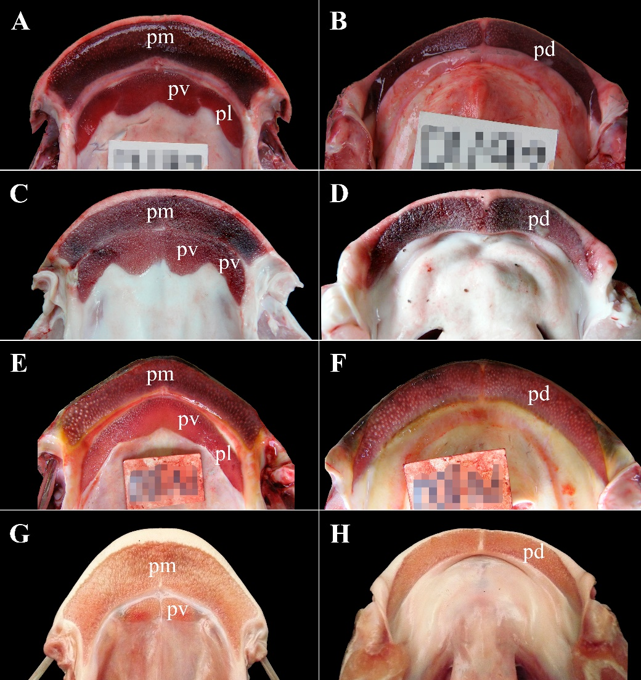

ANNEX 3. Maxillary and dentary dentition of: (A-B) Brachyplatystoma vaillantii, (C-D) B. platynema, (E-F) Leiarius marmoratus, (G-H) Sorubimichthys planiceps. vp: vomerine patch, pl: palatine patch, pm: premaxillary patch, dp: dentary patch. Photographs: Fernando M. Carvajal-Vallejos.
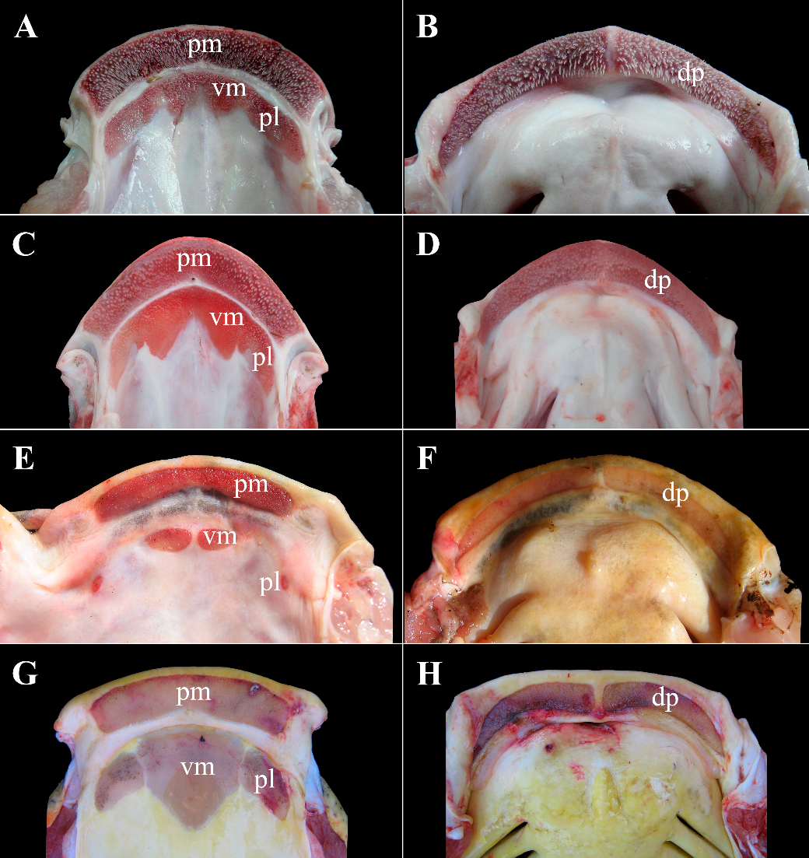

ANNEX 4. Maxillary and dentary dentition of: (A-B) Pseudoplatystoma fasciatum, (C-D) P. tigrinum, (E-F) Sorubimichthys planiceps, (G-H) Zungaro zungaro. vm: vomerine patch, pl: palatine patch, pm: premaxillary patch, dp: dentary patch. Photographs: Fernando M. Carvajal-Vallejos.
